One Pot Mexican Beef and Rice

This One Pot Mexican Beef and Rice is the ultimate weeknight dinner—quick to prepare, easy to clean up, and packed with bold flavor in every bite. Ground beef is browned and simmered with beef broth, sweet corn, and El Picante salsa, then combined with instant rice and melted cheddar for a hearty, satisfying meal that comes together in just 30 minutes.

The star of the dish is El Picante salsa, which infuses the beef and rice with a perfect balance of heat, brightness, and depth. Whether you use the All Natural, Habanero, or Verde variety, the salsa brings real flavor without the need for extra chopping or seasoning. It’s a one-pan recipe that’s both convenient and crave-worthy.

Serve it as-is or pile on your favorite toppings—like avocado, green onion, or jalapeños—for a custom finish. Perfect for family dinners, casual gatherings, or weekly meal prep, this dish is proof that real flavor doesn’t require complicated steps.

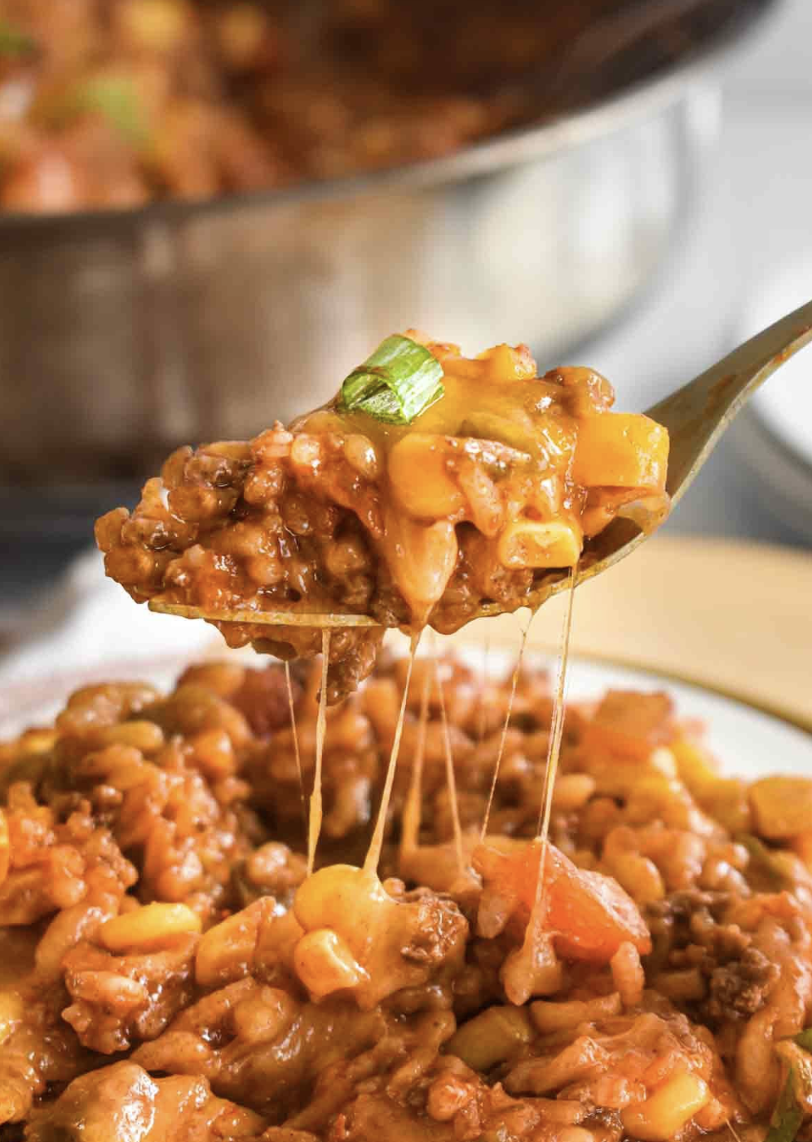

Prep Time:
10 mins

Cook Time:
20 mins

Total Time:
30 mins

Servings:
46

Ingredients
- 1 pound ground beef
- 2 cups low sodium beef broth
- One 16-ounce jar El Picante salsa
- One 15.25 ounce can corn (drained)
- One 1-ounce packet taco seasoning
- 1 tablespoon minced onion
- 1 1/2 cups instant rice
- 1 cup shredded cheddar cheese
- toppings, such as tomatoes, avocado, green onion, jalapeños, etc. (optional)

Directions
- n a large skillet, cook the ground beef over medium heat until fully browned, then drain off any excess grease.
- Stir in the beef broth, El Picante salsa, drained corn, taco seasoning, and minced onion. Bring the mixture to a boil.
- Add the rice and give everything a good stir to combine.
- Reduce the heat to low, cover the skillet with a lid, and let it simmer for 8–9 minutes, stirring occasionally to prevent sticking.
- Once the rice is tender, remove the pan from heat. Sprinkle cheese over the top, cover again, and let it sit until the cheese has melted.
- Top with your favorite garnishes—like sour cream, tomatoes, avocado, green onion, jalapeños, or extra salsa—and dig in!



