El Picante’s Green Chile Pork Skillet

Bring bold, zesty flavor to your table with this savory Pork in Salsa Verde. Made with tender cubes of pork loin seared to golden perfection and simmered in El Picante Salsa Verde, this dish delivers a vibrant kick with every bite. The fresh, tangy heat of tomatillos and peppers infuses the pork as it cooks, creating a rich, flavorful sauce that thickens into the perfect coating for the meat.

Finished with a sprinkle of fresh chopped cilantro, this dish is as visually appealing as it is delicious. Whether served over rice, alongside warm tortillas, or as the star of a taco platter, it’s a flavorful, crowd-pleasing meal that showcases the authentic taste of El Picante Salsa Verde. This recipe is a simple way to turn everyday pork into something unforgettable.

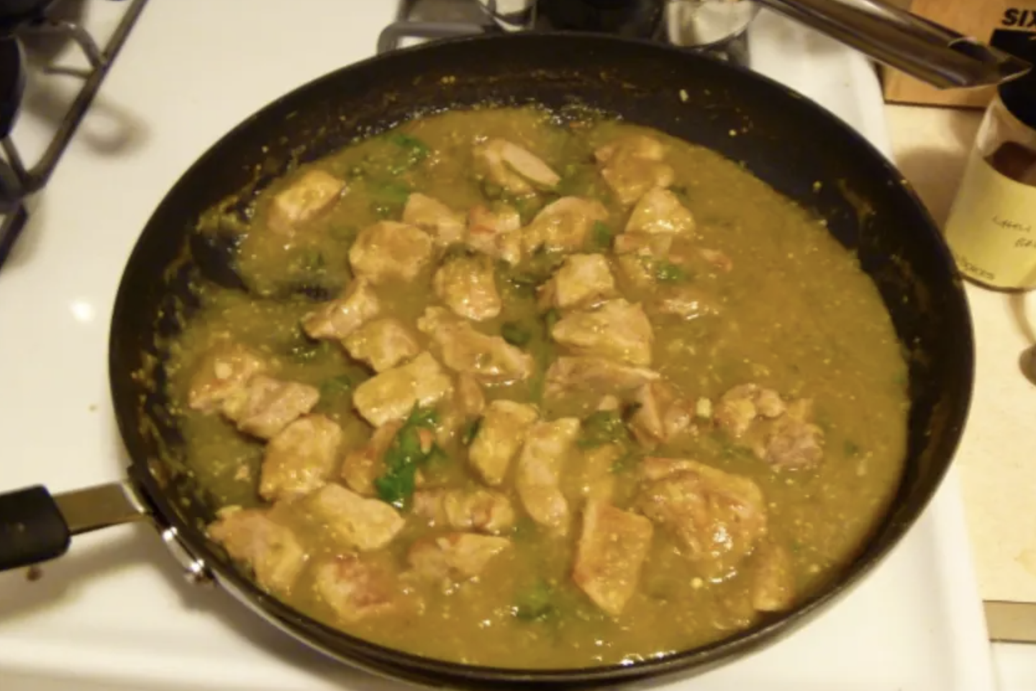

Prep Time:
25 mins

Cook Time:
2 hrs

Total Time:
2 hrs 25 mins

Servings:
6

Ingredients
- 2 cups El Picante salsa Verde
- 2 1⁄2 lbs boneless pork loin trimmed of all fat and cut into 3/4-inch cubes
- 2 tbs olive oil
- 1⁄4cup chopped fresh cilantro or 1/4 cup parsley

Directions
- Lightly coat the skillet with cooking spray and return it to medium-high heat.
- Add half of the pork cubes and sear, turning occasionally, until browned on all sides, about 5 to 7 minutes.
- Use a slotted spoon to transfer the browned pork to a plate, then repeat the process with the remaining pork.
- Return all the pork to the skillet and pour in the El Picante salsa Verde. Simmer for 8 to 10 minutes, or until the sauce thickens and coats the meat.
- Stir in the chopped cilantro just before serving.


