Slow Cooker Salsa Beef

This Slow Cooker Salsa Beef is a weeknight lifesaver that’s equal parts hearty, flavorful, and hands-off. Just a handful of ingredients—including ground beef, onions, bell peppers, and bold seasonings—come together in the slow cooker for a dish that practically makes itself. Stir in your favorite jar of El Picante salsa, and let the flavors simmer all day into a saucy, savory blend with just the right amount of kick.

What makes this recipe stand out is the use of El Picante salsa, which brings fresh, all-natural flavor and balanced heat to every bite. Whether you go with the classic All Natural, the fiery Diablo, or the bright Verde, your choice of salsa instantly upgrades this simple dish. Serve it in bowls with rice, pile it into taco shells, or spoon it over baked potatoes—however you plate it, this beef is full of flavor and endlessly versatile.

Perfect for family dinners, meal prep, or even casual entertaining, this dish offers comfort food satisfaction with minimal effort. Bonus: it works just as well on the stovetop if you’re short on time but still want something delicious.

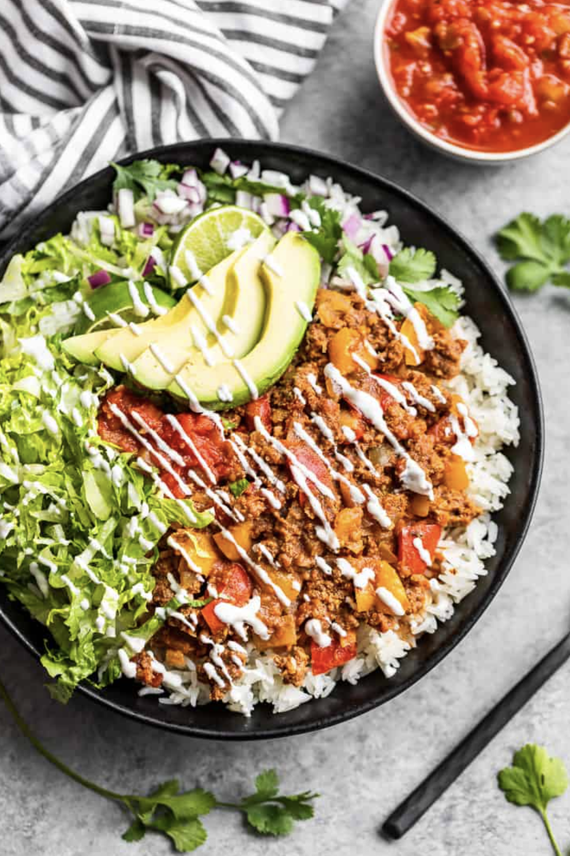

Prep Time:
10 mins

Cook Time:
8 hrs

Total Time:
8 hrs 10 min

Servings:
4

Ingredients
- 1 large onion - diced into 1/4″
- 2 bell peppers - I used red & yellow, cut into 1/2″ pieces
- 1 pound ground beef
- 1 clove garlic - minced
- 2 tsp ground cumin
- 1 tsp smoked paprika
- 1 tsp chipotle powder
- 16-ounce jar mild salsa - about 2 cups

Directions
- Add the onion, bell pepper, and ground beef to the bowl of your slow cooker. Use a wooden spoon to break the beef into small, crumbled pieces.
- In a separate bowl, stir the minced garlic and spice blend into the salsa. Pour this mixture over the beef and vegetables, then stir to combine. Set the slow cooker to low for 8 hours or high for 4 hours.
- If you prefer your peppers with a bit more bite, begin checking for doneness around the 5-hour mark on low.
- Serve hot with your favorite toppings—or go all out and use them all!


