El Picante Salsa Website
Summit Food Company is a startup consumer packaged goods (CPG) brand launching its flagship product line — El Picante Salsa. We’re seeking a talented web designer to create a bold, professional, mobile-optimized website using WordPress with a WP Maps store locator to help customers find local retailers.

Our goal is to build a strong online presence that supports both retail growth and direct-to-consumer sales.

Website Design Brief: www.elpicantesalsa.com

Overview:

Project Goals:
- Establish a bold, professional online presence that reflects the quality of our small-batch salsa
- Make it easy for customers to find nearby retail locations using WP Maps
- Introduce new customers to the brand

Platform Requirements:
- CMS: WordPress
- Store Locator: WP Maps plugin (or equivalent with store search + geolocation)
- Hosting-ready, responsive design with secure checkout capabilities (SSL)

Design Style:
- Reference Site: www.mateos.com
- The design of the El Picante Salsa website shall emulate the clean, polished aesthetic of Mateos.com.

Required Pages & Features:

Homepage
- Eye-catching hero image or banner
- Featured product section (All Natural Salsa)
- Reviews
- Recipes
- Instagram link
- Privacy policy
- Copywrite

Product Page
- 3 Products: All Natural, Habanero, Verde
- Each product should include:
- Description
- High-quality image
- Ingredient list
- Size/volume info
- Nutrition facts panel

High Quality Images

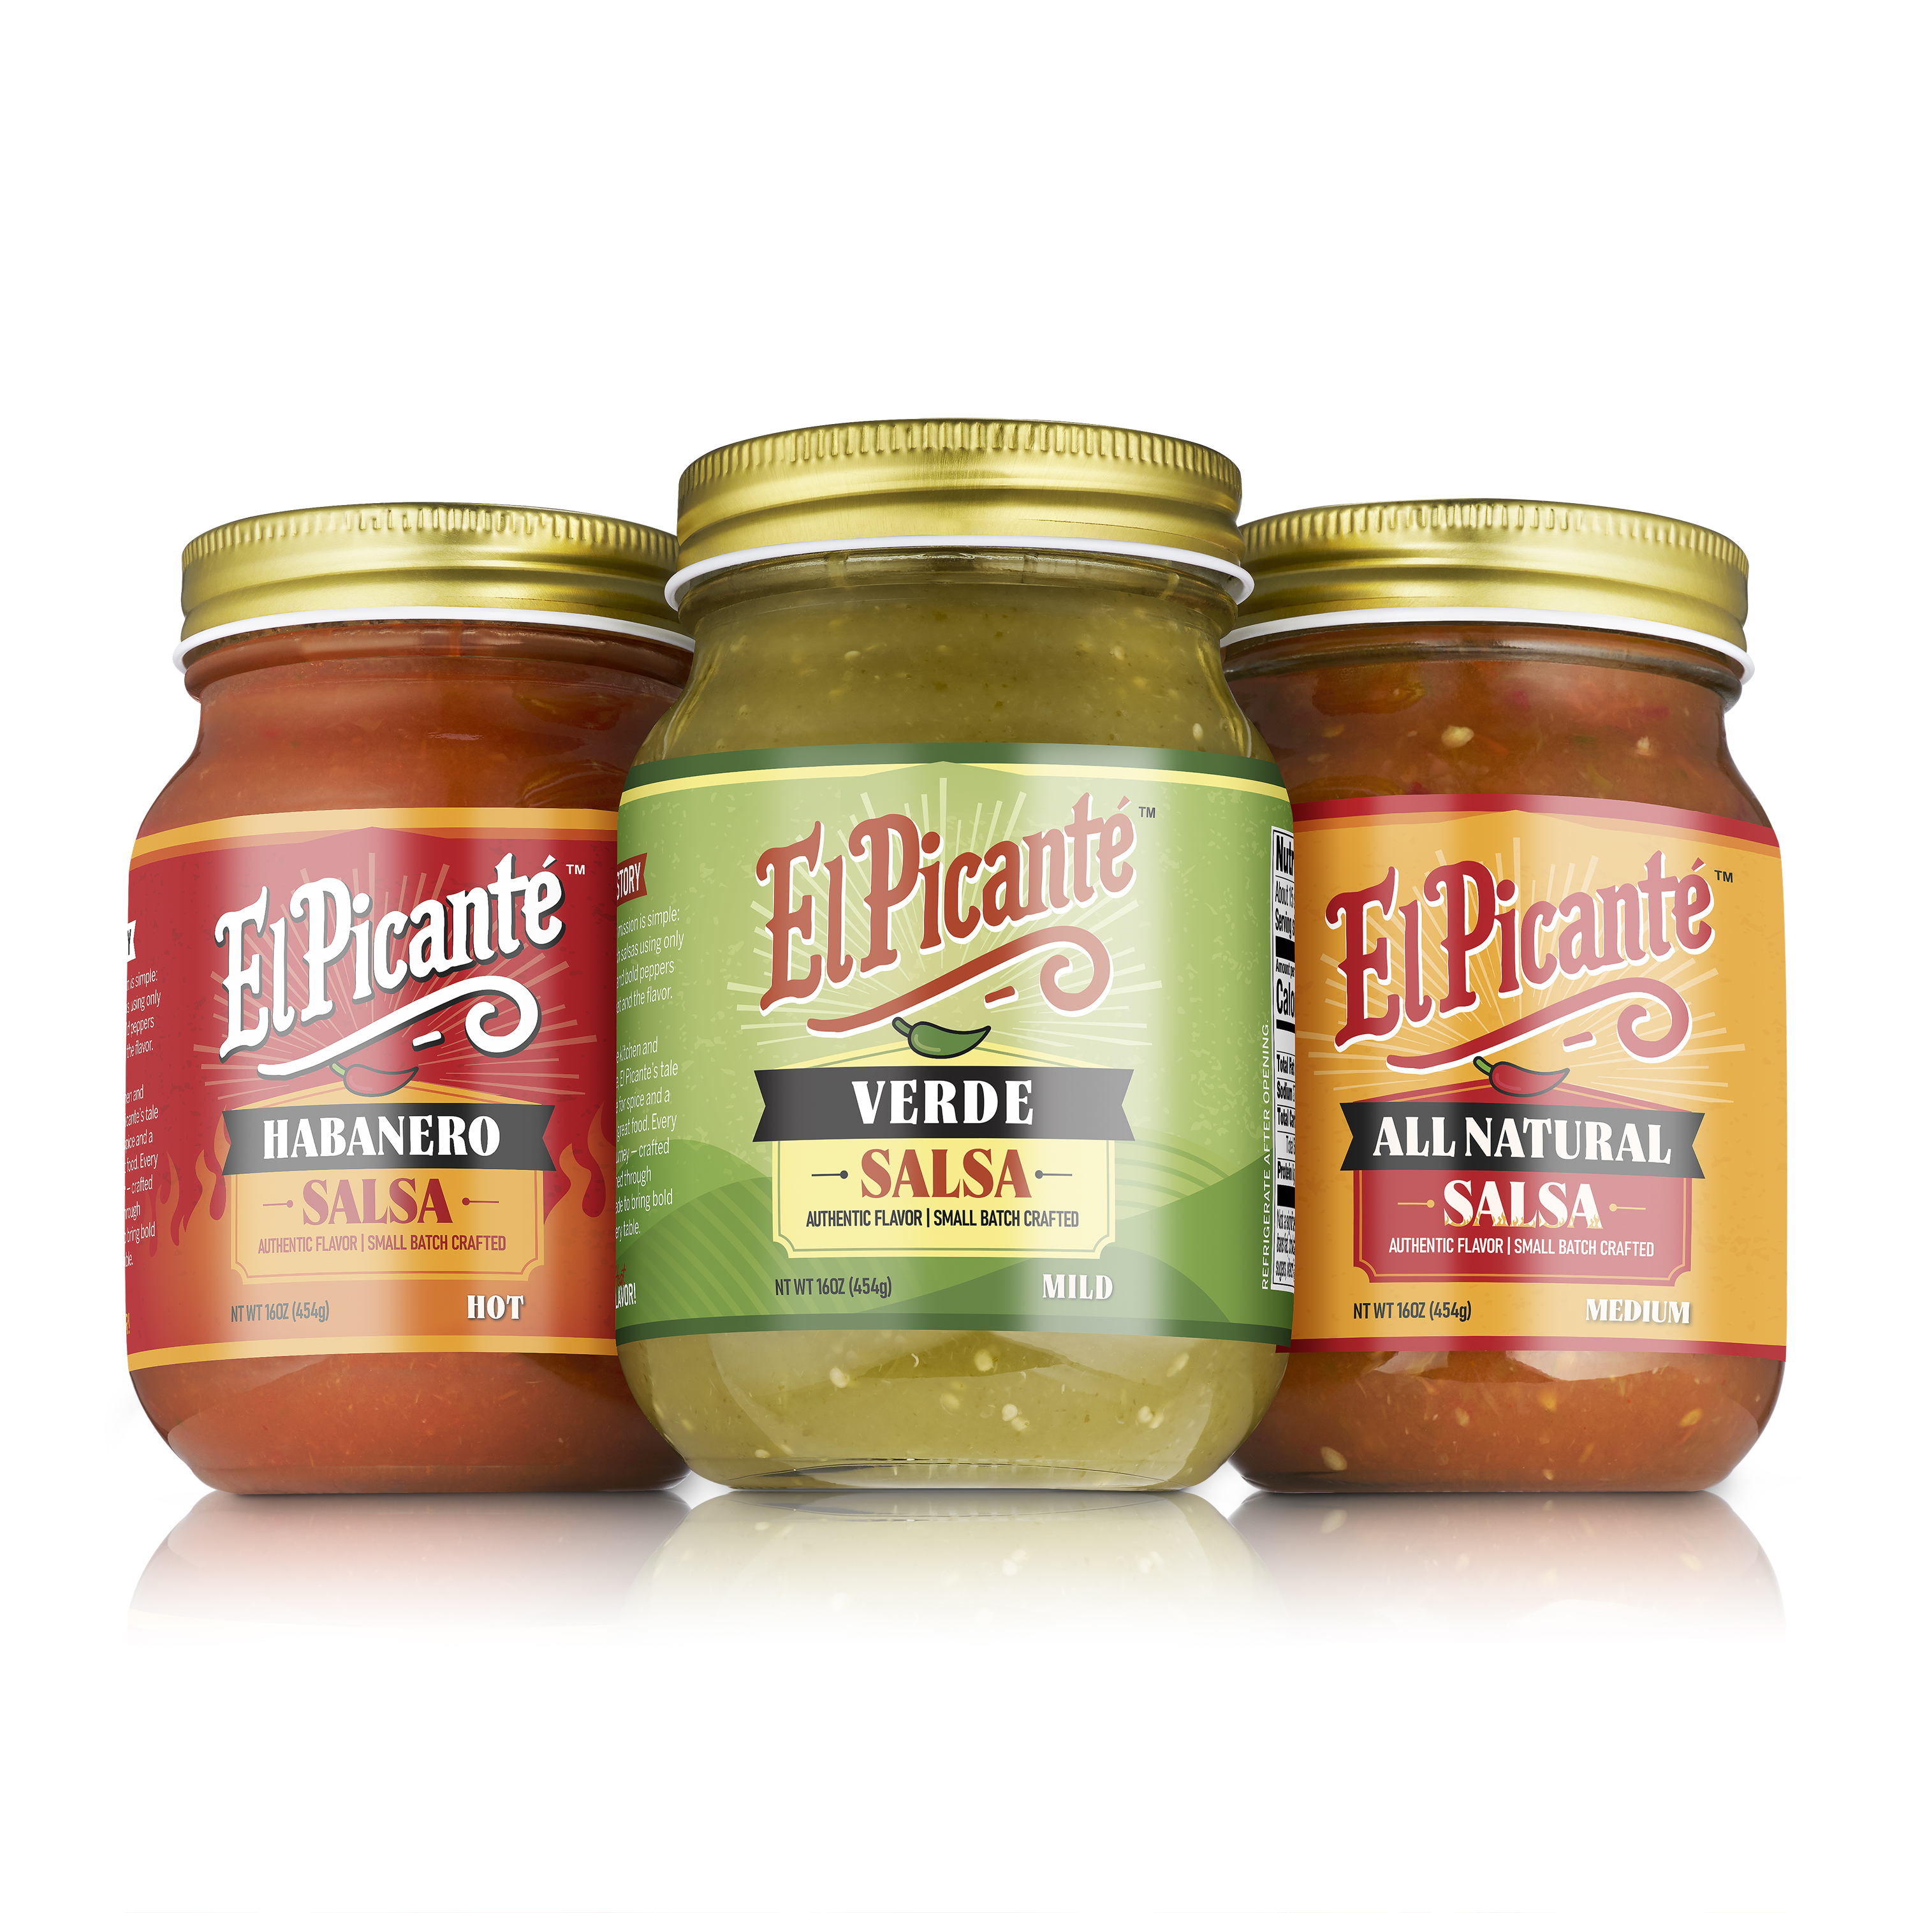

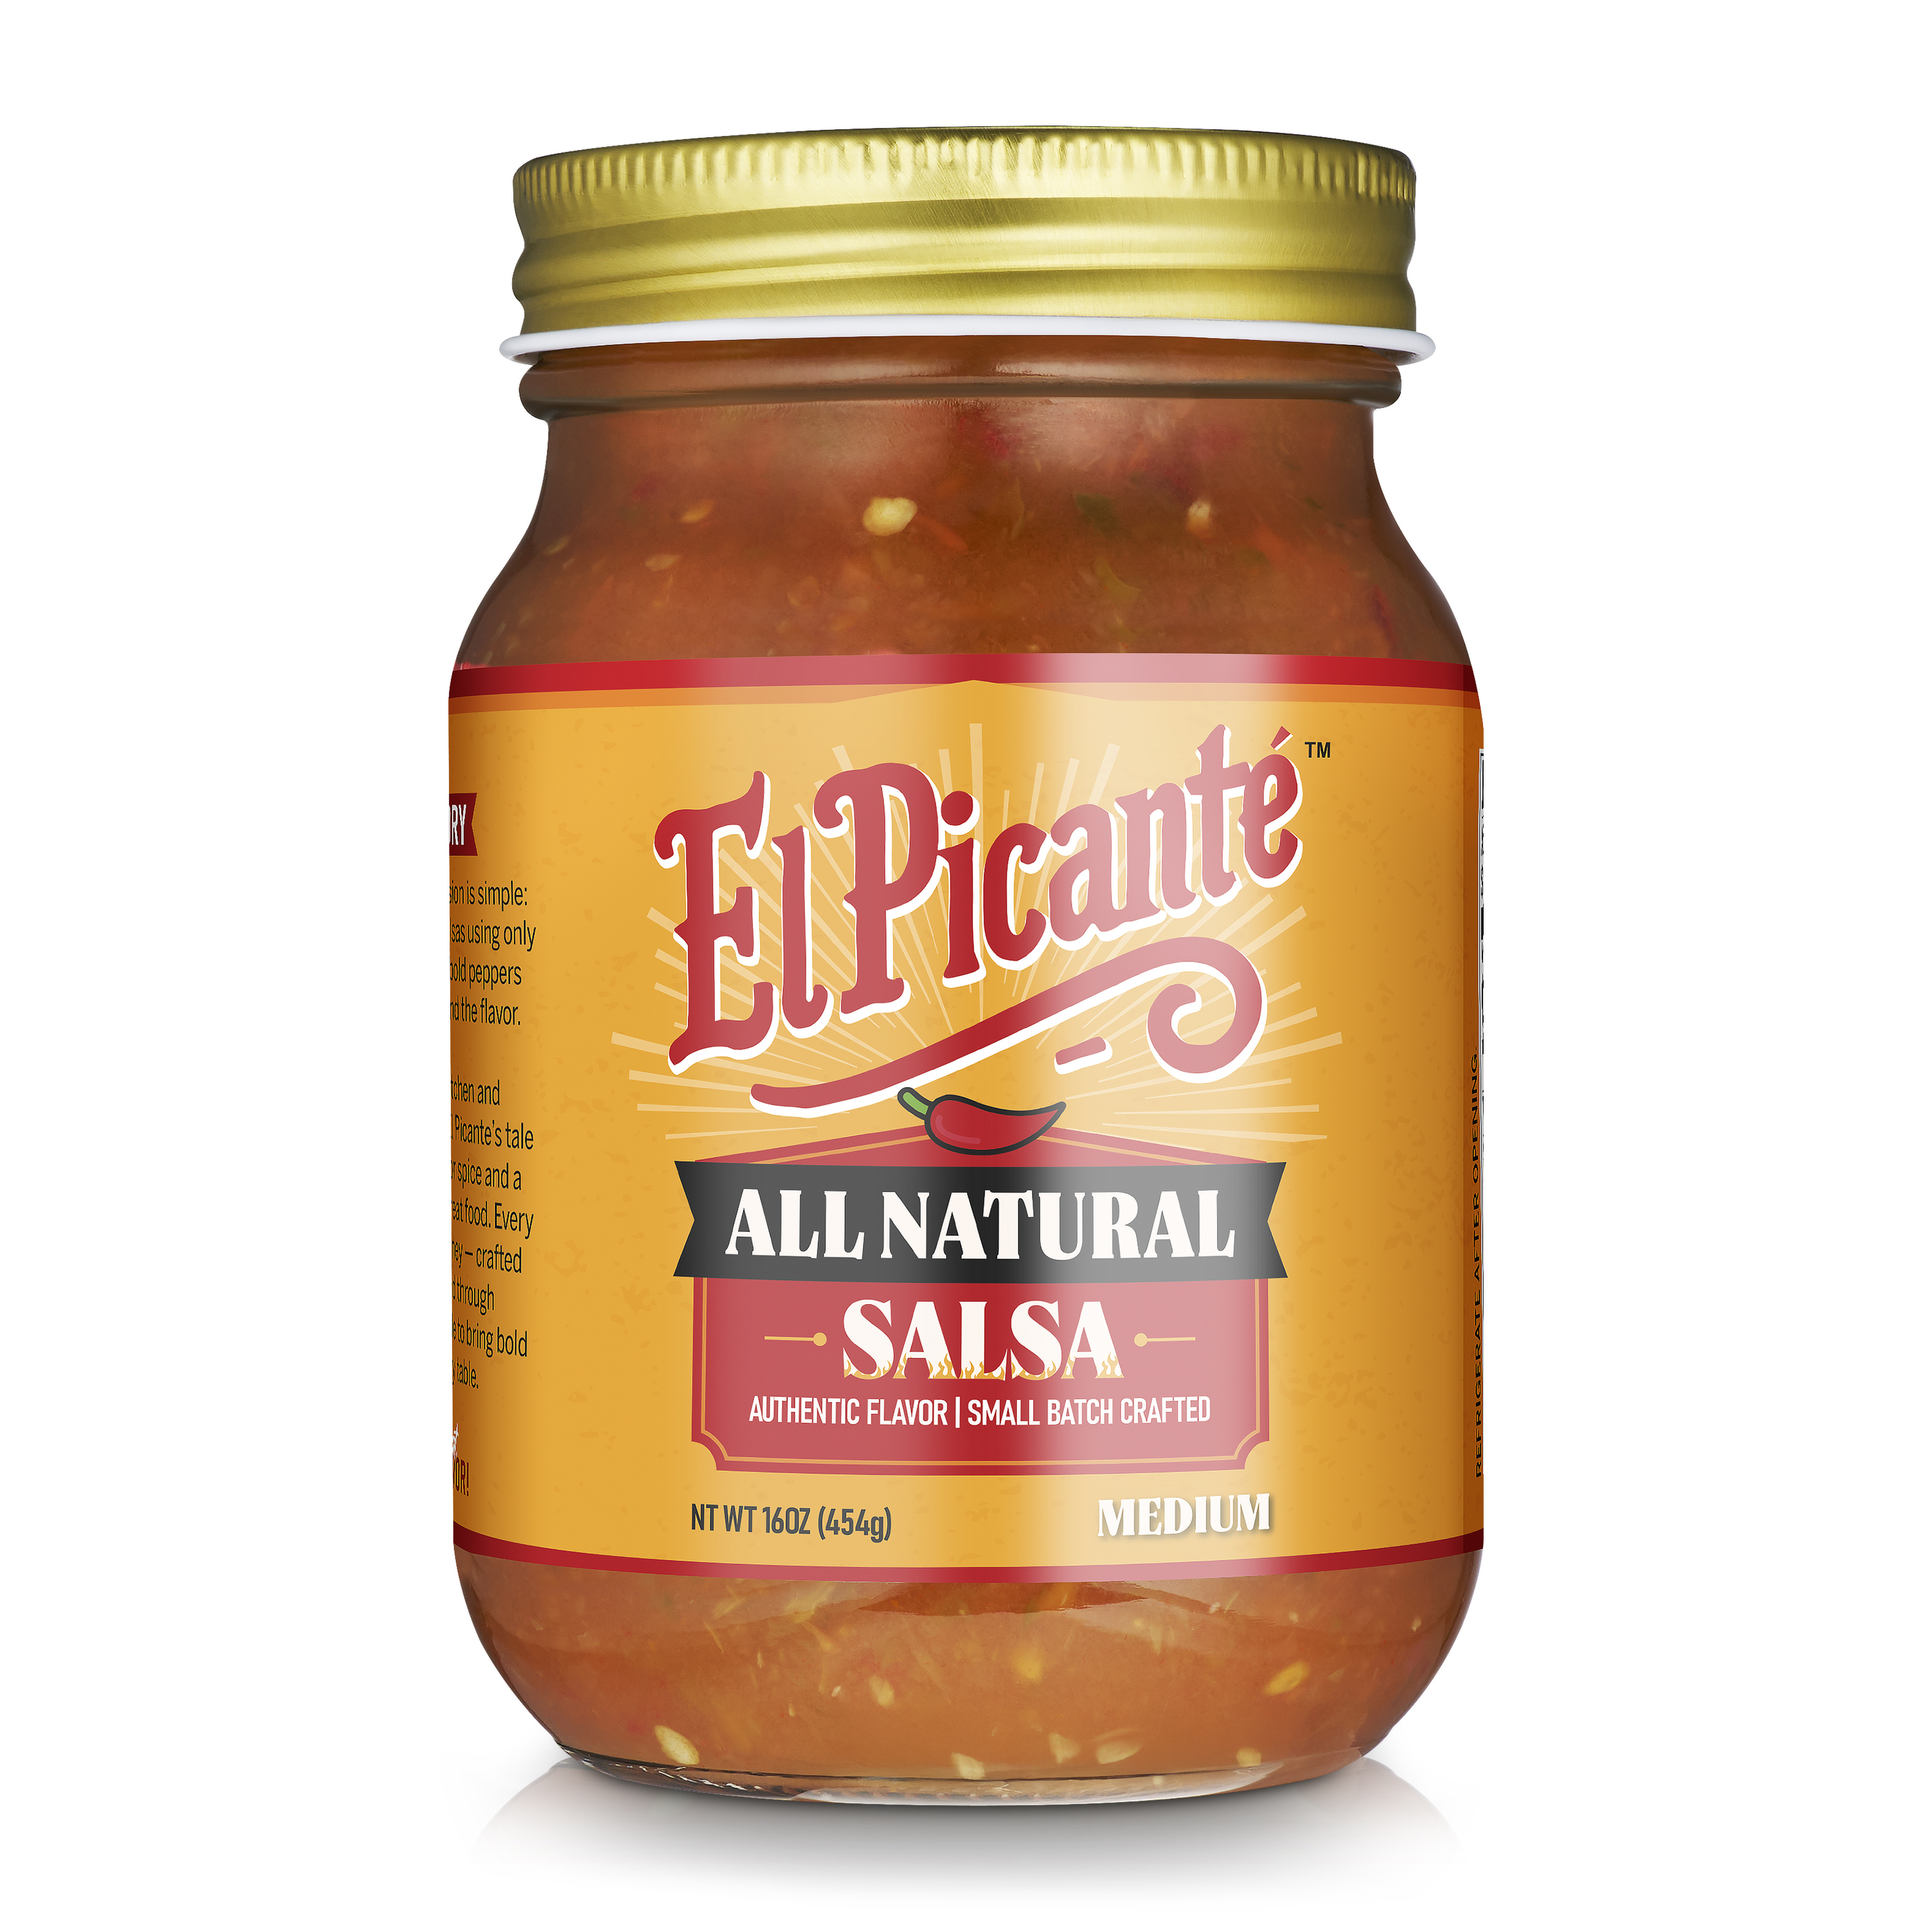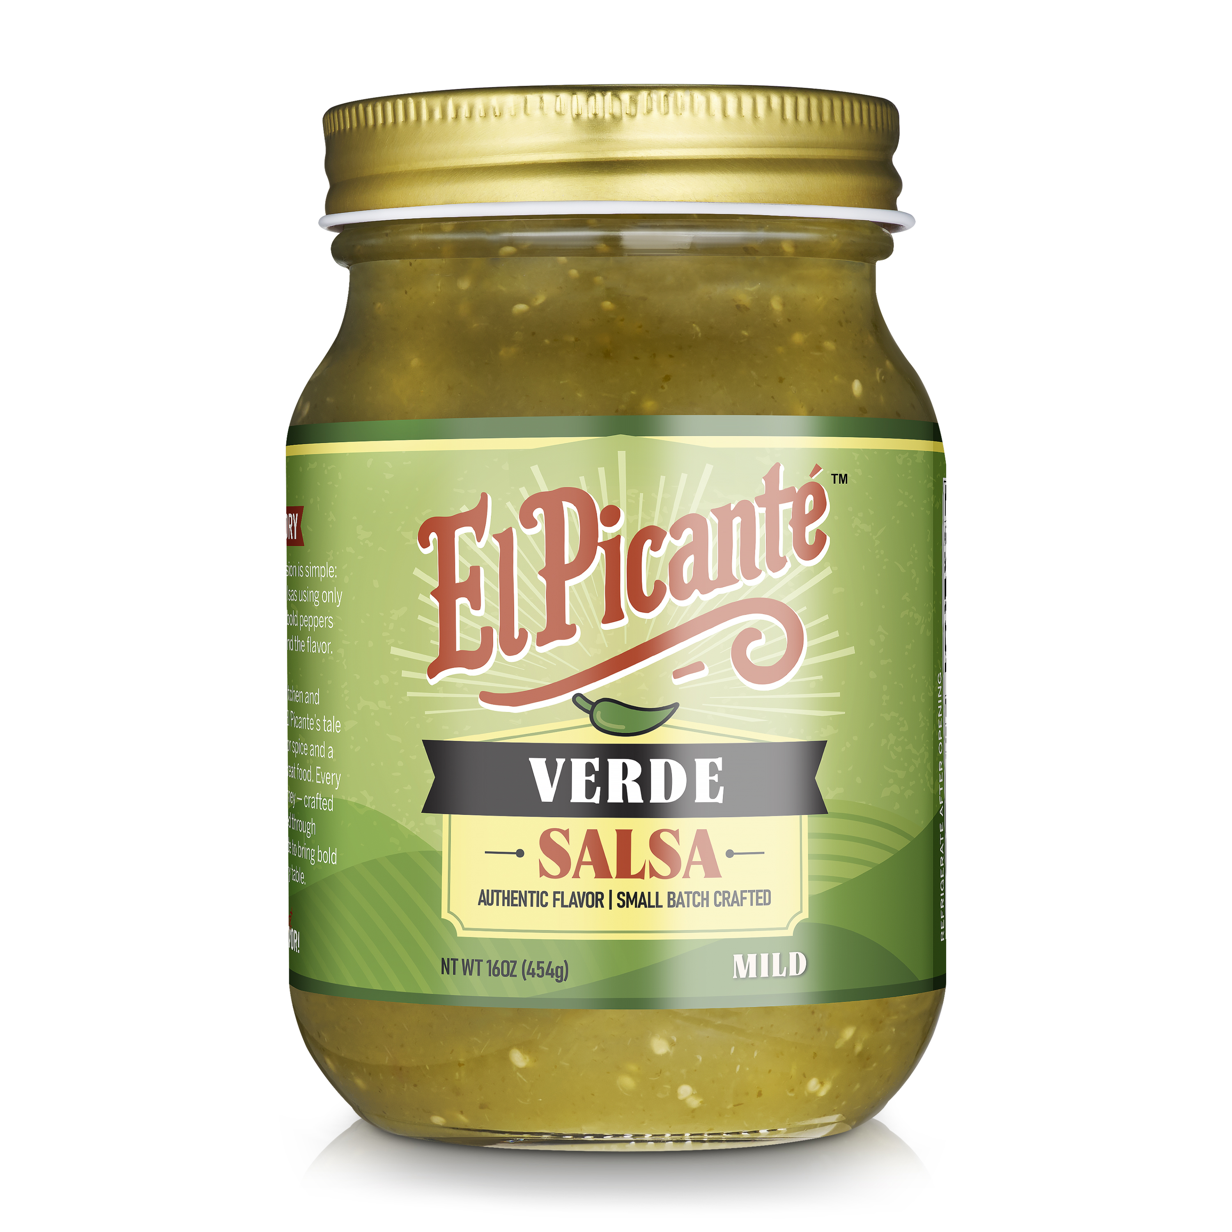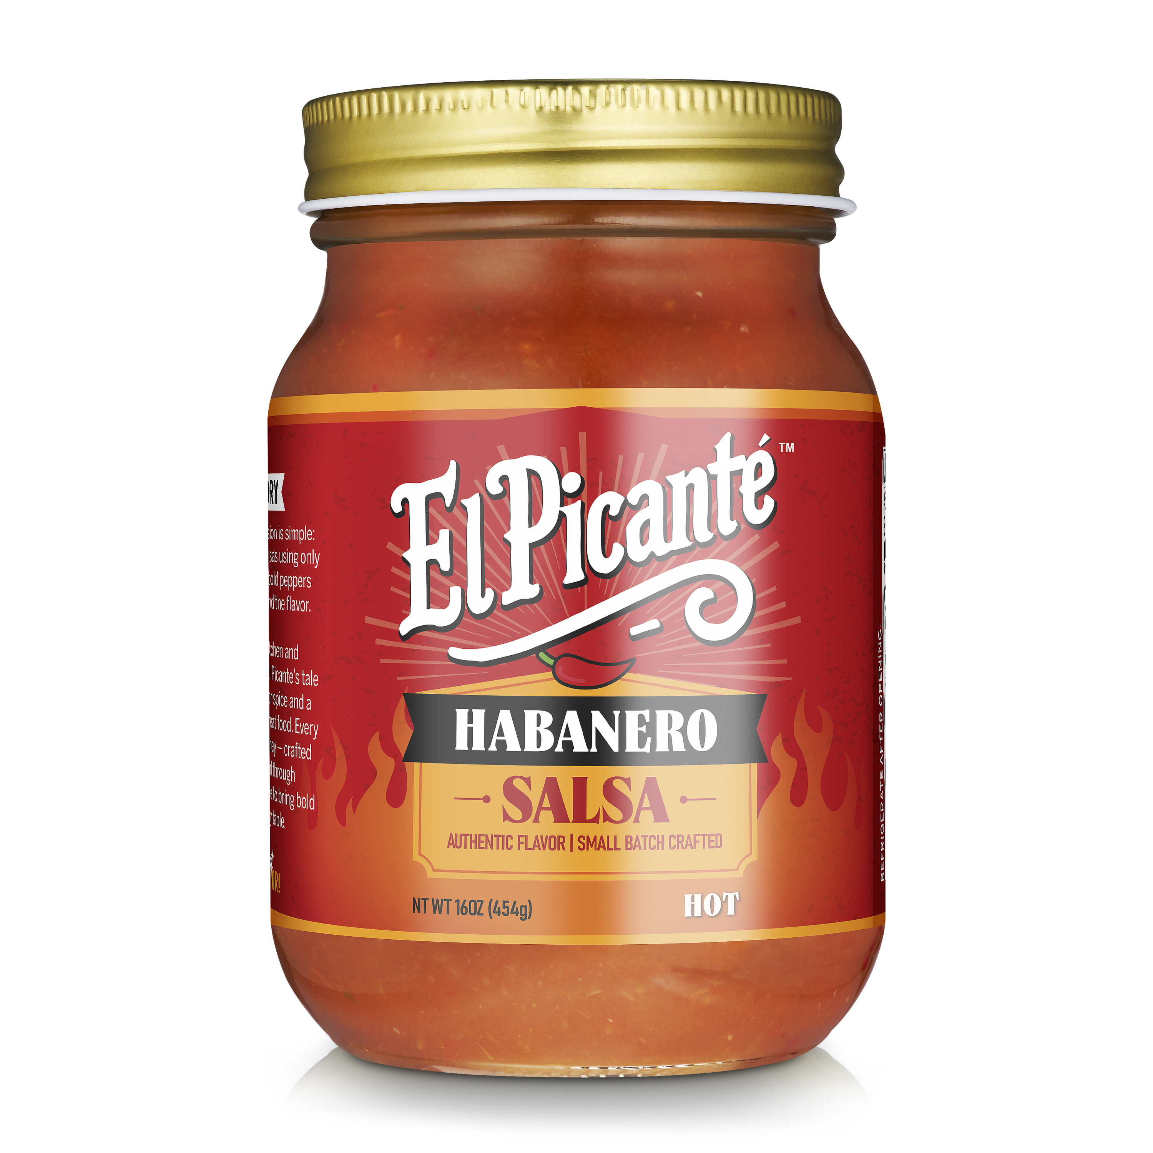

Where to Buy Page
- Store Locator (WP Maps plug in)
- Store search by zip code or location
- Interactive map with store pins and product availability

Recipe Page
- Featured recipes – see attached 10 recipes

About Page
- Include this writeup:
About El Picante

El Picante was founded in 2025 with a simple vision: to create bold, premium salsas that deliver authentic flavor using real, honest ingredients. What began as a homegrown recipe has grown into a professionally scaled brand, built for regional retail distribution and future expansion.

Crafted in small batches using vine-ripened crushed tomatoes, real chili pepper purees, and carefully balanced natural spices, each El Picante variety offers rich texture and depth—without fillers, preservatives, or shortcuts. From the classic All Natural to the Habanero, every jar reflects a commitment to quality and flavor integrity.

With production based in Texas, El Picante partners with local suppliers, regional co-packers, and independent retailers to ensure consistency, freshness, and operational scalability. The company is driven by a belief that great food is rooted in simplicity, and that authenticity always earns shelf space.

Review Page
- Add a Blind Taste Test results description as follows:

Blind Taste Test Results – June 2025
In June 2025, El Picante Salsa was put to the test in a blind taste challenge conducted by a third party with 38 participants. Without knowing the brand, tasters judged flavor, heat level balance, aroma, appearance, and overall satisfaction.
The result?
An impressive 4.67 out of 5 stars, with 89% of participants rating it 5 stars.
These reviews reflect the authentic flavor and bold character that make El Picante stand out in a crowded salsa market. Taste-tested, crowd-approved.
Flavor
Actual results: 17 5-star ,12 4-star, 4 3-star, 1 2-star, 0 1-star
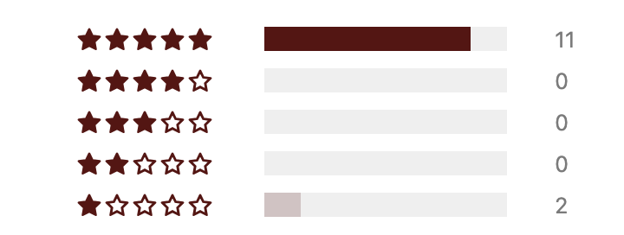
Heat Level Balance
Actual results: 13 5-star, 21 4-star, 4 3-star,0 2-star, 0 1-star
Aroma
Actual results: 20 5-star, 13 4-star, 5 3-star, 0 2-star, 0 1-star
Appearance
Actual results: 20-5-star,
Overall Satisfaction
(Actual results: 11 5-star, 24 4-star, 3 3-star, 1 2-star, 0 1-star)
- Include the following quotes from participants:
“Very good, and I’m a salsa snob!”
“Awesome taste, fresh.”
“Really good flavor.”
“Very nice overall. I cook a lot so I often make my own, but this is great!”
“At $4.79 that is a great value.”

Contact Page
- Simple contact form
- Email address ( support@elpicantesalsa.com)

Privacy Policy
- Link to privacy policy which reads as follows:

Effective Date: June 2025
At El Picante Salsa, we respect your privacy and are committed to transparency about how we collect and use data on our website, www.elpicantesalsa.com.

1. Information We Collect
We do not collect any personal information such as names, emails, or payment details.
The only data we collect is through cookies, which track general website usage.

2. How We Collect Data
We use cookies to collect anonymous usage data when you visit our site. This data may include:
- Browser type
- Device type
- Pages visited
- Time spent on the site
- Referral sources
This data is collected via tools like Google Analytics.

3. How We Use Your Information
We use this anonymous usage data strictly to:
- Improve our website’s performance
- Understand how users interact with our content
- Enhance the overall user experience
We do not sell, share, or disclose this data to any third parties.

4. Cookies and Tracking
We use cookies to better understand visitor behavior. You can disable cookies through your browser settings if you prefer not to be tracked.

5. Your Rights
While we do not collect personally identifiable information, you may contact us at any time to inquire about or request the removal of usage data associated with your visit: [support@elpicantesalsa.com]

6. Data Security
We protect all collected data using industry-standard security measures, including SSL encryption.

7. Policy Updates
This Privacy Policy may be updated from time to time. Any changes will be posted on this page with an updated effective date.

8. Contact Us
If you have any questions or concerns about this policy, please contact us at:
support@elpicantesalsa.com

SEO Optimization
- Fast load times
- Mobile-first responsiveness
- On-page SEO fundamentals (meta tags, alt text, heading hierarchy)

Deliverables:
- Fully responsive WordPress website
- Connect the completed WordPress site to my domain: elpicantesalsa.com
- Ensure DNS settings are properly configured to point to the correct hosting server
- SSL certificate must be active and functioning (HTTPS enabled)
- Installed WP Maps plugin with working store locator
- Contact form sends messages to: support@elpicantesalsa.com
- Provide WordPress admin login credentials
- Basic on-page SEO setup

Some Sites to Use for Inspiration:
- Mrs. Renfro’s (https://www.renfrofoods.com )
- Mateo’s (https://mateos.com)

Brand Logo:
-Here is the El Picante logo.

Visuals:
-Use these color HEX codes for the website:

- #000000 

- #FFFFFF 

- #C74524 

- #F0B739 

- #113C3E 

- #3B6A1D 

- #8CA85B 

- #bfe67c 

