Bold & Saucy Shredded Chicken

If you’re looking for a set-it-and-forget-it meal that delivers big on flavor, this Bold & Saucy Shredded Chicken is a guaranteed go-to. Made with just three simple ingredients—boneless chicken breasts, taco seasoning, and a full jar of El Picante salsa—this slow cooker recipe brings incredible taste with minimal effort. After six hours on low, the chicken becomes perfectly tender and shreds effortlessly with a fork.

What makes this dish shine is the salsa itself. El Picante’s clean ingredients and bold flavors infuse every bite, whether you use the original All Natural, fiery Diablo, or vibrant Verde variety. Adding a touch of fresh salsa at the end locks in even more flavor and moisture, giving you rich, saucy shredded chicken that’s anything but ordinary.

Serve it in tacos, burrito bowls, sandwiches, or on top of salads—it’s as versatile as it is flavorful. Whether you're feeding a family or meal prepping for the week, this is a recipe you'll come back to again and again.

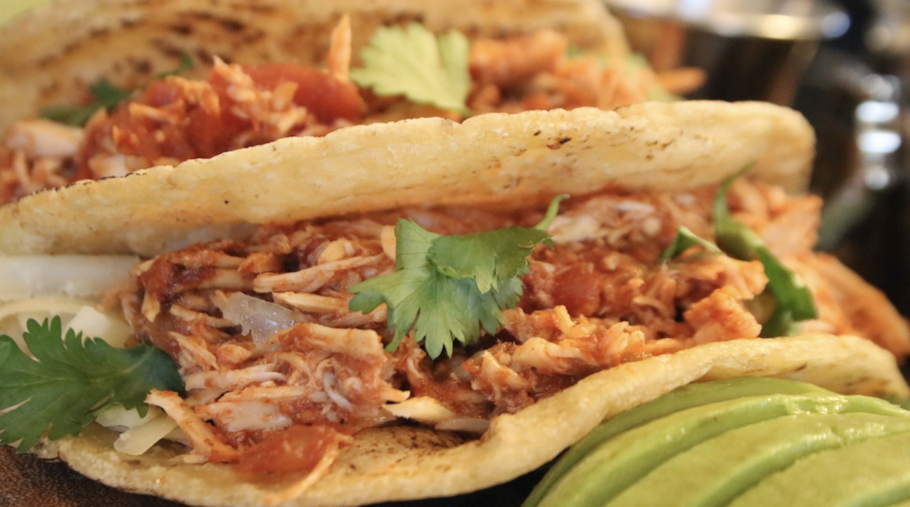

Prep Time:
10 mins

Cook Time:
6 hrs

Total Time:
6 hrs 10 mins

Servings:
4

Yield:
4 chicken breast halves

Ingredients
- 2 Boneless chicken breasts
- 3 tsp Taco seasoning
- 1 jar El Picante salsa (enough to cover chicken breasts)

Directions
- Place the chicken breasts in the bottom of your slow cooker.
- Sprinkle with 3 teaspoons of taco seasoning, then pour in enough salsa to fully cover the chicken.
- Use tongs to turn and coat the chicken evenly in the salsa, then position the pieces so they’re nestled and mostly submerged.
- Cover and cook on low for 6 hours, or until the chicken is tender and easily shreds with a fork.
- Transfer the cooked chicken to a mixing bowl, add about ½ cup of fresh salsa, and shred with two forks. Let the shredded chicken sit for a few minutes to soak up the added flavor.
- Serve it your way—stuffed in tacos, spooned into grain bowls, stacked in sandwiches, or scattered over salads.


