Cheesy Salsa Chicken

This Cheesy Salsa Chicken is a go-to dinner recipe that delivers bold flavor with minimal effort. Perfect for busy weeknights, it features tender, seared chicken breasts baked in a generous layer of El Picante salsa and topped with melted Cheddar cheese. With just a handful of ingredients and about 30 minutes from start to finish, it's a comforting, crowd-pleasing meal that feels home cooked but couldn’t be easier to make.

The real flavor hero here is El Picante salsa, which infuses the chicken with a balanced blend of heat, brightness, and real tomato-and-pepper depth. Whether you choose the All Natural, Diablo, or Verde variety, each adds its own signature kick that transforms this simple dish into something crave-worthy. Serve it over rice with a side of steamed vegetables, and you’ve got a complete meal that satisfies without the fuss.

Whether you're feeding the family or cooking for guests, this cheesy, saucy, skillet-to-oven recipe is sure to become a repeat favorite. It's proof that great flavor doesn't need to be complicated—especially when El Picante is involved.

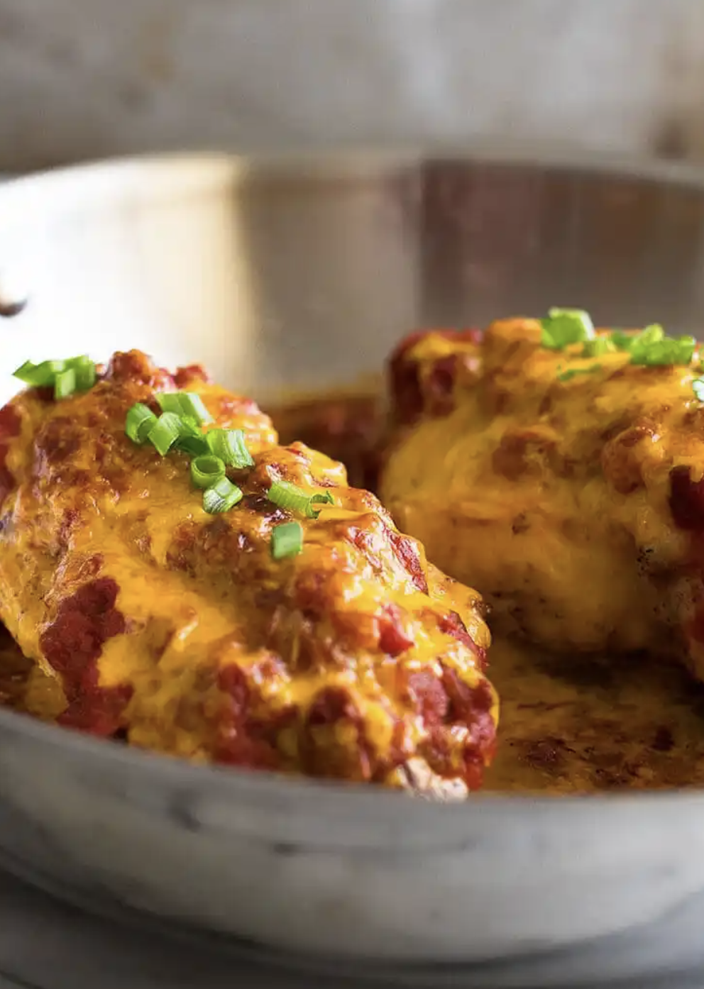

Prep Time:
5 mins

Cook Time:
25 mins

Total Time:
30 mins

Servings:
4

Yield:
4 chicken breast halves

Ingredients
- 2 Boneless chicken breasts
- 4 small boneless skinless chicken breasts
- Salt
- Pepper
- Taco seasoning
- 1 ½ cup El Picante salsa
- 2 scallions (chopped)
- 1 cup shredded Cheddar cheese

Directions
- Set your oven to preheat at 400°F.
- Season both sides of the chicken breasts with salt, pepper, and taco seasoning. Warm a large oven-safe skillet over medium-high heat and lightly coat it with cooking spray or a small amount of oil. Once hot, add the chicken and sear until nicely browned. Flip and repeat on the other side.
- After browning both sides, remove the skillet from the heat and pour El Picante salsa over the chicken. Transfer the pan to the oven and bake for 15 to 25 minutes, depending on the thickness of the chicken, until an instant-read thermometer registers 150°F in the center.
- Top the chicken with shredded cheese and return to the oven for another 5 to 10 minutes, or until the internal temperature reaches 165°F. Remove from the oven and let the chicken rest for 5 minutes. Top chicken with chopped scallions. Spoon the warm El Picante salsa from the pan over a bed of rice and serve alongside steamed broccoli or green beans. Enjoy!


