El Picante’s Black Bean and Salsa Soup
Looking for a quick, hearty dish that doesn't skimp on flavor? Our Black Bean and Salsa Soup is the perfect blend of comfort and kick—ready in just 20 minutes. This simple, satisfying recipe blends protein-rich black beans with savory vegetable broth, a hint of cumin, and a full cup of El Picante salsa for bold, vibrant flavor in every spoonful.
What makes this soup stand out is the heat and freshness delivered by El Picante. Whether you're using our All Natural, Verde, or Diablo variety, the salsa adds depth and spice without the need for extra chopping or seasoning. It’s a go-to option for busy weeknights, light lunches, or anytime you want something warm, wholesome, and deliciously Texan.
Top it off with a dollop of sour cream and sliced green onions for a creamy finish and a pop of color. Serve it as a stand-alone dish or alongside a crispy quesadilla or fresh salad for a complete meal that’s as easy as it is flavorful.

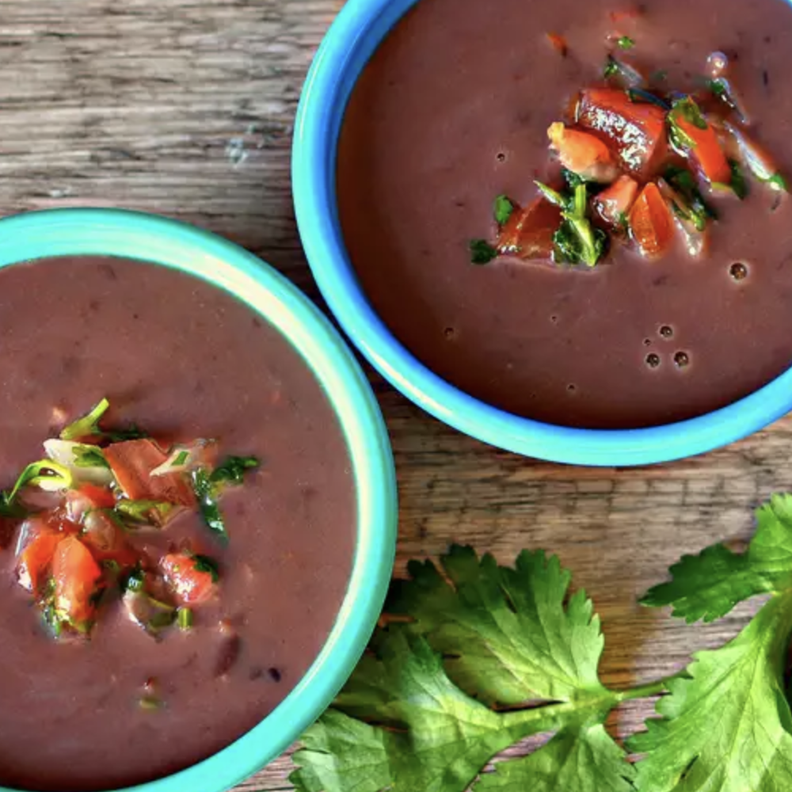

Prep Time:
10 mins

Cook Time:
10 mins

Total Time:
20 mins

Servings:
4

Yield:
4 servings

Ingredients
- 2 (15 ounce) cans black beans, drained and rinsed
- 1 ½ cups vegetable broth
- 1 cup El Picante salsa
- 1 teaspoon ground cumin
- 4 tablespoons sour cream
- 2 tablespoons thinly sliced green onion

Directions
- In an electric food processor or blender, combine beans, broth, El Picante salsa, and cumin. Blend until smooth.
- Heat the bean mixture in a saucepan over medium heat until thoroughly heated.
- Ladle soup into 4 individual bowls and top each bowl with 1 tablespoon of the sour cream and 1/2 tablespoon green onion.


