Project Overview – El Picante Salsa Tri-Fold Brochure
Summit Food Company is a Texas-based CPG startup launching its flagship product line — El Picante Salsa. We are seeking a designer to create a 3-panel, tri-fold sales brochure to support retail outreach and brand storytelling. The brochure will be handed out to retail buyers, food brokers, and distributors, so it should clearly convey our product quality, brand personality, and sales appeal.
The design should closely emulate the attached sample brochure image for layout inspiration and follow our existing color and brand guidelines.

Brochure Dimensions

Height and Width before Folding
- 8.5”x 11.0”

Panel Descriptions

Panel 1: Cover Panel
- In lower section include:
  - Title: “NOW AVAILABLE!”
  - Tagline: “Real Heat. Real Flavor.”
  - Include: “Authentic Flavor. Small Batch Crafted.”
  - Lower section background color palette: #C74524.
- In upper section include:
  - Feature the El Picante logo near the top.
  - Bold, high-impact product shot (group product shot adjusted to have transparent background)
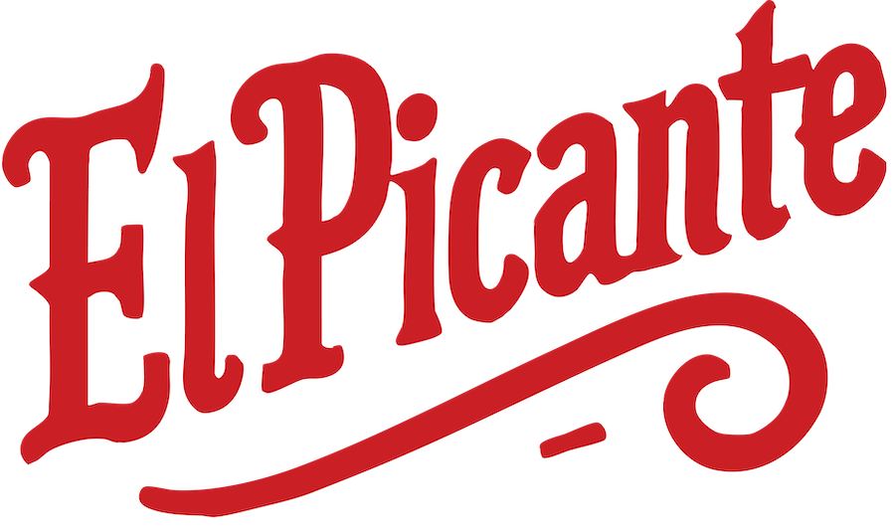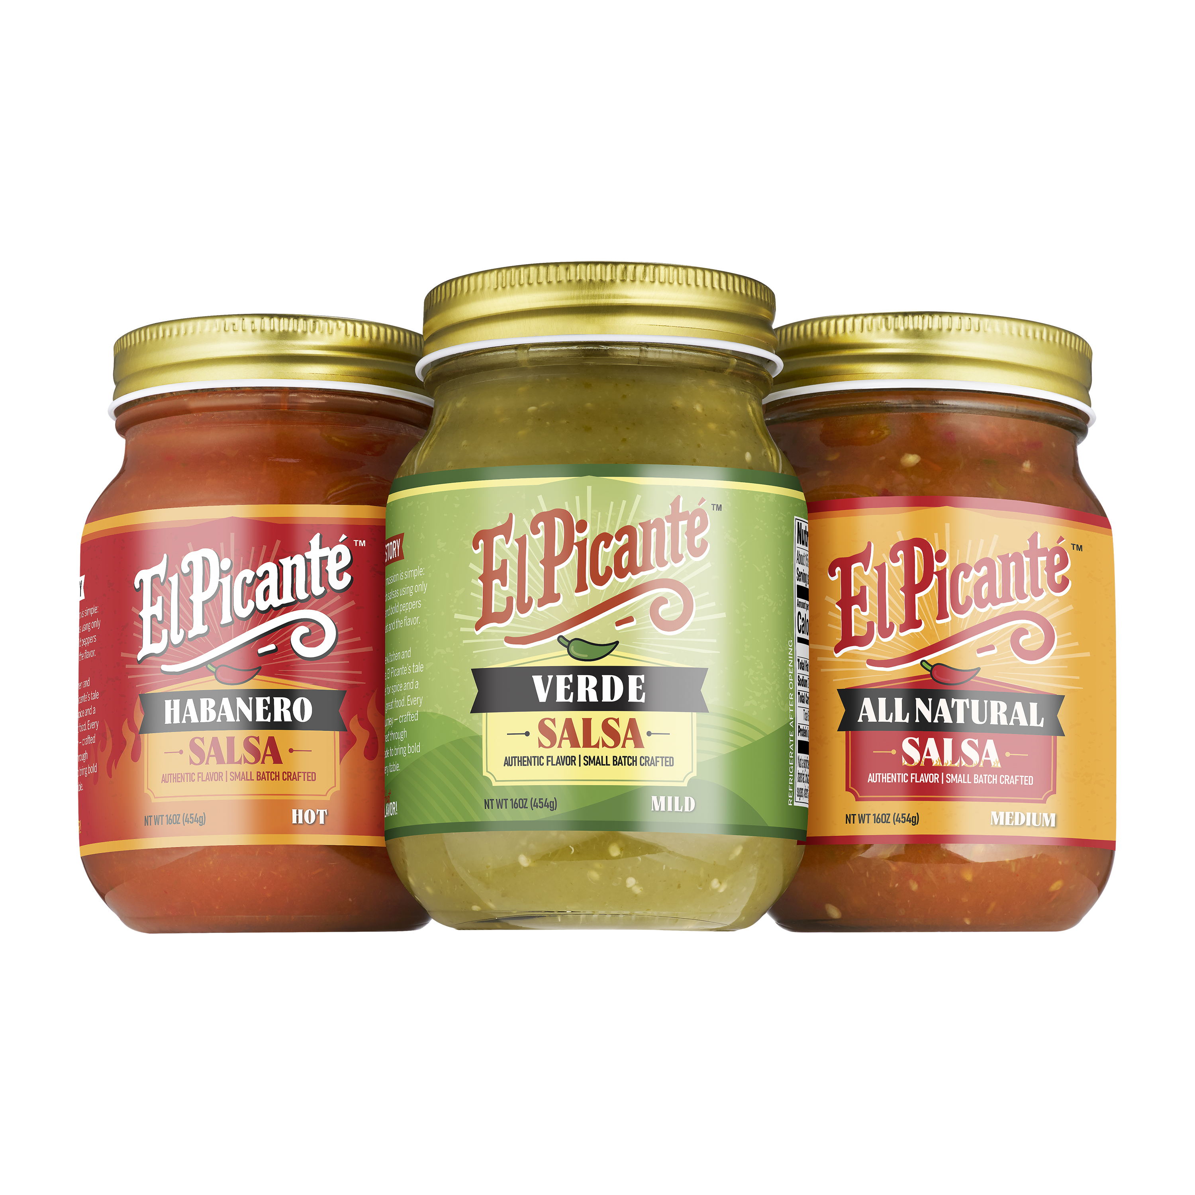
  - Please replicate a soft, blended swirl pattern like the Sample brochure image using varying shades of green — ranging from #113C3E to #3B6A1D to #8CA85B, with subtle light-to-dark radial or organic gradients. The effect should feel natural and smooth, almost like sunlight filtering through foliage or a bokeh-inspired blur with a slight sense of motion. Avoid hard lines or high contrast — it should remain soft and atmospheric, not noisy or artificial. The pattern should extend into the upper section of panel 2.

Panel 2: Brand & Product Highlights
- In lower section include:
- Background color palette: #F0B739 for the lower section.
- Add following text:
“At El Picante, our mission is to bring bold, honest flavor to the salsa aisle—without compromise. We craft every jar using all-natural ingredients, free from preservatives, fillers, or shortcuts, because we believe real food should taste real. Rooted in Southlake, Texas, our small-batch recipes are built for flavor seekers who want more from their salsa: more heat, more freshness, and more soul.
We exist to elevate everyday eating—whether you're dipping chips at a backyard BBQ or topping off your favorite tacos. El Picante is more than just a condiment; it's a celebration of clean ingredients, handcrafted heat, and the belief that flavor should never be faked. Our mission is simple: put better salsa on more tables, one bold bite at a time.”
- In upper section include:
  - Bullet icons or bold typography with 4–5 key selling points, such as:
    - Small-Batch Crafted in Texas
    - Bold Heat, Clean Ingredients
    - Gluten-Free
    - No Preservatives Added
  - Background color palette: Continuation of green swirl pattern from panel 1.

Panel 3: Company & Contact Info
- Upper section includes:
  - Use Panel 3 image
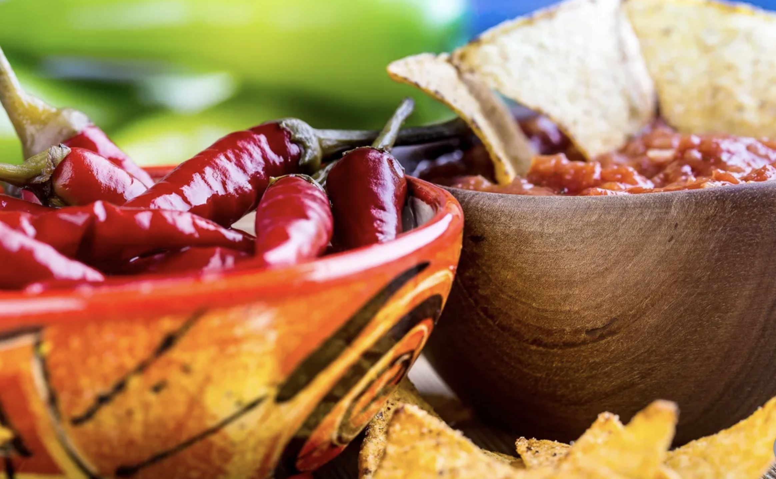

  - “Made with all-natural, shelf-stable ingredients: tomato, real chili pepper purees, onion, and garlic — nothing artificial, ever.”
  - Contact information:
🌐 Website: www.elpicantesalsa.com
📧 Email: info@elpicantesalsa.com.com
📞 Phone: (214) 801-0176
📱 Instagram: @elpicantesalsa
  - QR code leading to website


- Lower section includes:
  - Background color palette: #F0B739 for the lower section.
  - The following text:

“Retail Pricing Tiers
El Picante delivers clean-label, bold-flavored salsa that stands out on the shelf—without compromising retailer margins. Each product is packed in 6-jar cases (16 oz jars) and priced to offer strong value and solid profitability.
Product Flavor | Case Size | MSRP (Per Jar) | Wholesale Price (Delivered)
All Natural (Medium) | 6 × 16 oz | $4.49 | $18.84 ($18.24 Pickup)
Habanero (Hot) | 6 × 16 oz | $4.49 | $18.84 ($18.24 Pickup)
Verde (Serrano Tomatillo) | 6 × 16 oz | $4.49 | $18.84 ($18.24 Pickup)
Volume-Based Discounts:
• 1–10 cases: $18.84 per case
• 11–50 cases: $18.28 per case (3% discount)
• 51+ cases: $17.90 per case (5% discount)
Estimated Retail Margin: ~30% at $4.49 MSRP
El Picante is competitively priced to move, with premium positioning that supports confident shelf placement and repeat purchase velocity.”

Design Style
- Clean, natural, rustic-modern
- Bold and clear branding (using our logos and product label as anchor elements)
- Typography should be modern, legible, and well-weighted
- Colors must complement food imagery and evoke warmth, freshness, and authenticity

Assets Available
- Logo (PNG)
- Product label image
- Sample brochure image (for layout reference)
- QR code (PNG)

Color Palette (HEX Codes)
Please use or complement the following brand colors from our product label:

- #000000 

- #FFFFFF 

- #C74524 

- #F0B739 

- #113C3E 

- #3B6A1D 

- #8CA85B 

- #E9EBE5 

