Your Legacy, Engineered: QP Global Builds and Manages Custom Single-Family Offices


Private, Powerful, Purposeful:
We build sovereign family infrastructure & strong portfolios —customized, exacting, and engineered to outlast generations. Your family stays in full control; we do the work.
We serve no more than 25 families—by design. Because nothing about excellence scales. QP Global exists to set up, lead, and manage bespoke, high-touch single-family offices that operate with institutional precision and relentless integrity.
Fully customized and independent, providing families the greatest control and accountability, leading to best possible outcomes.
Curious About Starting Your Own Family Office?
[Speak With Brendan and Peter]

[Watch: 30-Second QP Welcome from Brendan MacMillan, CIO (Video Embed/Transcript)]
"What sets QP apart isn’t just that we’re embedded—it’s that we’ve actually built and led more SFOs than anyone in the field. Our mission is to keep your family in full control, to deliver world-class investment, governance, and strategy, and to take you further, faster, and with far less friction. No firm is as battle-tested as QP Global—because we wrote the playbook, and we keep evolving it for every new family."
— Brendan MacMillan, See my background here (cfany.org)

[Watch: 30-Second Vision from Peter Pauley, CEO (Video Embed/Transcript)]
"I’ve led and built family offices from New York to Bermuda to Santiago to Hong Kong. At QP, we do things differently—combining rigorous risk management with relentless family focus, and the highest access service possible. Your office, your way, with our expertise as your edge."
— Peter Pauley, CEO

H2: The “90-Day SFO Build” Flow—Show Exactly How QP Changes a Family’s Trajectory

Your Single-Family Office—Built the QP Way, Step by Step, Tailored Perfectly To You.
Day 1:
We sit down with you—not a call center, not a junior team, but our most senior partners—on your turf, listening to your goals, values, and unique challenges.
Month 1:
Our team conducts a full diagnostic of your holdings, trusts, family business, governance, and any legacy structures—spotting hidden risks and untapped opportunities.
By Month 2:
You receive a master action plan: customized entity charts, recommended hires, tax optimization strategies, and a risk map—all benchmarked against the world’s leading SFOs.
Within 90 Days:
We interview, vet, and hire complimentary top-tier talent to either join our QP team and/or your direct staff (lawyers, accountants, controller, admin, and more)—sourced just for you. Legal, tax, and operational frameworks are executed by our senior experts.
Ongoing:
QP embeds with your family, acting as your board members, CIO, and strategic quarterback. No “off the shelf” solutions—only a living, breathing SFO built around you, adapting as your needs evolve. Investing and services done your way.
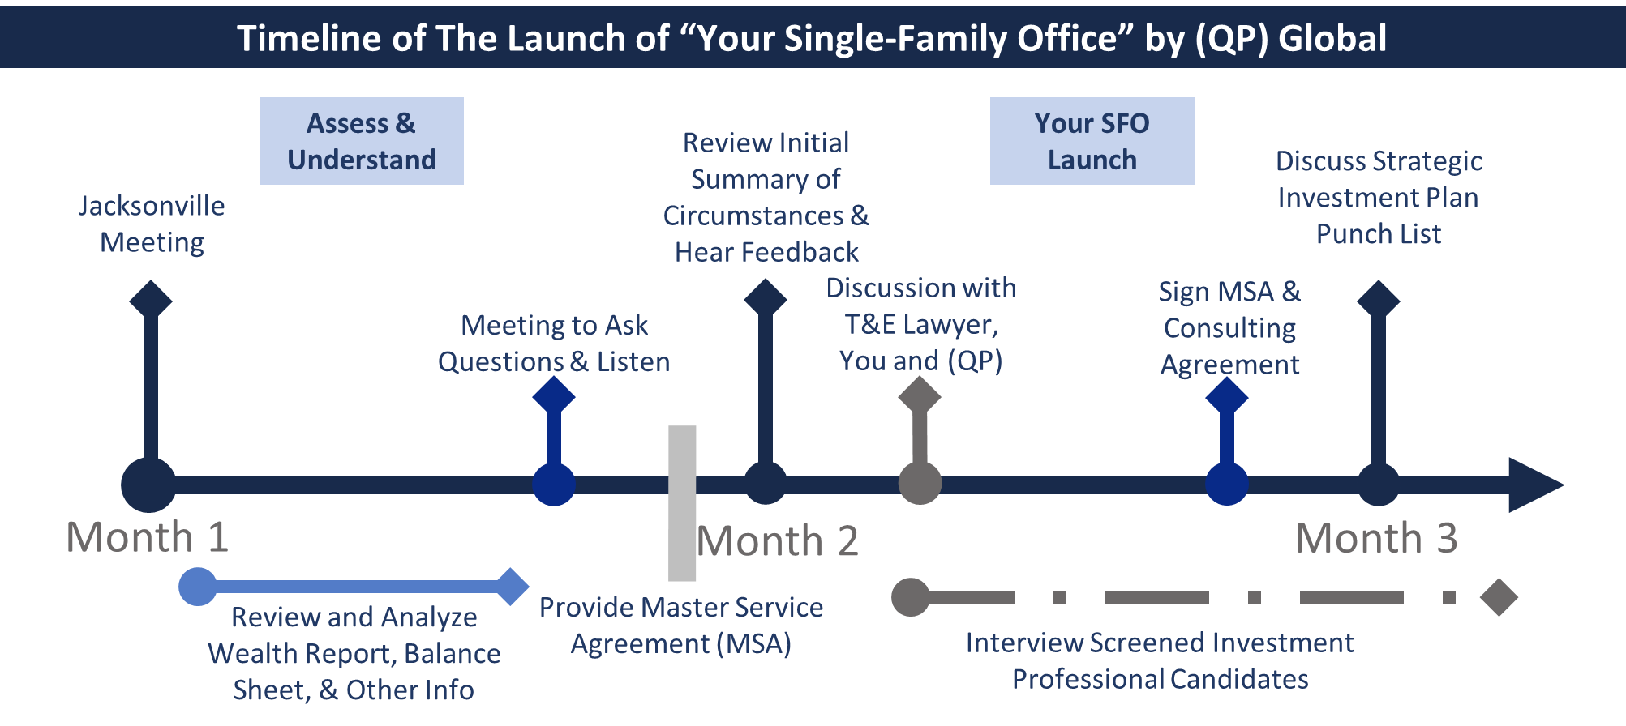

Family Testimonial: From Flustered RIA to Future-Building SFO
"I managed institutional portfolios for decades and thought I knew what ‘family office’ meant—until my own family outgrew the local RIA, in combination with a large private bank we’d used for years. I needed more than model portfolios and quarterly check-ins. I needed a true team—one that could guide my adult children as they moved from students to stewards, help me architect a plan for our legacy, and deliver investment excellence, not just allocation. I wanted a team that would sit with me in my home in Florida, whenever I needed them.
Working with QP was a revelation. From our first meeting, they engaged my kids as adults, not just ‘beneficiaries’—giving them a seat at the table, defining their roles, and making sure they could learn by doing, not just watching. With QP’s leadership, we built a Wyoming PFTC that finally integrated G1 and G2 into a living governance structure. Now, my voice is part of a real family council—and my kids have both responsibility and mentorship, with expert guidance every step. I see them regularly, and they are always on call for me.
What changed most was our investment process. Before, we chased interesting ideas as they came, always reactive. QP worked with us to develop a Family Strategic Investment Plan that mapped our values, ambitions, and risk appetite—then brought us investments we actually cared about, with a rigorous process. The best part? We still do deals that excite us, but now there’s discipline, orchestration, and a path that feels purposeful. I finally have a partner I can call every day—not a call center. Our legacy feels secure, and our kids are learning how to build their own."
— Former Investment Manager, G1/Patriarch, QP Family (De-identified for privacy)

H2: What Is a Family Office?
Even billionaires and near billionaires ask us.
For many families, the journey to a single-family office starts with a single question: “How do we secure our legacy—and our privacy—without giving up control or losing ourselves in complexity?” Or something even more fundamental, “What do I do with my money?” or “Where do I even begin?”
A true family office is not just an investment vehicle or a suite of services. It’s your command center, built around your family’s values, ambitions, and story. It’s the shield that lets you pursue world-changing ventures, protect your loved ones, and empower the next generation—without the distractions, leaks, or dilution that plague standard wealth management.
We are your first call for any challenge that arises.
At QP, every office begins with a blank page and a listening ear. We build from your aspirations outward. Want to launch a foundation? Buy companies? Educate grandchildren in three countries? Minimize tax? Bring real transparency and planning? Your SFO is engineered to make your vision real and your privacy absolute.
The world will never see another family like yours. Why settle for a cookie-cutter solution?
Read: Beyond the Blueprint: Designing a World-Class Family Office Structure With FOA
Your legacy deserves an office as unique as you are.
SFOs defy rigid definitions because they’re only limited by a family’s ambition and vision. Why? Because they are only limited by a family’s imagination. With near-unlimited wealth, an SFO can do nearly anything. They launch rockets, buy sports teams, and build dynasties. But at their core, every true family office is built on QP’s Quad Pillars of Family Office™, or the 4 Ps: Purpose, Philosophy, People, and Process.
- Purpose: The "why"—your family’s true north.
- Philosophy: The "how"—operating based on your beliefs and principles.
- People: The "who"—your team, not ours, living those values daily.
- Process: The "what"—sophisticated, institutional systems built around you.
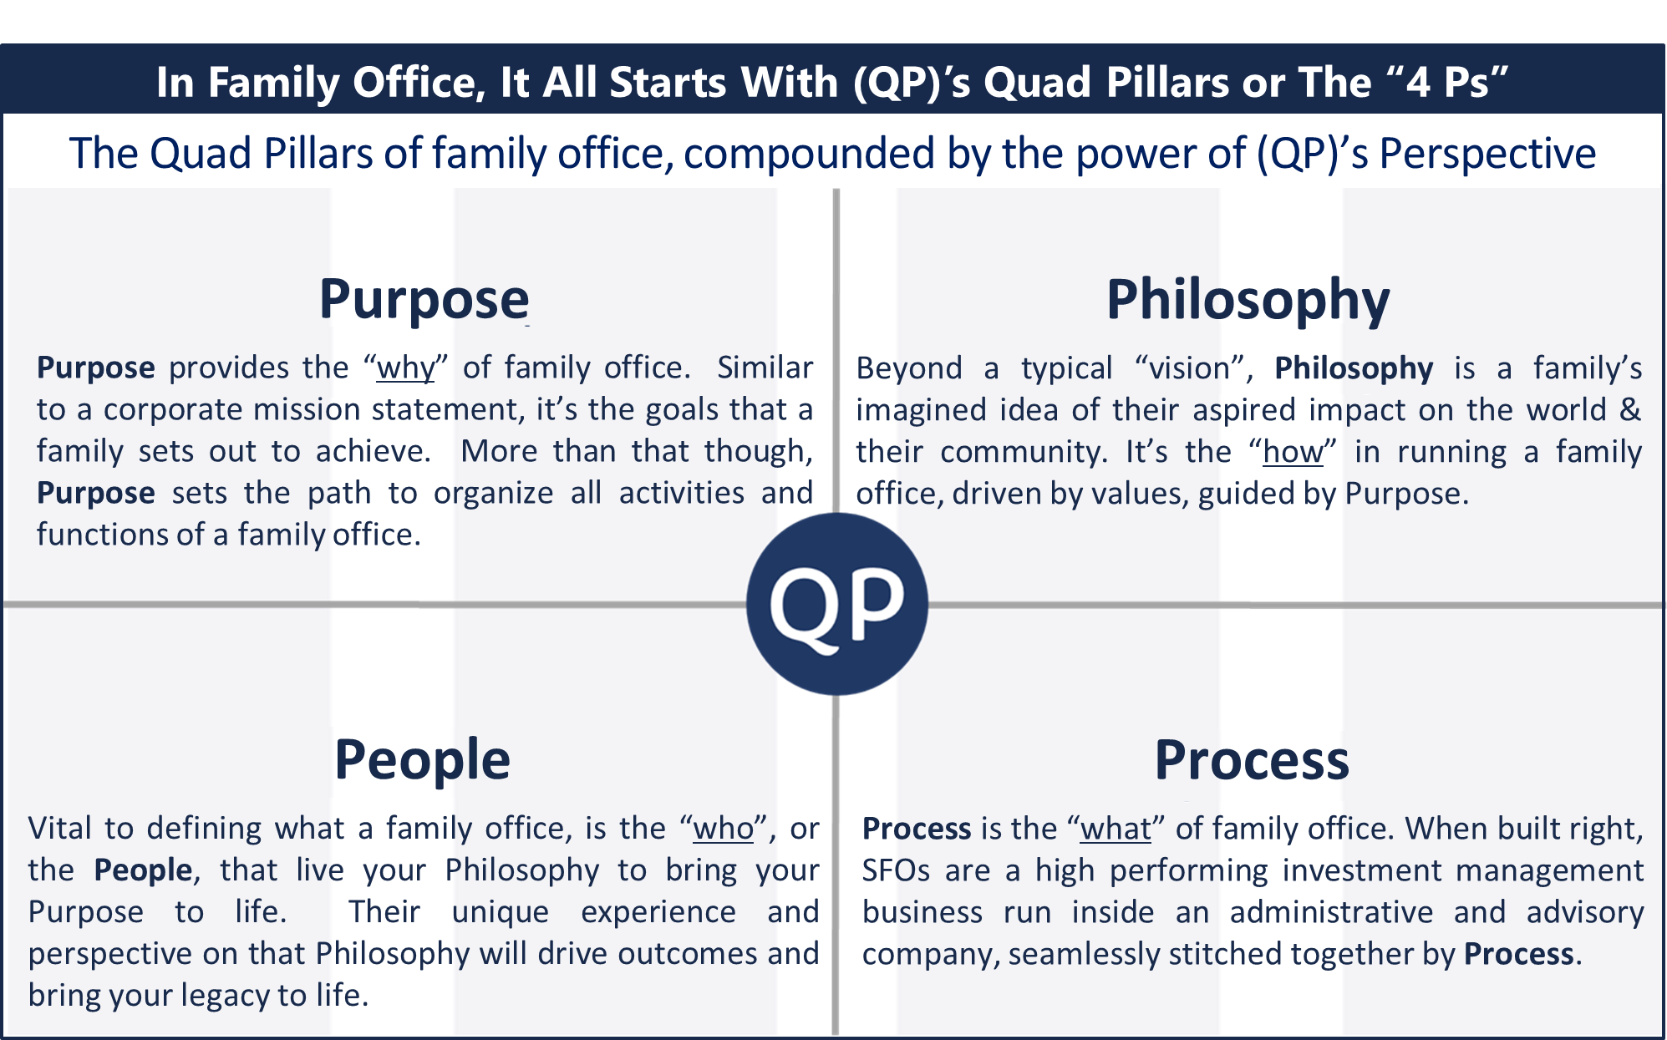
Want the deep dive? Read What Is a Family Office?
Curious why SFOs beat MFOs and “outsourced CIO” every time?
See Why SFOs Are Superior.
Are you wealthy enough to have a family office?
See How Much Do You Need to Start a Single Family Office?

H2: Anatomy of a True SFO
Before you commit, it’s critical to understand what actually sets a real single-family office apart from banks and wealth managers who say they are the same as your own SFO—here’s what defines the gold standard.
- Ownership: One family, full control, real fiduciary oversight. 100% owned.
- Functions: Investment management, legal/tax, business oversight, philanthropy, governance, education, healthcare, travel, home administration, and a lot more.
- Customization: No two SFOs are alike. We tailor every process, person, and policy to you—from investments to locations to services.
- Alignment: Every advisor, executive, and decision is solely focused on your family’s interests—no outside sales quotas, hidden agendas, or conflicts—just your goals.
- Secrecy & Security: Keep it in-house—SFOs are built for absolute privacy.
Cost: True SFOs start at $300MM+, but deliver value, control, alignment, and protection you simply can’t outsource.
What’s it Like to Be Served by QP Global?

[Bold CTA Row]
Build Your SFO with the Team the Industry Trusts
[Speak With a Brendan and Peter] [Download Our White Paper: "Size Is the Return Killer"]

H2: Why QP Global Is the Best at Everything That Matters in Single Family Offices
Elite Experience That Cannot Be Replicated
- Brendan MacMillan, CFA, Institutional Investor Rising Star,
Speaker at CFA NY,
Bloomberg Cited Expert
- Peter Pauley, CEO—built SFOs in US, Europe, Asia
- Seen at: Institutional Investor, Trusted Insight, Bloomberg
Our Unique Value Proposition
Every solution starts with your goals—because your family’s future isn’t off-the-shelf, and neither is our process. From day one, we align our team, our time, and our process with what matters most to you—not what’s easy for us.
- Elite Experience That Cannot Be Replicated
Our team has been built from the buyside up—composed of professionals trained by the greatest investors of our generation, including Peter Thiel, Jeff Altman, and the Chandler brothers. We are not wealth managers pretending to serve families. We are family office operators and institutional investors who do the real work. Real risk managers.
- One Mission: Serve the Family, Not Ourselves
Our business model is not about scale. It’s about stewardship. Every QP single family office is structured with the family as CEO. We fill the key C-suite roles—CIO, COO, President, governance lead, estate planner, project manager—and run the day-to-day. You retain full control without the hassle or organizational burden. We establish control by providing you and your family curated choices on every aspect of their office.
- We Don’t Have Clients. We Have Families.
We are not vendors. We embed. Our engagement is designed to be deeply relational and fully integrated. We are board members, operational partners, and legacy architects within your entities, that you and own and control. No onboarding. No QP products. We come to you. Conflict free.
- Bend the SFO Cost Curve—For Your Family’s Benefit, Not Our Profitability.
Access world-class, full-spectrum SFO services at a fraction of the cost and complexity of building your own, with no trade-off in talent or institutional expertise. By leveraging QP’s embedded team and operational scale, you get elite outcomes and high-touch service—without the headaches or runaway costs of a traditional SFO build-out and operations. More for less. That’s QP’s promise.
- Built for Excellence, Not Growth
We know excellence doesn’t scale. So, QP Global caps our families and our AUM—intentionally. We’ve seen firsthand that service quality, investment performance, and organizational clarity all deteriorate with scale. So, we refused to scale. That’s our edge. A never ending, ceaseless pursuit of excellence. All for your benefit.
- Deep Customization and White-Glove Execution
From entity structuring to health management to intergenerational governance, QP designs each family office from the ground up. We are embedded, not adjacent—your dedicated team—building a full-spectrum system of support tailored to each family’s specific needs.
- CIO-Led Investment Excellence
Our investment strategy is not outsourced. Our CIO leads directly—powered by a seasoned and accomplished team—driven by decades of institutional experience and access to bespoke opportunities, niche assets. We deliver risk-aware, high-conviction portfolios that can outperform expectations, precisely because we refuse to scale. Customized for every trust, family unit, and generation, as needed.
- Governance and Control Without the Burden
The family sits as CEO of your enterprise and your single family office. We do everything else. QP assumes the operational, managerial, and strategic responsibilities so families can focus on vision and values, not logistics or execution. We don’t take discretion. That remains with you. But we act as if we have it, with anticipatory leadership, to ensure your problems are solved before they occur.
Want to understand this better? QP’s Value Proposition: Seven Pillars of Family-Office Excellence

H2: Top 6 Functions within Your SFO—Tailored for Your Family’s Success – Delivered with Relentless Excellence.
At QP Global, every service we provide through your SFO and legal entities is designed around your family’s unique circumstances, ambitions, and legacy—not just a list of what we can do, but a map of how your life gets easier, more secure, and more rewarding at every step. Each solution below isn’t just theoretical; it’s been tested and refined in partnership with real families who refuse to settle for “good enough.”
- Bespoke Investment Strategy, With Purpose:
Imagine your family’s tailored portfolio built with conviction, purpose, and direct access to exceptional private deals—never mass-produced allocations. We manage risk and seize opportunity, so your wealth does more than just keep up: it leads.
- Governance & Entity Structuring:
You get legal, tax, and operational structures that put you in full control—no more uncertainty, blind spots, or tangled chains of command. Our ongoing stewardship ensures your entities evolve as your needs do, preserving flexibility and family harmony. Its more than a great entity map, its how it all operates day to day.
- Legacy & Philanthropy Planning:
Your legacy isn’t just protected—it’s activated. With advanced estate, trust, and philanthropic planning, you make an impact on your terms. Your vision for the future, your causes, your family name: all woven into a living plan that adapts over generations. Real outcomes that match your goals.
- Next-Gen Education & Integration:
Heirs are prepared—not coddled or sidelined. We curate education programs, governance opportunities, and real involvement for the next generation, so they become builders, not bystanders. Your family’s story grows stronger with each successor.
- Major Acquisition/Disposition Execution:
When your family’s arc takes a new turn—from buying a company to selling a legacy asset—we quarterback every detail, minimizing risk and maximizing value. These aren’t just transactions; they’re inflection points, and we make sure they set you up for the next chapter.
- Holistic Wealth & Lifestyle Management:
From healthcare to travel, privacy to security, we handle the complexities that come with great wealth—so you and your loved ones can focus on living life to the fullest, confident that every detail is handled by experts who know your family inside and out.
See for Yourself:
Read: What Is the Difference Between MFOs and SFOs? (And Why SFOs Win)
Read: The Myth of Scalable Family Office Service
Read: CIO-Led Investing: The Gold Standard for Family Office Performance

Family Testimonials (De-Identified, for Privacy and Power)
These aren’t marketing lines. These are real outcomes, from real families who entrusted their legacy to QP.
- “QP delivered a SFO structure in weeks that had stumped our legacy advisers for years. Our family trust now works—and we have real second generation participation.”
- “QP Global doesn’t just allocate capital—they are experienced investors who engineer portfolio strategies we’d never seen from a private bank or MFO. We finally understand what we own and why.”
- “QP’s team gave us the clarity and control we’d been missing for years. For the first time, our family and our lawyers, accountants, and other advisors work from the same playbook, now all centrally managed by QP through our family office.”
- “We had a 1,000 acre parcel of land that was part of the family’s legacy, and QP helped formulate and drive a strategy to monetize it, while also using it to carry out the families vision and desire to make an impact.”

H2: Industry Recognition—Opening Doors for Your Family
When you’re choosing who to trust with your legacy, nothing matters more than reputation earned through real impact. QP’s leadership and expertise have been recognized, featured, and sought out by the world’s most respected institutions—not for self-promotion, but because our insights shape the field and empower families like yours to thrive.
Every conference we keynote or speak at, every white paper we publish, every interview or panel—our purpose is simple: to bring back the best ideas, networks, and solutions for the families we serve. Our families get the inside track—not the sales pitch.
As Seen In & By:
- CFA Society New York (cfany.org) — For our thought leadership on investment excellence and family capital.
- Bloomberg — Cited for SFO expertise and building next-generation family offices.
- Institutional Investor — Recognizing QP leaders for innovation and top performance.
- Trusted Insight — Profiling our approach to SFO strategy, risk, and governance.
- Smart Asset — Highlighted for client service, technical expertise, and real-world results.
- STEP International Tax — Sharing global tax and structuring expertise with the world’s leading advisors.
- California’s Lawyer Association — Detailing the challenges of setting up and managing SFO’s and tailoring an FOA to a specific family.
Why does this matter to you? Because when your family partners with QP, you’re gaining more than an SFO manager and investor—you’re getting access to a dedicated team that sets the agenda, influences policy, and brings back a network of ideas, people, and opportunities that would otherwise be out of reach.
Read: -Artists vs. Musicians: A Conversation with Warren Buffett

H2: QP Global Occupies the Only White Space Left in Wealth Management
The intersection of low volume, deep experience, and full-spectrum service is where QP lives. There is no shortcut to what we do. It’s just hard work, talent, and time. We do this because we believe families deserve better—and we built a firm to deliver it. It means reinvesting into the business with every new family office we manage. Building the team. Always getting better for all the families we serve. When that stops. We stop growing.
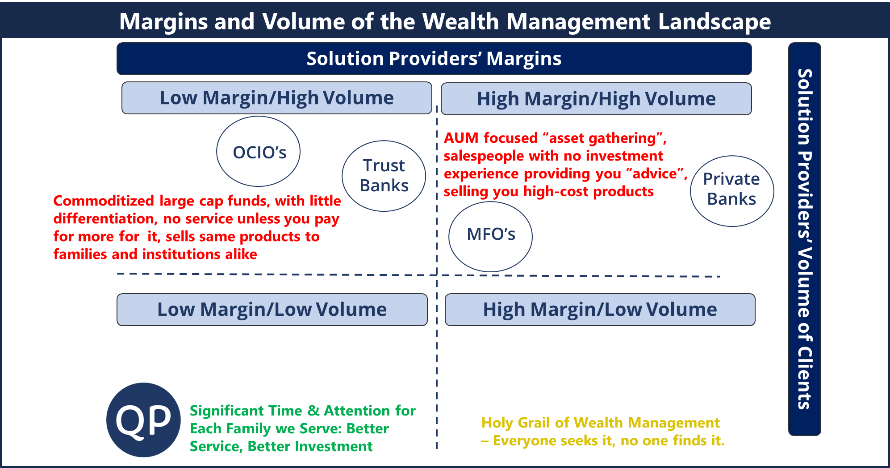

H2: Why Every Other Model Fails the Test of Real Excellence
- Traditional RIAs and Multi-Family Offices chase scale and asset growth. That model destroys intimacy, judgment, and quality. The lack expertise and any true single-family office experience.
- Private banks face gross conflicts of interest and product-pushing incentives. They care only about their bottom lines and again, have zero or near zero single-family office experience. Diluted family office services, centered around low quality bill pay and accounting don’t cut it. They care only about their bottom line.
- “OCIO” firms outsource the soul of the family office—leadership and integration. They all have too much AUM to provide niche, attractive investments, and provide no other services. It can be lower cost, but with minimal insight and pension fund like portfolios.
- Everyone else cuts corners to boost profits. We cut profits to stay elite. This is why we will always be peerless. We keep adding talent, to keep getting better.
Want more insight into this:
Read: Single Family Offices vs Multi-Family Offices: Why SFOs Are Always Better

Ready to Build Your SFO with the Only Team That’s Actually Built More Than Anyone?
Let’s talk about how QP Global can help you build the single-family office that fits your legacy, your values, and your future.
[Schedule a Call] [Download Our White Paper] [Ask QP Anything]

Explore Further:
- Succession Planning & Family Legacy
- How to Vet a Fiduciary: 10 Questions Billionaire Families Should Ask
- Learn more about QP’s Investment Philosophy and Approach.

SEO & EEAT Footer
Primary Keywords:
single-family office management, independent family office advisor, bespoke single-family office, SFO risk management, billionaire family office services, family office structure solutions, fiduciary family office firm
Long-Tail Keywords:
CIO-led family office, high-touch family office investing, private family office CIO, build a single-family office, elite family office advisory, boutique family office structure, how to start a family office, family office for generational wealth, embedded family office team, best family office firm
Connect:
[Insights] [Team] [White Papers] [Contact]
LinkedIn | Reddit AMA

What’s Working Exceptionally Well
1. Voice & Tone
Polished, high-authority, and jargon-appropriate for near-billionaire families. It sounds like it was written for elite peers, not the masses—critical for this audience.
2. Narrative Arc & Messaging
The why (legacy, control, complexity), the what (SFOs, full-spectrum services), and the how (QP’s bespoke approach) are woven together seamlessly. It does the heavy lifting of trust-building before asking for a call.
3. Positioning
You clearly articulate that:
- You’re not a vendor, you embed.
- You're not scalable — by design.
- You’re true operators, not salespeople.
- You actually build and run SFOs — not pretend to.
That differentiation is gold and is backed by authority and specific examples.
4. Testimonials & Proof
The anonymized client stories are emotionally resonant, specific, and feel real. They demonstrate transformation, not just satisfaction. Smart use of quotes for families who outgrew RIAs and private banks.
5. Service Descriptions
These are solutions, not features. You explain outcomes (privacy, family governance, smarter investing), not just tasks (we manage assets). That’s the language of trust.
Areas to Strengthen for Conversion and Flow
1. Headline Optimization
Current:
"QP Global: The Leader in Elite Single-Family Office Setup and Management"
Suggestion:
Make it about the client’s aspiration, not just your credentials. E.g.:
“Your Legacy, Engineered: QP Global Builds and Runs the World’s Most Elite Single-Family Offices”
Or:
“The Family Office Experts Trusted by Families with $250MM+ and a Vision”
This tiny shift puts the family, not QP, at the center.

2. Length and Skimmability
The page reads beautifully, but it’s long and dense. Even billionaires skim. Consider:
- Using more collapsible content sections for things like “Anatomy of an SFO” or “Why Every Other Model Fails.”
- Break long sections with subheadings or bullets. e.g., the testimonial story could be titled:
“How QP Turned a Family’s Chaos Into Clarity”

3. Calls-to-Action (CTAs) — Be More Intentional
You have great CTAs, but they could be more strategically placed and varied. Suggest:
- Top-of-page CTA button:
“Schedule a Confidential Conversation”
- Mid-page CTAs after key trust sections, like:
“Explore a Sample SFO Plan” or
“See If Your Family Is a Fit for QP”
This aligns with the long sales cycle—offer value first, not just a call.

4. Clarify What Makes QP Unique Operationally
You mention embedding, CIO-led investing, and global experience—but a quick side-by-side comparison graphic of:
QP vs Private Banks vs MFOs vs OCIOs
…would crystallize the value for left-brain decision makers. Especially helpful for the skeptical patriarch-type.

5. Simplify the “90-Day Build” Section
It’s impressive, but could be easier to absorb. Suggest formatting like:
The QP 90-Day Family Office Launch Plan
Timeline | What Happens | What You Get
Day 1 | Senior partners visit you | Discovery of goals, values, and pain points
Month 1 | Full family and financial diagnostic | Risk map, opportunity matrix
Month 2 | Master action plan delivered | Org charts, tax plan, staffing roadmap
By Day 90 | Implementation in motion | Vetted team, structures in place
Ongoing | Embedded strategic leadership | Living office, evolving with your needs

🔥 Final Thought
This homepage is already in the top 1% of B2UHNW (business to ultra-high-net-worth) marketing copy.
What sets it apart:
- You’re not selling services. You’re offering transformation.
- You don’t pander—you educate.
- You’re positioning QP Global not as a wealth manager, but as a sovereign infrastructure builder for families of consequence.
That is precisely what this audience needs—and rarely finds.

Would You Like Help With:
- Turning this into a high-converting PDF white paper or deck?
- Creating condensed landing page versions for cold traffic or LinkedIn outreach?
- Or a drip email series to move skeptical leads toward a meeting?
Happy to help you tighten and tailor any piece of this funnel.

