- HOMEPAGE

A Seat at the Table for Collaboration, Learning, and Meaningful Change.

Little Pineapple Collaborative is a dynamic consulting firm with four Core Offerings: Learning & Evaluation, Program Management, Facilitation & Coaching; Implementation & Transformation

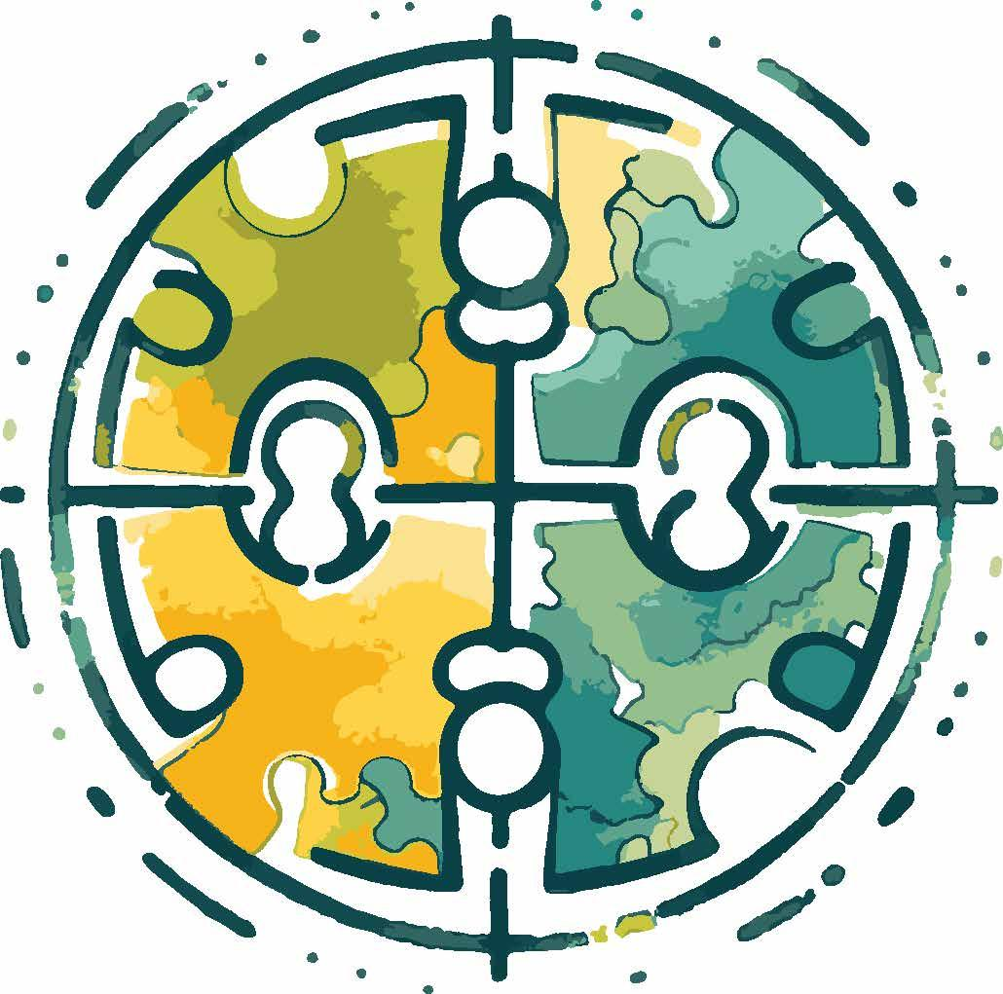

[The four quadrants of the image above represent LPC’s four core offerings: Learning; Implementation; Facilitation; and Program Management.]

[Notes on above image if we need to find a new image with a similar goal: The image is reminiscent of a globe; a table in the round; people meeting and aligning from various perspectives; and a sense of momentum, shifting, and shaping to form a cohesive collaboration.]

[Animate the above image to bring the pieces and elements together to form the full image. The animation would begin when a person visits the website for the first time. Immediately, a person is introduced to exactly what LPC offers and the image and animation help to illustrate, visualize, and inspire how this is done.]

[As the animation comes together and the core offerings are revealed as part of the four quadrants of the image, the following words appear as your homepage sub-tagline]:

[sub tagline]
Here for you and your team.

[The page scrolls to reveal]:

Our Mission

Our mission is to facilitate organizational change and transformation, and to make space for creativity, joy, belonging, and trust. If done successfully, we grow to better understand ourselves, each other, and the work we do together.

Our Vision

Our vision is to be part of a world where organizations and collaborators connect as human beings first. We envision a future where partners and colleagues strive for ongoing growth together.

Our Value

We are the tranquility in chaos. The steady partner always at the table with you.
We drive meaningful and measurable change, resulting in sustained progress towards key community outcomes and multi-sector initiatives. Our work produces values realignment, critical technical assistance, and develops strategic plans for innovative organizations ready to elevate their work.



[Note: there is a watercolor logo version that could work here.]

We Help Your Team…
[through a text scroll the following words appear]:

Turn bold visions into practical results.
Empower teams to be better together.
Transform conflict into opportunity.
Strengthen community-led systems.
Foster a sense of belonging…

…Find common ground.
[note: make this last line larger font and hold on the screen for longer.]

[The page continues scrolling to reveal:]

We Collaborate With
[deviate more here between nonprofit and corporate]
[through a text scroll the following words appear:]

Large-scale Companies
National and local nonprofits
State government agencies
International Partnerships & Organizations
Foundations
Tribal Serving-Organizations
Startups in tech

Why Us

Through our Core Offerings and guided by our founder’s traditional and nontraditional methods for engaging and steering a team, we create a sense of belonging, foster transparency, and help to build stronger relationships. Our approach helps to drive meaningful change so that organizations and initiatives can clear roadblocks and meet collective goals. Our team’s proven ability to transform conflict into opportunity will help to advance your organization and the communities you serve.

- ABOUT US

Little Pineapple Collaborative (Little Pineapple) is a values-driven partner with deep roots in multi-sector leadership, adult learning, facilitation, and systems transformation. Founded by Kelsey Donnellan, MPH, Little Pineapple has built a team of trusted facilitators, advisors, and coaches who share a core belief: transformation is most powerful when it is co-created with those closest to the work.

We partner with governments, foundations, and community-based organizations to turn bold visions into reality—whether that’s making communities more dementia-friendly, strengthening health systems, or empowering teams to work better together. From multi-day national summits to statewide alignment initiatives, our work is both strategic and deeply human. Since our founding, we’ve supported dozens of organizations and teams across the country to lead change from the inside out.

We don’t see ourselves as outside experts handing down best practices—we walk alongside leaders to activate what is already strong, clarify what’s needed next, and support sustainable, regenerative growth collaboratively. Our work is anchored in belonging and trust—and always carried out with a spirit of care, curiosity, and transparency.

Little Pineapple was created to bring something different to the table: a consulting model that leads with values, honors people’s lived experience, and makes space for creativity and joy. We believe that learning is not an end state – it’s a process of learning and relearning. As a partner, we’re here to learn with you.

- What’s behind the name “Little Pineapple”?

Little Pineapple Collaborative was founded by Kelsey Donnellan and named in honor of her grandmother and all the elders who came before her. Kelsey’s grandmother nicknamed her “Little Pineapple”, and most importantly, taught her to always set an extra place at the table and to never take life too seriously. That lesson lives on in everything we do—creating learning spaces where all are welcomed, wisdom is shared, and growth feels both possible and personal.

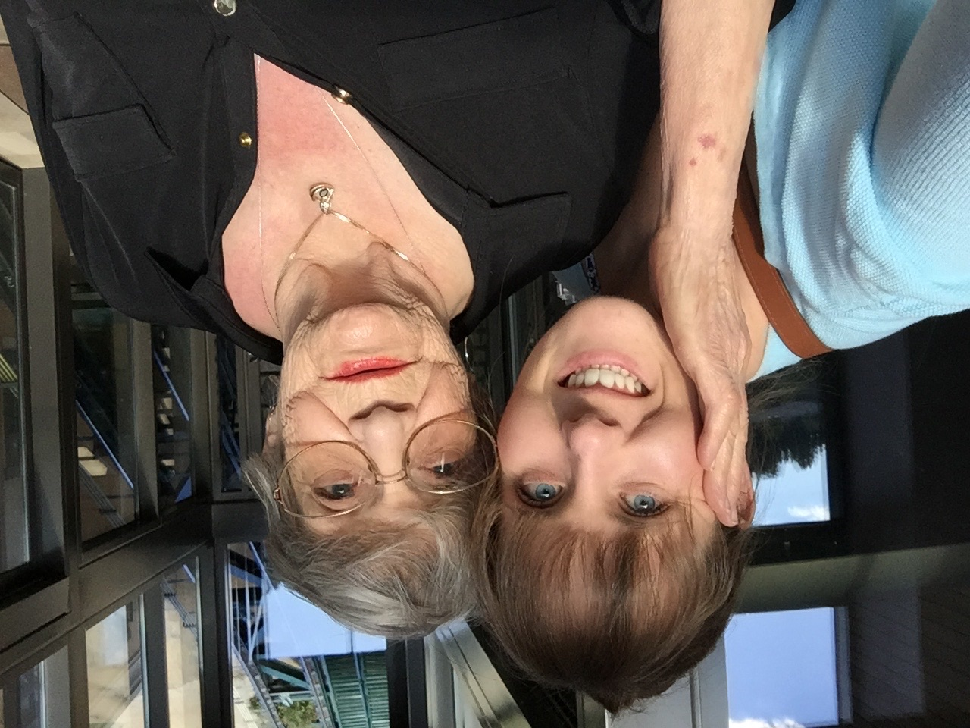

- What We Value

- Transparency. We believe in open communication and clear expectations. We do what we say, and say what we mean.
- Authentic Relationships. We foster genuine connection built on trust and shared understanding. We incorporate our humanity in everything we do.
- Dignity. We respect the worth and value of each individual.
- Accountability. We adhere to our own ethical standards and values, and take ownership of our work.

- FOUR CORE OFFERINGS

- Learning & Evaluation
- Program Management
- Facilitation & Coaching
- Implementation & Transformation

Learning & Evaluation

Nonprofit version:
Learning and Evaluation is LPC’s chief offering. In order for a project to successfully and meaningfully move forward, there are often various administrative, systems, and even interpersonal processes that need to be addressed first. Our strength is designing and facilitating learning projects that reflect the voices and needs of those impacted by the work in order to ensure solutions are relevant with the team. We use and conduct assessment and mapping tools in order to collect knowledge, advance engagement, and in turn, build better systems that are the sustaining force of your work.

Corporate version:
LPC understands that for a project to move forward successfully, it's crucial to address any underlying administrative, operational, and interpersonal dynamics that can impact progress. Our expertise lies in designing and facilitating learning initiatives that are informed by the perspectives and needs of those directly involved, ensuring that solutions are relevant, actionable, and aligned with team objectives. Evaluation can include organizational assessments, and systems mapping to support the effective integration of new processes and practices. We regularly garner actionable insights, foster team engagement, and strengthen the operational infrastructure that drives long-term impact.

Program Management

Nonprofit version:
Multi-Sector Program Management
Whether supporting small community-based programs or managing large-scale efforts, we are skilled at coordinating timelines, resources, and partners to drive projects toward successful outcomes. We design detailed project plans with clear milestones and deliverables, facilitate cross-functional collaboration to improve communication and efficiency, and offer consistent support to help teams adapt to shifting priorities or challenges. We are organized, responsive, and solution-oriented to ensure that projects stay on track. Our team has expertise in various organizational and project management softwares, such as SmartSheet, Notion, Asana, Monday.com, and Google Drive Suite.

Corporate version:
Cross-Functional Program Management
As project managers, the LPC team helps to coordinate timelines, resources, and partners to drive projects and teams towards successful and sustainable outcomes. We design detailed project plans with clear milestones and deliverables, facilitate cross-functional collaboration to improve communication and efficiency, and offer consistent support to help teams adapt to shifting priorities or challenges. We are organized, responsive, and solution-oriented to ensure that projects stay on track. Our team has experience and expertise in Salesforce for CRM needs.

Facilitation & Coaching

Nonprofit version:
Our team has a unique capacity for facilitating honest and open discussions, and encouraging conflict resolution. Very quickly our team can pick up on different perspectives and needs in a room, and with this innate skill, guide engagement on complex topics. We view conflicts big and small as healthy and normal, especially in a high stakes environment. We lead with our whole presence, giving voice to everyone in the room with a respectful and thoughtful approach. We have facilitated team or advisory groups in order to move projects forward, hosted small and large meetings to kickoff, provide input, or debrief on a project, and we have designed facilitation guides for train-the-trainer projects. While we’ve developed our own LPC facilitation approach, we often use learnings from tools like Technology of Participation, Liberating Structures, and others. Our approach helps all participants feel seen, heard, and understood through various techniques, including comedic strategies, movement-based work, and even elements of improv. Our conflict resolution work has helped to clear emotional roadblocks, catapult projects to the next level, and dramatically increase team morale for the long-haul.

Corporate version:
The most complex projects often benefit from facilitation and conflict resolution. We facilitate teams in order to move projects forward or debrief on a project once completed. We design facilitation guides for train-the-trainer projects, and we’ve developed our own LPC facilitation approach using learnings from tools like Technology of Participation, Liberating Structures, and others. Clients often hire LPC to facilitate a conversation in order to help drive successful outcomes. Our conflict resolution work has helped to clear emotional roadblocks, catapult projects to the next level, and dramatically increase team morale for the long-haul.

Implementation & Transformation

Nonprofit version:
LPC’s Implementation & Transformation Core Offering is about resource development in action. As resource development experts, LPC helps to build your team’s capacity by designing guides and templates, creating resource hubs that pull together existing tools and resources for easy access, and developing one-pagers to guide advocacy and conversations about new programs. Our toolkits and resource hubs consistently build project efficiency and empower staff to move forward with more clarity, cohesiveness, and confidence. Like any great partner, LPC is here to learn with you. Transformation is the most powerful when it is co-created with those closest to the work. Resource development and implementation doesn’t end with LPC but we help create the foundation upon which your team can continue to build.

Corporate version:
LPC’s Implementation & Transformation Core Offering is about resource development in action. As resource development experts, LPC helps to build your team’s capacity by designing guides and templates, creating resource hubs that pull together existing tools and resources for easy access, and developing one-pagers to guide advocacy and conversations about new programs. As a team, we use AI as a tool instead of a replacement for creativity. In our work, AI can help us to generate efficient recommendations or summaries, or help to create a new template or framework that we then can adjust manually to meet your team’s specific needs. Our toolkits and resource hubs consistently build project efficiency and enable staff to move forward with more clarity, cohesiveness, and confidence. Like any great partner, LPC is here to learn with you. Transformation is the most powerful when it is co-created with those closest to the work. Resource development and implementation doesn’t end with LPC but we help create the foundation upon which your team can continue to build.

A Note from the Little Pineapple Team:

Our Core Offerings are a way for us to help guide a conversation with clients about what they need to move forward with their work. Most projects incorporate an element of all of these offerings, while some may be more project management focused. Our team has been hired to address all aspects of an organization, company, or project, and we’ve also been brought on to initiate or confront a challenge more directly.

- CASE STUDIES
-tab on the landing page that directs people to that tab that says something like “Our Projects”
-and then imagining their logo/graphic with one or two sentences about that particular project and if someone wanted to read more, they could cick on it and go to that page.
-tags on the case studies (i.e. looking for their Core Offerings) which would mean tagging core offering description
-make sure each of the core offerings are represented by at least two of the case studies.
-maybe 3-4 more sentences on the case studies except for the puerto rico case study
-some level of graphic for each of them
-possibly sharing empty templates from those projects without showing specifics
-long list of things to procure: professional photography of LPC in action
- Zoom photo - ask WA team
- video of our templates, share screen

Washington State Department of Health
LPC is currently supporting the Washington State Department of Health (WA DOH) to align internal and external processes related to community health improvement planning. LPC needed to work with the state’s governor’s office to secure a letter of commitment to start these processes. As lead on the project, LPC founder Kelsey Donnellan has been facilitating three separate work groups, one of which is composed of 14 different sectors. As part of their work, Kelsey develops presentations and materials for the agencies to present outside of this partnership. Approaching their fourth year working together, the scope of the LPC and WA DOH partnership includes facilitating cross-agency dialogue, clarifying roles and responsibilities, and strengthening partnerships across policy, service, and implementation projects. LPC continues to guide internal leadership development and technical assistance components of this project with inclusivity at the heart of the work.
TAGS: PROGRAM MANAGEMENT; IMPLEMENTATION & TRANSFORMATION

Puerto Rico Department of Health & ASTHO
As part of ASTHO’s technical assistance to the U.S. Territories and Freely Associated States, LPC founder Kelsey Donnellan worked as an employee of the organization and led the design of a bilingual two-day workshop to support Puerto Rico Department of Health’s equity strategy. The convening centered the importance of clarity, belonging, and practical action, incorporating program planning materials and peer-to-peer sharing. After designing the meeting, Kelsey worked with an interpreter to translate all of the materials. The meeting was facilitated completely in Spanish allowing a wider range of staff to participate. Facilitating the meeting in Spanish was made with the intention of flipping the power dynamic and honoring the agency’s official language. Authenticity and transparency are two core values of the work Kelsey does as part of LPC, and they saw this project as an opportunity to put values directly into action. At the close of the session, participants reported increased understanding of their role and confidence in moving the work forward.
TAGS: FACILITATION & COACHING; IMPLEMENTATION & TRANSFORMATION

Local-level Focused

NACCHO OT21-2103 Technical Assistance Coordination – Capacity Building & Project Management
Through their work with NACCHO, LPC helped coordinate technical assistance across ten providers, facilitating conflict resolution, resource review, and staff development focused on public health and facilitation best practices. Our role also included advising on internal systems to support communication and role clarity across a dynamic of complex teams. LPC served as a liaison between NACCHO and their outside contractors, facilitating all project-related calls, and helped to triage communications by setting up a process for managing the project more efficiently. For example, LPC established monthly one-on-one calls with outside contractors and provided professional coaching to the staff on various topics, such as conflict resolution and facilitation. The goal was for the client to be trained on conflict resolution and facilitation so that they could continue facilitating the project once our work together was complete. LPC was able to improve communications, establish stronger team collaboration and partnerships with outside contractors, and even prepare and submit a comprehensive performance report for the agency’s funders.
TAGS: PROGRAM MANAGEMENT; FACILITATION & COACHING

Missouri Foundation for Health
The Missouri Foundation for Health (MFH) hired LPC to facilitate learning and understanding centered on their Medicaid Expansion work. This 18-month project focused on facilitated conversations about the foundation’s historical and future interactions with the Medicaid Expansion ecosystem. A learning agenda was established with evaluation questions to help guide conversations with the staff. Then interviews and focus groups, data collection through artifact reviews, and facilitated learning meetings to make sense of data and systems. Additionally, LPC created and managed a partner advisory group and served as a fiscal agent to manage all contracting and payments from the community.
TAGS: LEARNING & EVALUATION; FACILITATION & COACHING

[Corporate Case Study - Conflict Mediation]
National WIC Association (NWA)
LPC partnered with Third Settlements to support an assessment of NWA’s equity work and values. LPC guided conversations to highlight existing values, discuss, and identify these values with the staff and board. We worked with the NWA staff to practice implementing these values in real-work situations via simulated scenarios. The team explored their values associated with who they do work for, and any unspoken or underlying values. These conversations helped to highlight and reveal how and where the team was already living and working with their established set of values, which led the group to confidently move forward with their equity goals. By re-establishing values and goals, NWA felt ready to create a meaningful partnership with Third Settlements and be part of adapting an Inclusive Leadership training for their team.
TAGS: LEARNING & EVALUATION; IMPLEMENTATION & TRANSFORMATION

[Start-up]
Drizzle
Drizzle Health partnered with LPC after moving out of their research and development phase. Our team team was hired to help map out a year-long strategy to bring their product to market. Through our collaboration, we developed a strategy for managing Drizzle’s technical, administrative, and sales streams of work, including setting realistic but ambitious timelines, aligning technical milestones with client relationship development, and creating a framework for accountability beyond our initial contract. The team at Drizzle was equipped with more clarity and confidence, and with the systems still in place from our partnership, Drizzle continues to pivot and grow effectively.

