This document is a basic page-by-page layout of the content for the 16-page registration brochure.

It is for content (TEXT) development only. It is not intended to suggest or convey a specific page layout or organization. Please disregard all tables, headings, and temporary layout. This was only done to fit the content and show you what needs to fit on a page.

We are looking for the designer to develop an overall design concept for the entire convention based on the logos provided. Using that overall design concept, the first product will be this 16-page brochure.

For the sake of the Design Crowd competition, do not feel necessary to lay out this entire 16-page brochure document. Develop a design concept based on the logos and provide a few page ideas of what the concept would look like in this finished brochure.

Once we select a designer, we will then work together to provide all the missing content so the brochure can be fully designed and finalized.

Any questions, please email me and ask!
jason@majcllc.com

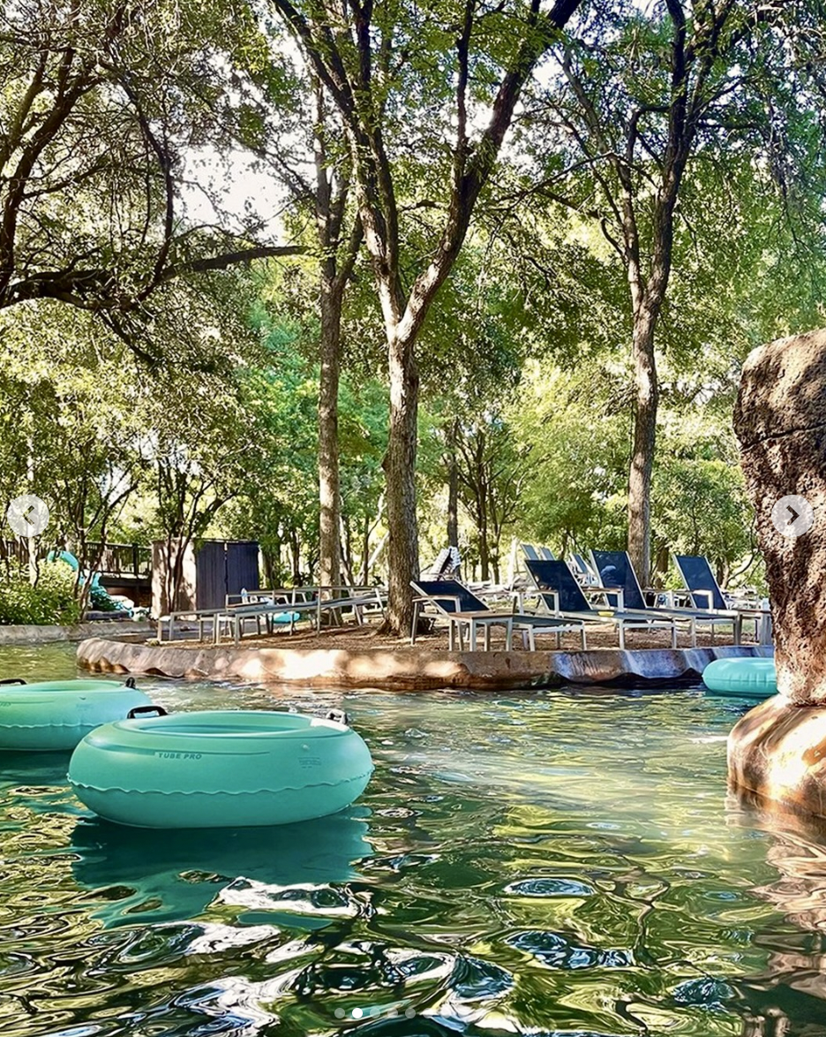
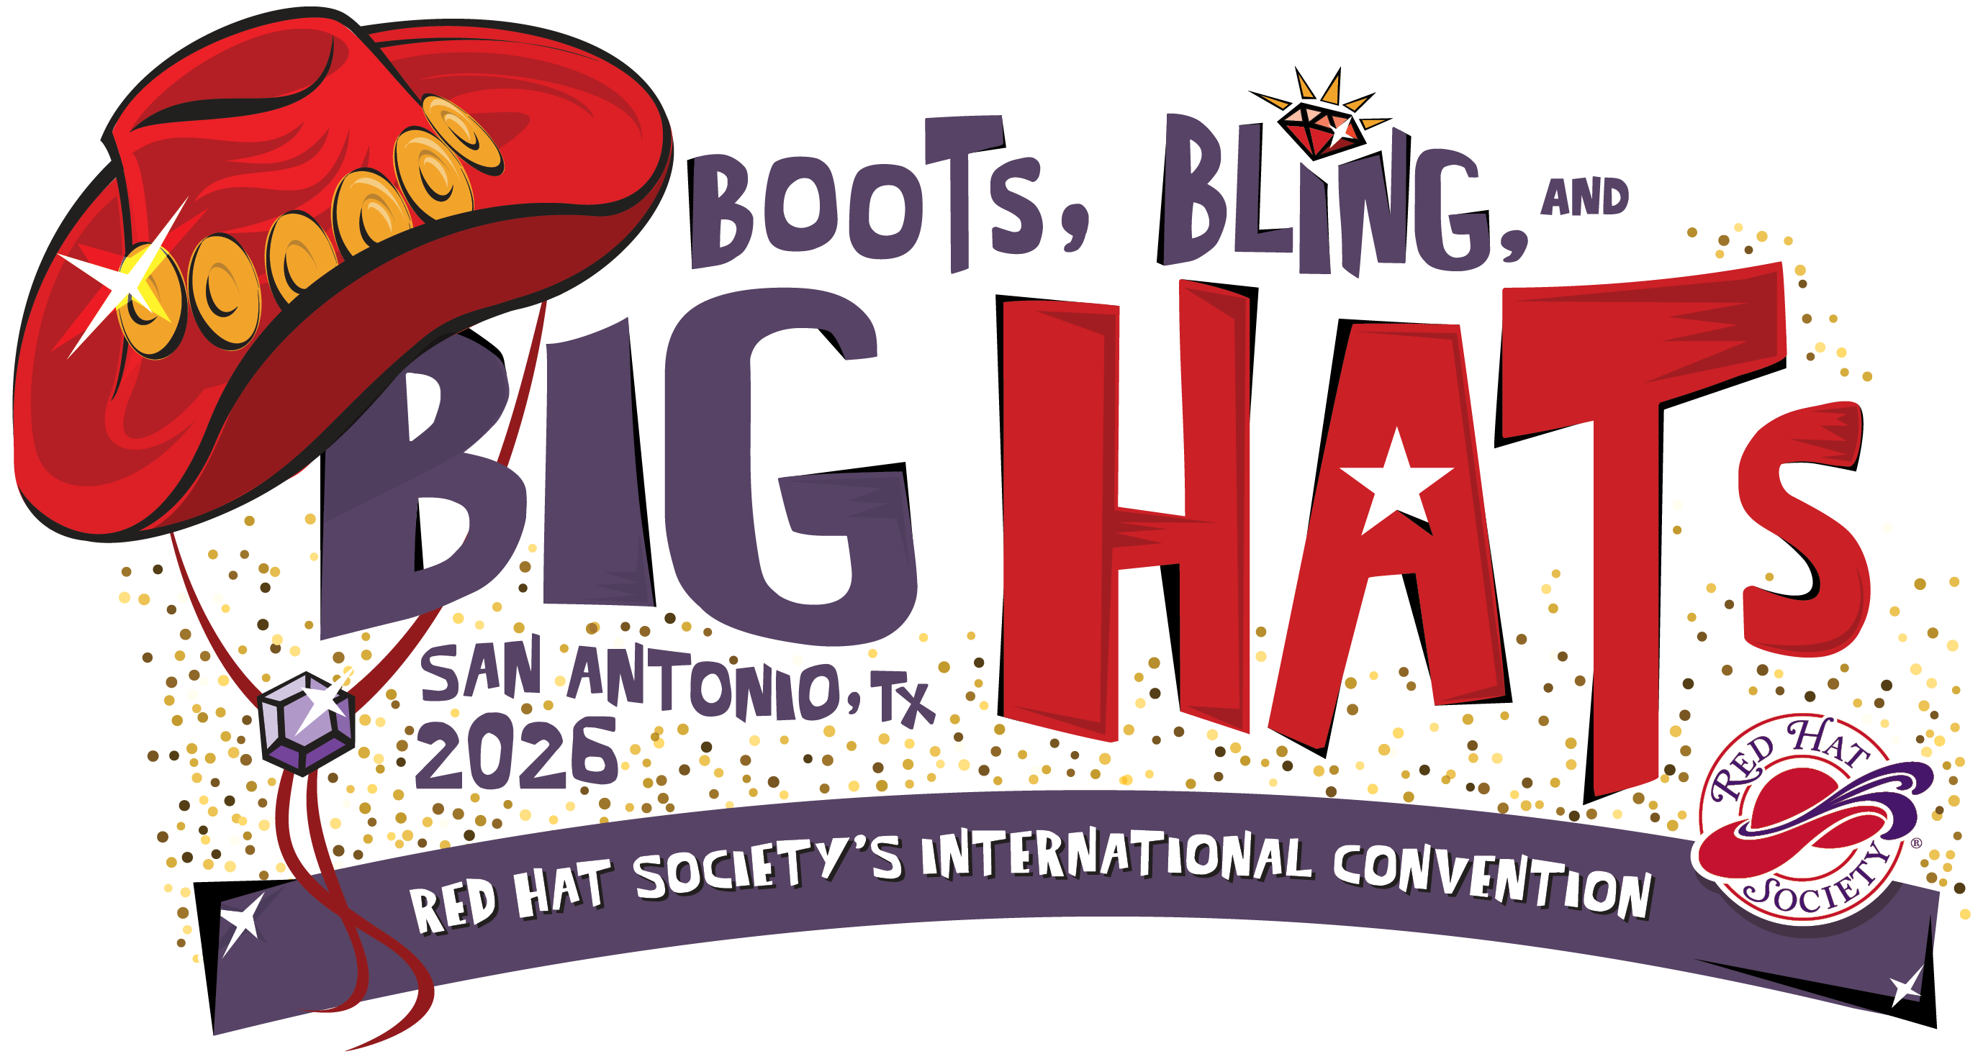

Full page w/ bleed background photo of San Antonio skyline, Hyatt Regency resort icon image, or past RHS convention photo with group of members, etc. Any image that will fit to full page size with bleed and allow for theme icon/text logo and text over top.

2026 RED HAT SOCIETY
INTERNATIONAL CONVENTION

August 10-13, 2026
Hyatt Regency Hill Country Resort & Spa
San Antonio, Texas
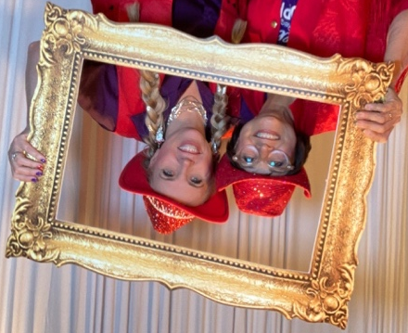

This page is NOT fully edited yet! Text provided is temporary and for sample only.

You’re Invited to…
Be Our Guest!

Debra headshot or Debra & Michel image

Dearest Sisters in Red and Purple,

[Debra invitation letter]

See you in San Antonio!
[SIGNATURE]
Debra Granich
CEO, The Red Hat Society, Inc.

An Invite from Your Mistress of Ceremonies

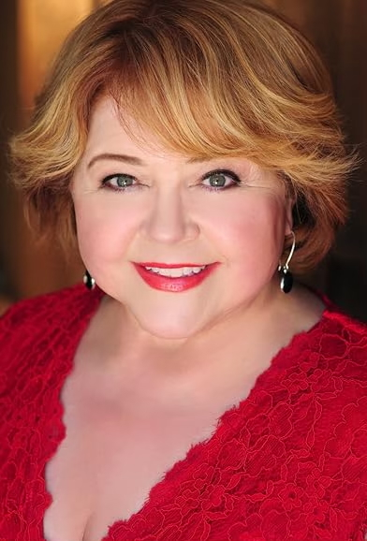
Hey Y’all!

Patrika Darbo here, and I’m thrilled to be joining you in San Antonio as your Mistress of Ceremonies. I’ve known of the Red Hat Society for years, and your reputation proceeds you. I’ve also seen some of your groups out and about, having fun, and spreading joy to everyone you encounter.

You may have seen me over the years as an actor on Days of Our Lives, Desperate Housewives, etc… More bio stuff here. Emmy award winner, etc.

I’m excited to meet you and I think we have a lot in common. I am your demographic. I love to wear fancy clothes, often with a lot of sass. I’m a bundle of energy (I can thank my red hair for that!). I never turn down dessert, and I’m all about fun. Just you wait and see the antics I’ve got planned during your luncheons!
Patrika Darbo headshot

You’ll be “seeing” me from time-to-time as I share important updates and announcements related to your International Convention next August. I am very much looking forward to joining you at “Boots, Bling & Big Hats.” Start planning your wardrobe ladies. Do we even need another excuse to go shopping?! I, for one, do not!

Stay Fabulous,
Patrika Darbo
Boots, Bling & Big Hats
This page is NOT fully edited yet! Text provided is temporary and for sample only.

BOOTS ARE STANDARD. We’re going to Texas ladies, you’re going to need a pair of western boots.
BLING IS AN ACCESSORY. We’re members of Red Hat Society, and everything we wear sparkles with bling.
BUT BIG HATS….THEY’RE A STATEMENT! Our hats are what make us who we are. And since everything’s bigger in Texas, our hats must be big as well!

Combine the three, and we’ve got the makings for a fabulous gathering that celebrates the best of Red Hat Society and honors the western traditions of San Antonio, Texas.

Half of this page should be about the theme.

Top 10 Reasons to Attend
- Three themed nighttime dinner and dance parties
- Three general session luncheons with entertainment, special guest speakers, and interactive activities
- Optional pirate themed evening event for early arrivers
- Farewell brunch with preview of 2027 convention and initial registration FOR 2026 ATTENDEES ONLY
- 12 hours (6 blocks) of classes, activities, and interactive programming
- 18 hours shopping time in Ruby’s Marketplace (bonus hours for tour participants!)
- Bonus tours day with multiple options to explore the San Antonio area
- Queen’s Retreat full day of social activities and interactive sessions focused on you and your chapter
- Multiple small group “invite only” events to recognize your involvement in Red Hat Society
- Memories you can’t make alone! The connections you form while traveling with RHS are truly special.

Your Accommodations
This page is NOT fully edited yet! Text provided is temporary and for sample only.

Nestled about 20 minutes from downtown San Antonio in Texas hill country is the Hyatt Regency Hill Country Resort. Situated on 300 acres of a historic former cattle ranch, Hyatt Regency Hill Country was developed in 1993 as the first destination resort in Texas. As your home for “Boots, Bling & Big Hats,” this self-contained resort will offer a different experience from prior RHS International Conventions. Once on the property, you’ll experience the natural beauty, rustic-elegance, and Texas friendliness in every nook and corner.
NEW FOR 2026!
Your hotel room is included in your convention registration package!

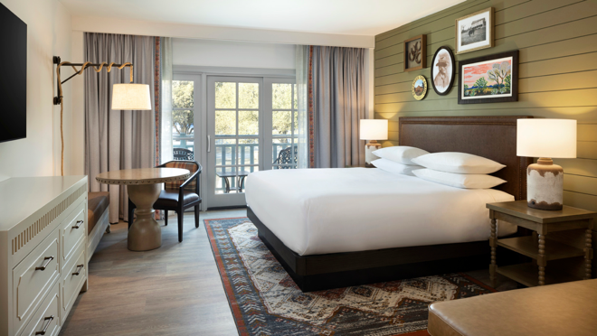 | 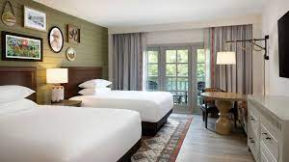
Standard King guest room | Standard Queens guest room
The recently renovated standard king guest room is 392 square feet and includes one king bed, a chaise lounge, and a sitting area with a table. The room accommodates up to two adults sharing one bed. | Relax and rejuvenate in 392 square feet of newly renovated space, featuring two queen beds and a sitting area with a table. The room accommodates up to four guests sharing two beds.
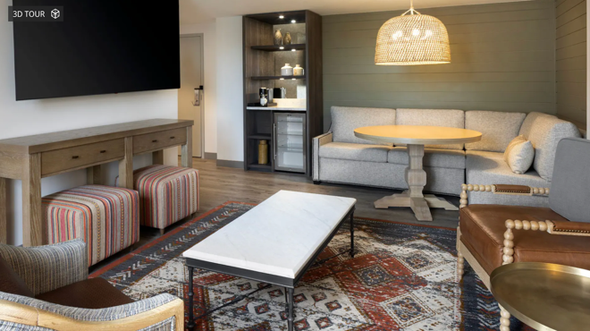 | Feel like splurging a little on a suite upgrade so you can spread out and have plenty of room for your wardrobe and hats? The 599-square-foot Hill Country Suite includes a private king bedroom and separate living area with a full-size sleeper sofa and dining table. A limited number of suites are available to upgrade your convention accommodations.
Hill Country Suite

Hyatt Regency Resort Amenities

Hyatt Regency Hill Country Resort and Spa feels a world away but is located within 20 minutes of the downtown Riverwalk and steps from SeaWorld San Antonio. Set on 300 acres of historic ranch land, this family-friendly resort features over 500 guestrooms and suites that are classically styled with Hill Country touches and modern amenities, plus plenty of space to relax, play and reconnect with your RHS sisters. You’ll find a five-acre water park, biking and nature walking trails, golf, tennis, pickle ball, sand volleyball and more.

On property, you can dine at multiple restaurant and bar options. Enjoy innovative twists on traditional Texas fare in Antlers Lodge, and upscale steakhouse. Springhouse Cafe is a casual dining restaurant, open for breakfast, lunch and dinner daily. Grab a stool and take in the views from the upscale Woodbine lobby bar. Savor the flavors of the San Antonio hill country region and indulge with a carefully curated menu of tapas, small plates and refreshing hand-crafted cocktails. Papa Ed’s Pool Bar and Grill serves up delicious food and cold beverages served right to you lounge chair.

Windflower Spa, a full-service spa set in an 1880s-style ranch house, featuring 21 treatment rooms offering a barn full of bliss to all who pass through its doors. The spa barn offers rejuvenating treatments paired with relaxing amenities, including a eucalyptus steam room, dry sauna, jetted tub and heated outdoor pool.

Coming in 2026, just in time for Red Hat Society’s International Convention, the resort will introduce a beautiful, 2.2-acre man-made lagoon, introducing an idyllic beach paradise located in Central Texas. This new water feature will be accompanied by beautiful white sandy beaches, luxurious private cabanas, a variety of fun water sports, and an additional poolside food and beverage venue. The lagoon expands the resort’s existing water amenity lineup of multiple outdoor pools and a winding and relaxing lazy river styled after the Guadalupe River.

Do you golf? Hill Country Golf Club is a sprawling 200-acre, 27-hole championship course designed by Arthur Hills and Associates with diverse terrain, lush hillsides, tree-shaded plateaus and tranquil ponds.

All resort accommodations feature: | All reservations include resort amenities:
65” smart HDTV with Chromecast streaming  Beautyrest Black mattress  Individual climate control  Hair dryer and makeup mirror  Coffee maker with complimentary tea and coffee  Minifridge  Iron and ironing board  In-room safe | 2 Complimentary bottles of water per day  Complimentary use of self-service laundry facility  Access to Swimming Pools and Lazy River  Bicycle Rental  Outdoor Games  Tennis Court Rental  24-Hour access to Health Club  Local/800/888 Telephone Calls  Golf Bag Storage and Preferred Golf Tee Times  Full use of golf practice facilities and chipping greens
This page is NOT fully edited yet! Text provided is temporary and for sample only.
Convention Highlights
Marketplace preview and bonus hours for Queen’s Retreat and Bonus Tours Day attendees only!

Daily General Sessions & Entertainment | Ruby’s Marketplace
Every day of the convention will be a dazzling delight when we gather for our General Sessions & Luncheons. Energy will be high, the company will be fabulous, and every seat will come with a front-row view of friendship and fun!  These midday gatherings will be packed with purpose and playfulness: you’ll hear from inspiring speakers who spark joy, curiosity, and confidence. Prepare to be entertained by performances that’ll have you clapping, swaying, or wiping away happy tears! You’ll have the chance to take part in fun, interactive activities that celebrate our incredible society.  And don’t miss the crowning moment of the weekend—a very royal Queen’s Coronation and REDuation ceremony. Whether you're being celebrated or cheering from the crowd, you'll leave each session feeling uplifted, connected, and proud to be part of this dazzling sisterhood. | Every RHS International Convention includes a lively and experiential shopping district. This convention will be no different. We’ve reimagined this member favorite as Ruby’s Marketplace, a shopping experience that combines dozens of vendor booths with exhibit floor entertainment and an agenda to keep you busy from open to close. Come prepared with a spare suitcase, you’ll thank us later!
Optional Programming | Invite Only Events
You asked for more—and we’re delivering in a big way! Get ready for 12 fabulous hours of interactive sessions, creative classes, and energizing activities, all wrapped up in red and purple!  Each 2-hour time block is bursting with opportunities to celebrate our signature 5 F’s: Fun, Friendship, Freedom, Fulfillment, and Fitness!  Think hands-on creative fun, engaging guest speakers, fun (but easy) fitness classes, enriching personal growth sessions, hobby adventures, and surprises that will keep your hat firmly on with delight. Get your sparkle ready! | With hundreds of members attending convention, getting to know new faces can be challenging. But small groups make it easier to meet sisters with something in common. Special “invite only” events are planned for first time convention attendees, gutsy gals (solo travelers), international members, pinkies, ambassadors, and social butterflies. If you’re affiliated with one of these groups, keep an eye out for your special invitation.
RHS Glee Club | Sunrise Yoga
Back by Popular Demand… with a Fabulous Twist! The RHS Glee Club is making a grand return—reimagined, refreshed, and more fun than ever!  Whether you’re a polished performer or just love to sing your heart out, we’re saving you a spot in the spotlight. So grab your boas, warm up those vocal cords, and get ready to raise the roof in true RHS style!  No professional singing talent required—just enthusiasm and a willingness to SHINE! | Start your day the RHS way—with gentle stretching and mindful breathing to awaken your spirit and soothe your body. You’re packing plenty of excitement into each day, so don’t forget to give yourself some well-deserved R&R!  Join us in the fresh air of an outdoor covered pavilion for one—or all three—energizing, instructor-led sunrise yoga sessions. Celebrate each new day feeling refreshed and ready to sparkle.  And here’s a little extra: you can pre-order a special RHS-branded yoga mat to take your practice—and your style—to the next level!
Late Night Shenanigans
Want to soak up every moment of convention magic—or maybe you’re simply a night owl who shines after dark? Either way, we’ve got you covered with late-night fun that keeps the party going!
Join your RHS sisters for a cozy nightcap and grab a chance to karaoke! Have a special talent just waiting to wow the crowd? Bring it to our open mic and shine bright!
You’ll also find table games, comfy lounge spaces, and plenty of room to keep the after-party vibes flowing.
The only thing missing is YOU—so come on, let’s make memories well past bedtime!
**ALL EVENTS AND ACTIVITIES ARE TENTATIVE AND SUBJECT TO CHANGE**
2026 Special Events
Let’s be honest—no Red Hat Society International Convention would be complete without fabulous theme events and showstopping outfits!
In 2026, we’re cranking up the glamour with not one, not two, but three unforgettable dinner and dance parties! Plus a bonus bash for our early arrivals. That’s four nights of music, movement, and magnificent Red Hat style.
Ladies, it’s time to start planning those jaw-dropping ensembles now! We all know that when Red Hatters gather, we don’t just dress to impress…we dress to dazzle, delight, and steal the spotlight! Every outfit is a statement, every moment is a photo op, and every night is a memory in the making.
60s Western Night Dinner & Dance Party | 70s ABBA Night Dinner &Dance Party
We’re kicking off the only way Red Hatters know how, in true Texas style with a 1960’s rhinestone-twanged twist!  Get ready for a rootin’-tootin’ evening under the stars (weather permitting), where the boots are high, the hats are big, and the music takes you back to the golden age of country. We’re talking the unforgettable sounds of Johnny & June, Patsy Cline, Tammy Wynette, Glen Campbell, and more! All brought to life by our fabulous tribute artists and musicians.  This isn’t just a party. It’s an RHS hoedown like no other. So dust off your best western bling, fluff up that big red hat, and come ready to two-step your way into our RHS International Convention weekend! | Boogie Back to the 70s—Red Hat Style!  The 1970s were all about bold fashion, iconic music, and unforgettable moves, and we’re bringing it all to life!  Get ready to groove to the timeless hits of ABBA, the decade’s most dazzling supergroup. Their music continues to light up stages and screens around the world, and now, it’s your turn to hit the floor and dance the night away.  Slip into your most fabulous red and purple 70s inspired party wear, think: sequins, bellbottoms, and platform flair! Join us under the Texas sky (outdoors, weather permitting) for a night of glittering fun, laughter, and sisterhood.  Disco dreams do come true, don’t miss your chance to shine!
80s Formal Gala Night Reception & Dinner | Pirate Themed Evening Event (Optional Event)
Break Out the Bling—It’s Time for Our Red Hat Homecoming!  Who remembers the thrill of prom night? The glitz, the glamour, the laughter, and the memories? Well, get ready to relive it all, RHS style, of course! Our Farewell Formal Gala is the crown jewel of the convention and your chance to shine like never before.  This isn’t just any party. It’s a full-on celebration of sisterhood, sparkle, and unforgettable 80s flair. You’ll be swept away by iconic throwback entertainment that brings the big hair, big hits, and big emotions. Expect dancing, laughter, and maybe even a few joyful tears as we close the 2026 International Convention with love, light, and legendary style.  Come dressed to dazzle in your most glamorous, over-the-top, formal red and purple couture, don’t hold back! This is your Red Hat Society homecoming, and the only requirement is: bring the bling!  Indoors and air-conditioned—so you can dance the night away in full comfort! | A Swashbuckling Soirée!  Avast, me Hearties! Before we officially set sail on our convention adventure, we’re kicking things off with a night of high-seas hijinks and heartfelt celebration. You’re invited to our optional pre-convention Pirate Party—a Red Hat Society favorite and a beloved tradition in loving memory of Queen Marlene Matthews and Queen Marcy LaSalle.  We’ll gather for A Swashbuckling Soirée at SeaWorld San Antonio, a private, after-hours dinner event filled with Red Hat revelry, laughter, and unforgettable memories.  What is a swashbuckler, you ask? A daring, adventurous soul with a flair for drama and fun—basically, a Red Hatter in pirate boots! So grab your most fabulous red and purple pirate attire, raise your goblet, and prepare to party on the high seas!  This special tribute evening is optional and requires a separate ticket. Because SeaWorld is hosting us privately, we need at least 100 fearless RHS pirates to make the magic happen—so grab your chapter sisters and join the crew.  For one night only, the Red Hat Society rules the seas. Don’t miss it!
**ALL EVENTS AND ACTIVITIES ARE TENTATIVE AND SUBJECT TO CHANGE**

Convention Schedule at a Glance

 | SATURDAY, AUGUST 8, 2026 | SUNDAY, AUGUST 9, 2026 | MONDAY, AUGUST 10, 2026
7:00 AM |  | 7:00-8:00 a.m.  Bonus Day Registration (Early Arrivals Bonus Tours Day & Queen's Retreat participants only) | 7:00 a.m.-5:00 p.m.  Convention Registration Desk open
7:15 AM
7:30 AM
7:45 AM
8:00 AM | 8:00-9:30 a.m.  Queen's Retreat Registration | 8:00 a.m. - 5:00 p.m.  Full Day Activities/Tours (Early Arrivals Bonus Tours Day & Queen's Retreat participants only) | 8:00-11:00 a.m.  Optional Morning Tours | 8:00-11:00 a.m.  Bonus Shopping Hours in Ruby’s Marketplace (Bonus Tours Day & Queen's Retreat participants only)
8:15 AM
8:30 AM
8:45 AM
9:00 AM
9:15 AM
9:30 AM | 9:30-10:45 a.m.  Session 1: Growing RHS from the Grassroots Level |  | 8:00-11:00 a.m.  Optional Morning Tours
9:45 AM
10:00 AM
10:15 AM
10:30 AM
10:45 AM |  |  | 8:00-11:00 a.m.  Optional Morning Tours
11:00 AM | 11:00 a.m. - 1:30 p.m.  Brunch & General Session  RHS State of the Chapters Update  Keynote Speaker/Chapters Motivational Interactive Idea Sharing |  | Opening Luncheon & General Session  11:00 a.m. - 1:45 p.m.
11:15 AM
11:30 AM
11:45 AM
12:00 PM
12:15 PM
12:30 PM
12:45 PM
1:00 PM
1:15 PM
1:30 PM
1:45 PM
2:00 PM | 2:00-3:15 p.m.  Session 2: Crown-Worthy Communication Tools |  | 2:00-6:00 p.m.  Ruby’s Marketplace Grand Opening
2:15 PM | 2:00-3:15 p.m.  Session 2: Crown-Worthy Communication Tools
2:30 PM | 2:00-3:15 p.m.  Session 2: Crown-Worthy Communication Tools
2:45 PM | 2:00-3:15 p.m.  Session 2: Crown-Worthy Communication Tools
3:00 PM | 2:00-3:15 p.m.  Session 2: Crown-Worthy Communication Tools
3:15 PM
3:30 PM | 3:30-5:00 p.m.  Session 3: Creative Chapter Connections
3:45 PM | 3:30-5:00 p.m.  Session 3: Creative Chapter Connections
4:00 PM | 3:30-5:00 p.m.  Session 3: Creative Chapter Connections |  | 4:00-6:00 p.m.  5F Programming Block 1  Fun  Friendship  Freedom  Fulfillment  Fitness
4:15 PM | 3:30-5:00 p.m.  Session 3: Creative Chapter Connections
4:30 PM | 3:30-5:00 p.m.  Session 3: Creative Chapter Connections
4:45 PM | 3:30-5:00 p.m.  Session 3: Creative Chapter Connections
5:00 PM
5:15 PM
5:30 PM
5:45 PM
6:00 PM | 6:00-10:00 p.m.  Coach Transportation to Offsite Venue  Offsite Social Event Including Dinner  Coach Transfer Return to Hyatt | 6:00-9:00 p.m.  “A Swashbuckling Soiree” Pirate Dinner Event at SeaWorld San Antonio (optional; separate ticket required) | 6:00-10:00 p.m.  Opening Night Dance Party: “1960s Texas-Size Western Supper & Shindig”
6:15 PM
6:30 PM
6:45 PM
7:00 PM
7:15 PM
7:30 PM
7:45 PM
8:00 PM
8:15 PM
8:30 PM
8:45 PM
9:00 PM
9:15 PM
9:30 PM
9:45 PM
10:00 PM |  |  | 10:00 p.m. – 12 midnight  Popcorn & Pajamas Movie Time | 10:00 p.m. – 12 midnight  Late Night Shenanigans
10:15 PM |  |  | 10:00 p.m. – 12 midnight  Popcorn & Pajamas Movie Time | 10:00 p.m. – 12 midnight  Late Night Shenanigans
10:30 PM |  |  | 10:00 p.m. – 12 midnight  Popcorn & Pajamas Movie Time | 10:00 p.m. – 12 midnight  Late Night Shenanigans
10:45 PM |  |  | 10:00 p.m. – 12 midnight  Popcorn & Pajamas Movie Time | 10:00 p.m. – 12 midnight  Late Night Shenanigans
11:00 PM |  |  | 10:00 p.m. – 12 midnight  Popcorn & Pajamas Movie Time | 10:00 p.m. – 12 midnight  Late Night Shenanigans
11:15 PM |  |  | 10:00 p.m. – 12 midnight  Popcorn & Pajamas Movie Time | 10:00 p.m. – 12 midnight  Late Night Shenanigans
11:30 PM |  |  | 10:00 p.m. – 12 midnight  Popcorn & Pajamas Movie Time | 10:00 p.m. – 12 midnight  Late Night Shenanigans
11:45 PM |  |  | 10:00 p.m. – 12 midnight  Popcorn & Pajamas Movie Time | 10:00 p.m. – 12 midnight  Late Night Shenanigans
**TENTATIVE, SUBJECT TO CHANGE**
Convention Schedule at a Glance

TUESDAY, AUGUST 11, 2026 |  | WEDNESDAY, AUGUST 12, 2026 | THURSDAY, AUGUST 13, 2026
7:00-8:00 a.m.  Sunrise Yoga |  | 7:00-8:00 a.m.  Sunrise Yoga | 7:00-8:00 a.m.  Sunrise Yoga
8:00 a.m. – 6:00 p.m.  Ruby’s Marketplace Open  (Closed for general session 11:00 a.m. – 1:00 p.m.) |  | 8:00 a.m. – 6:00 p.m.  Ruby’s Marketplace Open  (Closed for general session 11:00 a.m. – 2:00 p.m.)
9:00-11:00 a.m.  5F Programming Block 2  Fun  Friendship  Freedom  Fulfillment  Fitness |  | 9:00-11:00 a.m.  5F Programming Block 5  Fun  Friendship  Freedom  Fulfillment  Fitness | 9:00-11:00 a.m.  Closing General Session & 2027 Convention Preview
Lunch & General Session  11:00 a.m. - 12:45 p.m. |  | Lunch & General Session  11:00 a.m. - 1:45 p.m.
1:00-3:00 p.m.  5F Programming Block 3  Fun  Friendship  Freedom  Fulfillment  Fitness |  | Lunch & General Session  11:00 a.m. - 1:45 p.m.
2:00-4:00 p.m.
5F Programming Block 6
Fun
Friendship
Freedom
Fulfillment
Fitness
3:00-3:30 p.m.
Coffee Break
3:30-5:30 p.m.
5F Programming Block 4
Fun
Friendship
Freedom
Fulfillment
Fitness
5:00-7:00 p.m.
Formal Photo Studio
6:00-10:00 p.m.  Tuesday Night ABBA Dance Party: “1970s Dine & Disco” |  | 5:00-7:00 p.m.  Formal Photo Studio
7:30-11:00 p.m.
Closing Night Gala: “1980s Formal Feast & Frolic” Dance Party
10:00 p.m. – 12 midnight  Popcorn & Pajamas Movie Time | 10:00 p.m. – 12 midnight  Late Night Shenanigans
10:00 p.m. – 12 midnight  Popcorn & Pajamas Movie Time | 10:00 p.m. – 12 midnight  Late Night Shenanigans | 11:00 p.m. – 12 midnight  After Party & Late Night Shenanigans
**TENTATIVE, SUBJECT TO CHANGE** Detailed Convention Schedule & Agenda TBA
Bonus Tours Day
This page is NOT fully edited yet! Text provided is temporary and for sample only.

What could be better than a three-day International Convention with your Red Hat Society sisters? Why not add on a bonus day and tour some of the sites and attractions of the San Antonio area! Sunday, August 9 is reserved for exploring the region to maximize your convention experience. Bonus Tours Day is only available as an add-on to the three-day convention; registrations are not available for Tour Day alone.

Preliminary Schedule for Bonus Tours Day
MORNING  (8:00 a.m. - 12 noon) | NOON  (12 noon – 1:00 p.m.) | AFTERNOON  (1:00-5:00 p.m.)
Half-Day Morning Tour Options:  - San Antonio Missions UNESCO World Heritage Site Tour  - San Antonio: The Grand Historic City Tour - Part 1 | Joint Luncheon with All Participants | Half-Day Afternoon Tour Options:  - San Antonio Missions UNESCO World Heritage Site Tour  - San Antonio: The Grand Historic City Tour - Part 2

Ruby’s Marketplace Bonus Hours
All members registered to participate in Sunday’s Bonus Tours Day will also be invited to a three-hour bonus shopping experience in Ruby’s Marketplace on Monday, August 10 before the opening general session. This is your chance to browse and shop our vendors without the crowds of a typical convention day. Don’t miss your chance for this semi-private shopping experience, reserved exclusively for participants registered for Bonus Tours Day!

Bonus Tours Day Add-On Package Includes
- 1 night hotel accommodations (Sun. August 9-Mon. August 10)
- Sunday morning tour (sign up options first come/ first reserved)
- Joint luncheon with all tour groups
- Sunday afternoon tour (sign up options first come/ first reserved)
- 3 bonus hours of private shopping in Ruby’s Marketplace (Mon. August 10)

**TENTATIVE, SUBJECT TO CHANGE** Detailed Tour Schedule & Itinerary TBA

2026 Queen’s Retreat
This page should look noticeably different, using the colors and logos specific to queens.
Because Every Queen Needs Her Day!

Hear ye, hear ye! Calling all Queens, Vice-Queens, and Co-Queens from every corner of our Red Hat Society realm! Your throne awaits at our official gathering of The Royal Court of Queens!

Whether you’ve led your chapter for years or you have just stepped into your royal role, this exclusive one-day retreat (plus Bonus Tours Day) is your moment to recharge, reconnect, and reignite your RHS sparkle. We know your royal duties aren’t always easy, this is our way of celebrating the heart and soul you pour into our sisterhood.

Get ready to shine, share, and sparkle with your fellow Queens as we dive into a fabulous lineup of three uplifting, energizing sessions led by a dynamic professional facilitator who truly “gets” chapter life. You’ll discover fresh inspiration, renewed purpose, and that extra sprinkle of Queenly flair to bring back to your Hatters.

- Session 1: Growing RHS from the Grassroots Level: Let’s dig into the roots of what makes RHS flourish at the local level. From sparking interest in new members to keeping your chapter thriving with purpose and joy, we’ll explore what’s working, and what could use a little extra care, when it comes to recruiting, retaining, and revitalizing your group of ladies. It’s about empowering your chapter to grow strong and shine bright, starting with the sister right beside you.
- Session 2: Crown-worthy Communication Tools: Discover smart, simple ways to stay connected with your chapter, from texting and emailing, to tapping into helpful tools from Hatquarters. We’re unlocking a treasure chest of digital resources you can start using right away.
- Session 3: Creative Chapter Connections: Get ready to swap your best ideas and uncover fresh inspiration for chapter gatherings that wow. We’ll explore creative approaches to chapter events that energize your members, reflect your chapter’s unique spirit, and keep the fun flowing all year long.
This day is all about sisterhood, connection, and celebrating your chapter magic, Red Hat style!
You’ll join a fabulous circle of fellow Queens to laugh out loud, swap stories, and lift each other up through heartfelt conversations and plenty of shared “ah-ha!” moments. Together, we’ll reflect on what it truly means to reign with joy, creativity, and confidence. You’ll walk away refreshed, recharged, and ready to rule your realm with heart.
And what’s a Queen’s Retreat without a spectacular sendoff?
The day concludes with a special royal dinner celebration that’s all about good food, great company, and well-deserved joy. You’ve earned it, Queen!
Every Queen’s Retreat registration also includes Sunday’s Bonus Tours Day: two tours, group luncheon, and boutique shopping in Ruby’s Marketplace before the crowds roll in. It’s our gift to you for saying “yes” to your RHS reign.

Your Exclusive RHS Queens Retreat Package Includes:
- 3 energizing, interactive networking sessions with a professional facilitator
- A delicious luncheon with a special guest speaker
- A joyful evening offsite event with dinner included!
- 2 nights hotel accommodations (Sat. August 8th,-Mon. August 10)
- Access to Bonus Tours Day: Sunday, August 9th morning tour (you choose from fabulous options, first come/ first reserved)
- Joint luncheon with all Red Hatters on the tours
- Sunday afternoon tour (you choose from fabulous options, first come/ first reserved)
- 3 bonus hours of exclusive private shopping in Ruby’s Marketplace on Monday, August 10th, beat the convention crowd!

Queens, this is your time to shine! Don’t miss the royal gathering where your crown gets brighter, your circle gets stronger, and your spirit sparkles!

Transportation & Logistics
This page is NOT fully edited yet! Text provided is temporary and for sample only.

Flying to San Antonio
The San Antonio International Airport is approximately 17 miles from the Hyatt Regency Hill Country Resort. Air transportation to San Antonio for the 2026 RHS International Convention will be available in September. We will have at least one official airline partnership to offer price discounts and/or special perks to RHS members who book their flight reservations using our unique convention code. We will announce these airline partnership(s) in early September to allow you maximum time to plan your travel to San Antonio.

We also plan to organize a meet and greet service at San Antonio International Airport, where you will see a friendly “Red Hatter” on your arrival. These local volunteers will provide you with immediate Texas hospitality and help you navigate the airport and transportation options available to the Hyatt Regency Hill Country Resort.

Driving to San Antonio
We have negotiated a special parking rate at the Hyatt Regency Hill Country Resort for all members attending the 2026 RHS International Convention. Your parking pass must be purchased in advance and prepaid through Red Hat Society Travel. Parking information will be shared in early September with all registered attendees so you can plan accordingly.

August Weather in San Antonio
The average temperature in San Antonio in August for a typical day ranges from a high of 100°F (38°C) to a low of 76°F (24°C). It generally feels really hot and breezy. With that in mind, most people would dress for outdoors activity in something very light like a sleeveless shirt. August is the dryest month of the year, with a 9% chance of rain on an average day and gets 0.12 in (3.0 mm) of precipitation. Sunrise in August is usually around 7:01 AM and sunset at 8:13 PM. In August, San Antonio is somewhat humid with an average amount of 57% (relative humidity), which could be described as comfortable.

Please remember that indoor meeting room temperatures and personal comfort zones vary widely by attendees. The average meeting room temperature is set at 68°F - 72°F range. For your comfort, we highly recommend all bring a sweater or light jacket to the sessions.

Attire
Each day of the convention will have a unique theme, with special attire recommendations for evening dance parties and other functions. This is a preliminary list of themes for each day. Please remember our plans are all subject to change.
DAY/DATE | Daytime Theme/Attire | Nighttime Theme/Attire
SATURDAY, August 9 | Queen’s Retreat: red and purple RHS colors/logo attire (or something specific to your chapter or city) | Queen’s Retreat: red and purple western wear for offsite dinner event
SUNDAY, August 10 | Bonus Tours Day: red and purple RHS colors/logo attire | Optional Pirate’s Dinner: red and purple pirate wear for offsite dinner event
MONDAY, August 11 | 1960s red and purple RHS colors/logo attire | Red and purple western wear for 1960s country-western dinner/dance party
TUESDAY, August 12 | 1970s red and purple RHS colors/logo attire | Red and purple disco wear for 1970s ABBA dinner/dance party
WEDNESDAY, August 13 | 1980s red and purple RHS colors/logo attire | Formal red and purple wear (with bling!) for gala dinner/dance party
THURSDAY, August 14 | Red and purple RHS colors/logo attire
**TENTATIVE, SUBJECT TO CHANGE**

Registration Packages & Options
This page is NOT fully edited yet! Text provided is temporary and for sample only.

Convention Registration
Registration Includes: | Accommodations (Standard Hotel Room, 1 or 2 Beds) | PAY IN FULL  (Discounted when Paid at Registration) | PAYMENT PLAN  (10 months August 2025-May 2026)
- 3 nights hotel accommodations (Mon. August 10-Thurs. August 13)  - 3 general session luncheons  - 1 brunch  - Afternoon coffee break  - 60s Western Night dinner party  - 70s ABBA Night dinner party  - 80s Gala Formal Night dinner party  - Gala reception and photo studio  - 3 late night after party events  - 12 hours (6 blocks) programming classes and activities  - 3 sunrise yoga fitness sessions  - 18 total hours shopping time in Ruby’s Marketplace  - Commemorative gift item | 1 Member/  1 Bed in Room | $0.00 | $250 deposit  plus $0.00 monthly
 | 2 Members/  1 Shared Bed in Room | $0.00 per person | $250 deposit per person  plus $0.00 monthly
 | 2 Members/  2 Beds in Room | $0.00 per person | $250 deposit per person  plus $0.00 monthly
 | 3 Members/  2 Shared Beds in Room | $0.00 per person | $250 deposit per person  plus $0.00 monthly
 | 4 Members/  2 Shared Beds in Room | $0.00 per person | $250 deposit per person  plus $0.00 monthly

Early Arrival Bonus Tours Day Registration (Convention Registration Required)
Registration Includes: | Accommodations (Standard Hotel Room, 1 or 2 Beds) | PAY IN FULL  (Discounted when Paid at Registration) | PAYMENT PLAN  (10 months August 2025-May 2026)
- 1 night hotel accommodations (Sun. August 9-Mon. August 10)  - Sunday morning tour (sign up options first come/ first reserved)  - Joint luncheon with all tour groups  - Sunday afternoon tour (sign up options first come/ first reserved)  - 3 bonus hours of private shopping in Ruby’s Marketplace (Mon. August 10) | 1 Member/  1 Bed in Room | $0.00 | $0.00
 | 2 Members/  1 Shared Bed in Room | $0.00 per person | $0.00 per person
 | 2 Members/  2 Beds in Room | $0.00 per person | $0.00 per person
 | 3 Members/  2 Shared Beds in Room | $0.00 per person | $0.00 per person
 | 4 Members/  2 Shared Beds in Room | $0.00 per person | $0.00 per person

Queen’s Retreat Registration (Convention Registration Required)
Registration Includes: | Accommodations (Standard Hotel Room, 1 or 2 Beds) | PAY IN FULL  (Discounted when Paid at Registration) | PAYMENT PLAN  (10 months August 2025-May 2026)
- 2 nights hotel accommodations (Sat. August 8-Mon. August 10)  - 3 chapter development and programming sessions with professional facilitator  - Luncheon and professional guest speaker  - Offsite evening special event with transportation  - Sunday morning tour (sign up options first come/ first reserved)  - Joint luncheon with all tour groups  - Sunday afternoon tour (sign up options first come/ first reserved)  - 3 bonus hours of private shopping in Ruby’s Marketplace (Mon. August 10) | 1 Member/  1 Bed in Room | $0.00 | $0.00
 | 2 Members/  1 Shared Bed in Room | $0.00 per person | $0.00 per person
 | 2 Members/  2 Beds in Room | $0.00 per person | $0.00 per person
 | 3 Members/  2 Shared Beds in Room | $0.00 per person | $0.00 per person
 | 4 Members/  2 Shared Beds in Room | $0.00 per person | $0.00 per person

Optional Add-Ons (Convention Registration Required)
Registration Includes: | PAY IN FULL  (Discounted when Paid at Registration) | PAYMENT PLAN  (10 months August 2025-May 2026)
“A Swashbuckling Soiree” Pirate Dinner Event at SeaWorld an Antonio
Extra Hotel Night
Hotel Upgrade:
- Hill Country Suite
- Villa
Roundtrip Airport Transfers (Sorry, shuttles cannot accommodate scooters; we recommend booking an accessible Uber or private shuttle.)
Yoga Mat (branded with convention logo; or, feel free to bring your own!)
Official Convention T-Shirt
Non-participant Guest (Your spouse/ guest may accompany you in the hotel, but all convention events and activities are for RHS members only.)
Self parking at Hyatt Regency resort

Registration Procedures & FAQ
This page is NOT fully edited yet! Text provided is temporary and for sample only.

Registration Timeline
Registration for the 2026 RHS International Convention will open on a rolling priority group schedule. This allows us to manage the flow of registrations and maximize the number of participants we can accommodate.
Order | Group | Estimated Dates
1 | RHS Travel Alumni (participants from “Sip, Sail & Celebrate” and registrants for the upcoming “Broadway Lights, Bermuda Nights”) | July 8-14
2 | San Antonio Convention VIPs (members who signed up for the VIP interest list by March 16, 2025) | July 15-21
3 | San Antonio Convention interest list (members who signed up for the convention interest list after March 16, 2025) | July 22-28
4 | RHS Queens and Ambassadors (all members with a Queen membership and RHS ambassadors as of the opening date) | July 29-August 4
5 | All remaining RHS members | August 5

Registration Procedure
The preferred (cheapest and fastest!) way to register is online. Each member participant must have and use a unique email address and complete their own registration form. Online registrations require a credit card for payment of fees. If a member does not have access to complete their own registration online, or if they do not have a credit card for payment of fees (or prefer to pay by check), an online paper registration form can be printed and mailed with your check payment. Paper registration forms do not allow for credit card payments; all paper registration forms must be accompanied by full payment by check. Paper registration forms are processed only after they are received, so be aware that any activities or requests may sell out before your form is processed. You are encouraged to call our Red Hat Society Travel vacation consultants for information about the 2026 RHS International Convention, however, they cannot take registrations over the phone.
 | Online Registration | Paper Registration (Offline)
How to Register | Complete the registration form online at: www.WEBSITEHERE.com | Download and print the registration form here: www.WEBSITEHERE.com
Payment Options | Pay in Full or Monthly Payment Plan available using credit card only | Pay in Full with Check only
Confirmation | Immediate on receipt of credit card payment and signed authorization form | Processed on receipt of signed registration form and full payment by check

Discount Codes
Do you have a discount code from responding to our SurveyMonkey in the fall of 2024? If so, be sure to include your discount code on your registration form. We cannot apply discounts retroactively after your registration has been processed. Also, be sure to submit your registration with enough time for processing prior to the discount codes expiration date of October 12, 2025.

Questions/Additional Information
Call Red Hat Society Travel at (866) 5-RED-HAT [866-573-3428].

FAQ Continued
This page is NOT fully edited yet! Text provided is temporary and for sample only.

Hotel reservations

Roommates

Insurance

Cancellation

This page is NOT fully edited yet! Text provided is temporary and for sample only.

