Background: CRI Cyber Risk International has developed a platform known as CyberPrism. I know you have done some brochures recently for CRI. However the styling on the logo for CyberPrism is very different from CRI but there is a connection with the use of red color. The CyberPrism platform itself is a mixture of old legacy styling mainly blues and greys and slowly we are introducing the new colors of CRI/CyberPrism with black/silver, red etc
Task 1) Logo Displaying in Top left
FYI this is the current portal screen when they login
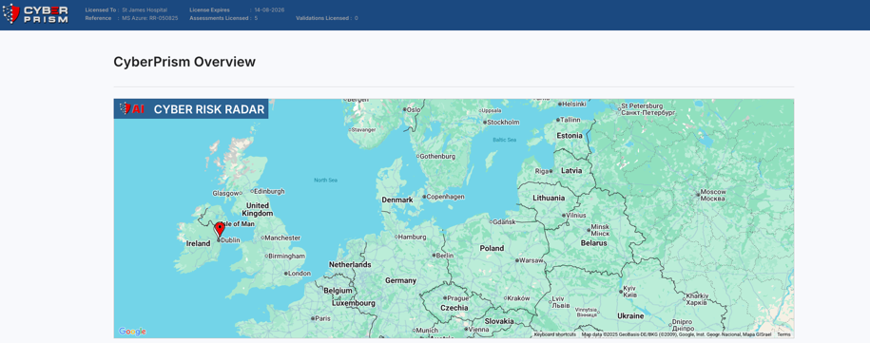
Please note the cyberprism logo is just displayed in the top left
I want to change the screen layout and display the logo with the words
“CONTROL CENTRE” and “DIGITAL RISK RADAR”
but I want that text to be in keeping with the cyberprism logo e.g. similar font to be used etc. I will upload the design files I received from the cyberprism logo designer, so that should make it easier for you. Obviously image with transparent background would be best
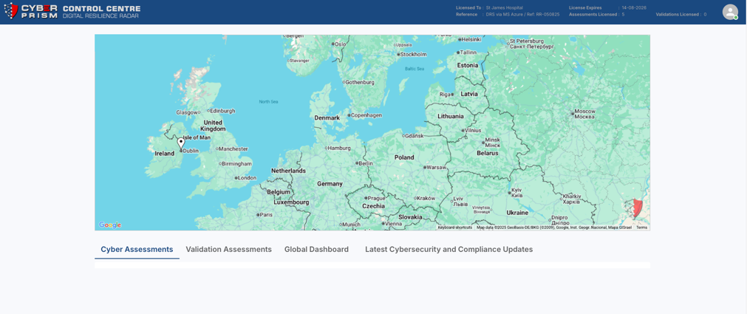
Task 2) Image for CyberPrism Login Screen
My developer sent me this screenshot and has asked for an image we can use for this login page. I need you to create something that marries the CRI brand with CyberPrism and relates to the fact it is a digital resilience platform being used by financial, health and other critical sectors. No need for much if any text at all but it should look impactful, corporate audience and professional


Task 3) Avatar for CyberPrism Logged in User
See the image in the above, you can see profile pic of user. I want to just have an avatar or silhouette image of generic user when logged in. Obvioulsy it should be based perhaps on something centric to cyberprism , perhaps the shield or something? That should be a user profile pic I could use for users when they don’t have a photo

