MAXXKLEEN Label and bottle Design brief –

The label dimensions are – exact measurements - 188mm wide x148mm high.
Label is a single wrap around label on a bleach type shape bottle see below examples.
We have provided a label mock-up idea below but we require a professional touch to really finalise and advance the ideas. Below is the key information required to be included on the label but we look forward to seeing the design ideas.
We require the label design for printing and imagery of the bottle with the label etc The bottle colour is white as seen below and the label should be mostly black background to be in keeping with the logo design colours.

Brand Name – MAXXKLEEN
Brand Tagline - PROFESSIONAL CLEANING | MAXIMUM PERFORMANCE – not part of the official logo but used under the logo, font is Montserrat semibold. See below label example
Product Name – INK KLEEN - Advanced Anilox Cleaning Gel
Key product Info - NON CAUSTIC | NON TOXIC | NON FLAMMABLE | NON CORROSIVE
Product weight - 1KG
Suitable for: UV Based Inks | Solvent-Based Inks | Water-Based Inks
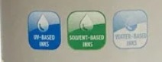

Uses:
INK KLEEN is a highly concentrated, powerful cleaning gel formulated to safely remove solvent-based, water-based, and UV inks from anilox rollers.
It’s thickened formula clings to surfaces, allowing deep penetration into anilox cells and is safe for use on both ceramic and chrome rollers.
INK KLEEN Gel is also suitable for general pressroom cleaning of machinery, components and floors.
Additionally, it can be used to remove most varnishes, coatings, and emulsion adhesives.

Directions:
1. Apply:
Apply INK KLEEN Gel directly to the surface of the anilox roller using an anilox cleaning pad or brush. Ensure full and even coverage with a thick layer of gel.
2. Dwell Time:
Allow the gel to sit for 10–15 minutes
3. Agitate :
Use a anilox cleaning pad or brush to agitate and remove stubborn ink deposits.
4. Rinse Thoroughly:
Rinse the roller thoroughly with warm water to remove all residue.
5. Dry:
Wipe dry with a clean lint-free cloth making sure the roller is completely dry before returning to production.

INK KLEEN Gel can also be used for general press cleaning (rubber rollers, ink trays, doctor blades, press room floors etc)

For more information see full product data sheet

Caution – pre testing on all surfaces is recommended before use.

Health and Safety – (Each side of the red border on the warning sign must be a minimum of 10mm)
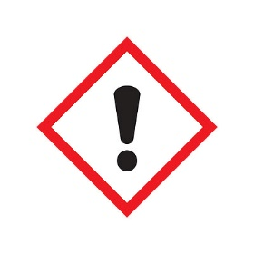

Contains - <5% Non-Ionic surfactants
WARNING Contains: Alcohols, C9-11, ethoxylated. Causes skin irritation. Causes serious eye irritation. Wash hands thoroughly after handling. Wear eye protection. IF IN EYES: Rinse cautiously with water for several minutes. Remove contact lenses, if present and easy to do. Continue rinsing. If eye irritation persists: Get medical advice/attention.

See SDS for full safety information

MAXXKLEEN LTD
272 Bath Street, Glasgow, G2 4JR
E - info@maxxkleen.co.uk | W - www.maxxkleen.co.uk

Bottle shape example -

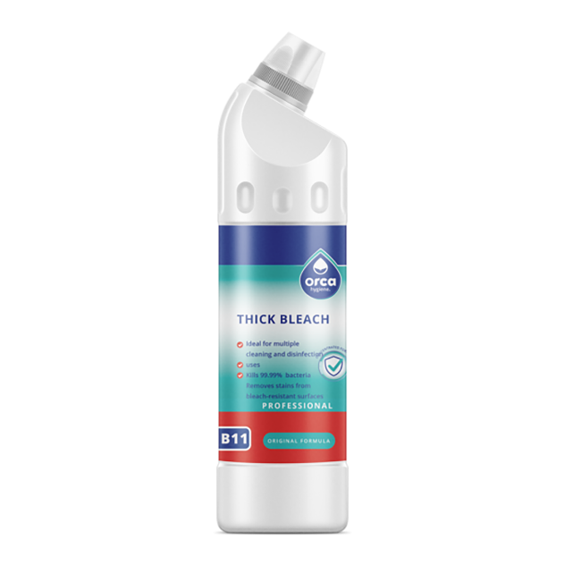

Actual Bottle that we will be using
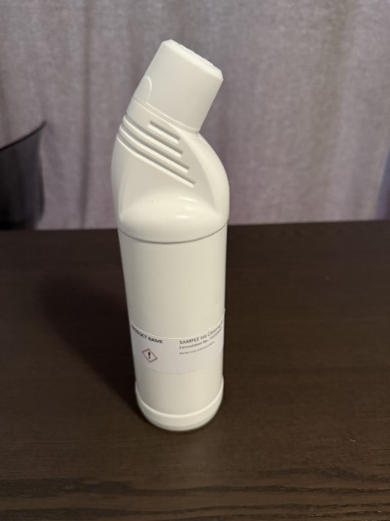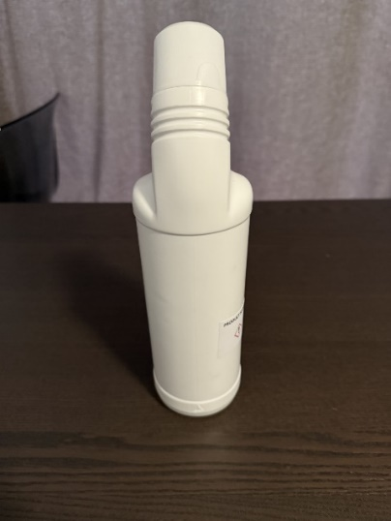

Label concept idea –
This is an initial concept idea of what the label could look like and all the key information required to be on the label, please make this more professional and refined label with some ideas of your own. We like the hex background on the black as this represents the cell shape of the anilox roller cells.

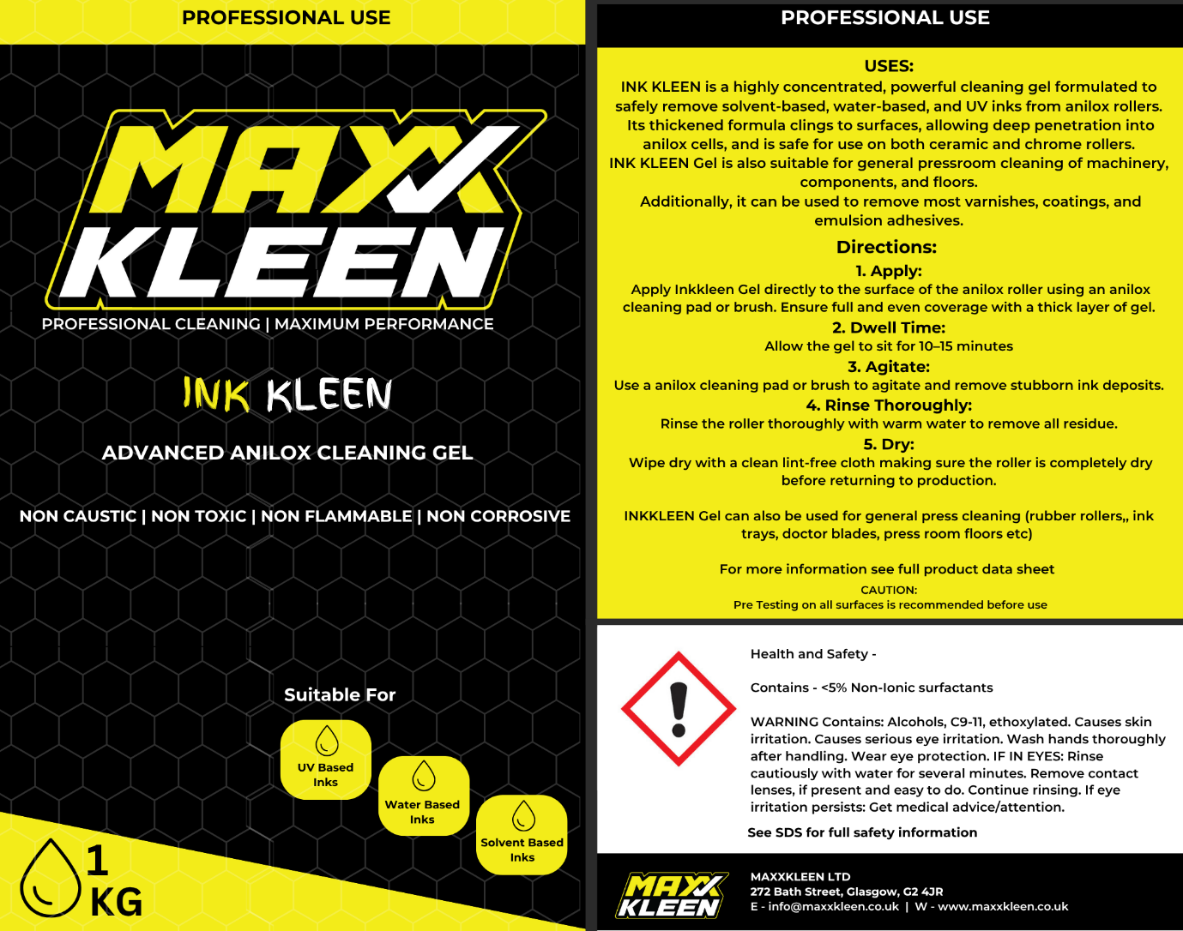

Use the below images as ideas for the suitable for boxes design -

Other brands we can use for label design ideas:
