Name – Wollemi group
Name Wollemi represent – survival, adaptation and strategy to last the years of time in construction.
Our construction is long lasting and resilience
Article on Wollemi - https://www.earth.com/news/the-wollemi-pine-from-the-jurassic-period-is-the-most-protected-tree-on-earth/

Wollemi pines and climate resilience
The Wollemi pine’s survival strategy may offer clues for climate change adaptation in other species. Its ability to persist through massive shifts in Earth’s environment makes it a valuable subject for studying long-term ecological resilience.
Researchers are exploring how the pine’s physiology handles temperature extremes and water stress. Insights from its ancient genome could guide future efforts to protect modern forests facing worsening climate instability.

https://www.abc.net.au/gardening/factsheets/protecting-the-prehistoric/13419730?jwsource=em

SERIES 32 | Episode 20
Costa meets the team tasked working to protect one of Australia’s most unique plant species.
The Wollemi Pine is a remarkable plant, with ancient lineage harking back to the Jurassic period. It is one of the worlds’ oldest and rarest plant species, and belongs to a unique a genetic lineage, thought extinct for some 65 million years. Growing undetected only a 150km from Australia’s biggest city, Sydney, it is often (though perhaps not accurately) described as a pino-saur or a living fossil. When it was rediscovered in 1994, it became an international super-star.
Dr Cathy Offord has been working on the Wollemi since that moment. “Well, I wasn’t there the day it came in but pretty soon after!” A park ranger was canyoning in Wollemi National Park and they stopped for lunch in a deep valley. He spotted a tree he didn’t recognise and when he presented the leaf to his team, it had them stumped. Eventually it made its way to the Royal Botanic Gardens and was named as a new genus and species to science.
Cathy says, “there are multiple threats to their survival”, but a big problem is boots! People accessing the site brings in the risk of soil-borne pathogens like phytophthora, which has been introduced into the population in the past. It is one of the reasons the decision was taken to make the Wollemi available to home gardeners, to remove that motivation for people to visit. We have to restrict access to those who are working to protect the wild trees”.
As part of this protection, they have collected wild material and cultivated ex-situ populations. “We have propagated at least 3 clones of each wild tree, which are maintained at the PlantBank, but they also collected some translocated and propagated populations, including here at Mt Tomah.
Berin McKenzie is one of the people who has regular access, collaborating with Cathy and others to safeguard the species. Cathy, “this is genuinely the envy of the world, it is the biggest most beautiful conservation collaboration that exists, with a huge range of organisations and skills working together over what will be generations”. But in the 2019 Black Summer Fires, the work became urgent.
While these ancient trees would have experienced some fire in their epic history, Black Summer presented an unprecedented risk. And as a rainforest species, their ability to survive and adapt was unknown.
As the massive Gospers Mountain Mega fire advanced across the Blue Mountains, and many more burnt across the region, everyone feared for their lives and homes. The last population of Wollemi were also under threat, requiring immediate action.
In a secret mission, 4 NSPWS team members, including Berin, were choppered into the valley that is home to the most mature stand of trees. “Some are dated at around 1000 years old; they stand about 40m high. They are so unique and precious, losing them would be like losing all the wild koalas”. With a makeshift kit of pumps and pipes, they disinfected everything and got to work.
“So many people knew where we were and what we were doing, it was incredibly well organised and safe. There was a moment, when the ash started raining down, we all looked at each other but our radios weren’t going off, so we kept working for another hour until we got the call to get out”.
Retardant was also placed around the perimeter of the valley, plus water bombers and teams followed up the fire front.
Berin has continued research since the fires and says that the news is good. The mature trees survived, some resprouting from damage, but their future is still unclear. “With changing climate and fire behaviour – the wild Wollemi is still under threat”. He sees himself as a mere moment in the life of this ancient species, “it is like time travelling to work on the Wollemi, we are only the first generation of scientists who will do it. We have only been looking at them for a ¼ century, but they have been around or millions of years. I won’t see a seedling in the valley reach maturity in my lifetime”.

Pictures

Wollemi Tree
Construction
Colours nature, green, brown,

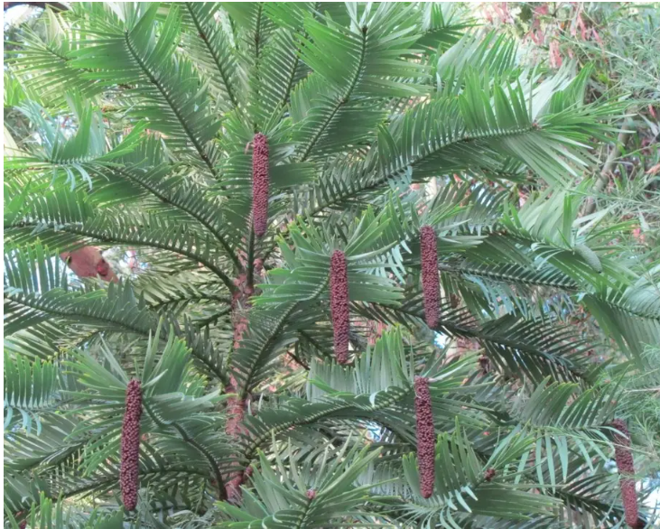

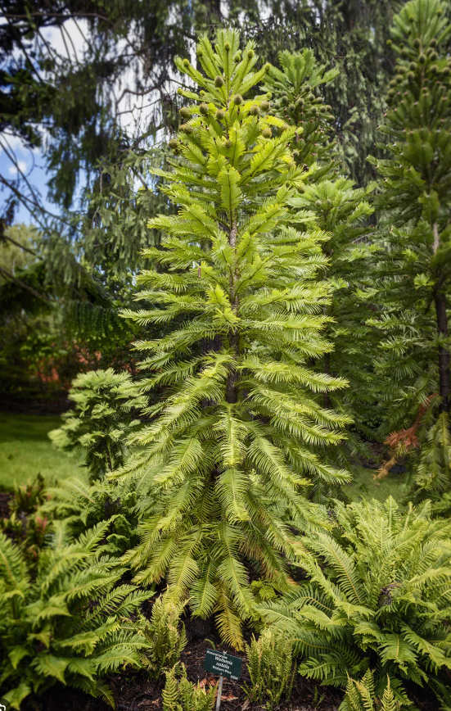

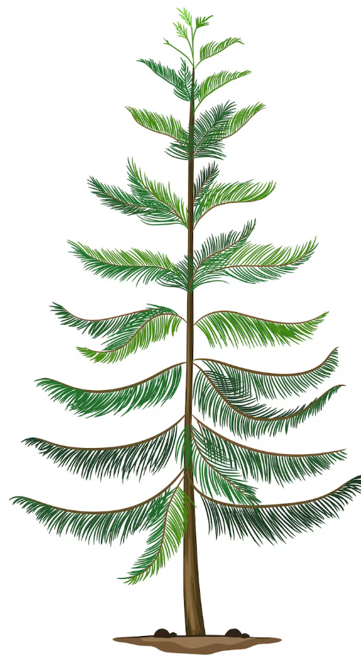

group

