Project Overview – El Picante Diablo Salsa Label
Summit Food Company is company launching its second product line — El Picante Diablo Salsa. We need a label that closely emulates the attached El Picante All-Natural Salsa label for layout inspiration and follows our existing color and brand guidelines as described.

Label Dimensions

Height and Width
- 2.75”x 8.5”

Panel Descriptions

Front Panel
- In lower section change “MEDIUM” to “HOT”.
- In middle section change “ALL NATURAL” to “DIABLO HOT”

Left Side Panel
- Update the UPC code to new one 860013959623:
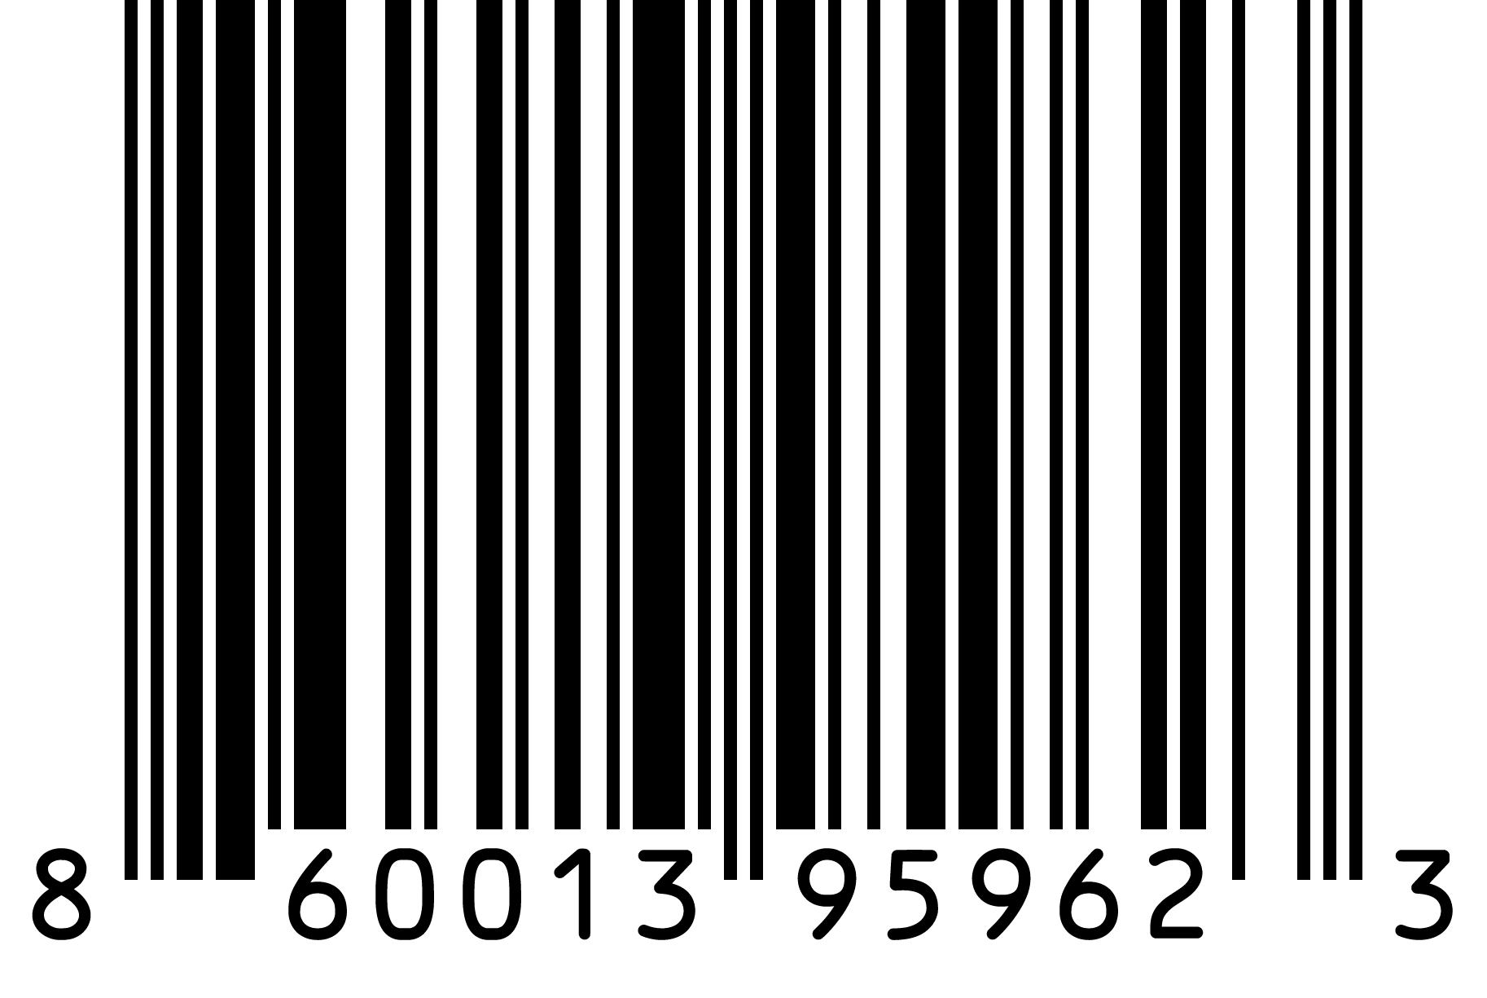

Label Colors
- Designer will create a bold, eye-catching label using a heat-inspired color palette.

Color Palette (HEX Codes)
Please use or complement the following brand colors for our product label:

- #000000 

- #FFFFFF 

- #C74524 

- #F08c73 

- #F0B739 

- #3B6A1D 

- #8CA85B 

