Rogue Compass Packaging Design Brief

Project Overview:
  - Brand Design for a line of spirits called ‘Rogue Compass’
  - The branding will be printed on the glass bottles
  - The bottle itself will be off the shelf, comfortable for bartenders to grab and pour, and sit well at any speed.

Goals and Objectives:
  - Want the label to have a rebellious, unconventional cool, that suggests fun

Target Audience:
  - 18-45 males and females who like to drink cocktails
  - Bartenders: Want them to have confidence in the product and not think it is a “black and Gold” brand

Project Scope:
  - Glass printed, Options of single colour and two colour, depending on costs
Deliverables:
  - A brand design that feels authentic and a little edgy, that will be associated with quality and unconventional style
Timeline:
  - As soon as possible

Budget: What is the allocated budget for the project?

Product Label Design for "Rogue Compass"

1. Brand Name & Logo:
- Masterbrand Name: "Rogue Compass"
- SKU name: White Rum / Spiced Rum / Vodka
- Font Style: Use a bold, modern sans-serif font that conveys a sense of adventure and rebellion. Consider a slightly distressed texture for a rugged look.
- Logo Element: Incorporate a compass rose in the design, symbolising navigation and exploration, intertwined with rebellious elements like a skull or lightning bolt to emphasise the unconventional nature of the spirit.

2. Colour Palette:
- The bottle will be clear glass
- Spirit will be clear, or slightly golden (Spiced Rum)
- Primary Colours: Deep navy blue and rich copper. Navy conveys trust and depth, while copper adds warmth and sophistication.
- Accent Colours: Bright crimson and matte black for text and highlights. Crimson grabs attention and adds a rebellious flair, while black enhances readability.

3. Label Shape & Size:
- Shape: A unique, slightly irregular shape to convey the unconventional aspect
- Size: Standard 700ml bottle label size. The information required should be able to sit on the front.

4. Front Label Design Elements:
- Main Title: "Rogue Compass" prominently displayed at the top, with the logo incorporated.
- Sub-Title: “An Inspirational Spirit” beneath the brand name in a smaller, elegant italic font.
- Illustrative Elements:
  - A stylised compass design behind the text, with subtle details like nautical maps or abstract waves to suggest adventure.
  - Use a watercolour effect to blend the colours, giving it an artisanal feel.
- Tagline: Below the main title, include a catchy tagline like “Find Your Path to Adventure” in a playful script font.
5. Back Label Design Elements:
- Inspirational Message: A short, engaging paragraph that reflects the spirit's philosophy. Example:
  - Suggestions:
    - “Life's too short for the ordinary”
    - “Embrace the unexpected”
    - “Off course, on purpose.”
    - “Not all who wander are aimless.”
    - “Rules are just suggestions.”
    - “Navigate by instinct, not convention.”
    - “Born to stray.”

- Alcohol Content: Will be put on the clear Sticker. Clearly state the ABV (Alcohol By Volume), e.g., “40% ABV”.
7. Compliance & Legal Information:
- A clear, small sticker with black font can be used on the back to provide information necessary to meet current licensing guidelines.
- Ensure that all necessary legal requirements for alcohol labelling are met, including:
  - Alcohol by Volume
  - Number of Standard Drinks
  - government warning statements,
  - recycling symbols, and
Summary:
The "Rogue Compass" label should evoke a sense of adventure, rebellion, and inspiration. The combination of bold typography, artistic illustrations, and a cohesive colour scheme will create an eye-catching design that appeals to the modern adult looking for fun and unconventional experiences. This label should resonate with consumers who seek not just a drink, but a story and an experience with every sip.

Inspiration and Examples:

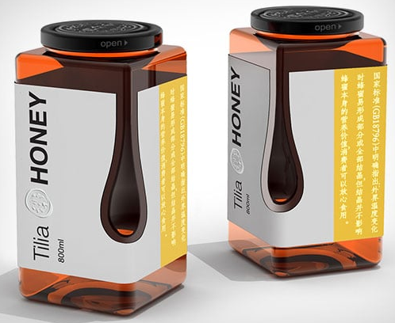

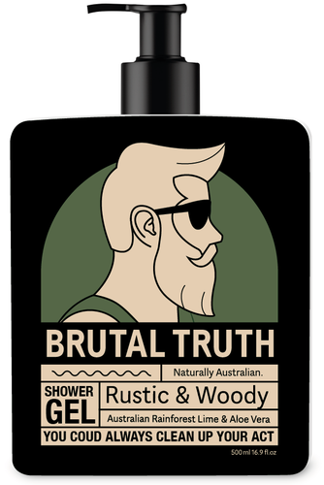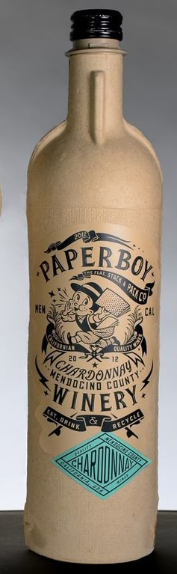
this one above is a nice reference. Two colours though, and black bottle. 