JJ SOCIAL MEDIA GRAPHICS

We are looking for a series of social media graphics for Instagram (new size: 4:5 (1080 x 1350 pixels) ratio that are ALL TEXT. We want the following quotes below on each graphic; one quote per graphic. AND, In very small letters at the bottom of each graphic, add @JJSmithOnline

The look and feel of these graphics should be complimentary to the color palette attached below (you don’t have to use every color in the color palette); but keep them simple. But the design is up to you; at the end of this document, I provided various samples of all text graphics that I like as examples.

The QUOTES:

You can absolutely be down 20–30 pounds by end of summer. All it takes is the right plan—and you’ve found it. Comment “Hot Girl” for the Hot Girl Summer Slimdown!

You don’t need another diet—you need a system that works. Drop 30 pounds with the Hot Girl Summer Slimdown. Comment “Summer” to start now.

This summer ain’t over—and neither are your body goals. Drop 30 pounds with the Hot Girl Summer Slimdown. Comment “Hot Girl” to get the plan

If your goal is a tiny waist, flat belly, and 30 pounds down—this is the plan. Comment “Summer” to join the Hot Girl Summer Slimdown!

There’s still time to drop the 30 pounds and slay this summer. The Hot Girl Summer Slimdown has the blueprint. Comment “Hot Girl”!

Snatched waist, flat tummy, 30 pounds lighter —that’s what the Hot Girl Summer Slimdown Challenge delivers. Comment “Hot Girl” to get the plan

Nothing feels better than seeing that scale drop week after week. Let’s lose up to 30 pounds this summer—together. Comment “Summer” to join the Hot Girl Summer Slimdown!

Sis, we’re dropping belly flat and saying goodbye to stubborn pounds. Join the Hot Girl Summer Slimdown—comment “Summer”!

Don’t wait ‘til next summer to get right. The time is NOW. Drop 30 pounds with the Hot Girl Summer Slimdown. Comment “Summer”!

You’ve got 8 weeks and the perfect plan to drop 30 pounds. Let’s get snatched this summer with the Hot Girl Summer Slimdown. Comment “Summer”!

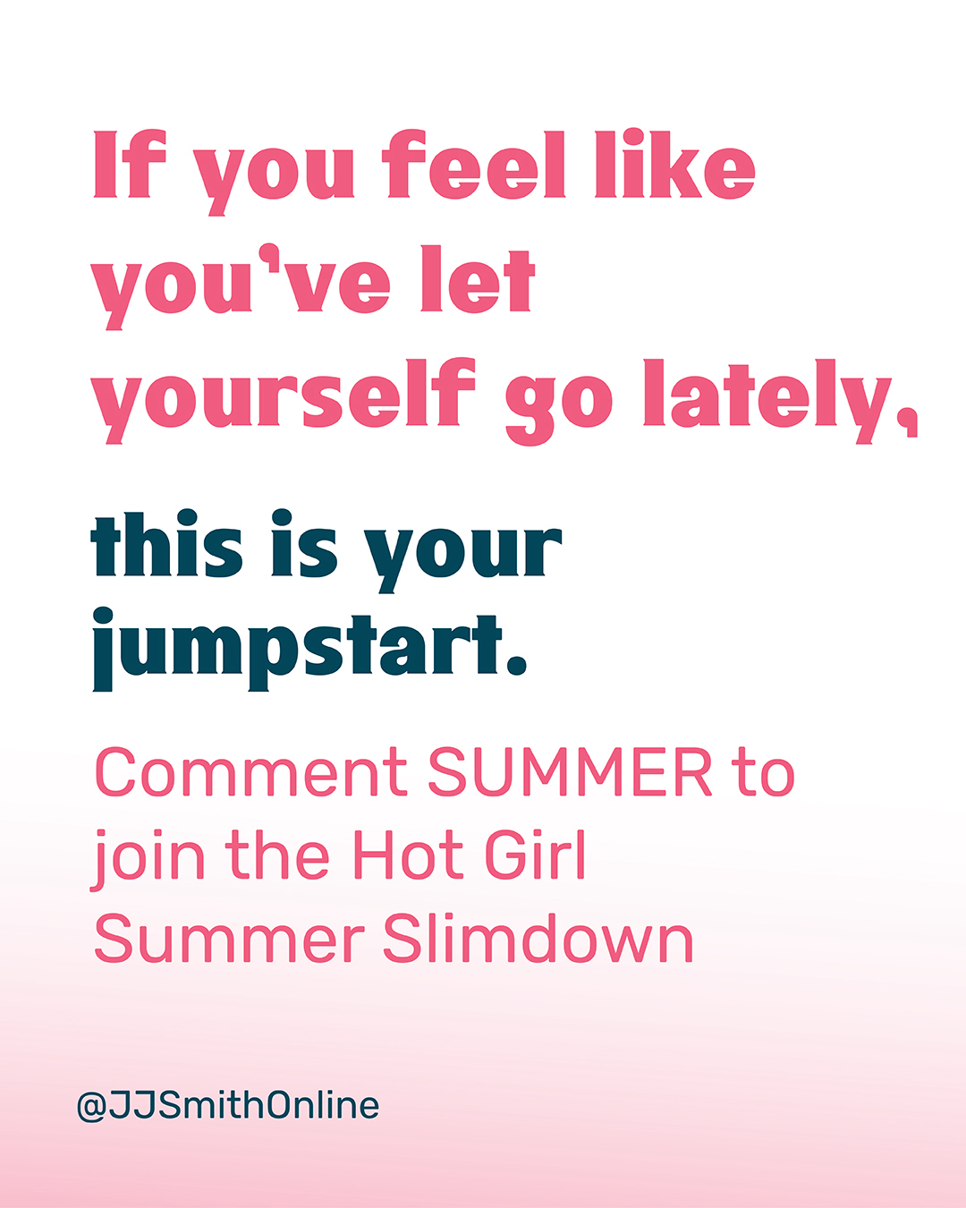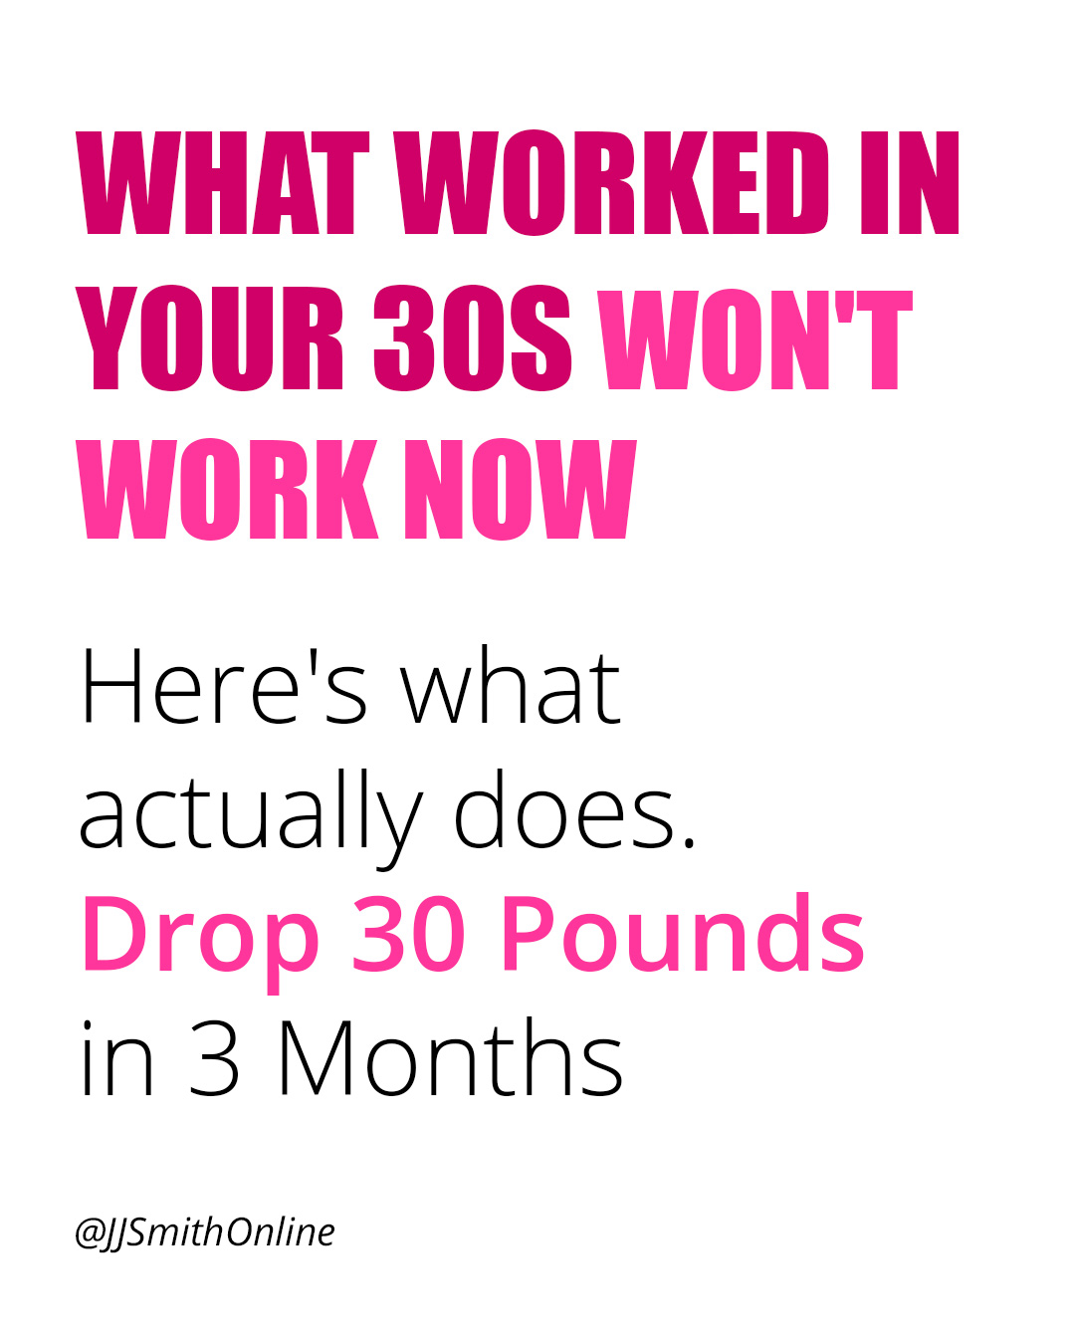
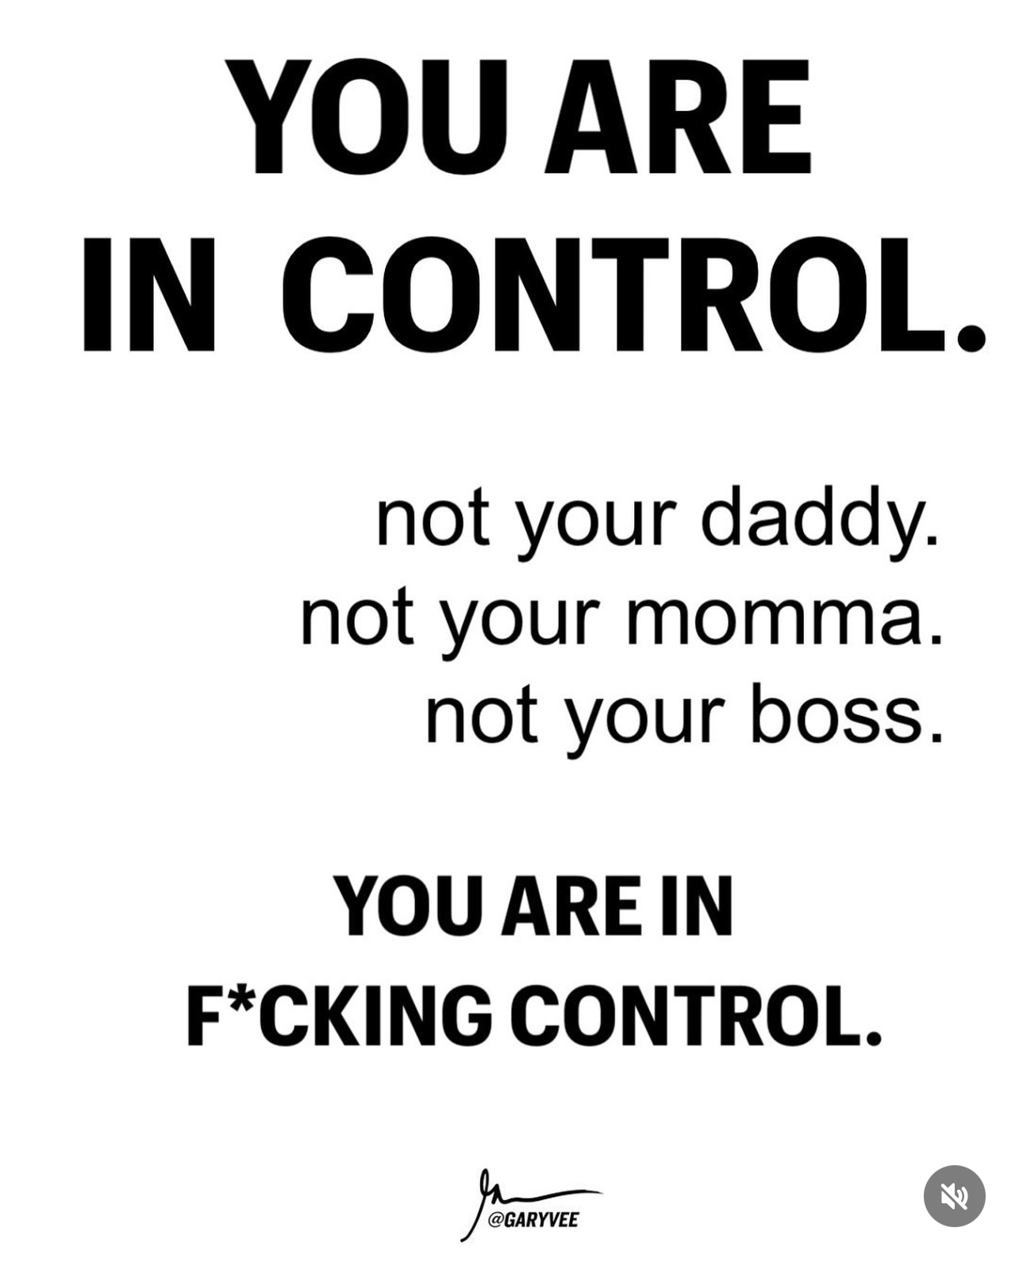

Color Palette

