Site Structure: Horizontal Navigation on Website & Drop Down Tabs in brackets.
- Support Us (Raise Funds, Donate, Resource Tips, Events, Where Do Funds Go?)
- About Us (Our Movement, Our Cause, Our Impact, Our Story, Our Values, Our Cause Areas)
- Smartphone Health (Finding Balance, Healthy Habits, Healthy Tips)
- Digital Challenges (Pre-April Digital Challenges, April Commitment Options)
- Blog & Resources (Blogs, Publications & Articles)
- LOGIN
- REGISTER
- DONATE

- SUPPORT US
Analogue April is more than just a digital detox—it’s a movement to reclaim our time, focus, and mental well-being. Whether you're going full analogue or cheering from the sidelines, there are plenty of ways to get involved.

1. Raise Funds
Turn your smartphone sabbatical into a fundraising powerhouse. Whether you're swapping your device for a classic handset, hosting a screen-free game night, or challenging friends to a digital-free day, your efforts can support mental health initiatives across the UK

Ideas to get you started:
- Digital Detox Challenge: Get sponsored to go smartphone-free for a day, a week, or the entire month.
- Screen-Free Socials: Host events like board game nights, book clubs, or outdoor adventures.
- Workplace Warriors: Encourage colleagues to join the movement and match funds raised. Need inspiration? Our fundraising toolkit is packed with tips, templates, and resources to help you succeed.

2. Donate
Every contribution fuels our mission to promote healthier digital habits and support mental well-being.
Ways to give:
- One-Time Donation: Support the cause with a single gift.
- Monthly Giving: Become a regular supporter and help sustain our year-round initiatives.
- In Honour: Donate in honour of someone embracing the analogue lifestyle.

3. Resource Tips
Embarking on a digital detox? We've got your back. Our resource hub offers practical tips and tools to help you navigate the analogue life.
Top resources:
- Analogue Starter Kit: Guides to help you transition smoothly.
- Daily Challenges: Fun tasks to keep you engaged and motivated.
- Community Stories: Read about others' journeys and share your own.
Explore our full range of resources to make the most of your Analogue April experience.

4. Events
Join the movement in person! Our events are designed to bring people together, away from screens, to connect and celebrate.
Upcoming highlights:
- Launch Party: Kick off Analogue April with fellow participants.
- Community Meetups: Engage with others in your area embracing the analogue lifestyle.
- Runs, Rides, Treks, Fitness Challenges: 12 April 26 – London Landmarks Half Marathon
- Mindfulness – TBA

5. Where Do Funds Go
UK Charities and Initiatives
- Positive Social
Delivers interactive sessions in schools to help students, parents, and teachers navigate social media positively, addressing issues like addiction and online behaviour. Positive Social
- Childnet
Empowers children and young people to navigate the internet safely, providing educational resources and working with stakeholders to prioritise young people's online rights. Childnet
- Internet Matters
Offers advice and resources to parents and professionals to keep children safe online, collaborating with major internet service providers and participating in initiatives like the UK Council for Internet Safety. Internet Matters
- Partnership for Children
Provides evidence-based programs for schools that teach children coping skills, communication, and emotional resilience, aiming to integrate mental health development into everyday life. partnershipforchildren.org.uk
- YoungMinds
Focuses on supporting young people's mental health, providing tools and resources to help them and the adults around them navigate mental health challenges. YoungMinds
- The Mix
Offers support to under-25s on various issues, including mental health, through digital channels like helplines, chat services, and online communities. Wikipedia
- Maudsley Charity
Partners with organisations to make social media safer for young people, addressing issues like exposure to harmful content and its impact on mental health. Maudsley Charity

Strategic Allocation of Funds
- Educational Workshops: Fund sessions in schools to educate students, parents, and teachers on digital well-being.
- Resource Development: Support the creation of toolkits and materials that promote healthy digital habits.
- Mental Health Support: Invest in programs that offer mental health resources tailored to the challenges posed by digital life. YoungMinds

- ABOUT US

1. Our Movement
Analogue April is a grassroots initiative challenging the pervasive culture of constant connectivity. Each April, we encourage individuals—adults, teenagers, and families—to swap their smartphones for basic handsets, take a break from social media, and reconnect with the world around them. It's a collective step towards digital mindfulness and mental well-being, aiming to reshape societal norms around technology use.

2. Our Cause
In an age where screen time dominates our daily lives, we've seen a rise in anxiety, sleep disturbances, and diminished real-world connections. Analogue April aims to spotlight these issues, promoting a healthier relationship with technology. By taking a month-long digital detox, participants can experience the benefits of reduced screen time and increased presence in their daily lives.

We advocate for delaying the age at which children receive smartphones and access social media, aligning with growing discussions in the UK about raising the digital age of consent from 13 to 16 . By encouraging families to participate together, we aim to foster environments where children can develop without the pressures of the digital world.

3. Our Impact
Since our inception, hundreds have joined the Analogue April challenge, reporting improved sleep, heightened focus, and deeper personal connections. Families have shared stories of strengthened relationships and more meaningful interactions at home. Our community has grown organically, with participants inspiring others to reconsider their digital habits. Together, we're fostering a culture that values balance over constant connectivity.

4. Our Story
Analogue April began with a throwaway line—an offhand idea tossed out in a conversation between friends overwhelmed by how much of our lives were being swallowed by our smartphones. “I’d call it Analogue April.” To our surprise, a friend working in a senior role at a major global tech company lit up and said, “That’s brilliant—trademark it.” The irony wasn’t lost on us.
That moment stuck. Despite our friend’s role in a company built around keeping people online, he instinctively recognised something powerful in the idea. Like many of us, we were feeling the creeping mental fatigue, distraction, and disconnection that comes with constant smartphone use—not just in ourselves, but in our families and children too.
So we decided to act. We turned off notifications. We snoozed then deleted social media apps. We carved out quiet. We investigating swapping smartphones for old-school handsets. What started as a personal experiment—a one-month digital reset—began to resonate with others. Friends, then friends of friends, joined in.
Today, Analogue April is more than a challenge—it’s a growing movement. A chance to reset, reconnect, and remember life beyond the scroll.

5. Our Values
- Mindfulness: Encouraging intentional use of technology.
- Connection: Fostering real-world relationships and experiences.
- Well-being: Prioritising mental and emotional health.
- Simplicity: Embracing the benefits of a less cluttered digital life.
- Community: Building a supportive network of individuals seeking balance.
- Leadership: Empowering adults to set positive examples for younger generations.

Join us this April in taking a step back from screens and a step forward into a more present, connected life.

6. Our Cause Areas
- Empowering Families to Reclaim Connection
In today's digital age, screens often dominate our daily lives, affecting the quality of family interactions. Analogue April encourages families to unplug together, fostering deeper connections through shared activities like board games, outdoor adventures, and creative projects. By setting aside devices, families can rediscover the joy of face-to-face conversations and strengthen their bonds.

- Advocating for Delayed Smartphone and Social Media Use in Children
The early introduction of smartphones and social media to children has been linked to increased anxiety, sleep disturbances, and exposure to inappropriate content. We support initiatives like the Smartphone-Free Childhood campaign, which encourages parents to delay giving smartphones to their children until at least age 14. By promoting this delay, we aim to protect children's mental health and well-being.

- Promoting Digital Literacy and Mindful Technology Use
Understanding how to use technology responsibly is crucial in today's world. Analogue April provides resources and workshops to educate both parents and children on digital literacy, helping them make informed choices about their online activities. By fostering awareness, we aim to cultivate a culture of mindful technology use.

- Supporting Cultural Shifts Toward Healthier Digital Habits
We recognise the importance of creating a healthier digital environment for children and young people. Analogue April aims to raise public awareness about the impact of early smartphone and social media use, and to encourage more mindful digital habits. Through community engagement, partnerships, and education campaigns, we support broader societal conversations that prioritise mental wellbeing and childhood development.
- Encouraging Adults to Lead by Example
Children often emulate the behaviours of adults around them. By consciously reducing our own screen time and engaging in offline activities, we can set positive examples for younger generations. Analogue April encourages adults to be role models in embracing a balanced digital lifestyle, demonstrating the value of real-world connections.

Join us in championing these cause areas to foster a more connected, mindful, and healthy society.

C. SMARTPHONE HEALTH

1. Finding Balance in a Hyperconnected World
Smartphones are powerful tools—they keep us informed, entertained, connected, and organised. But without healthy boundaries, they can also contribute to stress, poor sleep, reduced attention spans and feelings of disconnection from the people and world around us.
At Analogue April, we’re not anti-tech. We’re pro-balance.
This guide offers practical, research-informed suggestions on how to use your phone more intentionally. Based on common usage categories (like social media, entertainment, and productivity), it helps you take stock of where your screen time is going—and where you might want to draw a line.
Whether you’re preparing for a full digital detox this April or just curious about your daily habits, use these guidelines to reconnect with what matters—on and off your screen.
2. Healthy Habits
These are general guidelines for adults and teenagers—not prescriptive rules—and are meant to support better mental wellbeing, focus, and rest. Adjust based on personal/work context.
Suggested Daily Totals (Non-work use)
Category | Daily Limit
Social & Chat | 30–60 mins
Entertainment | 60 mins
Gaming | 30–45 mins
Other Apps | 15–30 mins
Total Rec. Time | Under 2.5 hours/day
Healthy Daily Screen Time Limits Using Smartphone Categories
- Social Networking / Social (Social & Communication)
Includes: Instagram, Snapchat, Facebook, TikTok, Threads
Suggested Limit: 30–60 minutes per day
Why: Limiting social apps reduces passive consumption and comparison-driven scrolling, helping with focus and mental health. Limiting time helps reduce passive scrolling and promotes more intentional use.
- Entertainment / (Media & Video)
Includes: YouTube, Netflix, Spotify, Disney+, Prime Video
Suggested Limit: 1 hour per day (max)
Why: While music/podcasts can be healthy in moderation, binge-watching can displace physical activity, sleep, and in-person socialising. Prioritise quality over quantity.
- Games
Includes: All games, from casual (Candy Crush) to immersive (Call of Duty: Mobile), puzzle, strategy, multiplayer, etc.
Suggested Limit: 30–45 minutes per day
Why: Gaming can support relaxation and cognitive stimulation, but too much can lead to isolation, dopamine burnout, or sleep disruption.
- Reading & Reference / (Education / News)
Includes: Kindle, News apps, Wikipedia, Medium
Suggested Limit: No limit unless usage disrupts sleep
Why: Reading is beneficial, but doomscrolling news can increase anxiety. Use Focus Mode at night if needed.
- Productivity
Includes: Notes, Calendar, Reminders, Notion, Trello
Suggested Limit: No limit (as needed)
Why: These apps support organisation and work—generally healthy screen time unless they become procrastination tools.
- Health & Fitness
Includes: Apple Health, Headspace, meditation apps, Strava
Suggested Limit: No limit
Why: These apps encourage movement and wellbeing. Usage here is generally positive.
- Other / Uncategorised Apps
Includes: Custom/utility apps that don’t fall under main categories
Suggested Limit: Case by case
Tip: Review these weekly in Screen Time settings to spot unexpected time sinks.

3.Healthy Tips
Aim for < 2.5 hours/day with no screen use :
- 60 mins before bed
- 30 mins after waking,
- During meals
1 Screen-Free Day per Week: Try a full Sunday without non-essential screens.

- Use Wind Down Mode: Grey out your phone and reduce blue light 1 hour before bed
- Limit Notifications: Turn off non-essential app alerts to reduce distractions
- App Timers: Set daily limits for time-draining apps directly in Digital Wellbeing
- Focus Mode: Use this to block distracting apps during work, study, or social time

D. DIGITAL CHALLENGES
The Commuter Challenge
Leave your phone in your bag (or pocket) for your entire commute—no scrolling, no music, no messages. Just be present with your thoughts, your book, or the world around you.
The Door Drop
As soon as you arrive home, drop your phone in a bowl or drawer by the door. Enjoy an evening phone-free—cook, talk, play, read, or unwind without notifications.
The Bedroom Ban
Keep your phone out of your bedroom for a full week. Use an analogue alarm clock and don’t look at your phone first thing in the morning or last thing before bed.
The Table Free Challenge
Do not place your phone on a table, even face down. Leave your phone at your desk or in your bag for business meetings. Leave your phone in bags or pockets for restaurant and café outings. Keep tables handset free.
The Analogue Sunday
Spend one full Sunday without a smartphone. No social media, no apps, just offline living.
The 1-Hour Window
Pick one hour each day (e.g. lunch or early evening) to put your phone on silent and out of sight—no cheating! Use this time to go for a walk, cook, or chat to someone in person.
The Dinner Detox
Make every mealtime phone-free, even if you’re eating alone. Focus on your food, your company, and the moment without screens competing for your attention.
The Screen-Free Scroll Swap
Replace your usual scrolling time with a book, podcast, or walk. Track how many minutes or hours you gain across the week.
The Notification Audit
Go into your phone settings and disable all non-essential notifications. Notice how your stress levels and concentration change over the week.
The Social Media-Free Weekend
Delete your social media apps on Friday evening and go the whole weekend without them. Reflect on what you miss, what you don’t, and how you felt.

E.BLOGS & PUBLICATIONS
Subsections in the drop down menu

1. Blogs
(Need Page To Upload Blogs)
2. Publications & Articles
a. EE Launches Age Guidance For Smartphone Usage In Drive To Improve Children’s Digital Awareness
https://newsroom.ee.co.uk/ee-launches-age-guidance-for-smartphone-usage-in-drive-to-improve-childrens-digital-wellbeing
EE Online Newsroom, 25 August 24

b. Is there a middle way on children and smartphones? This researcher thinks so
https://www.ft.com/content/c122775a-f664-4c06-90c2-eba077367757
Financial Times – Henry Mance – 12 May 24

c. EY study: Over a third of UK consumers keen on a New Year "digital detox"
https://www.ey.com/en_uk/newsroom/2025/01/over-a-third-of-uk-consumers-keen-on-a-new-year-digital-detox
EY Study, Chris Brown, 10 Jan 25

d. Age Appropriate Design: Assessment of TikTok, Twitch, and YouTube Kids -2208.02638v1.pdf
School of Computing University of Kent, Canterbury, UK, Virginia N. L. Franqueira, Jessica A. Annor and Ozgur Kafali – 4 Aug 22
e. Understanding Engagement With Platform Safety Technology For Reducing Exposure To Online Harms
Public Policy Programme, The Alan Turing Institute and Oxford Internet Institute, University of Oxford - Jonathan Bright, Florence E. Enock, Helen Z. Margetts, Pica Johansson, Francesca Stevens – 3 Jan 24
2401.01796v1.pdf
f. ‘We wanted to change the norm on smartphone use’: grassroots campaigners on a phone-free childhood’

https://www.theguardian.com/lifeandstyle/article/2024/jun/30/we-wanted-to-change-the-norm-on-smartphone-use-grassroots-campaigners-on-a-phone-free-childhood
The Guardian – Alex Moxhakis, 30 Jun 24

- LOGIN
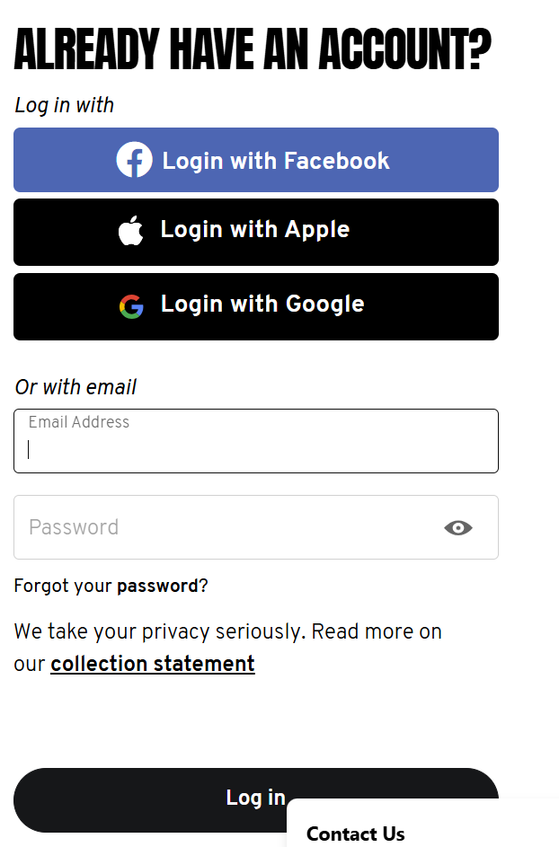

- REGISTER

- DONATE
