JJ SOCIAL MEDIA GRAPHICS

We are looking for a series of social media graphics for Instagram (new size: 4:5 (1080 x 1350 pixels) ratio that are ALL TEXT. We want the following quotes below on each graphic; one quote per graphic. AND, In very small letters at the bottom of each graphic, add @JJSmithOnline

The look and feel of these graphics should be complimentary to the color palette attached below; but keep them simple. But the design is up to you; at the end of this document, I provided various samples of all text graphics that I like as examples.

The QUOTES:

Feeling bloated, sluggish, and too big? Your detox starts now. Comment SUMMER to join the Hot Girl Summer Slimdown

The scale keeps climbing and nothing’s working? This challenge is your lifeline. Comment HOT GIRL to join now!

Your belly bloat and stubborn weight gain aren’t going anywhere… unless you do something different. Comment HOT GIRL to join us!

Need a jumpstart? We’re detoxing, burning fat, and getting snatched. Comment HOT GIRL to join us on July 7

Cravings, belly fat, and water weight? Say goodbye in 30 days. Comment SUMMER to join the Hot Girl Summer Slimdown

If you feel like you’ve let yourself go lately, this is your jumpstart. Comment SUMMER to join the Hot Girl Summer Slimdown

Summer’s here, but your body doesn’t feel ready? You’re not too late. Comment SUMMER to join the Hot Girl Summer Slimdown

This Hot Girl Summer Slimdown plan is helping women drop pounds and feel sexy again. Comment SUMMER to join us

We’re getting a tiny waist and dropping pounds together. Don’t miss this. Comment HOT GIRL to join

You don’t need motivation. You need a proven plan and some accountability. Comment HOT GIRL to get join us July 7

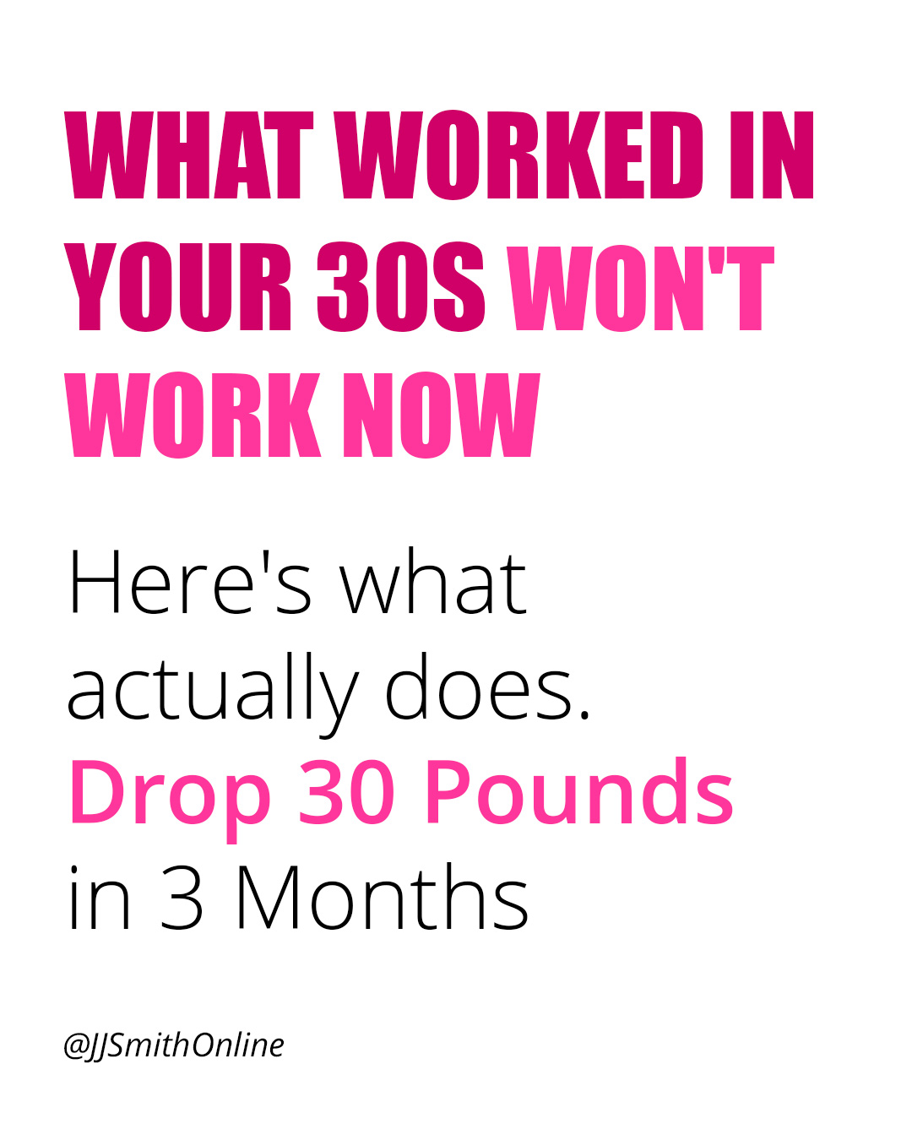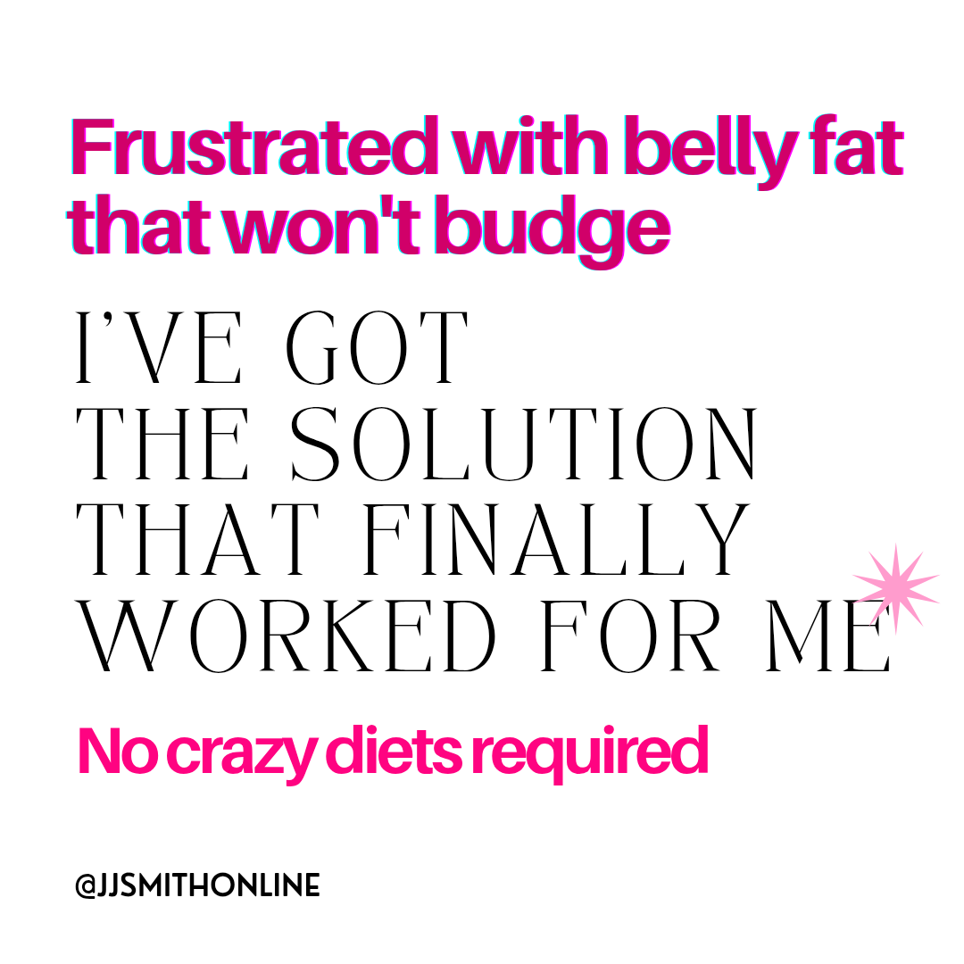
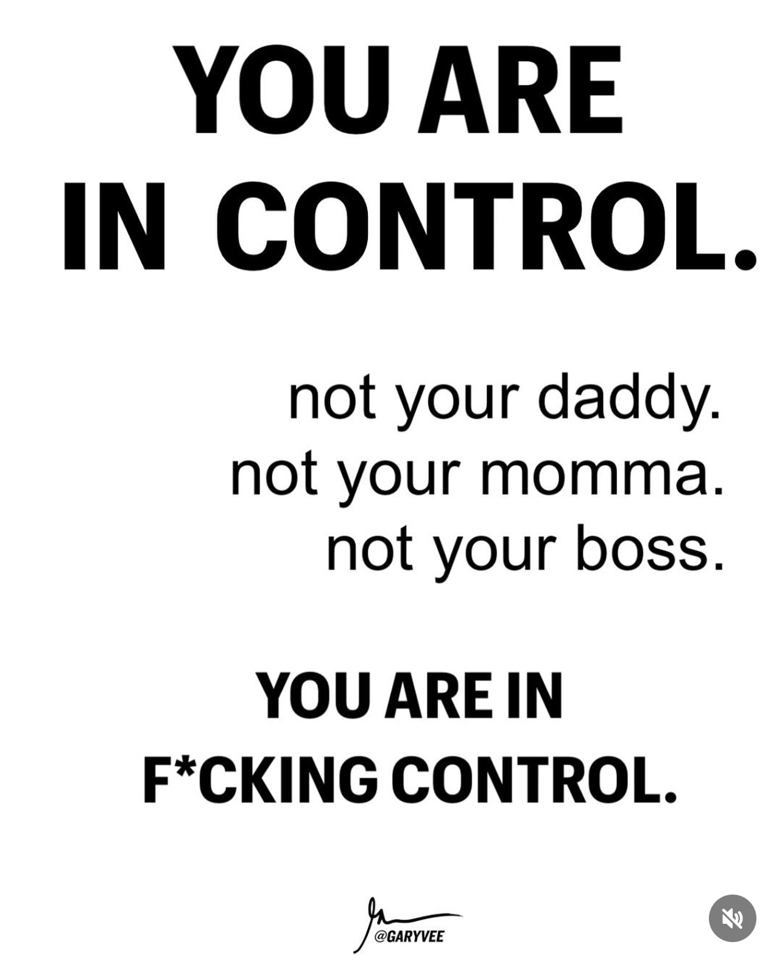

Color Palette

