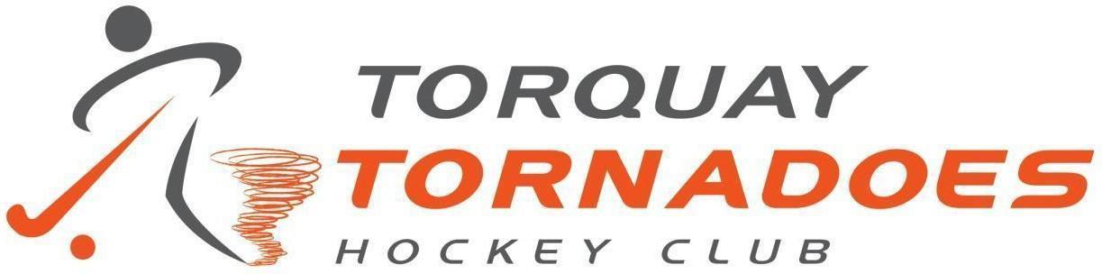

Sponsorship Proposal 2025

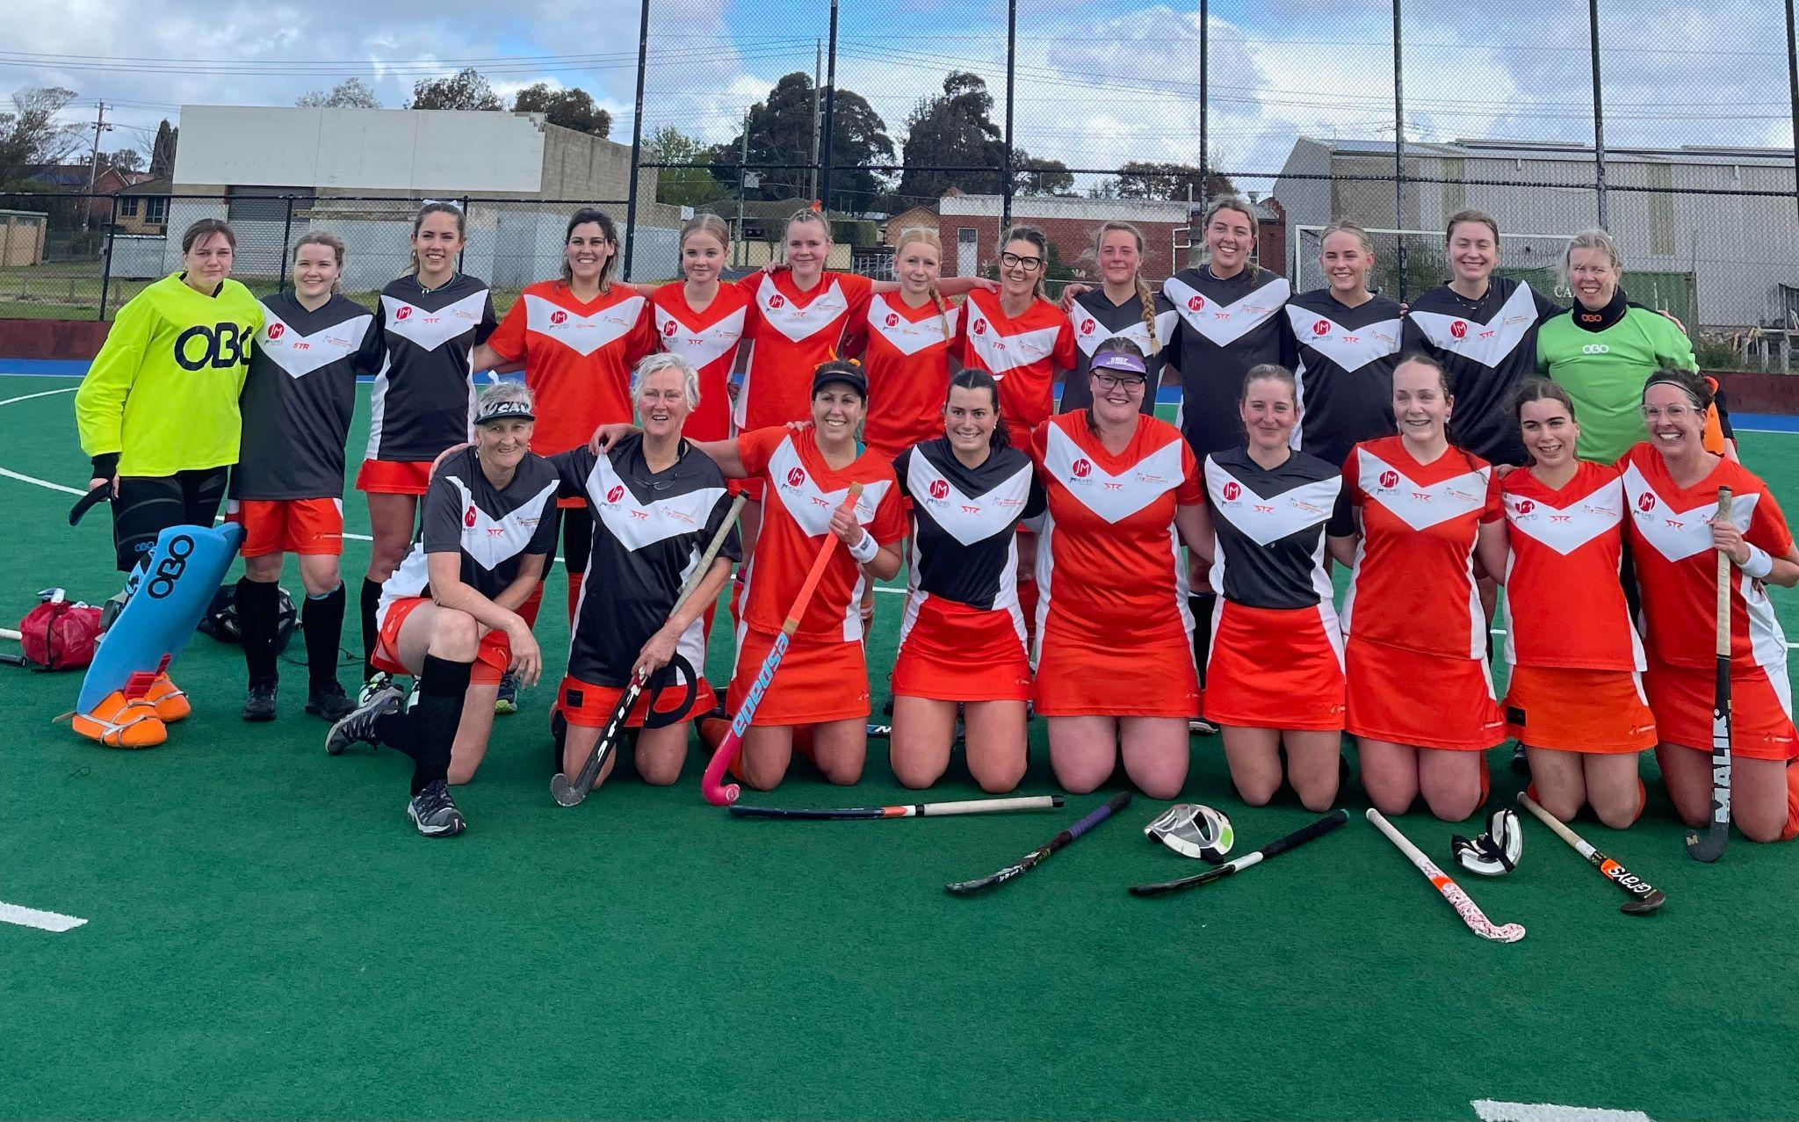
Division 2 Women 2024

Introduction

Torquay Hockey Club would like to offer your business the opportunity to partner with the Tornadoes in 2025.
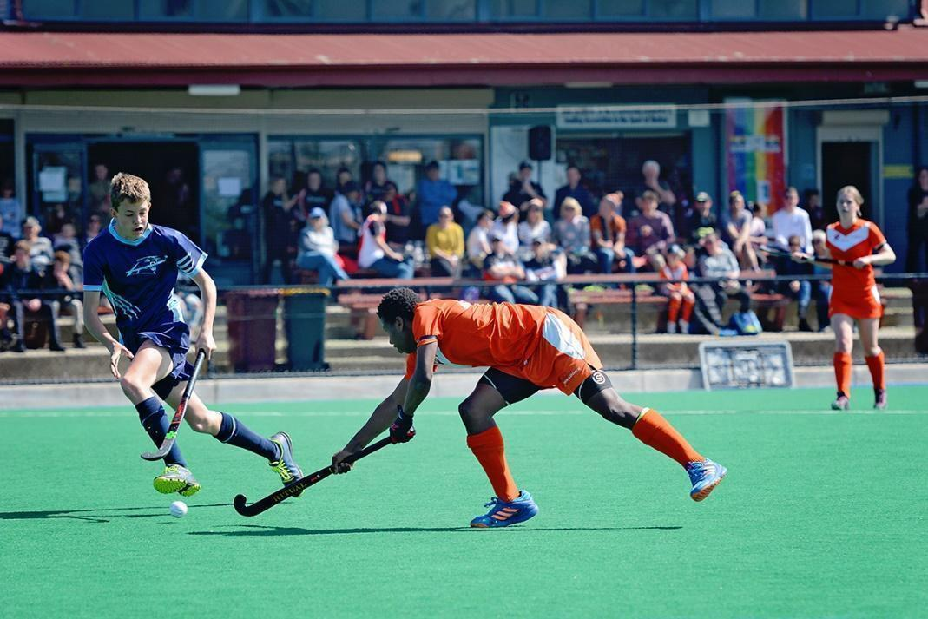
Junior match Stead Park

We are a local community club that is a not-for-profit organisation and one of the most successful regional hockey clubs in Australia. We have a significant sporting presence in the Surf Coast and Geelong.

We have over 160 current playing members and 11 teams competing in men’s, women’s and junior competitions. Torquay also has 5 summer teams.

In 2024 the Tornadoes won Premierships in 3 grades. Division 1 & 2 Men and Division 2 Women.

We pride ourselves on being an inclusive, welcoming and friendly club.
Moving into 2025 we will be getting a new home facility that will be open by the end of the year.
By being a business partner with the Torquay Tornadoes you can be assured that you are investing in grass roots community sport with a club that has both genders and age groups ranging from 6 years of age to players in their 60s.

The History of Torquay Hockey Club
Torquay Hockey Club was established in 2010. Since then, we have become a great club within the broader Surf Coast Community. More recently, we have seen an increase in the number of new members from Armstrong Creek.

As a sport, hockey is in the unique position of offering full family participation, with teams for men, women, boys and girls and is open to all ages from Hook in2 Hockey, a program for young children through to open age. Hockey can be a lifelong sport.
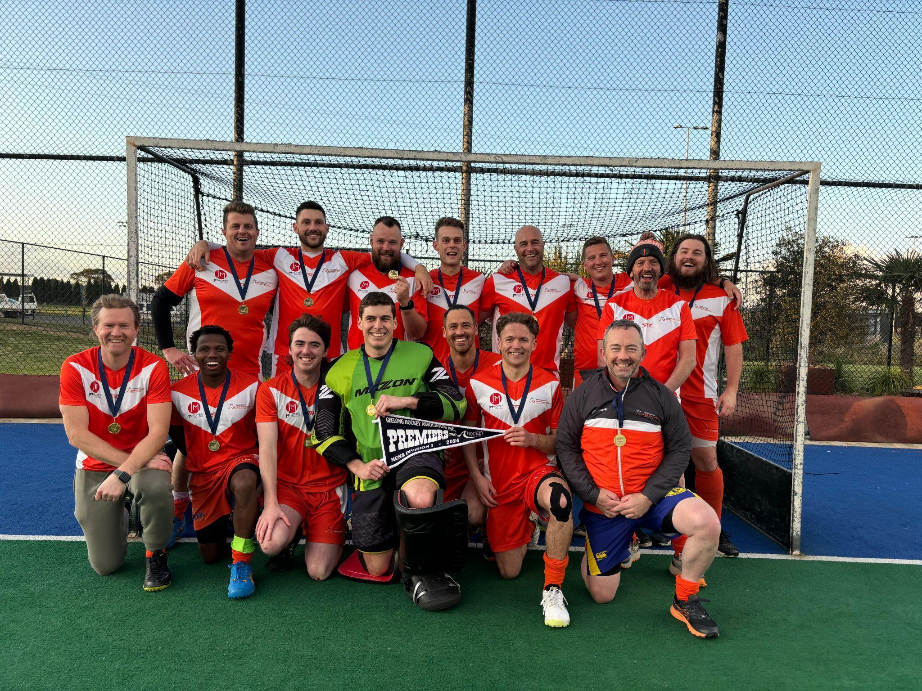
Division 1 Men Premiers 2024

Torquay Hockey Club fielded one junior team in 2010 and is now a sustainable community sports club. The club fields teams in the following age groups in the Hockey Geelong Association:

Men’s Division 1 (Premiers 2017, 2018, 2021, 2022, 2023 and 2024)
Men’s Division 2 (Premiers 2024)
Women’s Division 1 (Premiers 2016, 2019, 2021, 2022 and 2023)
Women’s Division 2 (Premiers 2013 and 2024)
Under 17 (Premiers 2021 and 2023)
Under 14 (Premiers 2019, 2021 and 2022)
Under 12 (Premiers 2019, 2021 and 2023)
Under 10 (Premiers 2014, 2019, 2021 and 2023)
Under 8 - 1 team in 2025

Synthetic Hockey Field in Torquay

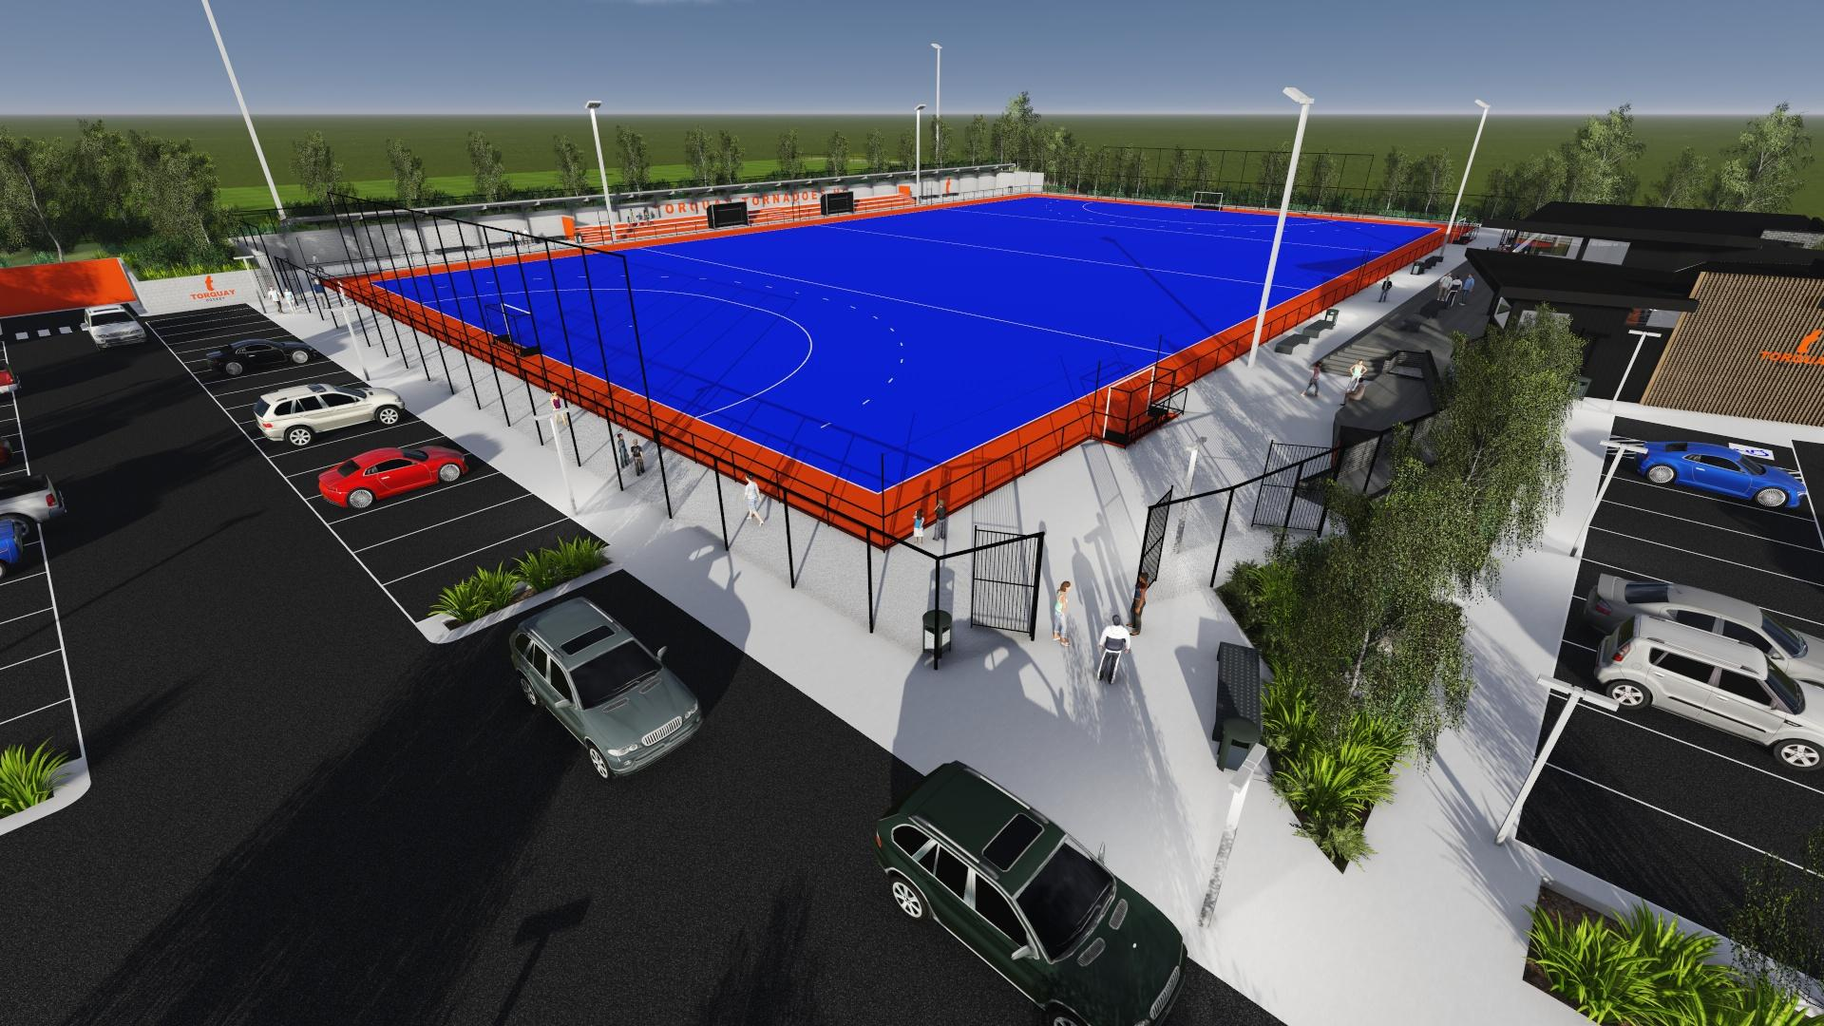

Proposed Torquay Synthetic Facility

In 2025 Surf Coast Shire will be constructing a synthetic hockey facility with funding from the Victorian State Government. This is going to be significant for the Torquay Tornadoes Hockey Club. We are going to be able to grow participation and the number of players in the club.

The development of the new facility will also allow our sponsors to promote their names at the venue through signage.

Our 2025 sponsors will have the first opportunity to get involved with Torquay Tornadoes at this prime location.

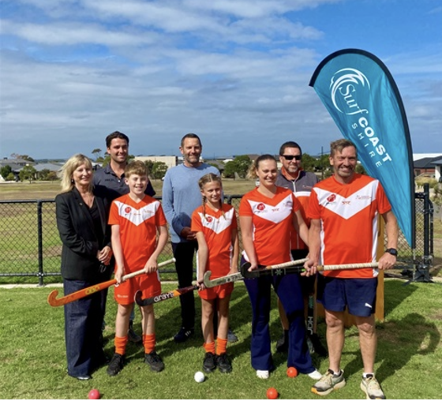
Announcement of project

How will you be promoted?

Torquay Tornadoes website

Sponsors will be featured on the Torquay Tornadoes Website.
Torquay Hockey Teams Sponsors - Torquay Tornadoes Hockey Club

Torquay Tornadoes Stack Team App
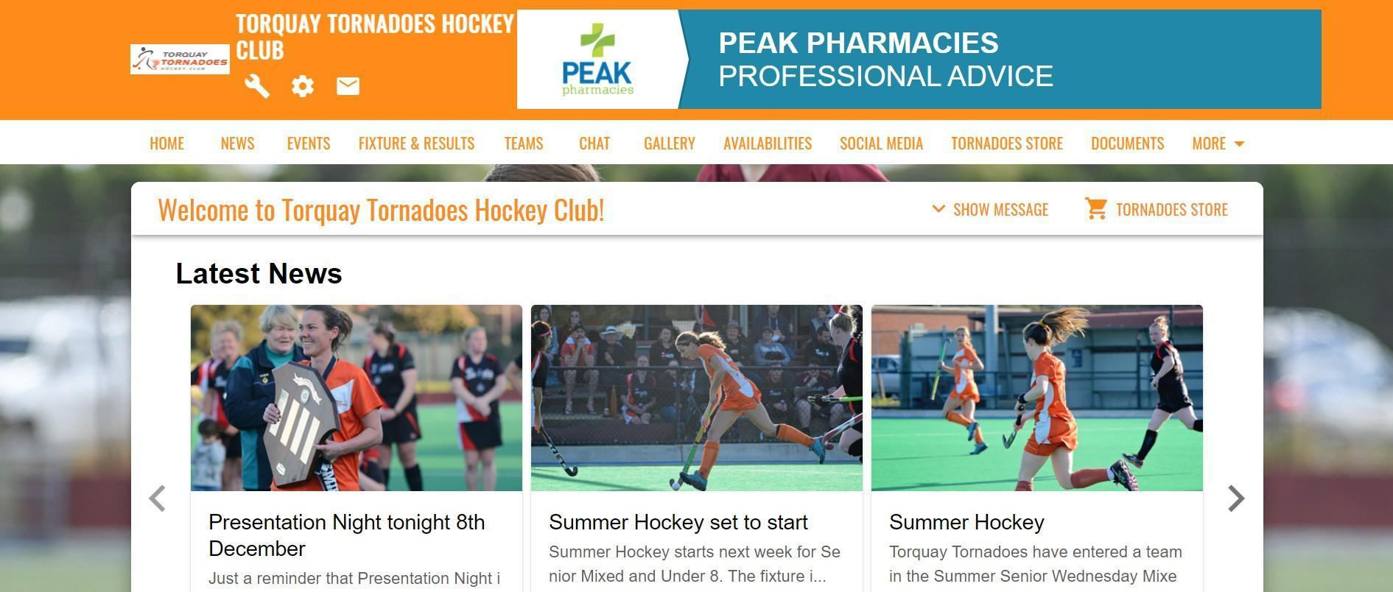
Team APP https://torquaytornadoeshockeyclub.teamapp.com/?_webpage=v1

Stack TeamApp is the major form of communication to members. There are currently over 500 registered users of the Torquay Tornadoes TeamAPP. Posts are generally weekly throughout the hockey season and can have a reach of up to 300 members and families.

Torquay Tornadoes social media

Torquay Hockey Club has a great, engaging social media presence with Facebook and Instagram. Below are examples of our social media.
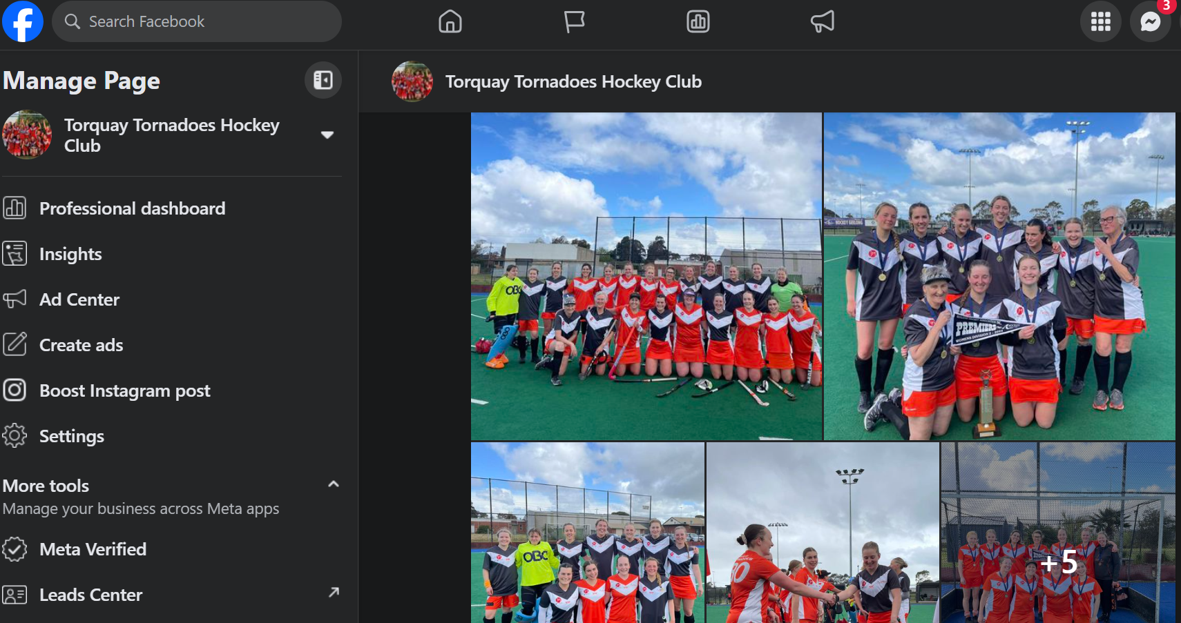

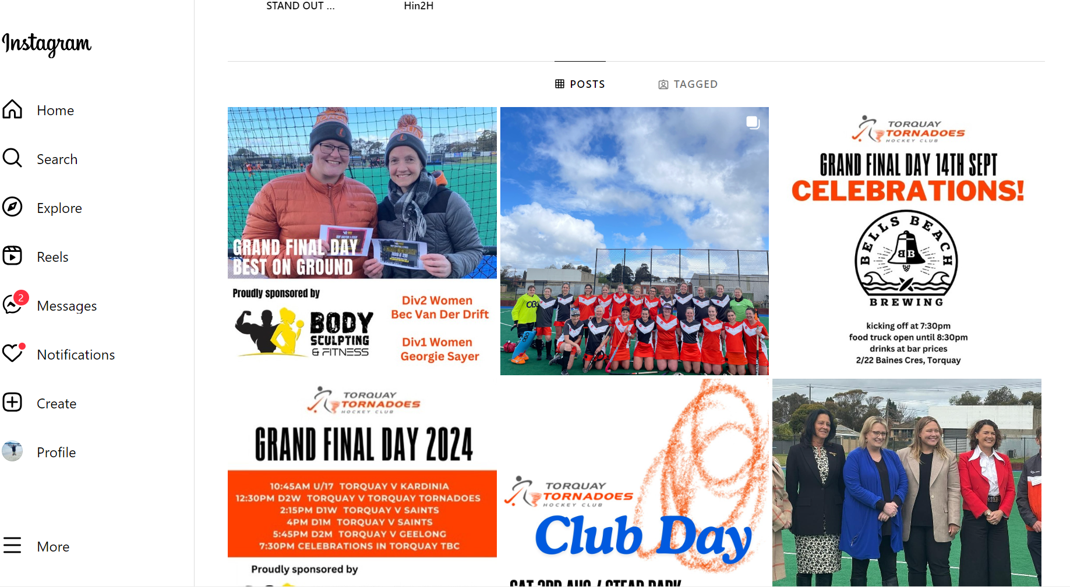
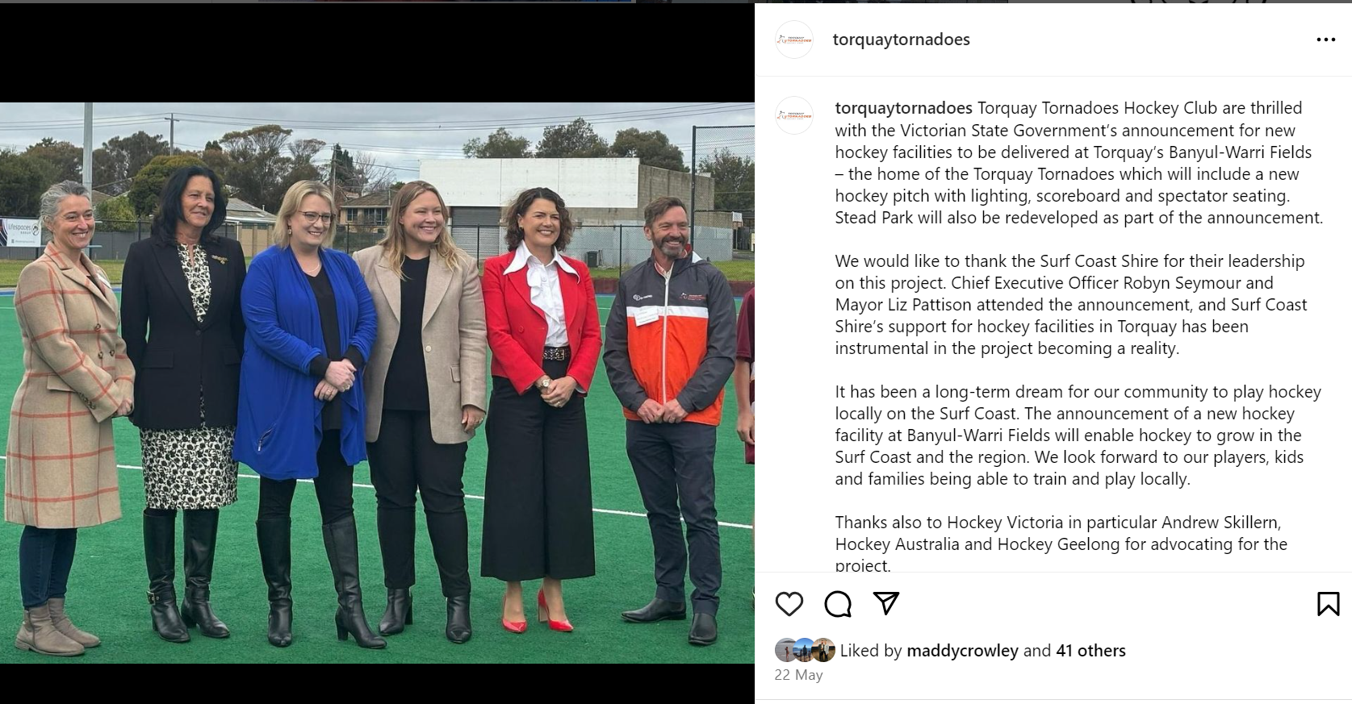

Local media
The Torquay Hockey Club regularly has articles in the Surf Coast Times. An example below is the Stand Out Cup in Melbourne where Torquay had 2 teams entered.

These articles have a large reach in the Surf Coast Shire.
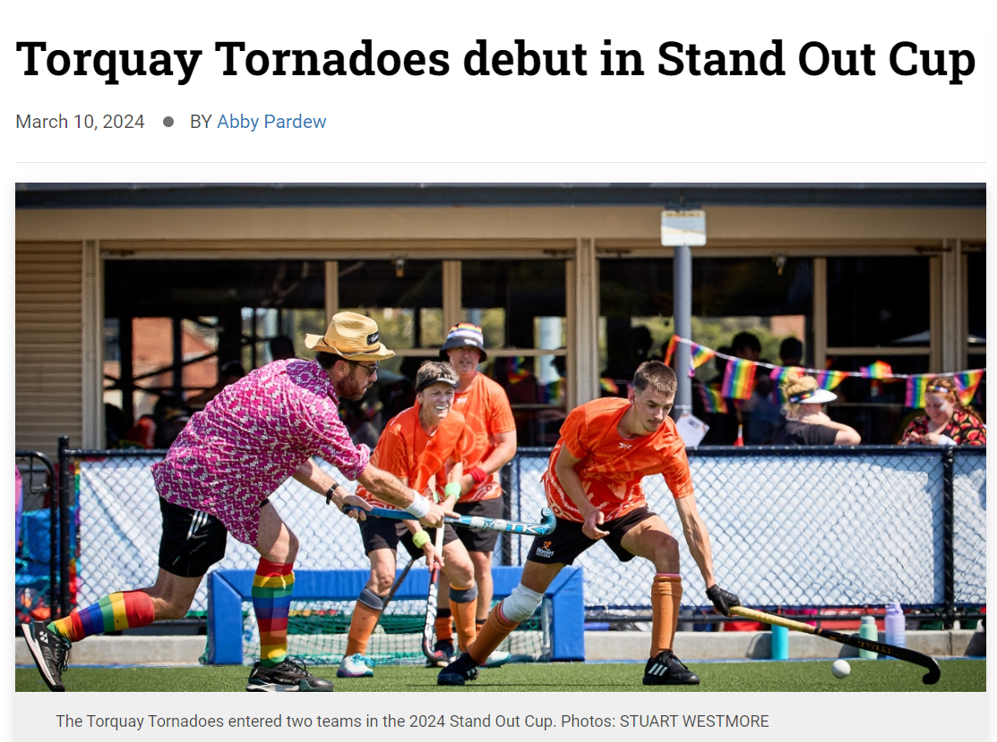

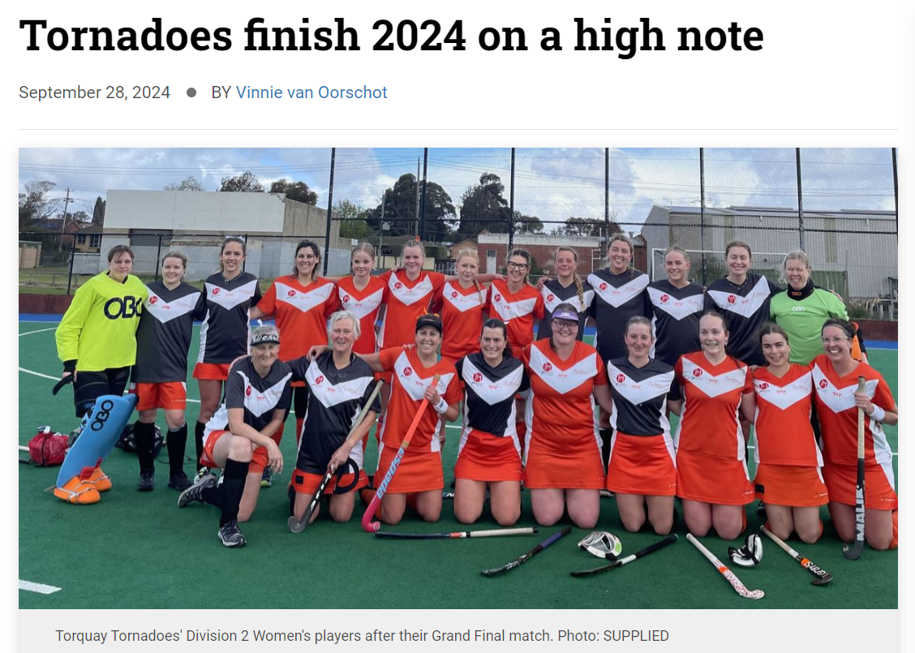

Equity and diversity
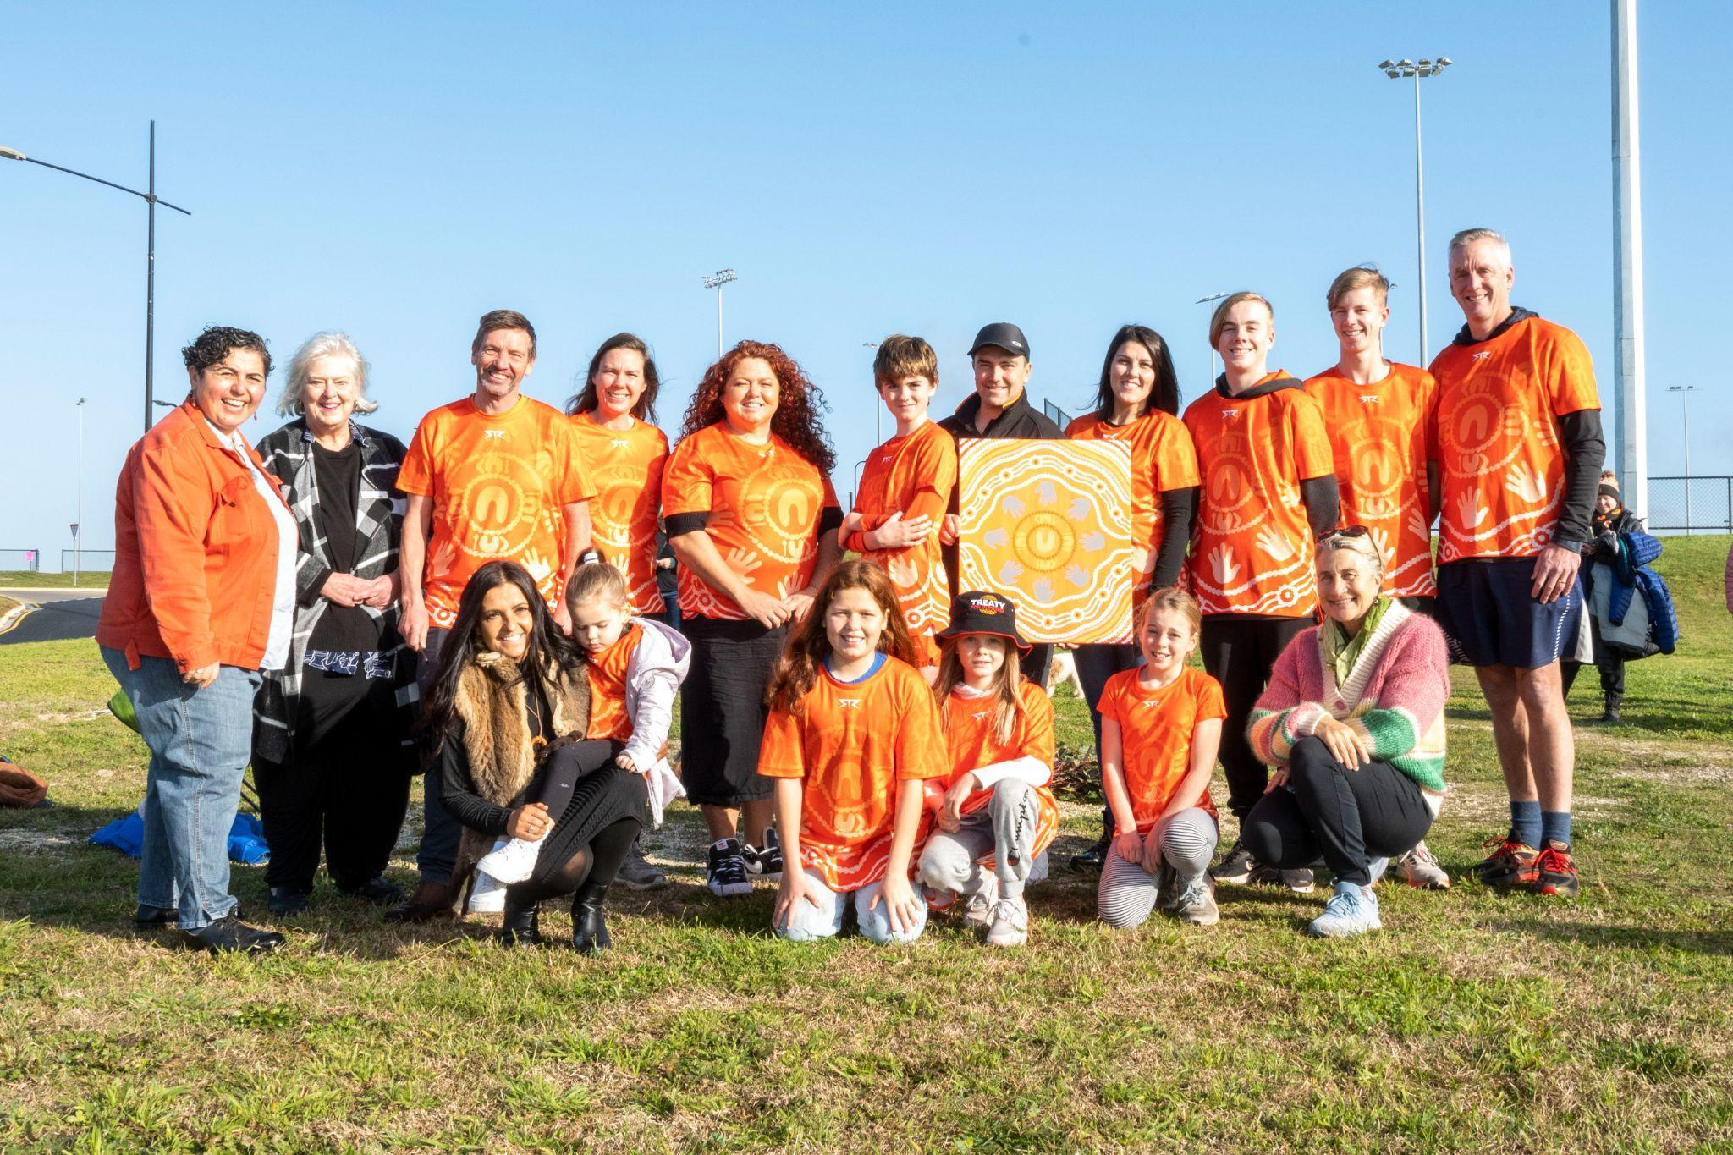
Torquay Hockey Club has a strong commitment to equity and diversity. Examples of this are:
- Equal representation on the committee with a minimum of 50% female committee members
- Female President
- Specific role on the committee for equity and diversity
- Indigenous shirt for NAIDOC week matches
- Participated in Hockey Victoria Pride Cup

How will your support be distributed
The Torquay Hockey Club considers all funds coming into our club as being integral to the running of the club and to ensure a strong future for both our players and members.

We pride ourselves on offering the most affordable membership fees available, especially for junior members. Minimizing the cost of membership makes Torquay Hockey Club a more viable option for a wider range of participants in the Surf Coast Community.
Sponsorship Packages

Major Sponsorship Package (Gold)
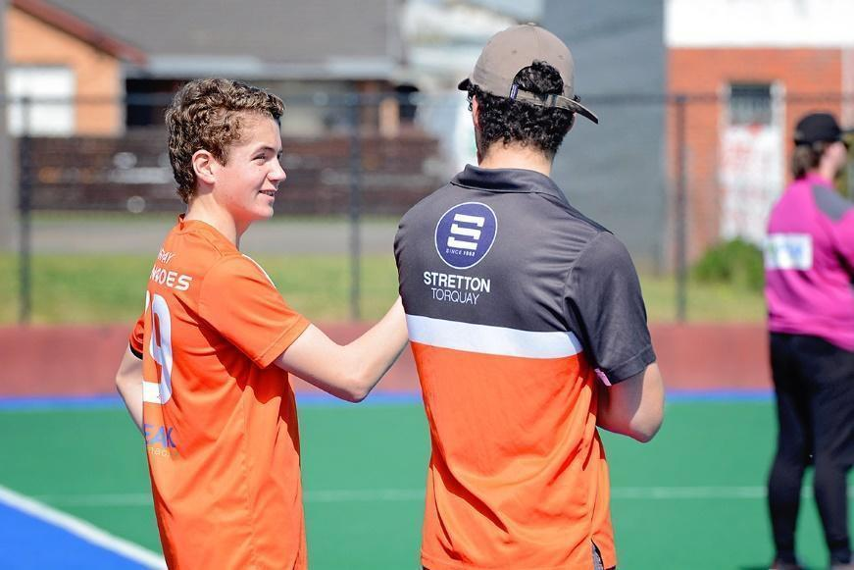
Example of Major Sponsorship

Investment $5,000 per annum, 2-year commitment

- Signage at future hockey facility
- Apparel designed with your logo
- Signage at Future Torquay Hockey Facility
- Logo featured on the Torquay Hockey Club Website
- Featured on our Torquay Tornadoes Team App
- Announcement on Stack TeamAPP to all members announcing the partnership
- News item on the website and social media announcing sponsorship
- Promotion of your company to our other sponsors encouraging to use the products

Silver Club Sponsorship
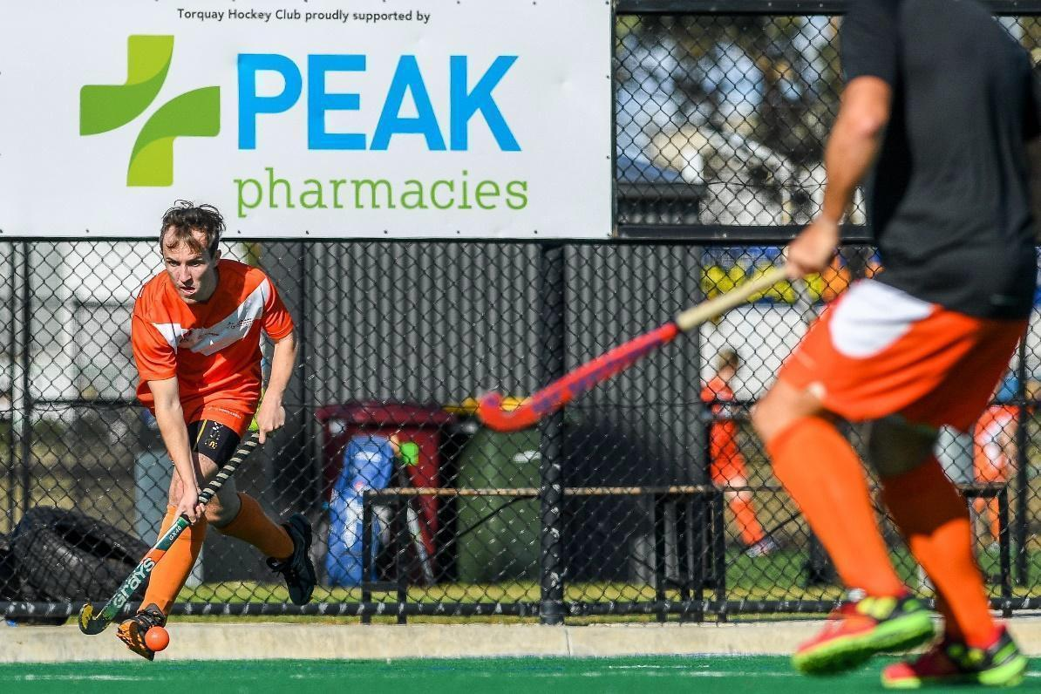
Example of Silver Sponsorship

Investment $2,000 per annum

- You can design a package that fits with your company. Examples include
  - Business partner
  - Dental partner
  - Physiotherapist partner
  - Osteopathic partner
  - Podiatry
  - Diversity and Inclusion program partner
  - Junior Development program partner
  - Senior teams program partner
- Future sign at Torquay Hockey Facility
- Logo featured on the Torquay Hockey Club Website Featured on our Torquay Tornadoes Team App
- Announcement on Stack TeamAPP to all members announcing the partnership News item on the website and social media announcing sponsorship
- Promotion of your company to our other sponsors encouraging to use the products

Bronze Club Sponsorship
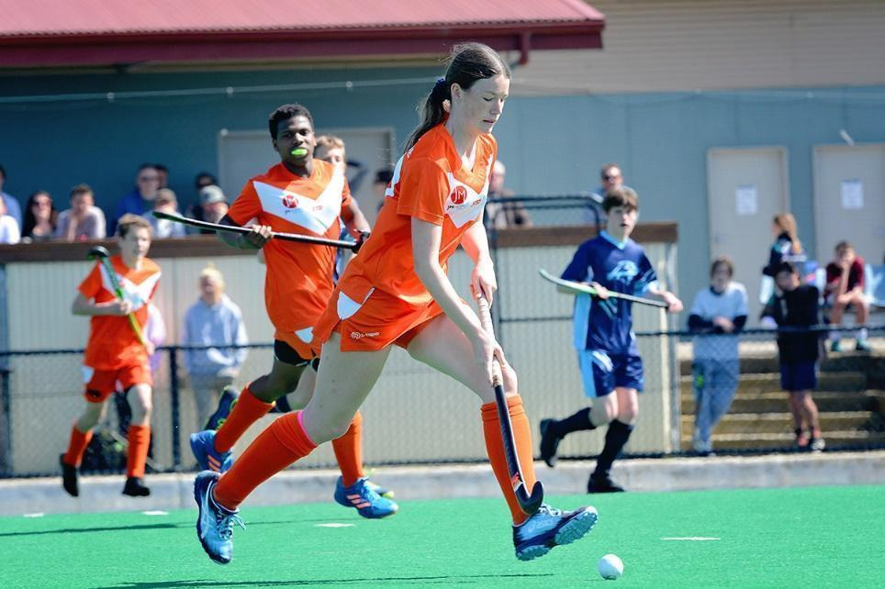
Example of Silver Sponsorship

Investment $1,000 per annum

- Small sign at future Torquay Hockey Facility
- Logo featured on the Torquay Hockey Club Website
- Featured on our Torquay Tornadoes Team App
- Announcement on Stack TeamAPP to all members announcing the partnership
- News item on the website and social media announcing sponsorship
- Promotion of your company to our other sponsors encouraging to use the products

Community Partner Club Sponsorship Game Day or Raffle
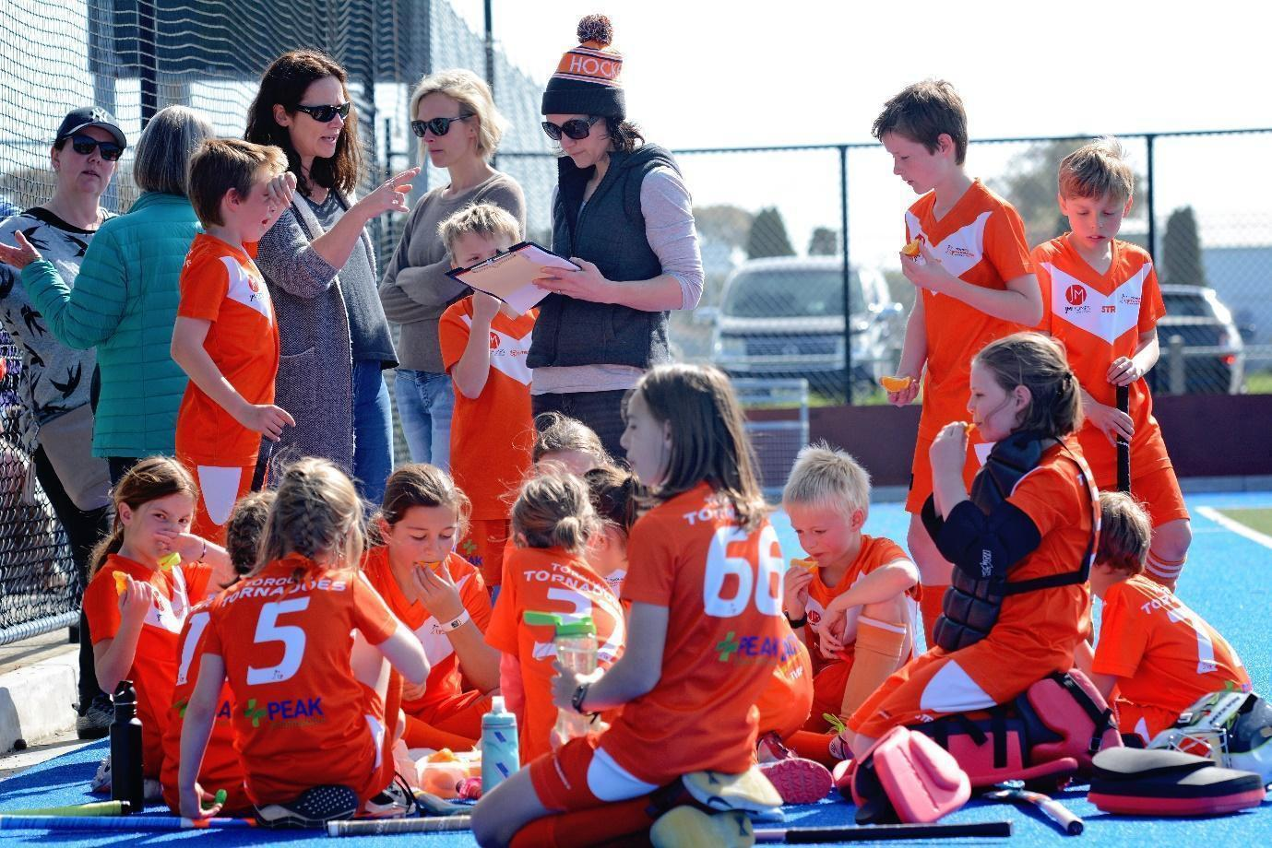
An example of support is a local community sports club

Investment $500 - cash or In Kind

Logo featured on the Torquay Hockey Club Website Featured on our Torquay Tornadoes Stack Team App
Promotion of your company to our members to encourage using your products
Design you own promotion

Contact details
For further details or the opportunity to discuss the sponsorship opportunities, please contact:

Torquay Hockey Club Andrew Crowley
andrew.crowley@torquayhockeyclub.com.au 0417 932174

