General rules:
- Stick to the proportional dimensions as presented.
- The board have three main parts:
  - Green: background
  - Blue areas
  - Yellow aras
- Note: Some images, part of it have been lined in black as it is not desired.

Yellow tiles:
- Same style as the presented rocks in the next images:
- Note: each tile style needs to be unique.

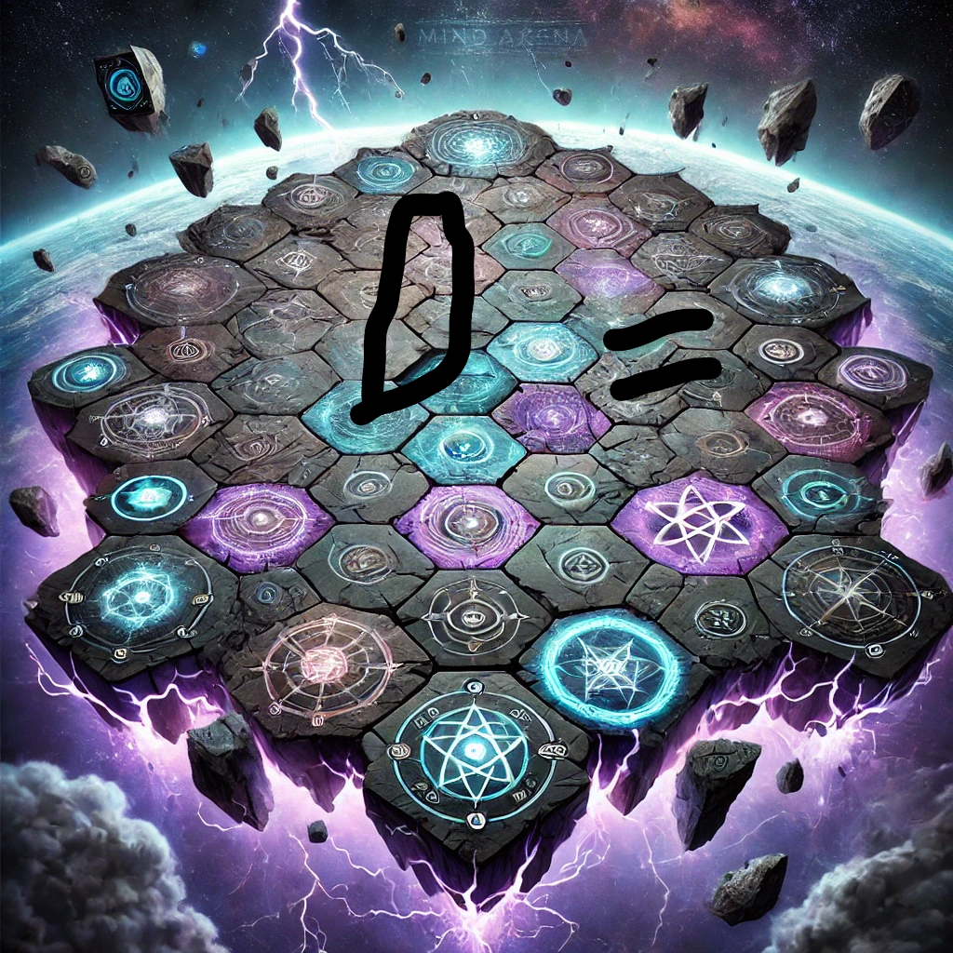
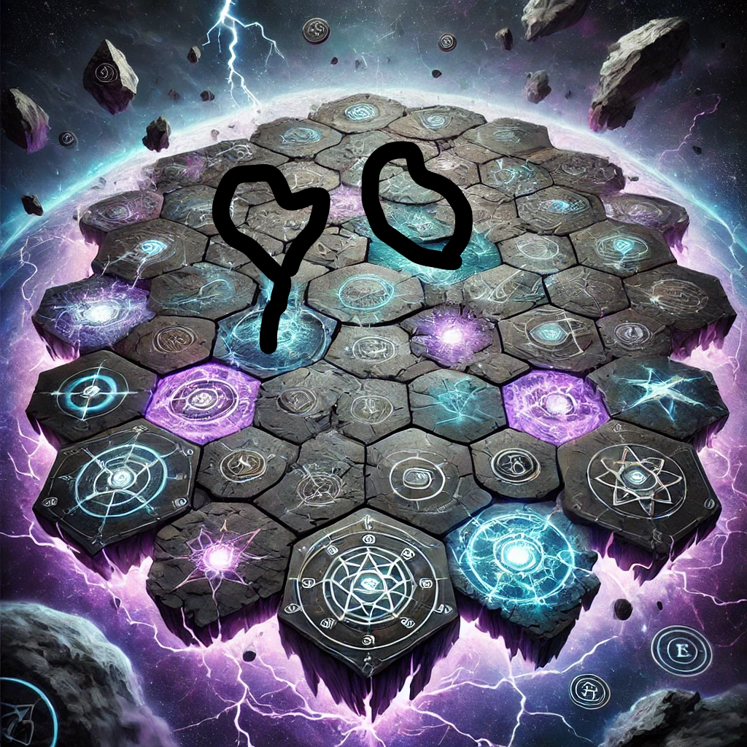

Blue tiles:
- The tiles to be the same as the presented image:

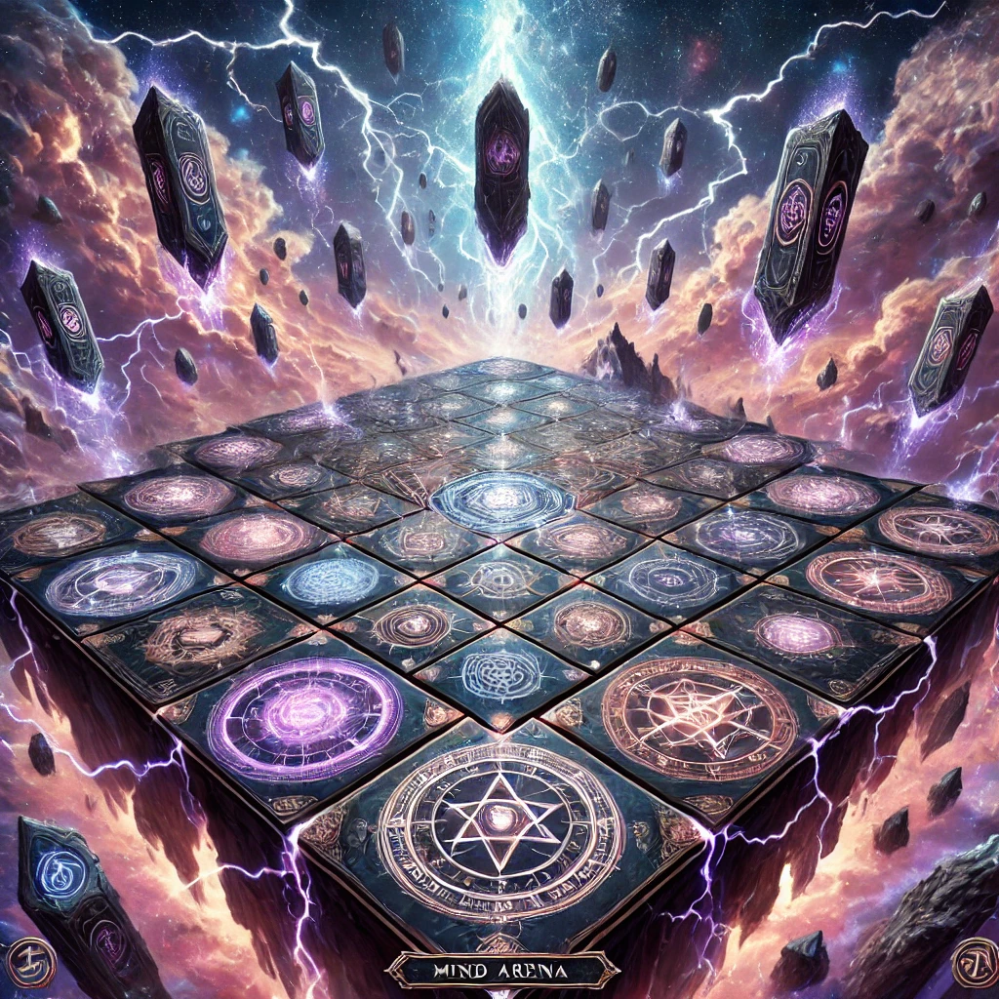

- Additional symbols that you can use (but the tile style to be the same as the previous image)
- Note: each symbol need to be unique.
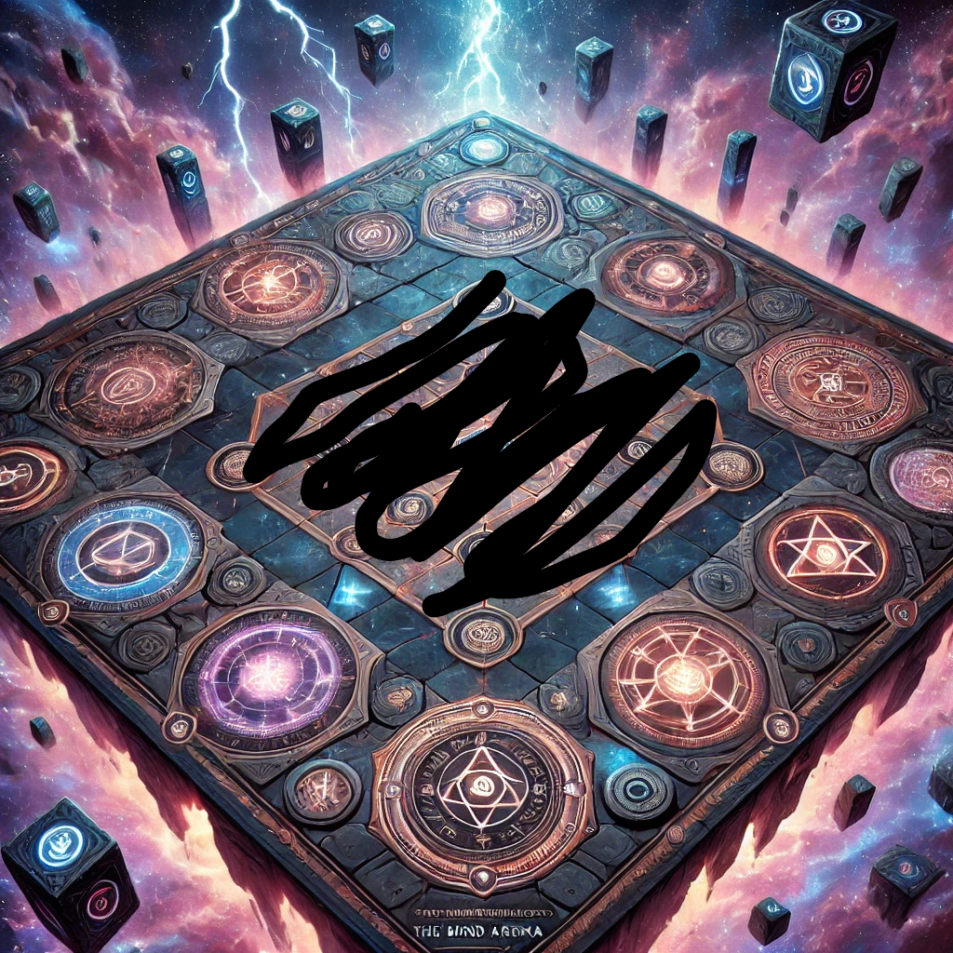
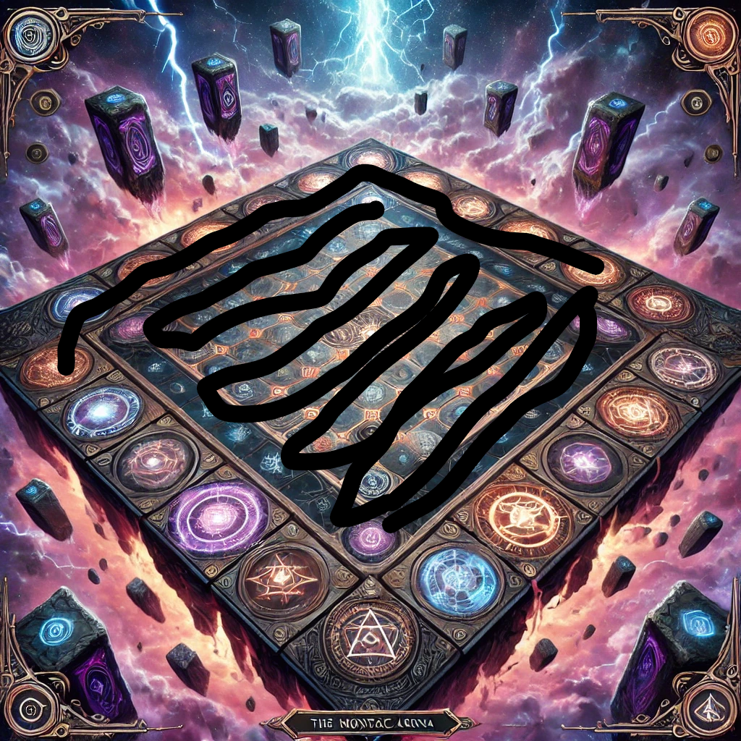

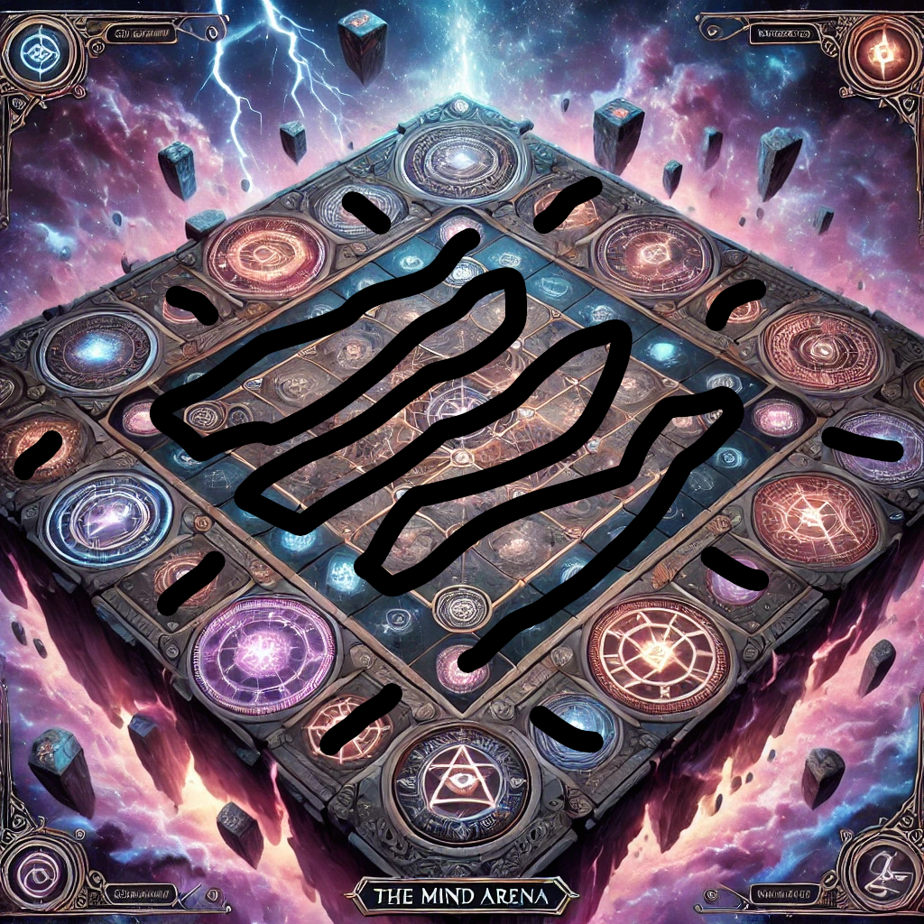

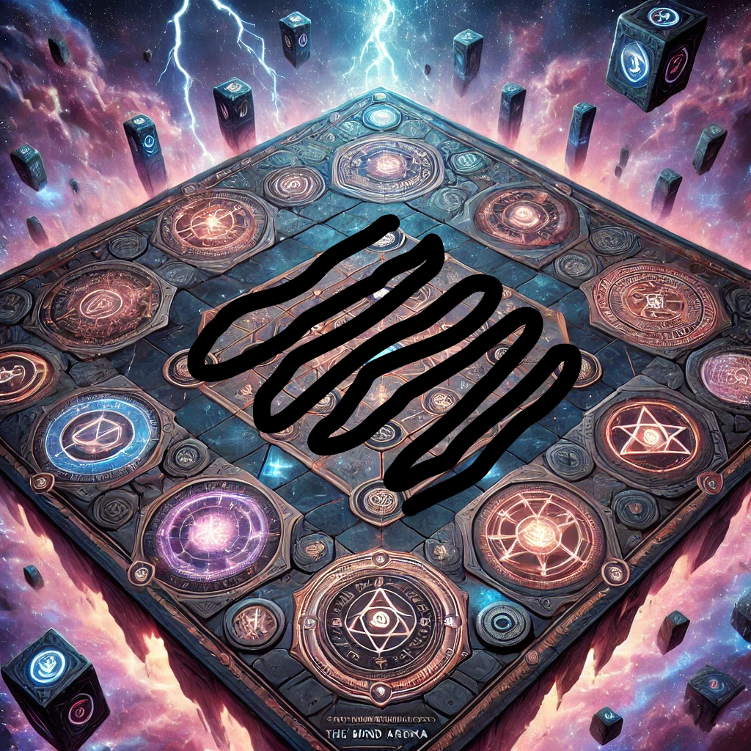

Green background:

- Use this background style

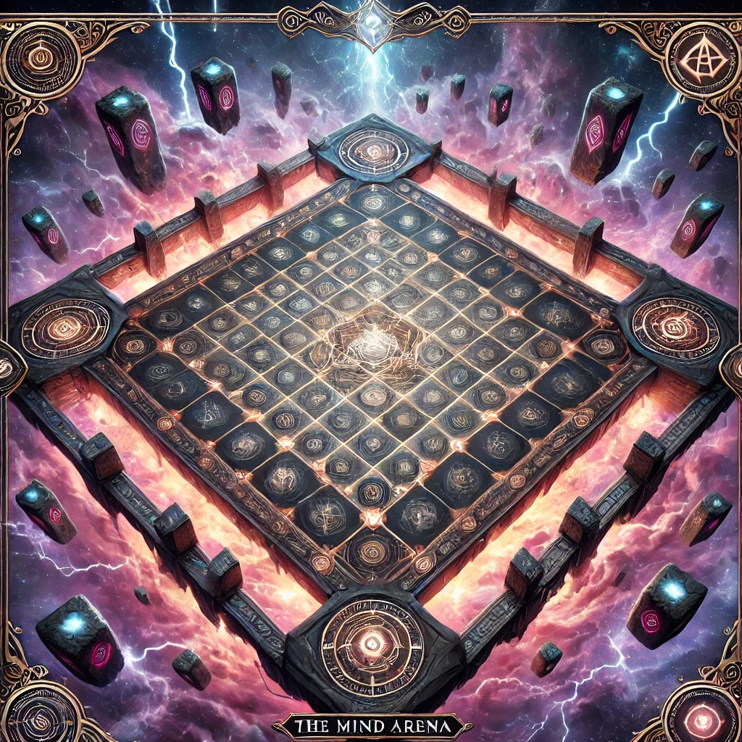

- And use all the background styles for all the images presented in the blue tiles section (not the yellow tiles section).

