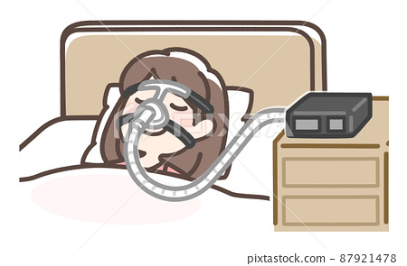

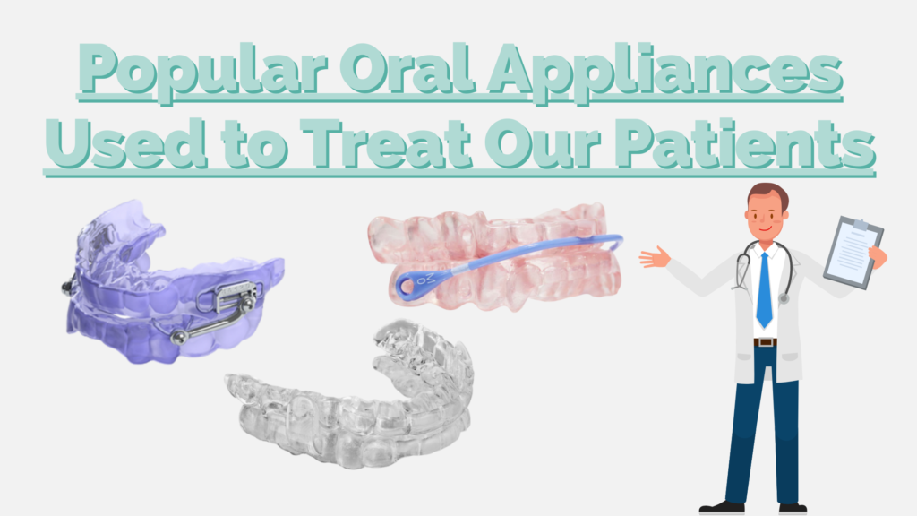
In today’s article, we will be sharing some of the most popular oral appliances prescribed to our patients. Dr. Brandon Canfield and Dr. Collin Emerick, both Diplomates of the American Board of Dental Sleep Medicine take numerous factors into consideration to ensure the right appliance is chosen for each unique patient. During a patient’s initial screening and evaluation, Dr. Canfield and Dr. Emerick work with our patients to determine the best oral appliance design for them. Continue reading below to learn why these appliances are some of our most popular appliances amongst our patients.

1) The SomnoDent® Herbst Advance® by SomnoMed®
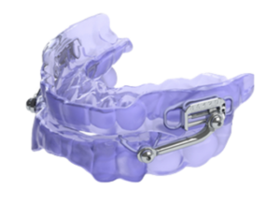A popular selection is the Herbst Advance by SomnoMed. Ohio Sleep Treatment is an authorized Medicare provider, so the Herbst Advance is one we deliver to our patients often. The Herbst Advance comes with a 3-year product warranty against manufacturing defects for Medicare patients; 2 years for Non-Medicare patients. Since it allows for more side-to-side movement, this appliance is great for patients who grind their teeth at night. Equally important is the visible indicator for easier titration. This allows our patients to adjust their appliances at home with guidance from our team of sleep professionals. The Herbst is easy to adjust, offering a comfortable fit, and helps to manage sleep apnea effectively. This device will continue to be a popular oral appliance used to treat our patients

2) The SomnoDent® Avant™ by SomnoMed®
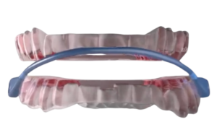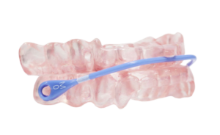The Avant by SomnoMed is a strong, sleek oral appliance designed for optimal comfort and precision. This appliance features an innovative titration system. using a tough and flexible strap. At just 2mm thin, the strap attaches to the appliance at a single point near the front two teeth. This limits the mouth opening, while still allowing a full side-to-side and forward mouth movement. The Avant is the world’s first milled dual-material oral appliance offering both comfort and precision. The soft liner enhances the consumer experience, ensuring a great night’s sleep, every night.

3) ProSomnus® EVO™
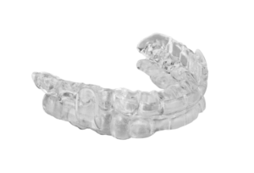Another popular oral appliance used to treat our patients is the ProSomnusEVO. Created with cutting-edge materials, robotics, and artificial intelligence the EVO leads the way in treating obstructive sleep apnea (OSA). The Robotic milling manufacturing process allows for accurate and dependable treatment for every patient. This virtually unbreakable appliance is flexible, durable, comfortable, and easy to clean. The high-performance, medical-grade class VI material also comes with a soft liner for superior comfort.

When working with our team of sleep professionals, our patients quickly learn that the success of their treatment is our top priority. Overall, delivering quality sleep to those suffering from obstructive sleep apnea is our mission. Because of companies like SomnoMed and ProSomnus., the team at Ohio Sleep Treatment can continue serving Central Ohio suffering from obstructive sleep apnea.
If you have questions, give our clinic a call at 614-396-8286 or click here to contact us online! You can also check out our Sleep Apnea Treatment blog archives for more information on oral appliance therapy, the “first-line therapy” for mild to moderate OSA patients, by the American Academy of Sleep Medicine.



Share on Facebook Share on Twitter Share on LinkedIn

Leave a Reply

Comment *

Name *

Email *

Search for:

Recent Posts
- Over the Counter Snore Guards vs Oral Appliance Therapy

