Design Brief: ITAA 2026 Annual Conference Logo
Client: International Textile and Apparel Association (ITAA)
Event: ITAA Annual Conference 2026
Location: Jacksonville, Florida
Dates: November 2026
Theme: Bold Shores, Endless Possibilities

Project Overview:
The International Textile and Apparel Association (ITAA) is seeking a talented designer to create a unique and memorable logo for our 2026 Annual Conference. The logo will be a key visual element used across print, digital, and event materials, and must reflect both the spirit of the conference theme and the identity of our organization.

Conference Theme: "Bold Shores, Endless Possibilities"
This theme captures a sense of innovation, creativity, and exploration—both in the textile and apparel industries and in the context of Jacksonville’s vibrant coastal setting. It should evoke a feeling of optimism, forward-thinking, and boundary-pushing ideas.

Design Inspiration & Style:
1920s influence: We are drawn to design aesthetics from the 1920s—Art Deco lines, stylized forms, and elegant typography. This should be used as inspiration, not replication. This was a logo Ai generated that we are drawn to:
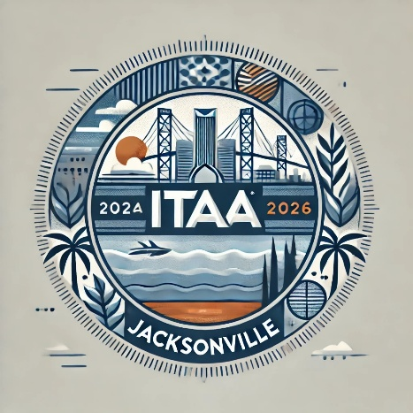
Professional, yet creative: The logo should balance scholarly professionalism with artistic flair, reflecting the academic and creative nature of our community. Must not change the official ITAA logo style, but color can be adjusted.

Geographic context: A nod to both the textile and apparel industries, as well as Jacksonville, Florida, and its coastal environment is encouraged.

Logo Usage:
The final logo will be used in:
Digital and print promotional materials (e.g., flyers, programs, email marketing)
Website and social media platforms
Onsite signage and event merchandise (e.g., tote bags, badges, lanyards)

Deliverables:
Primary logo (full color)
Black and white and/or single-color versions
Vector files (.AI, .EPS) and web-optimized formats (.PNG, .JPG, .SVG)
Font and color specifications

