Thankyou for looking at my psychology business project.
- I am currently running 3 design contests (2 x logos + 1 x info graphic)
- Please look at all 3 currently listed projects
- I have several other infographic/poster projects to complete this month, and will post these jobs after the first 3 contests are complete

About the project
The purpose of the project is to promote a new theory of psychology which I have developed, called “Relational-Experiential Theory”. This theory is not yet in the public domain, and I will be introducing it at a psychology conference in July this year.
The theory suggests that the intersection of experiences and relationships is a fundamental determinant of psychological growth and regression across the life span. It emphasises the importance of healthy connected relationships and having enjoyable and fun experiences. In a nutshell, it says that we thrive when we share positive experiences with other people, and we suffer when we have poor relationships and negative experiences. The model emphasises the interplay of 5 key factors: relationships, experiences, mental state, embodiment, and growth.
Below is a graphic representation of the model/theory…
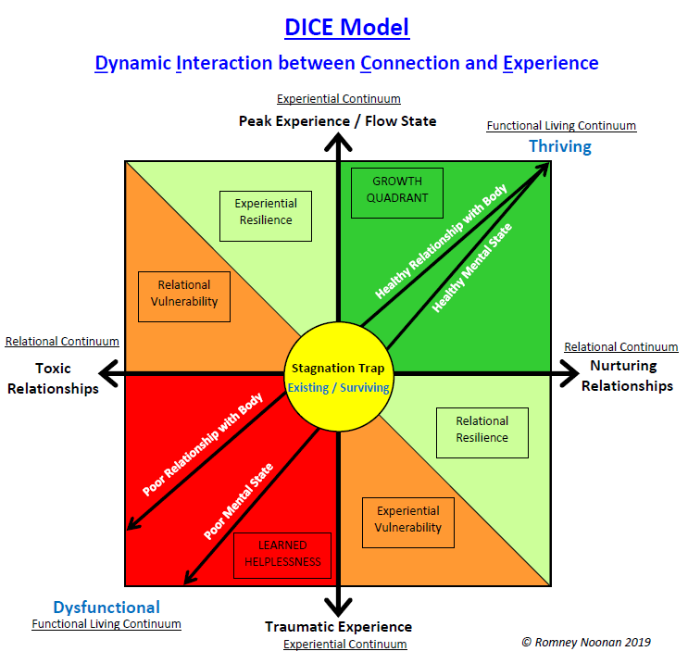

This is a mock-up of the consumer version of the model
(one of my current design contests is to redraw this )
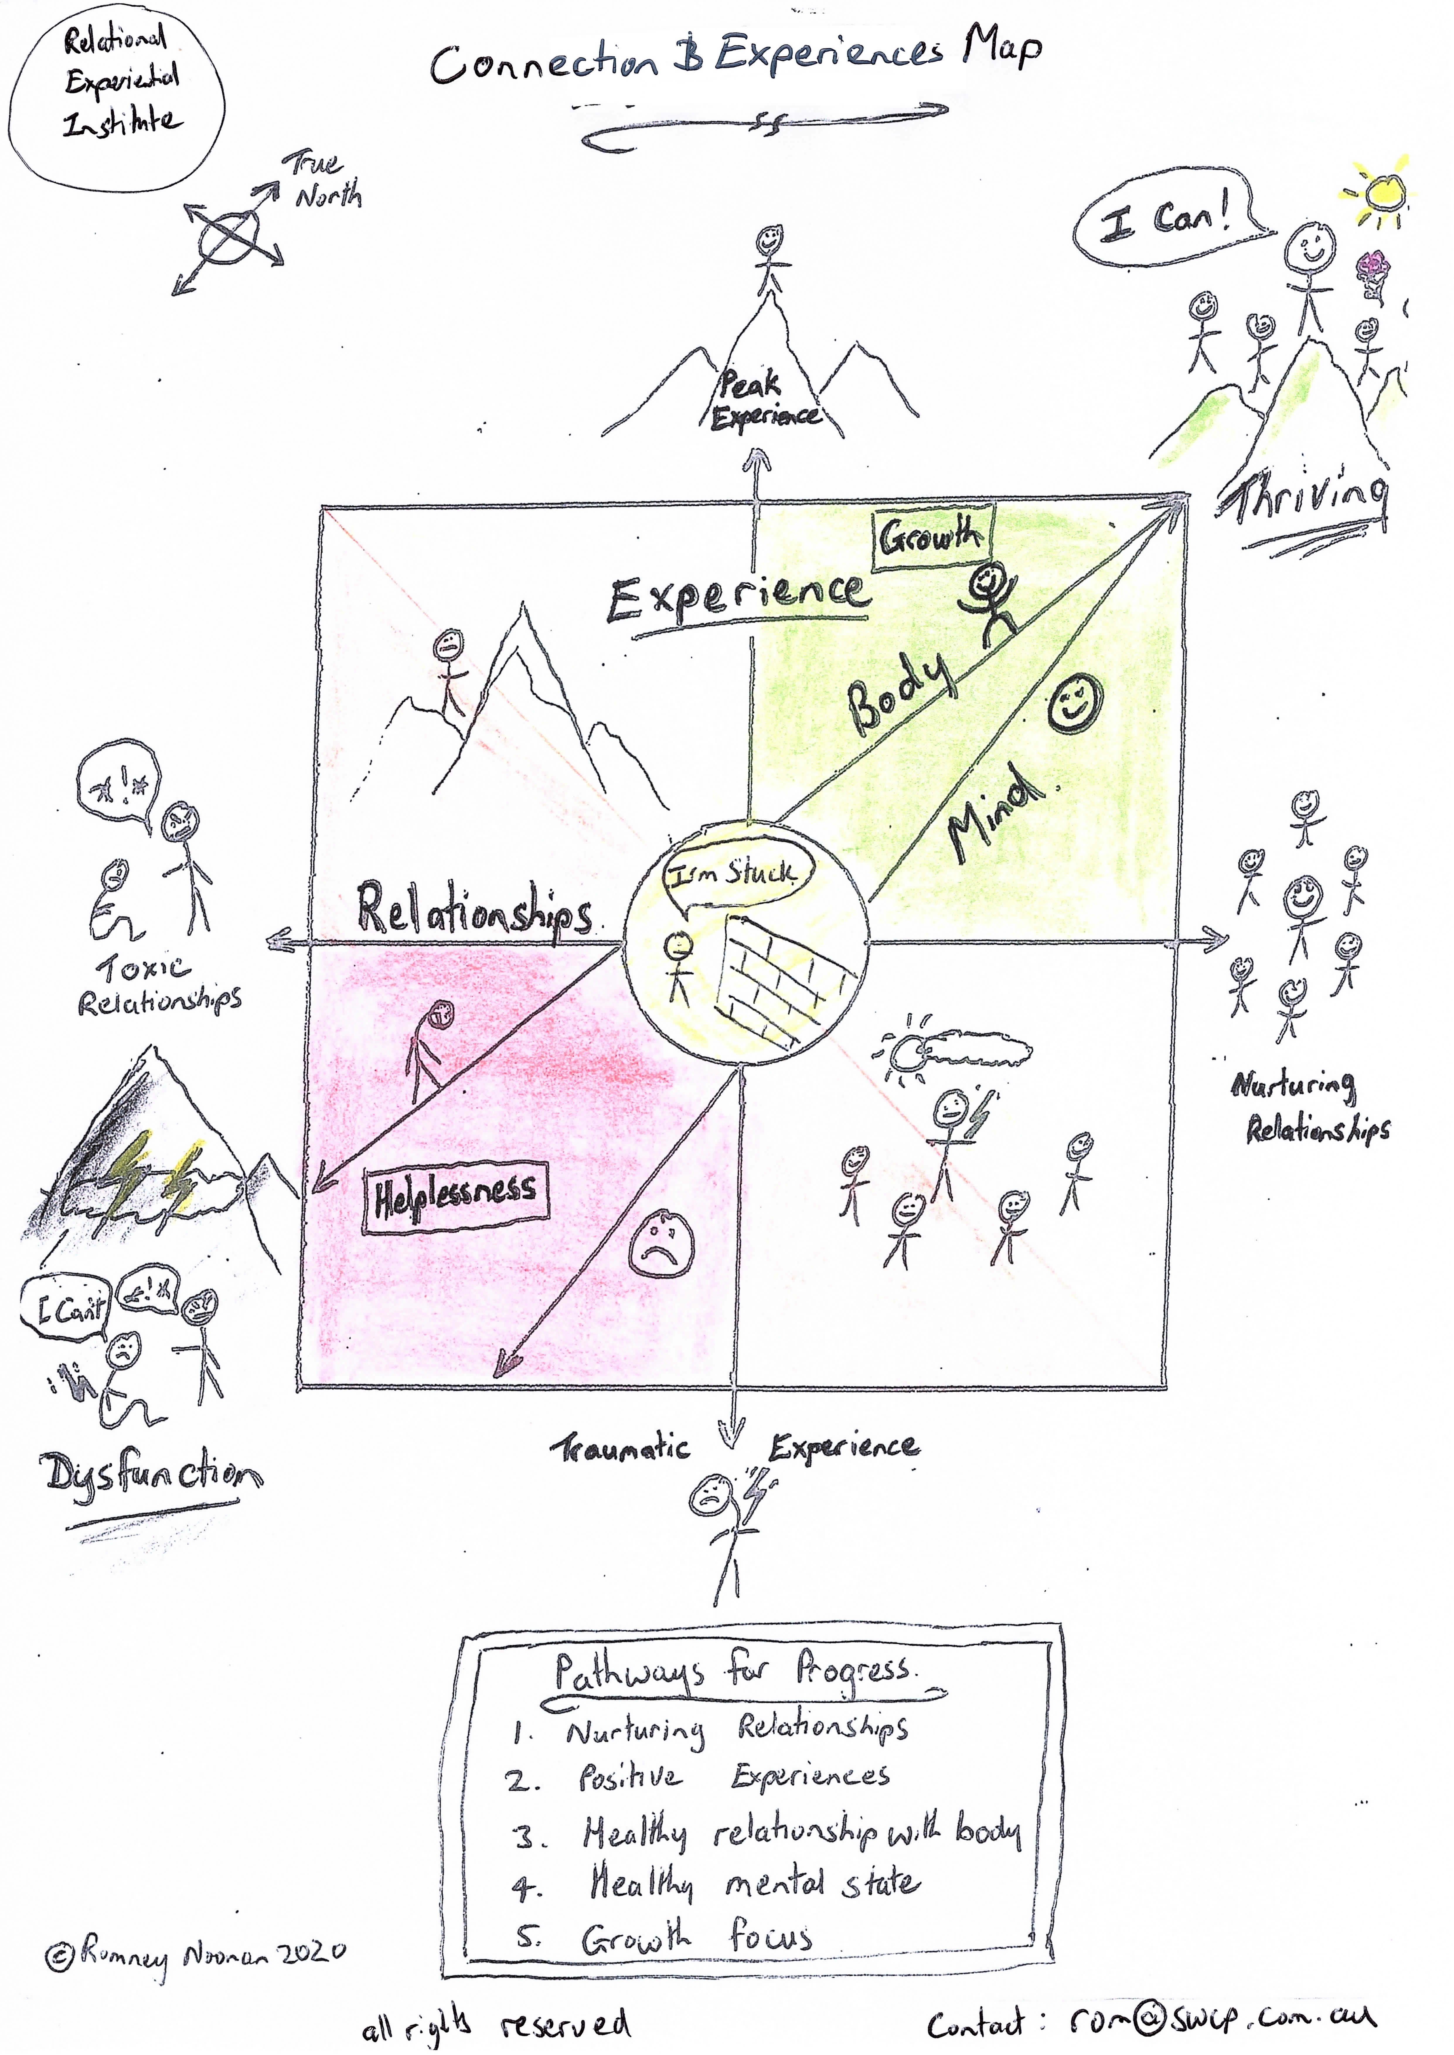

Logo #1 : Relational Experiential Institute
The first logo that I need is for the academic branch of the project.
Some notes:
- The logo must have the words ”Relational Experiential Institute”
- Style is leaning into academic/formal but this is somewhat flexible
- Colour scheme is flexible. I tend to choose blue colour schemes (see my other logos at end of this document)
- The key themes are connection/relationships, positive experience, and personal growth
- I would prefer an image-based design (not just text)
- I understand that the name is quite long to fit into a design (sorry)

Some mock-up suggestions (these are just a guide and I am very open to better ideas)
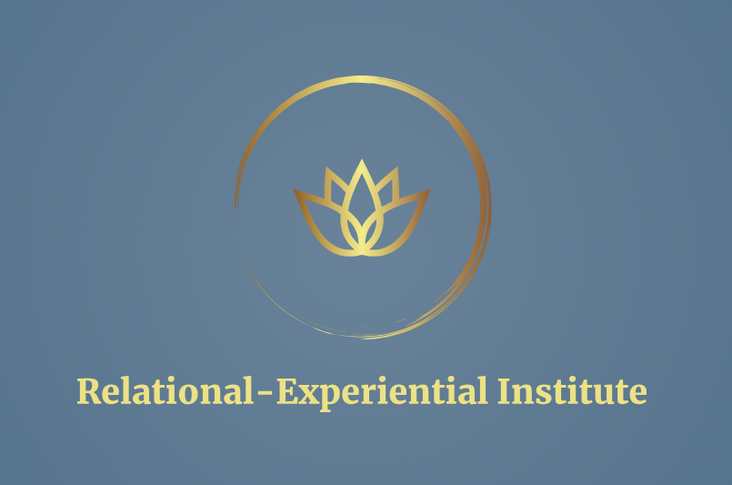 | 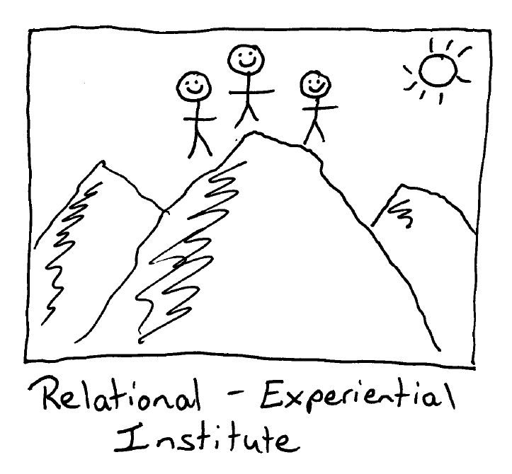
 | 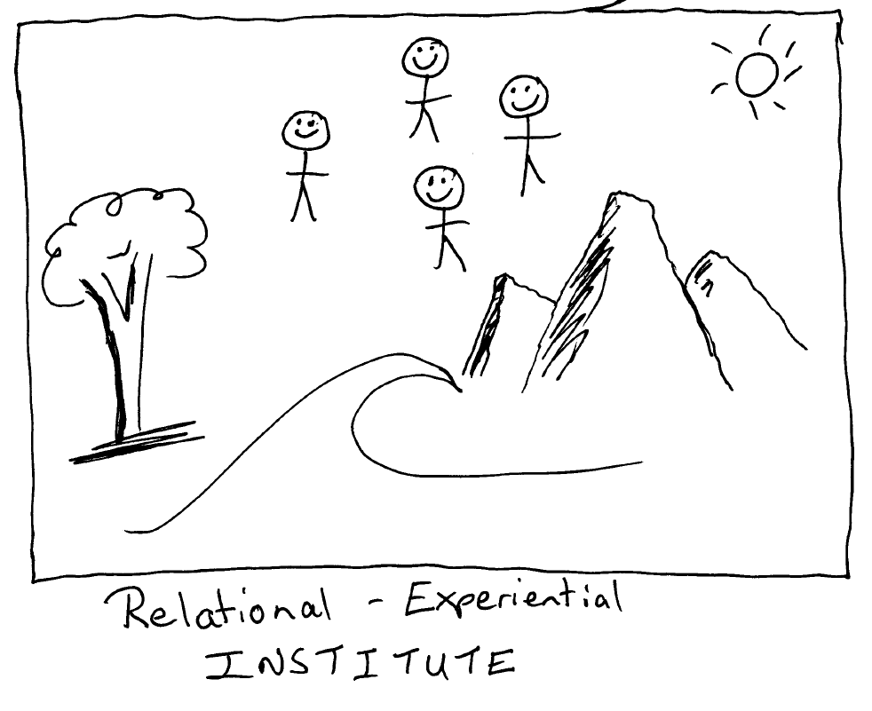

Logo #2 : Growth Quadrant
The second logo that I need is for the commercial branch of the project which will run personal development courses. teaching positive psychology skills to help people live happier, more balanced, and more fulfilling lives. The name “The Growth Quadrant” comes from the part of Model that represents when people are thriving in life, growing as a person, and learning new things. I think a bolder style of logo would most likely work best for this part.
Notes:
- The logo must have the words ”Growth Quadrant”
- A bold and informal style is likely to work well
Below are some design mock ups that I would be happy with
 | 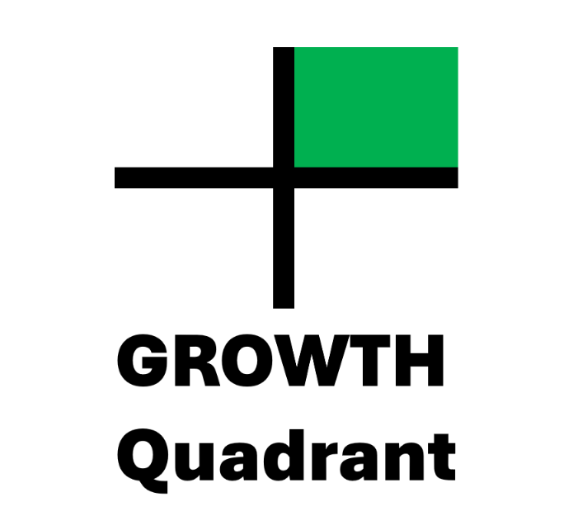

Here are some of my other business logos for reference:
 | 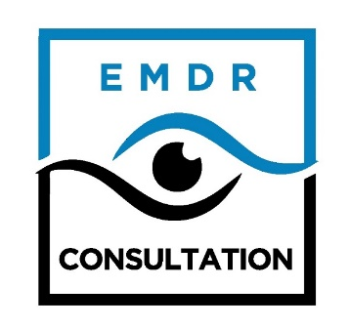
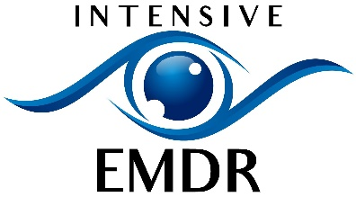

Thank you for your time looking at my project!
Cheers, Rom.

Romney Noonan
Email: rom@swcp.com.au
Ph +61 407985671

