Please prepare two rollups according to the attachment when it comes to the dimensions file name "Szablon_Roll-up-85_druk24h.pl_ (1)"
Design guidelines:
Format: 85 cm wide × 200 cm high
Template: Compatible with the file "Szablon_Roll-up-85_druk24h.pl_ (1)"
Mandatory elements:
- Company logo (from the "salloytech_logo_official.zip" file)
- Adres strony: www.salloytech.com
- Photo of the plane
- Colors in line with your corporate identity

Colors
Based on the Salloytech website, the dominant colors are:
- Navy blue (background and accents)
- White (text and negative spaces)
- Orange (accents and highlights)
For consistency with visual identification, it is recommended to use these colors in the design.​

Format
Top (Header)
- Salloytech logo placed centrally or in the upper left corner.
- A photo of an airplane in the background, symbolizing the aviation industry.​
Middle part (content)
Content where rollup 1 and 2 are written separately,

Bottom part (foot)
Website Address: www.salloytech.com

Additionally:
To place the AS9100 logo

Content for the first rollup

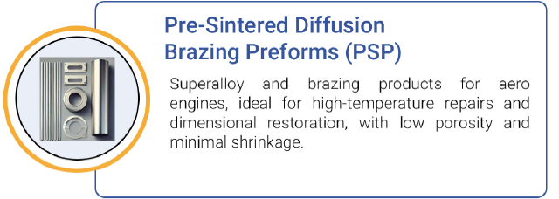
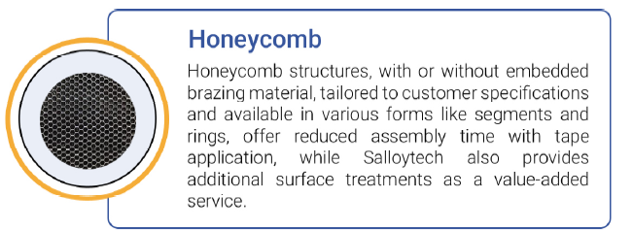

Content for the second rollup

