Ad 1
- Copy – move ‘the’ down to the second line
Ad 2
- I like the darker blue/green bottom color
- I like the background image better than the white
- I’d like versions with the darker blue green with both the Evoke background (which you are currently using), and the KE Soul Walnut image in the background.
  - I like the opacity you have on AD_2ND_AD-2560-V3
  - I don’t like the drop shadow beneath the sample image on the bottom on AD_2ND-AD-2560-V1
  - I like the order a free sample CTA in AD_2ND-AD-2560-V1 because it is not overlaying on the wood.

AD 3
- The only think I’d change is the Class a sticker/icon.
- Try white with a white circle, and a clear background in the bottom left for the Evoke image.
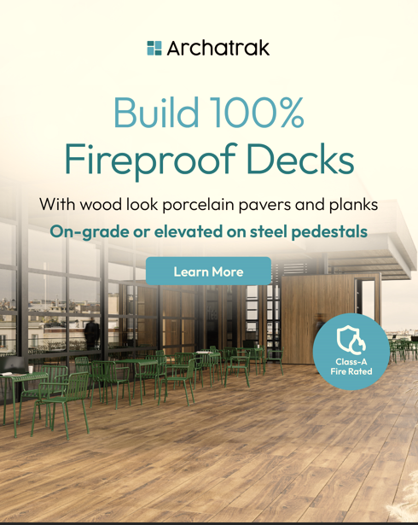
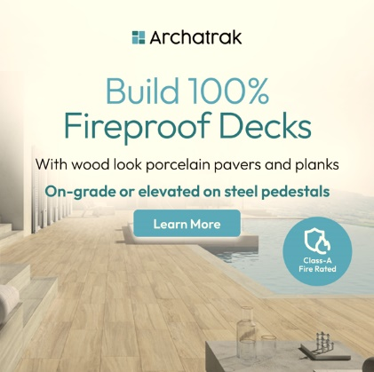
- Try black with a black circle, and a clear background in the bottom left for the pool image .

