Ad set 1 is good to go

Ad set 2
In the 1440 x 1440 you can keep the copy all on one line.
In the other versions, will you make sure all versions have ‘the’ starting on the second line? Some have it on the first line.
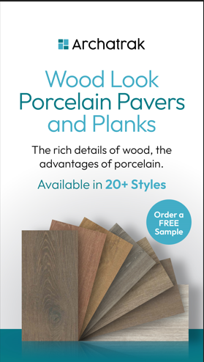
I like the way the images look in the background. Can you nudge the opacity up just a little. Especially in the Soul Walnut version. I know this is not exact feedback, sorry, just want a little more detail. Maybe 5-10% is enough.
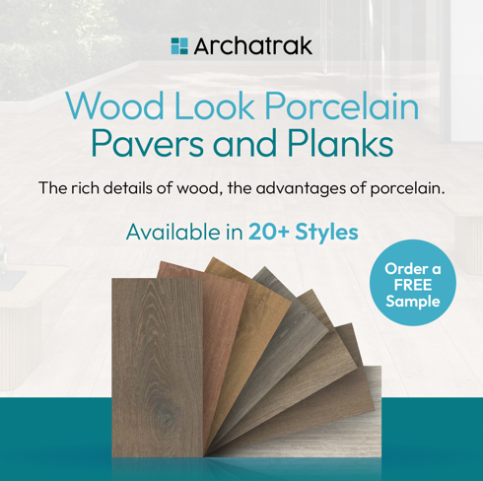

Ad 3
Sorry, I didn’t give good direction here. I’d like to make the Class-A Fire Rated logo more subtle.

Please move to bottom left on all pieces.
I’d like single color with clear background for the Class-A Fire Rated logo
Class A Fire Rated could be stack like you have it, or one line like example below.
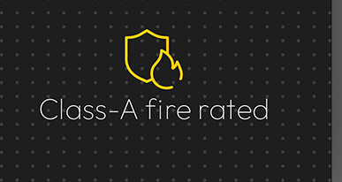
I think white logo in the bottom left would work best for this version. Capital letters for Fire Rated like you have it is better.
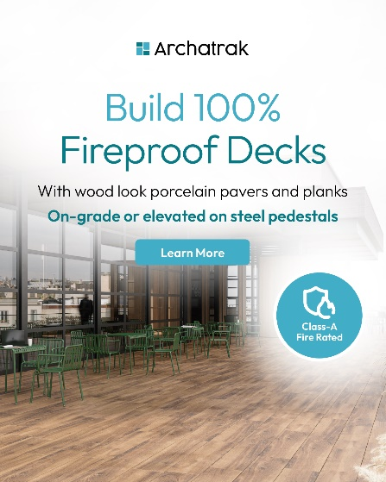

One color clear background in bottom left for this one. Color of your choice or what works best. Maybe black ro the dark green/blue. Clear background.
