Ad 1
A.
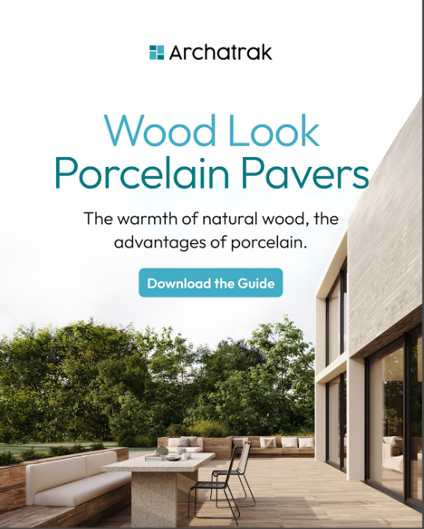
- (above) Nudge the image up to see more of the wood look pavers in the foreground
B
Same general concept but using the KE Evoke image.3 sizes.
- This version will be geared more towards our commercial customers.
C
- 3 size versions like this as well?
  - Delete the arrow
- 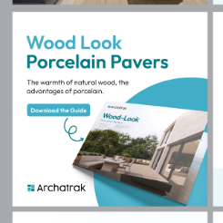
C

Ad 2
- The rich details copy – have ‘the advantages of porcelain’ on the second line.
- Change CTA to ‘Order a Free Sample’
- Try a version with the darker color as the bottom color. I like the reflection.
- I’d like to see a version with the KE - Soul Walnut photo in the background, with the opacity turned down. The white is clean, but just a little boring.
Ad 3
A
- Add the copy ‘with wood look porcelain pavers and planks’ beneath Fireproof Decks
- Will need to separate the above copy with the On-grade copy in some manner.
B
- Design a version of this ad with the KE Evoke image also. (in the image brief)
- Add the copy ‘with wood look porcelain pavers and planks’ beneath Fireproof Decks
- Will need to separate the above copy with the On-grade copy in some manner.

