Here are my inspirational logos that I really, really really love, however, whether or not they are being used, they have been created for a client. That being said, obviously I can’t use it but use as a guide
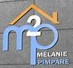


I created these but oviouly I can’t use because it could be a copyright but was just messing around




This logo is too basic for me but I do like the color combo


I also think this one is too basic but I like (but not love)
the attributes of the M.

