EstroGlow™ – A Natural Solution to Relieve the Symptoms of Menopause and Post-Menopause

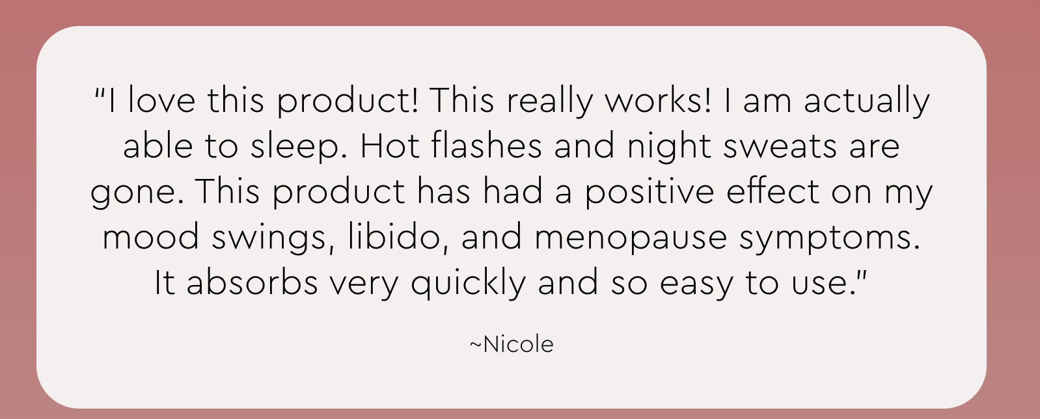

Feel Like Yourself Again—Naturally.

Is Hormonal Imbalance Disrupting Your Life?
If you're experiencing hot flashes, night sweats, mood swings, or vaginal dryness, you’re not alone. Hormonal shifts caused by menopause, post-menopause, or hysterectomy can leave you feeling out of sync with your body. Many women struggle to find a gentle, effective solution that provides real relief—without unwanted side effects.
That’s why we created EstroGlow™, a bioidentical estrogen cream designed to restore balance and comfort naturally.

Why Choose EstroGlow™?
Made with bioidentical Micronized Estriol and Estradiol USP, EstroGlow™ helps ease menopause-related discomforts and promotes overall hormonal well-being. EstrowGlow:
- Supports relief from menopausal/post-menopausal symptoms – Helps reduce hot flashes, night sweats, and vaginal dryness
- Promotes mood stability & mental clarity – Feel calmer, more focused, and emotionally balanced
- Nourishes & hydrates the skin – Infused with Aloe Vera, Olive Oil, Coconut Oil, and Shea Butter for soothing moisture
- Easy-to-Use, Fast-Absorbing Formula – Lightweight, non-greasy, and fragrance-free

Real Women, Real Results

Photo testimonials (UGC PICS)
<Insert photos and videos of women holding the bottle througout the page>

https://www.dropbox.com/scl/fo/6dl0a43rim346bvm7lpc4/AFNCXAqseoGSBDM1rVjmPNM?rlkey=o7q4xfssy6x2ivxb479dih6cp&st=brm9kinp&dl=0

How EstroGlow™ Works
Bioidentical estrogen therapy is one of the most effective ways to support hormone balance in women experiencing menopause, post-menopause, or hysterectomy-related symptoms. Unlike synthetic alternatives, bioidentical estriol and estradiol mimic the natural hormones your body produces, allowing for smoother absorption and fewer side effects.

Powerful Ingredients for Lasting Relief:
- Micronized Estriol & Estradiol USP – Naturally supports hormone balance and alleviates menopausal discomfort
- Aloe Vera, Olive Oil, Coconut Oil & Shea Butter – Deeply hydrates and nourishes the skin
- MSM & Herbal-Active® (Natural Preservative) – Supports skin health and optimal absorption

Menopause Support Bundle: Your Complete Relief from Menopausal/Post-Menopausal Symptoms

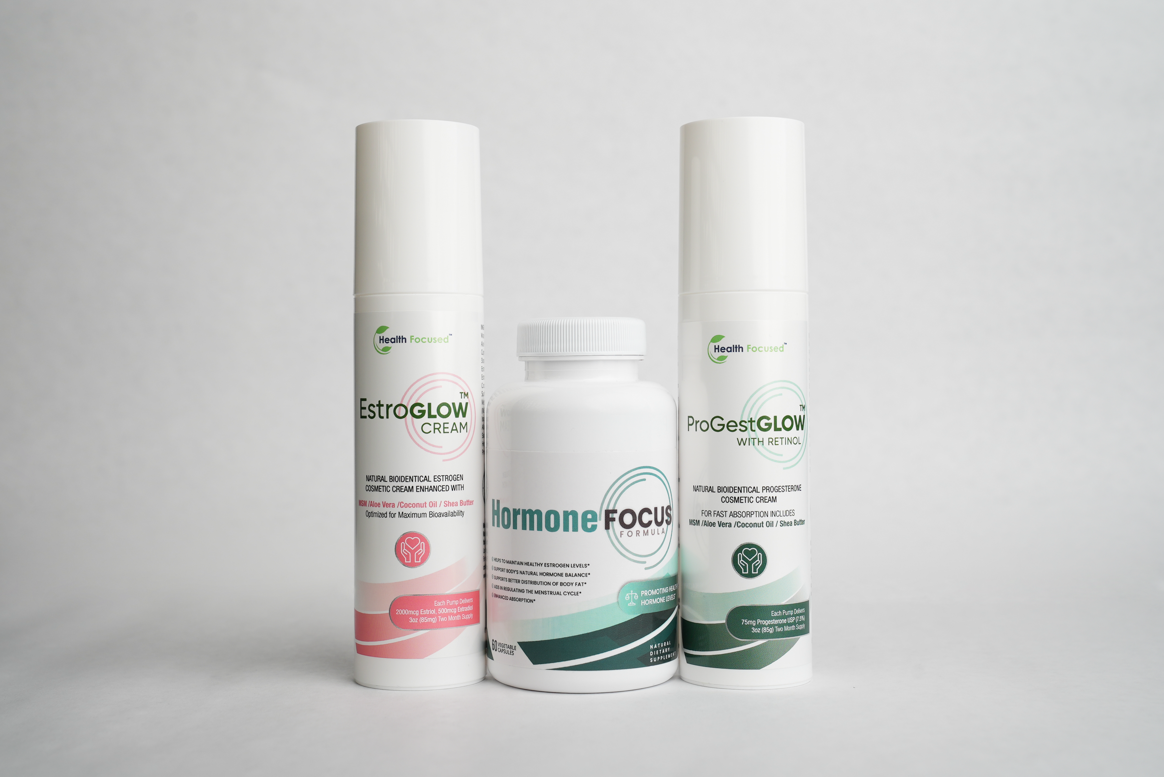

Say Goodbye to Menopause Disruptions—Naturally
- Hot flashes, night sweats, mood swings, and stubborn weight gain—menopause can feel like an uphill battle. But what if you could take control of your hormones and restore balance naturally?
- Introducing the Menopause Support Bundle, a powerful trio designed to help you navigate menopause with ease. This bundle includes:
  - Hormone Focus – Supports estrogen metabolism for hormonal balance and overall well-being.
  - EstroGlow – A natural approach to estrogen support to ease menopausal discomforts.
  - ProGestGlow – A bioidentical progesterone cream to promote calm, restful sleep and hormone balance

Why Choose the Menopause Support Bundle?
- Comprehensive Hormonal Balance – Targets estrogen, progesterone, and overall endocrine health.
- Mood & Energy Support – Feel calmer, more focused, and energized throughout the day.
- Restorative Sleep & Skin Health – Wake up refreshed and support skin elasticity naturally.
- Science-Backed Ingredients – Harnessing nature’s best for real, noticeable relief.

Reclaim Your Confidence & Comfort
You don’t have to suffer through menopause—take charge of your body today.
Shop the Menopause Support Bundle Now
Save $15 When You Bundle!
Hormone Focus™ + EstroGlow™ + ProGestGlow Bundle – $134.00 Now Only $119!
Get the Menopause Support Bundle & Save! <BUY NOW>

Our Customers are Loving Their Results
<ADD UGC Videos and Pics>
https://www.dropbox.com/scl/fo/6dl0a43rim346bvm7lpc4/AFNCXAqseoGSBDM1rVjmPNM?rlkey=o7q4xfssy6x2ivxb479dih6cp&st=brm9kinp&dl=0

Which Hormone Products Are Right For You?
Not sure which product is right for you? Use this guide to find your perfect hormone support solution!
<Insert table: Discover Which Products Are Right For You>
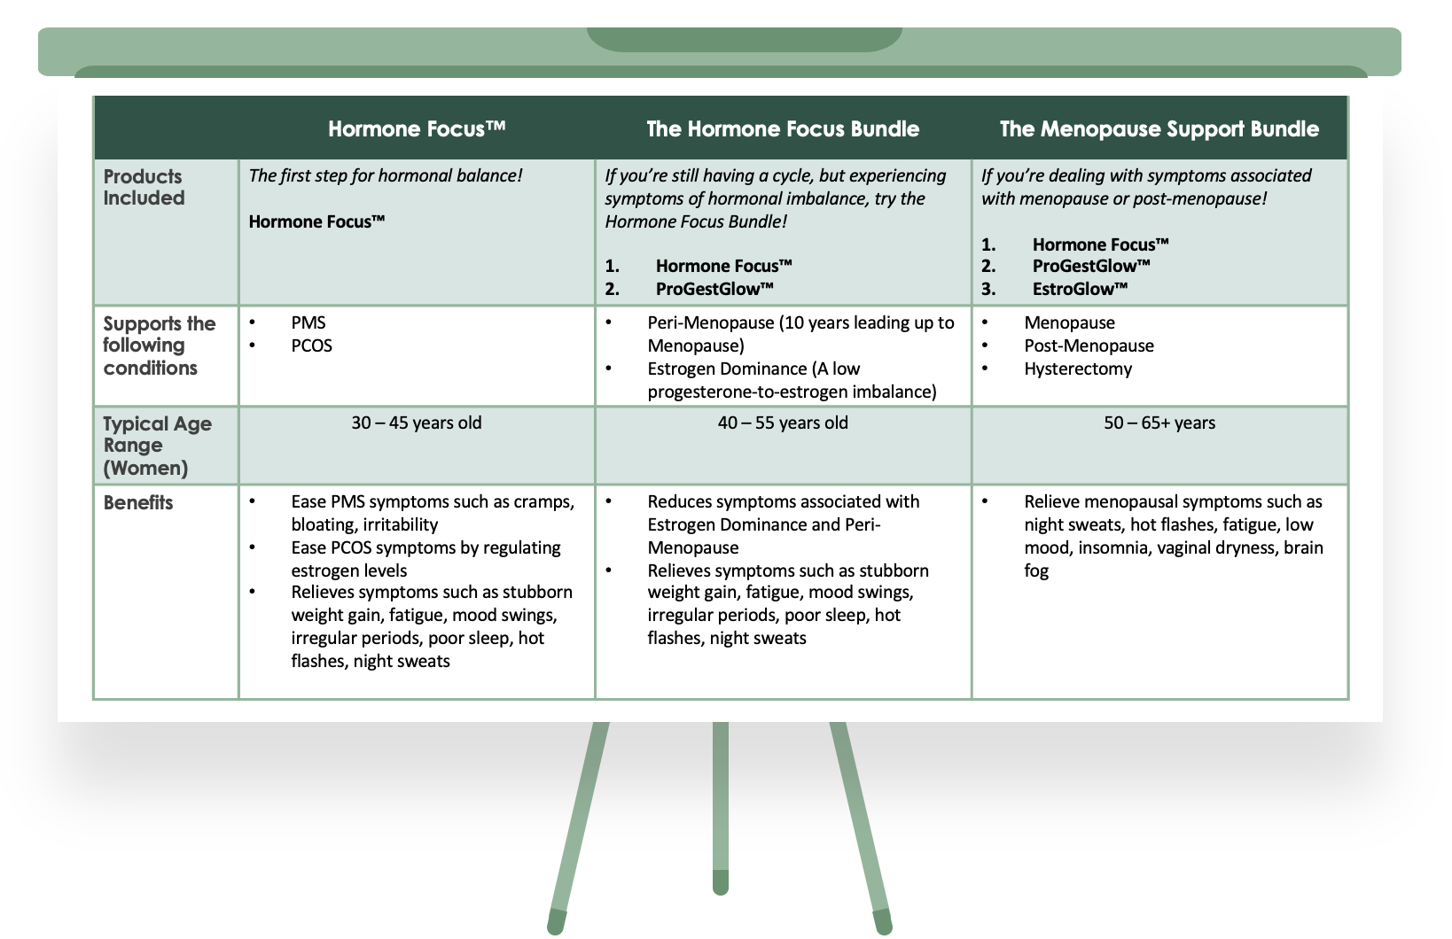

Don’t settle for feeling ‘off.’ Find real relief with EstroGlow™—the gentle, effective alternative to oral estrogen. Try it today!

<FAQ: Insert FAQs from other WORD DOCUMENT ATTACHED>

Still Unsure if EstroGlow™ is Right for You?
Wondering if EstroGlow™ is the right choice for your hormone health? Not sure if a topical estrogen cream can truly make a difference?
You’re not alone—many women have the same questions before trying EstroGlow™, and they’re so glad they did.
- Backed by Science – Topical estrogen therapy has been clinically shown to effectively relieve menopausal symptoms while avoiding the risks of oral hormone therapy.
- Trusted by Women Like You – Thousands of women have experienced smoother transitions, better energy, and renewed confidence with consistent use.
- A Formula You Can Trust – Made with bioidentical estriol and estradiol, plus nourishing botanicals and skin-loving ingredients.
Your body deserves gentle, effective hormone support.
<FAQ: Insert FAQs from other WORD DOCUMENT ATTACHED>

<Insert photos of women holding the bottle>

CUSTOMER REVIEWS
LEAVE SPACE for OKENDA Reviews to be added


