ProGestGlow™ – A Natural Solution to Ease the Symptoms of Hormonal Imbalances

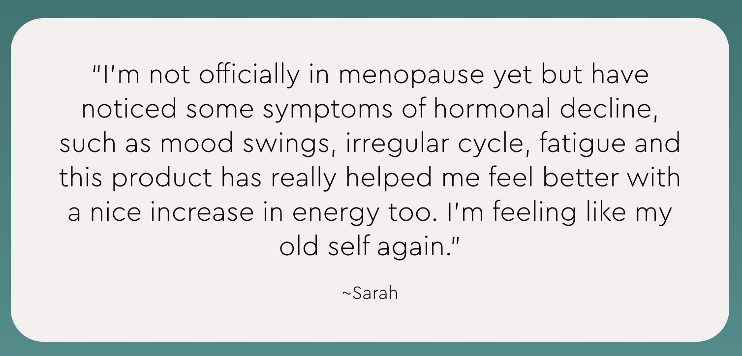

Your Body Deserves Harmony—Support It Naturally
If you’re struggling with irregular cycles, mood swings, stubborn weight gain, sleep disturbances, or perimenopausal symptoms, your body may be low on progesterone—the hormone that keeps estrogen in check and promotes hormonal balance.
While many women turn to synthetic solutions, bioidentical topical progesterone offers a gentle, natural alternative to support your body's needs.
ProGestGlow™ is a premium bioidentical progesterone cream designed to support:
- Hormonal balance during PMS, perimenopause, and estrogen dominance
- Restful sleep and relaxation by calming the nervous system
- Weight management & metabolism by keeping estrogen levels in check
- Skin health & collagen support with nourishing vitamins and botanicals
A clean, effective formula to help you feel like YOU again.

Why Your Body Needs ProGestGlow™
Hormonal imbalances can leave you feeling drained, anxious, and out of sync. Synmptoms during Perimenopause, such as Estrogen dominance—when there’s too much estrogen compared to progesterone—can cause:
- Bloating & weight gain
- Mood swings & irritability
- Irregular cycles or heavy periods
- Difficulty sleeping
- Brain fog & low energy
By replenishing your natural progesterone levels, ProGestGlow™ helps restore hormonal harmony so you can feel balanced, calm, and in control.

Real Women, Real Results

Photo testimonials (UGC)
<Insert photos and videos of women holding the bottle througout the page>

https://www.dropbox.com/scl/fo/fc4beysorgbuapr6n2tbw/AGpcuDt2-8w4i0Q9LXhMWh0?rlkey=7bqqqflb5414htxqchcvzu7b7&st=etixx66n&dl=0

The ProGestGlow™ Difference – More Than Just Progesterone
Unlike synthetic hormone therapies, ProGestGlow™ contains bioidentical progesterone derived from wild yam—molecularly identical to the progesterone your body naturally produces.
- Bioidentical Progesterone (USP, Wild Yam Derived) – Supports hormonal balance, cycle regularity, and emotional well-being
- MSM (Methylsulfonylmethane) – Helps reduce inflammation and support skin elasticity
- Nourishing Oils (Olive, Coconut, Shea Butter) – Hydrates and supports skin absorption for optimal results
Every application absorbs quickly into the skin, delivering targeted, gentle hormone support—without unnecessary additives.

Backed by Science: Why Bioidentical Progesterone Works

Below is an illustrative representation summarizing the potential benefits of topical progesterone cream based on the studies:
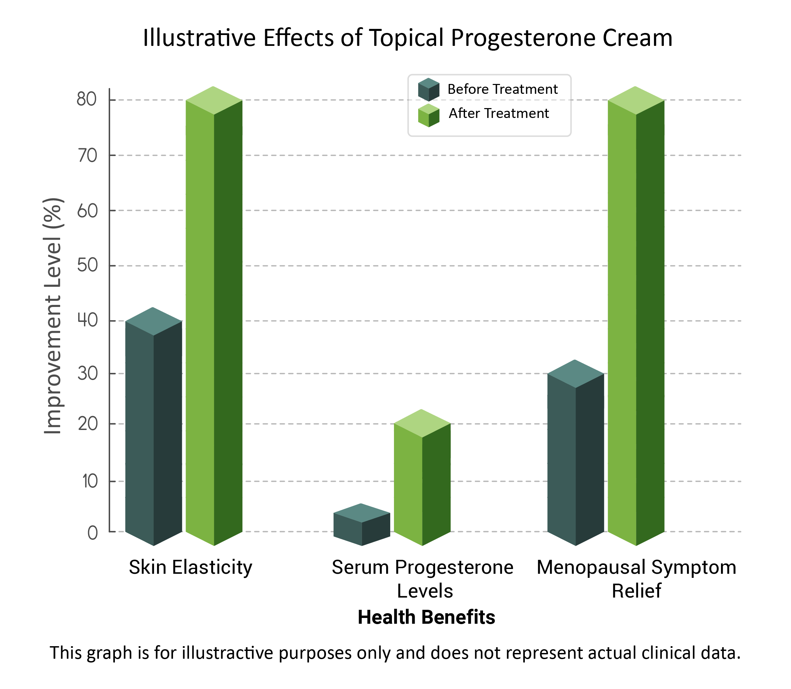

Find Your Perfect Hormone Balance

Hormone Focus Bundle (For Daily Hormonal Support)

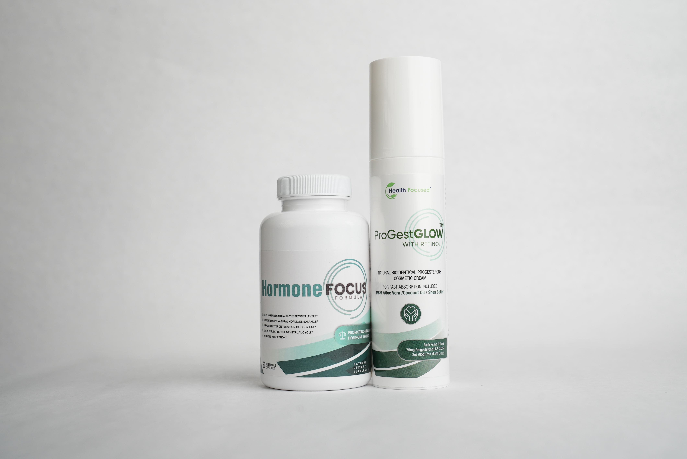
Includes: Hormone Focus + ProGestGlow
- Supports estrogen metabolism & progesterone balance
- Helps with PMS, mood swings, and hormonal acne
- Promotes energy, focus, and overall well-being
[Shop Hormone Focus Bundle: https://www.jjsmithonline.com/supplements/hormone-focus-bundle/]

Menopause Support Bundle (For Complete Menopause Relief)

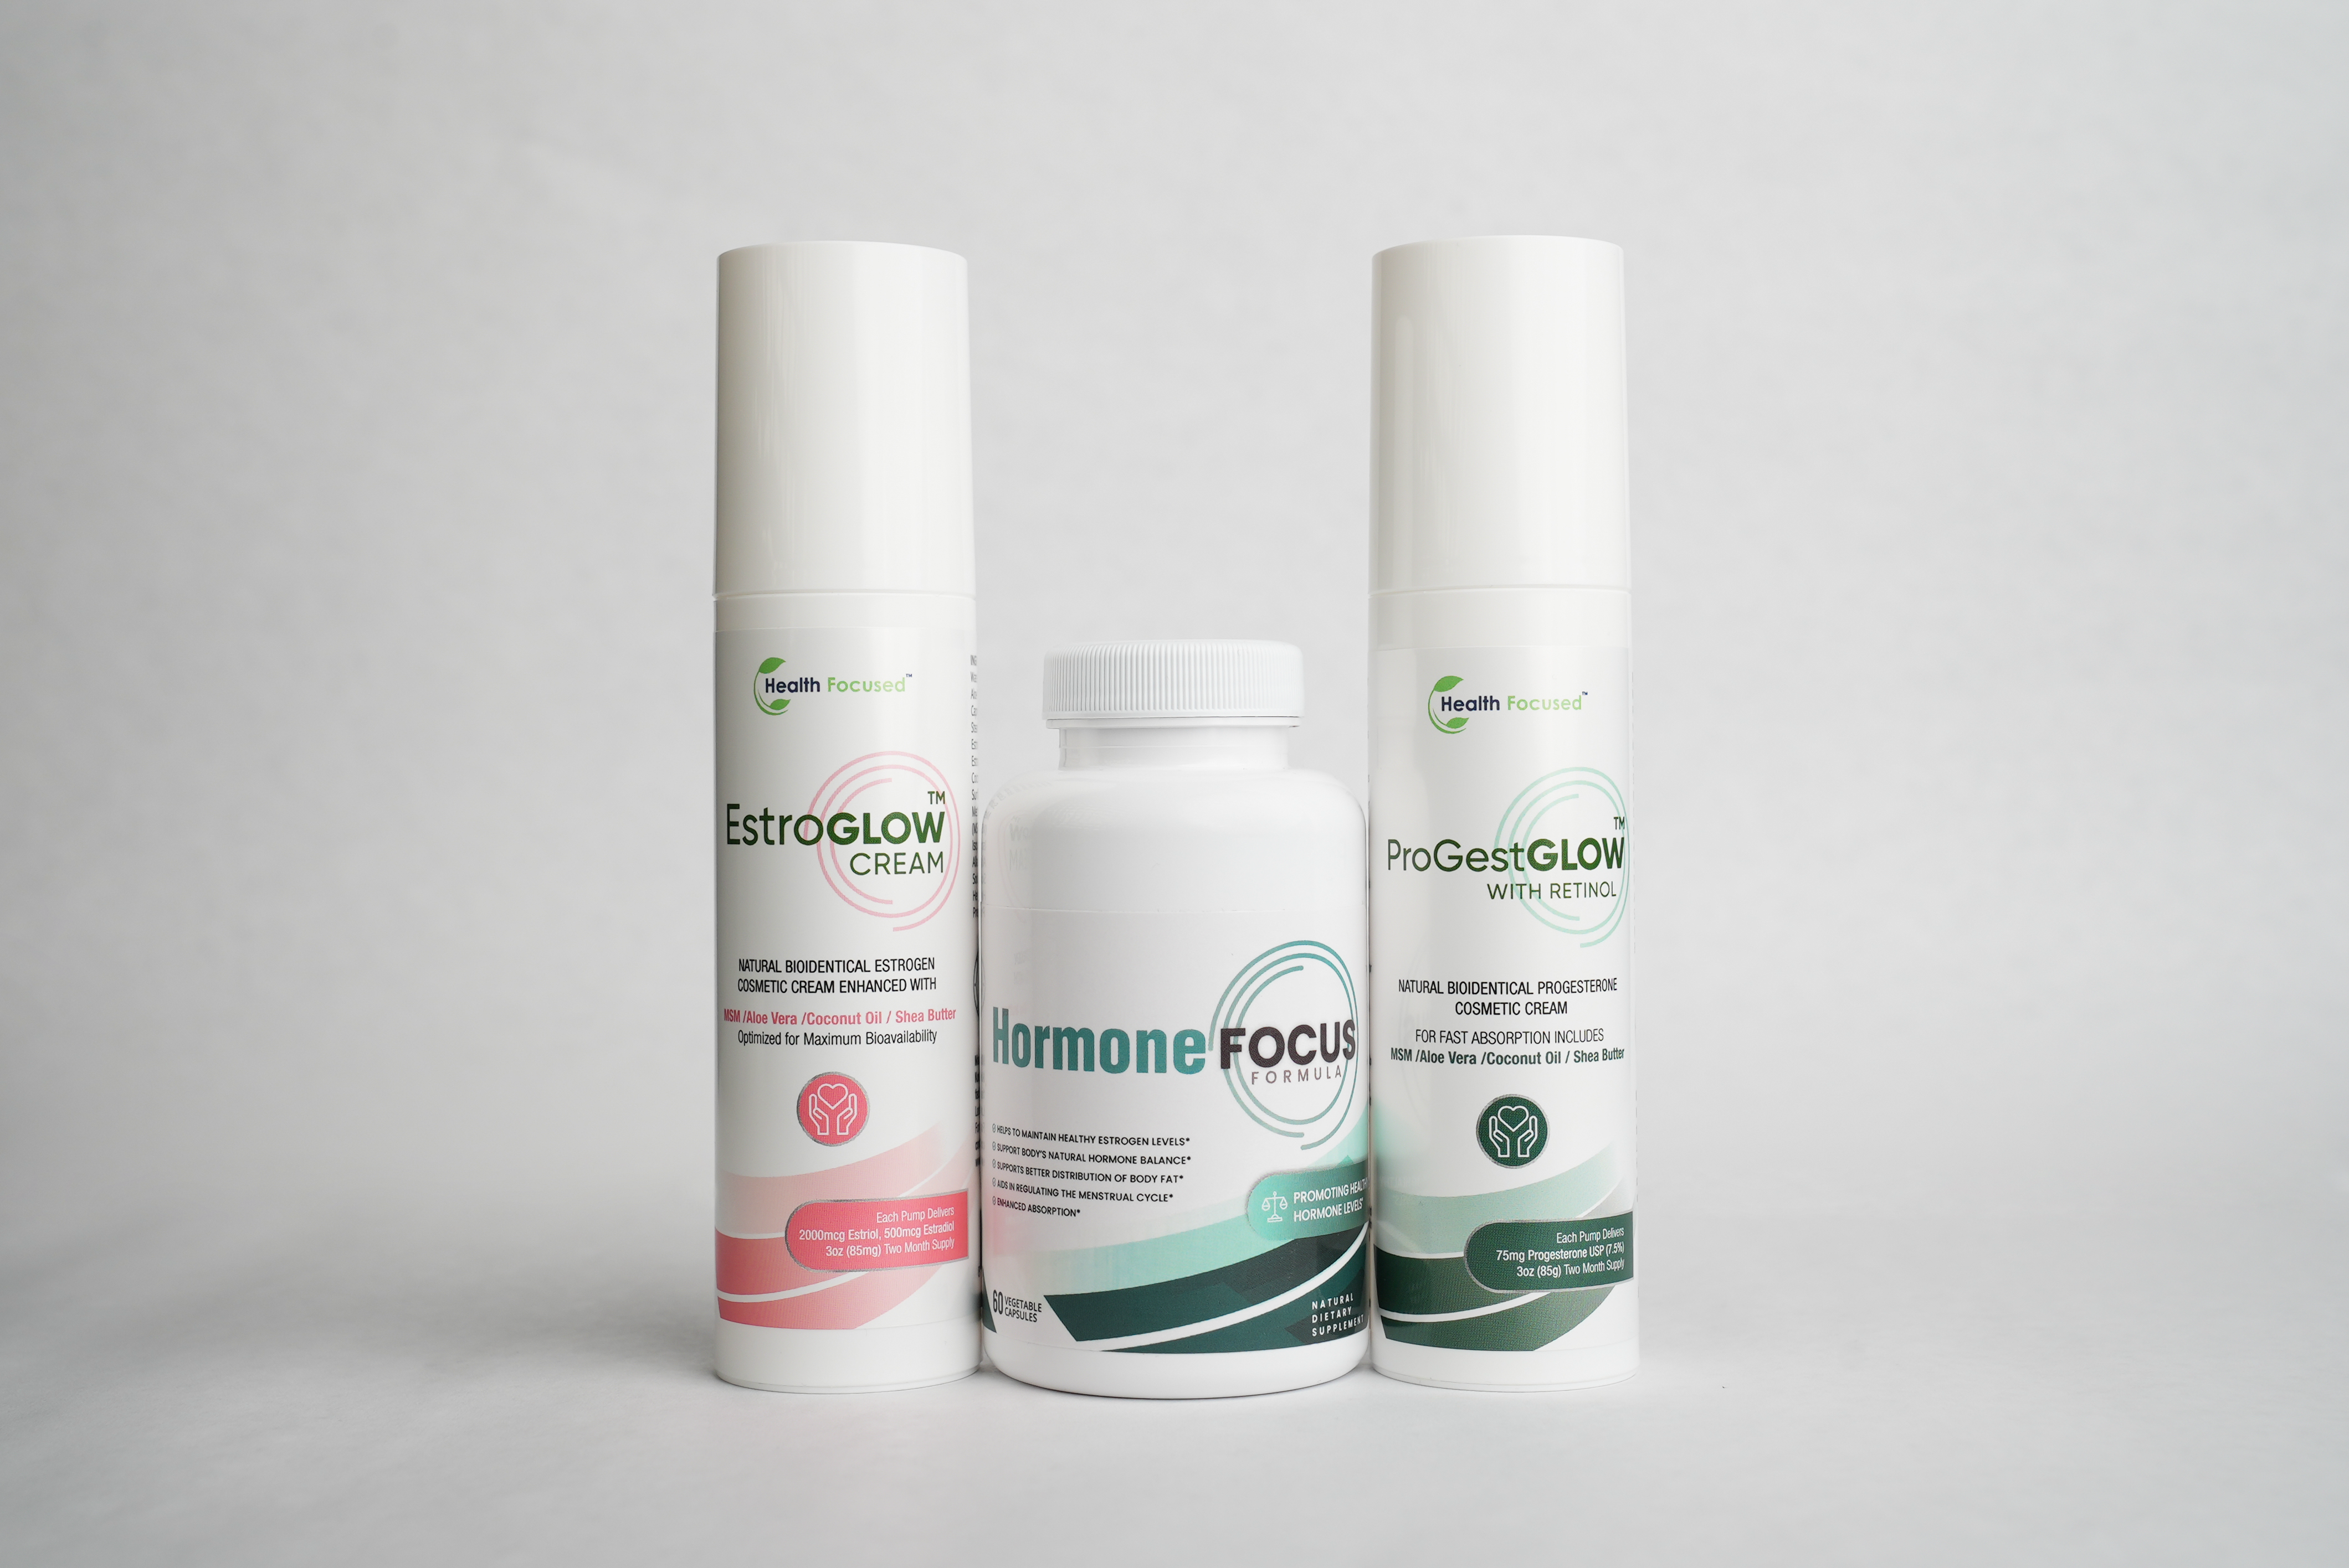
Includes: Hormone Focus + EstroGlow + ProGestGlow
- Eases hot flashes, night sweats & mood swings
- Supports restful sleep & skin elasticity
- Helps restore hormonal balance naturally
[Shop Menopause Support Bundle: https://www.jjsmithonline.com/supplements/menopause-support-bundle/]

Our Customers are Loving Their Results
<ADD BEFORE AND AFTER PICS>

https://www.dropbox.com/scl/fo/fc4beysorgbuapr6n2tbw/AGpcuDt2-8w4i0Q9LXhMWh0?rlkey=7bqqqflb5414htxqchcvzu7b7&st=etixx66n&dl=0

Which Hormone Products Are Right For You?
Not sure which product is right for you? Use this guide to find your perfect hormone support solution!
<Insert table: Discover Which Products Are Right For You>
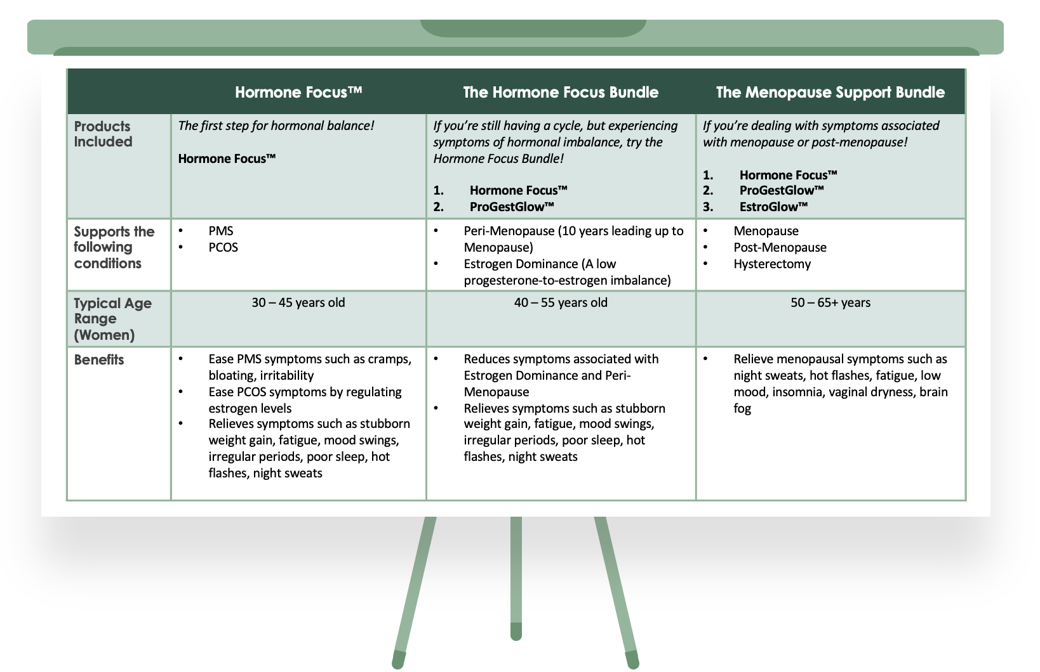

<FAQ: Insert FAQs from other WORD DOCUMENT ATTACHED>

Still Unsure if ProGestGlow™ is Right for You?
- Wondering if topical progesterone is what your body needs?
- Not sure if estrogen dominance is the cause of your symptoms?
- Looking for a natural, bioidentical solution backed by science?
Many women feel uncertain before trying ProGestGlow™—but once they experience the difference, they never look back.
- Bioidentical, naturally derived formula
- Clinically researched for effectiveness
- Trusted by women seeking hormonal balance
[Photos of women holding the bottle]
Your body deserves gentle, effective support. ProGestGlow™ is here to help.

CUSTOMER REVIEWS
LEAVE SPACE for Reviews to be added


