Press Golf App Email Campaigns

📧 Press Golf App – Week 1 Welcome Email

🟩 HEADER SECTION
Image/Header Banner:
Placeholder: Fun image of 4 golfers laughing on the green, phone in hand, with text overlay:
“Side Bets. Settled.”

🏌️‍♂️ INTRO TEXT
Subject Line:
Stop Arguing Over Bets. Press Golf Has You Covered.
Preheader Text (preview in inbox):
Track side games. Settle bets. Play like legends. Let the app do the math.

💬 MAIN BODY CONTENT
Headline:
🎯 Set Up Your Side Bets in Seconds — Then Let the App Do the Math
Body Text:
You know how it goes — someone forgets their press on 16, someone else “didn’t agree to that $20 skin,” and suddenly post-round beers feel like a courtroom.
That’s exactly why we built Press Golf App.
With just a few taps before you tee off, you can:
- Play 8 popular games like Nassau, Skins, Vegas, Banker and more
- Track bets live during the round
- Get a hole-by-hole breakdown for total transparency
- See exactly who owes who what at the end 💰
No arguments. No spreadsheets. Just clean, competitive fun.

📱 FEATURE IMAGE / DEMO SECTION
Placeholder: Screenshot or animation of the app showing real-time scoring with money changing hands or game summaries
“More golf. Less math. Way more chirping.”

🔘 CALL TO ACTION
CTA Button (centered & bold):
🎲 Start Your First Match Now
Link: Your App Store / Google Play landing page

💬 CLOSING LINE
P.S. If you're the "math guy" in your group... you're officially retired. Enjoy the round 🍻

⚪️ FOOTER (LIGHT GRAY BACKGROUND)
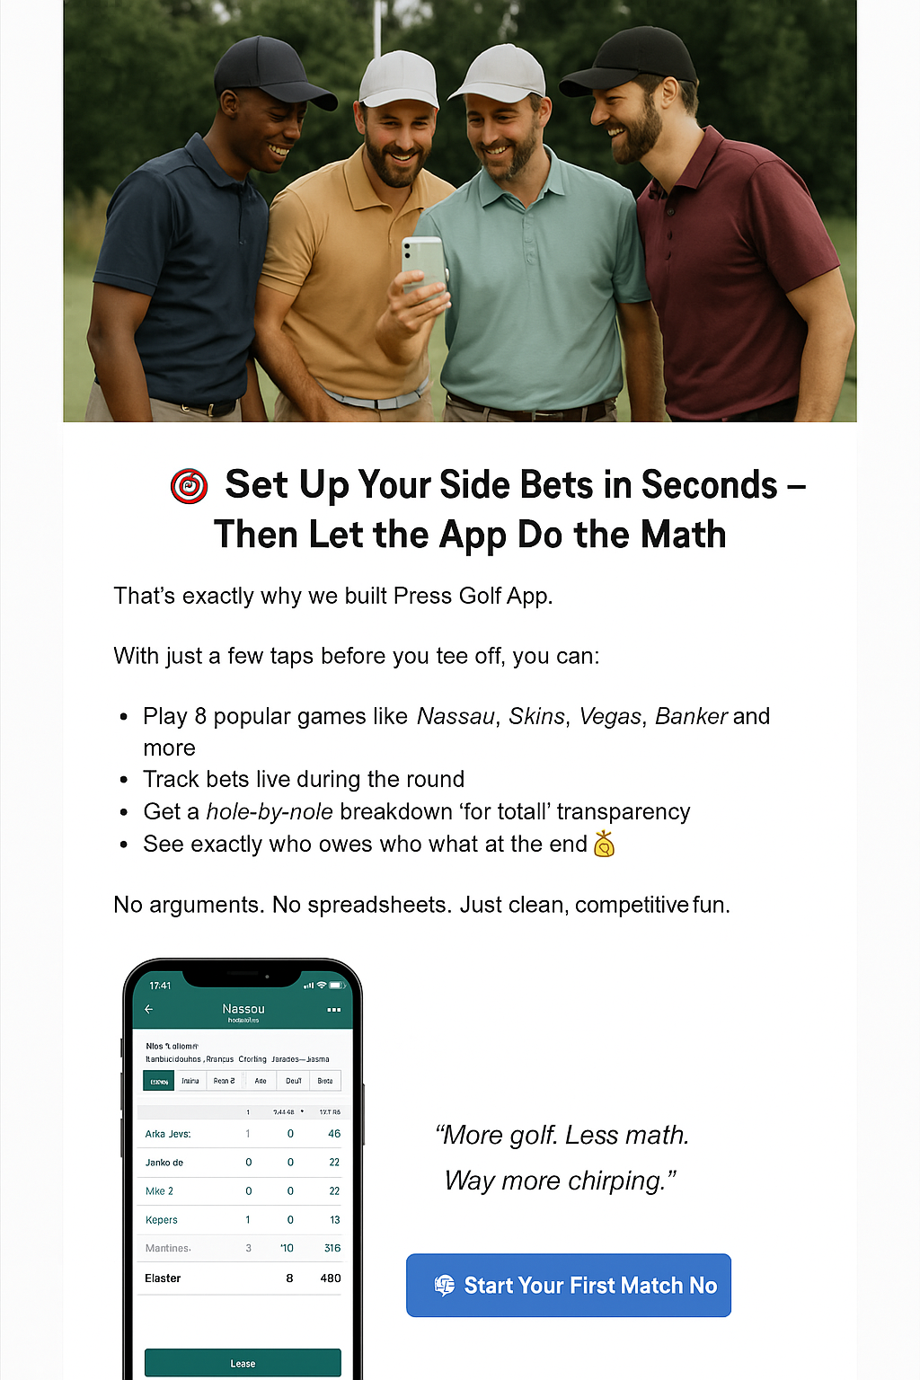
Include:
- Download links for iOS & Android
- Social media icons
- Small print: “© 2025 Press Golf App. All bets, no stress.”

📩 Email #2: Game Spotlight — Nassau

Subject Line Options:
- “Nassau: The OG of Golf Side Action” ✅
- “Front. Back. Total. Presses? Press Golf Tracks It All.”
- “You Bring the Trash Talk. We’ll Handle the Math.”
- “Tired of ‘I Thought That Was a Press’? We Got You.”

✍️ Email Copy (Formatted)

🟩 HEADER SECTION
Image/Header Banner:
Placeholder: Golfers watching a putt with money exchanging hands, overlaid with text:
“Nassau Made Easy”

🏌️‍♂️ INTRO TEXT
Subject Line:
Nassau: The OG of Golf Side Action
Preheader Text:
Your favorite bet, made automatic. No more press confusion, no more scorecard scribbles.

💬 MAIN BODY CONTENT
Headline:
⛳️ Front. Back. Total. Presses? We Handle All of It.
Body Text:
If you’re reading this, chances are you’ve played Nassau — the legendary 3-part bet that’s been stirring up golf carts and Venmo requests since forever.
But… we all know the pain:
- “Wait, was that press automatic?”
- “I think we halved the back nine?”
- “Who owes who again?”
Press Golf App takes all of that confusion off your hands.
Set up your Nassau games pre-round, choose your press rules (manual or automatic), and the app does the rest — tracking the match live, press by press, hole by hole.
✅ Automatic calculations
✅ Real-time match updates
✅ Crystal-clear payouts at the end
All you have to do is make putts and win holes. We’ll take care of the scorekeeping and side action.

📱 FEATURE IMAGE / DEMO SECTION
Placeholder: App screenshot showing live Nassau tracking with “press” alerts
“It’s like having a caddie who’s also your accountant. But cooler.”

🔘 CALL TO ACTION
CTA Button (centered):
🏌️‍♂️ Play Your Next Nassau with Press Golf

💬 CLOSING LINE
P.S. Still using the scorecard to track bets? That’s cute. Try the upgrade.

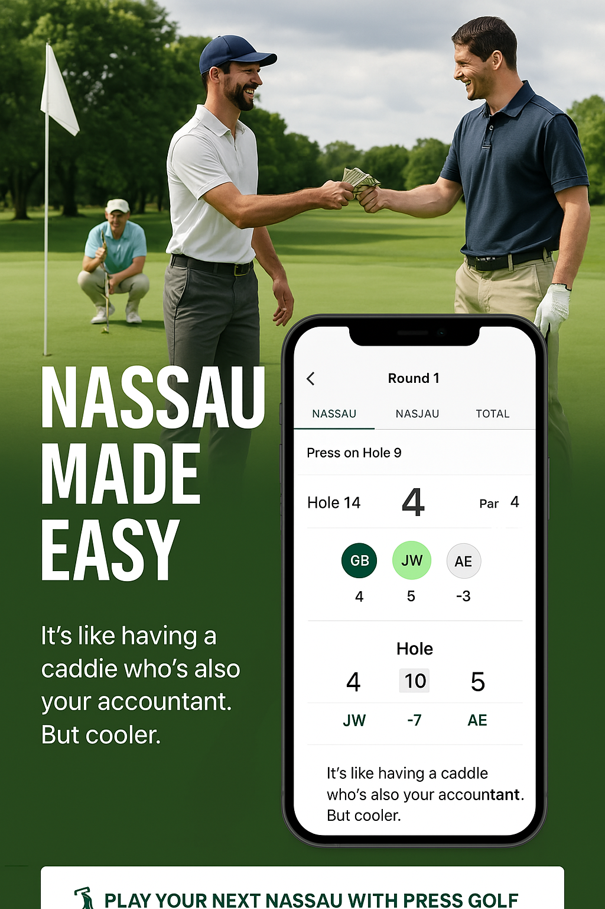
⚪️ FOOTER
Standard:
- App Store / Google Play links
- Socials
- Support email
- “© 2025 Press Golf App — Know Who Owes Who.”

📩 Email #3: Game Spotlight — Skins

Subject Line Options:
- “No More Confused Looks on the Tee – Skins Made Easy” ✅
- “Skins Game Drama? We’ve Got a Fix for That.”
- “Every Hole Matters. Especially When Money’s on the Line.”
- “Track Skins Like a Pro (Without a Spreadsheet)”

✍️ Email Copy (Formatted)

🟩 HEADER SECTION
Image/Header Banner:
Placeholder: Two golfers fist-bumping on the green while one updates the app, text overlay:
“Skins Just Got Smarter”

🏌️‍♂️ INTRO TEXT
Subject Line:
No More Confused Looks on the Tee – Skins Made Easy
Preheader Text:
Every hole is a fresh opportunity to win cash — and now, it’s easy to track.

💬 MAIN BODY CONTENT
Headline:
💸 Skins Should Be Fun — Not a Post-Round Puzzle
Body Text:
Skins is one of the best games in golf… until someone forgets a carryover or insists they birdied a hole you swore was halved.
With Press Golf App, Skins stays clean, competitive, and 100% transparent.
You set it up before the round:
- Choose gross or net play
- Add carryovers (optional)
- Lock in who’s in — and how much the pot is
Then just play. We’ll:
- Track hole winners in real-time
- Apply carryovers automatically
- Show a running pot and payouts after 18
No arguments. No confusion. Just bragging rights — backed by receipts.

📱 FEATURE IMAGE / DEMO SECTION
Placeholder: Screenshot or animated clip showing a Skins game in progress, with a carryover building and a “Winner” alert on a par-3
“That birdie on 12? Yeah, it was worth $30. The app saw it too.”

🔘 CALL TO ACTION
CTA Button (centered):
🔥 Run Your Next Skins Game with Press Golf

💬 CLOSING LINE
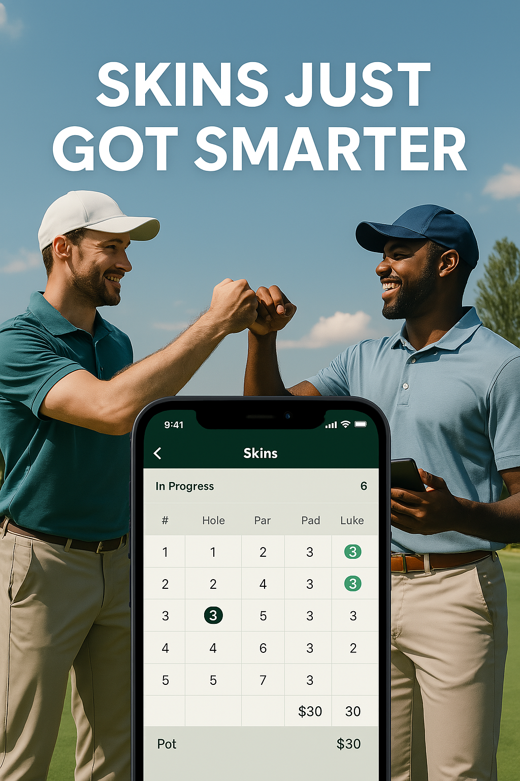
P.S. We can’t stop your buddy from three-putting — but we can make sure he pays up when he loses a skin.

⚪️ FOOTER
- App Store / Google Play links
- Follow us on Instagram / TikTok
- “© 2025 Press Golf App — Real Games. Real Winnings. Real Fun.”

📩 Email #4: “How-To” Series — Setting Up a Match

Subject Line Options:
- “3 Taps and Boom — Your Match is Ready” ✅
- “Set Up Your Bets Before the Cart Girl Shows Up”
- “Start the Round Right (With a Game That’s Already Set)”
- “No Setup Stress. Just Side Action.”

✍️ Email Copy (Formatted)

🟩 HEADER SECTION
Image/Header Banner:
Placeholder: Golfer sitting in a cart, smiling and setting up games on their phone before teeing off. Text overlay:
“Fast Match Setup = More Time to Win”

🏌️‍♂️ INTRO TEXT
Subject Line:
3 Taps and Boom — Your Match is Ready
Preheader Text:
Don’t waste time sorting out bets on the 1st tee. Set it up in seconds before you even step out of the car.

💬 MAIN BODY CONTENT
Headline:
⚡️ How to Set Up a Match Before the First Swing
Body Text:
Press Golf App is built to move as fast as your pre-round trash talk.
Here’s how easy it is to set up your group’s side action:
- Open the app and start a new round
- Add your players and select a game (or stack a few)
- Customize press rules, payouts, or tee boxes if needed
- Hit “Start Match” — and boom, game on
🎥 Want to see it in action?
[Watch this 45-second setup demo →] (link to video or gif)
It’s faster than warming up your driver — and way more useful.
You’ll get live updates, score tracking, and automatic payouts calculated as you go.

📱 FEATURE IMAGE / DEMO SECTION
Placeholder: Side-by-side screenshots of the 4 setup steps (player selection, game selection, settings, match start)
“No arguing over the format. No mid-round recalculations. Just vibes and verified bets.”

🔘 CALL TO ACTION
CTA Button (centered):
🎯 Set Up Your First Match Now

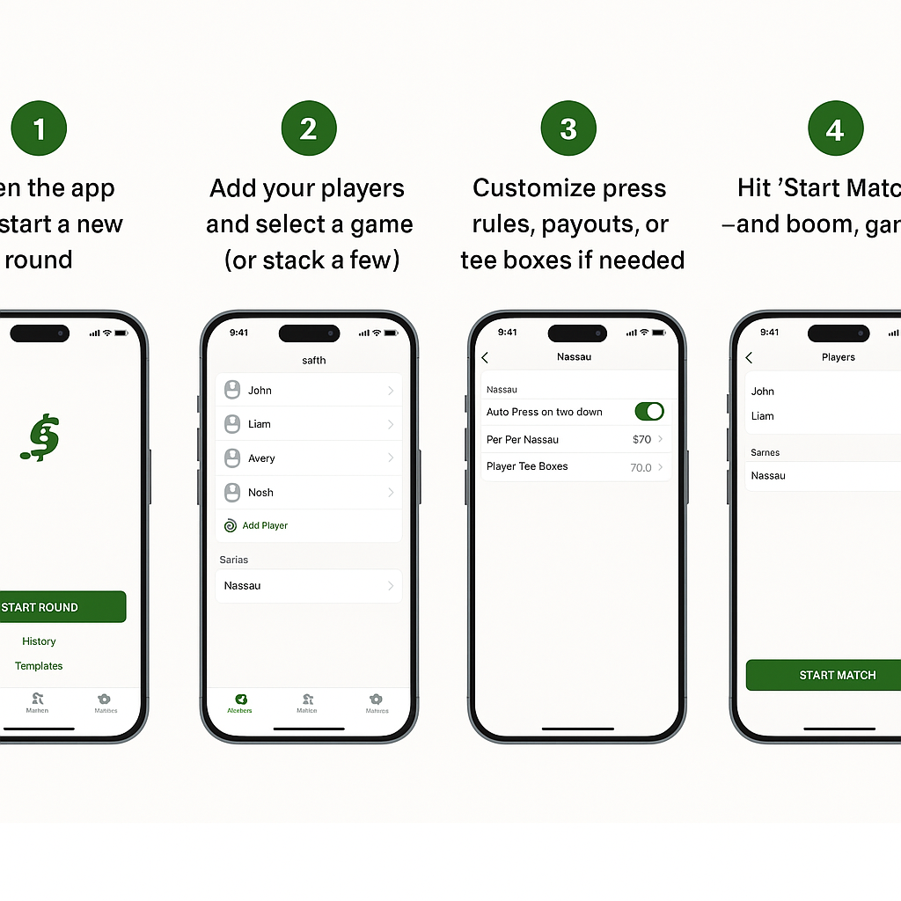
💬 CLOSING LINE
P.S. No one wants to be that guy fumbling with a scorecard on the 3rd tee.

⚪️ FOOTER
- App Store / Google Play download buttons
- Socials
- “© 2025 Press Golf App – Built for the Bet-Ready Golfer”

📩 Week 5: Game Spotlight — Wolf

Subject Line Options:
- “Wolf: Strategy. Side Bets. And a Little Bit of Betrayal.” ✅
- “Are You the Alpha or the Underdog?”
- “The Most Savage Game in Golf (We Made It Easy)”
- “Pick ‘Em or Go Lone Wolf – It’s Game On.”

✍️ Email Copy (Formatted)

🟩 HEADER SECTION
Image/Header Banner:
Placeholder: Golfer teeing off while others watch, one with a sly grin. Text overlay:
“Wolf Made Simple. Let the Pack Hunt.”

🏌️‍♂️ INTRO TEXT
Subject Line:
Wolf: Strategy. Side Bets. And a Little Bit of Betrayal.
Preheader Text:
Call your shot. Choose your team. Or go solo and hunt. Press Golf App makes Wolf automatic.

💬 MAIN BODY CONTENT
Headline:
🐺 Wolf: For Golfers Who Like a Little Strategy (and Trash Talk)
Body Text:
If you’ve ever played Wolf, you know it’s not just about scoring — it’s about choosing your moment to team up… or go full lone wolf mode.
But tracking all that on paper? Nah.
Here’s how Press Golf App makes Wolf effortless:
- You pick the order, we keep it locked
- Each hole, choose a teammate or go solo
- We handle point tracking automatically
- Live leaderboard updates after every hole
Customize point values, set press rules, and keep the round moving without pulling out your calculator. Whether you're running the pack or playing rogue, we’ve got you covered.

📱 FEATURE IMAGE / DEMO SECTION
Placeholder: App screenshot showing a Wolf game in progress with teammates chosen and scores tracked
“It’s not just golf. It’s mind games. With money.”

🔘 CALL TO ACTION
CTA Button (centered):
🐺 Start Your Next Wolf Game in the App

💬 CLOSING LINE
P.S. Going lone wolf and winning? That’s alpha behavior. But we’ll still do the math for you.

⚪️ FOOTER
- iOS & Android download buttons
- Socials
- “© 2025 Press Golf App — Golf Gets Competitive”

📩 Week 6: Referral Challenge + Giveaway Promo

Subject Line Options:
- “Win a Free TaylorMade Qi35 Driver – Just for Sharing the App” ✅
- “Send the App. Win the Driver. Swing Like a Pro.”
- “Your Next Driver Could Be Free (And Forgiving 👀)”
- “Help Your Buddies Bet Better — Get Rewarded Big Time”

✍️ Email Copy (Formatted)

🟩 HEADER SECTION
Image/Header Banner:
Placeholder: A shining TaylorMade Qi35 Max driver on green grass, spotlighted like a trophy. Text overlay:
“Win This Club. Brag All Summer.”

🏌️‍♂️ INTRO TEXT
Subject Line:
Win a Free TaylorMade Qi35 Driver — Just for Sharing the App
Preheader Text:
Each referral = 1 entry to win the hottest driver of the year. Time to spread the word.

💬 MAIN BODY CONTENT
Headline:
🏆 Send the App. Win the Driver. Swing Into Summer Like a Legend.
Body Text:
We're giving away a brand-new TaylorMade Qi35 Max Driver (yep, the one with all the forgiveness and none of the slice).
All you have to do is refer your golf crew to download and play a round using the Press Golf App.
Here’s how to enter:
- Open the app and tap “Refer a Golfer”
- Share your referral link
- Each golfer who signs up + plays a round = 1 entry to win
- Boom — you’re in the running 🏁
The more you refer, the better your odds.
Winner announced at the end of the month!

🖼 IMAGE SECTION
Placeholder: Side-by-side — the Qi35 driver + app screen showing the referral feature
“Good golfers bring good swings. Great golfers bring their whole foursome.”

🔘 CALL TO ACTION
CTA Button (centered):
🏌️‍♂️ Refer a Golfer – Enter to Win

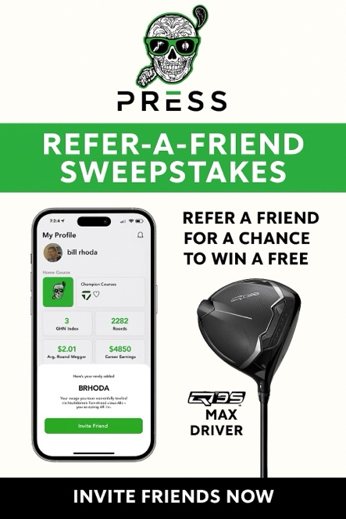
💬 CLOSING LINE
P.S. Even if you don’t win, you’ll still have more friends to bet against. So… win-win.

⚪️ FOOTER
- Terms & conditions link (optional small print about eligibility, U.S. only, no purchase necessary, etc.)
- App Store / Google Play links
- Socials
- “© 2025 Press Golf App — Play Hard. Track Smart. Win Big.”

📩 Week 7: Masters Hype + Feature Tie-In

Subject Line Options:
- “It’s Masters Week. You Betting on It or Playing Through?” ✅
- “The Green Jacket’s Nice. But So Is $20 on 17.”
- “A Tradition Unlike Any Other… Like Pressing on 18.”
- “Watch the Drama. Then Create Your Own.”

✍️ Email Copy (Formatted)

🟩 HEADER SECTION
Image/Header Banner:
Placeholder: Augusta-inspired design — iconic green, azaleas, maybe the silhouette of Amen Corner with your Press skull logo worked in. Text overlay:
“The Masters Is On. Time to Play Your Own Major.”

🏌️‍♂️ INTRO TEXT
Subject Line:
It’s Masters Week. You Betting on It or Playing Through?
Preheader Text:
Inspired by Augusta? Fire up Press Golf App and get your own matches rolling — while the pros chase the green jacket.

💬 MAIN BODY CONTENT
Headline:
🏆 A Tradition Unlike Any Other — Side Bets, Trash Talk & Greenside Drama
Body Text:
While the best in the world battle Amen Corner, you and your crew can tee up some drama of your own.
This week’s the perfect excuse to:
- Fire up a Skins game at your local course
- Run a Nassau with Masters-themed payouts
- Or settle rivalries with a Stroke Play grudge match
The Press Golf App tracks every bet, press, and skin in real time — so your action feels just as serious as Augusta (but with more beer and less pressure).

📱 FEATURE IMAGE / DEMO SECTION
Placeholder: App screenshot showing a live match happening while someone watches the Masters on TV
“You might not win a green jacket… but you could win beers, cash, and bragging rights by Sunday.”


🔘 CALL TO ACTION
CTA Button (centered):
⛳️ Set Up Your Own Masters Match

💬 CLOSING LINE
P.S. Watching the final round from the couch is fine. But playing your own money game during it? That’s how legends are made.

⚪️ FOOTER
- App Store / Google Play links
- Follow us on Instagram / TikTok for live Masters trash talk
- “© 2025 Press Golf App — Bet Bold. Track Easy. Play Loud.”

📩 Week 8: Game Spotlight — Banker

Subject Line Options:
- “Who’s the Banker? You or Your Wallet?” ✅
- “Banker: The Most Underrated Game in Golf”
- “This Game Will Test Friendships — And Handicaps”
- “You Can Switch Partners Every Hole. Just Don’t Screw It Up.”

✍️ Email Copy (Formatted)

🟩 HEADER SECTION
Image/Header Banner:
Placeholder: A group on the tee box, one player making a “money” hand sign, another holding a phone. Press skull logo subtly in the background. Text overlay:
“Banker Made Easy. But Winning It? That’s on You.”

🏌️‍♂️ INTRO TEXT
Subject Line:
Who’s the Banker? You or Your Wallet?
Preheader Text:
The strategic game that rotates partners — and reveals who really knows how to bet smart.

💬 MAIN BODY CONTENT
Headline:
🏦 Banker: The Golf Game That Rewards Brains AND Birdies
Body Text:
Every hole, a new team. Every shot, a new decision. Banker is like poker and match play had a baby — and we built Press Golf App to handle it all so you can just focus on strategy.
Here’s the quick version:
- One golfer is the “banker” each hole
- Others decide to challenge or pass
- If they challenge — they choose to play 1v1 or pick a partner
- Win? You collect. Lose? Pay up.
It’s chaotic, tactical, and insanely fun.
And yes — Press Golf does all the calculating and tracking in real-time.
So you just worry about picking the right partner… and not chunking it after talking trash.

📱 FEATURE IMAGE / DEMO SECTION
Placeholder: App screen with a Banker match in progress — showing rotation of bankers, payout values, and partner selections
“Banker is where golf IQ meets game-time pressure. The app makes it smooth. The rest is on you.”

🔘 CALL TO ACTION
CTA Button (centered):
💸 Try a Banker Match This Weekend

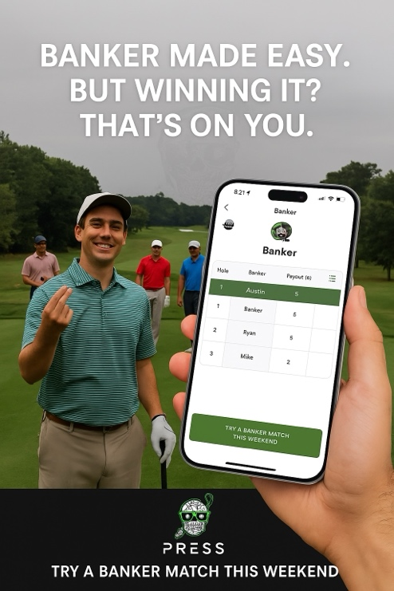
💬 CLOSING LINE
P.S. Think you're the smartest bettor in your foursome? Time to prove it.

⚪️ FOOTER
- App Store / Google Play download links
- Social links
- “© 2025 Press Golf App — For the Golfers Who Want the Action AND the Edge.”

📩 Week 9: Skins — Advanced Mode

Subject Line Options:
- “Net Skins, Carryovers & Trash Talk — All Dialed In” ✅
- “We Upgraded Skins. So You Can Raise the Stakes.”
- “Skins Just Got Real”
- “Forget the Scorecard. Press Handles All the Fine Print.”

✍️ Email Copy (Formatted)

🟩 HEADER SECTION
Image/Header Banner:
Placeholder: Golfers marking a scorecard mid-round, one holding a phone that shows the Skins screen. Press skull logo subtly in a corner. Text overlay:
“Advanced Skins. Same Drama. No Math.”

🏌️‍♂️ INTRO TEXT
Subject Line:
Net Skins, Carryovers & Trash Talk — All Dialed In
Preheader Text:
Your Skins game just got upgraded. Add net scores, carryovers, and custom tiebreakers — Press does the math.

💬 MAIN BODY CONTENT
Headline:
🎯 Skins, But With All the Features Your Crew Needs
Body Text:
We know your group doesn’t just play basic skins.
There’s always that guy who insists on net scoring, another who loves carryovers, and someone who swears “ties don’t split.”
That’s why Press Golf App lets you:
- Choose between gross or net scoring
- Turn carryovers on or off
- Set tiebreaker rules the way your crew plays
- Track everything live, hole-by-hole
It’s all the nuance and fairness of a serious Skins match — handled automatically.

📱 FEATURE IMAGE / DEMO SECTION
Placeholder: App screen showing a live Skins game with net scores, a carryover pot building, and players toggling settings
“More drama. More options. Still zero arguments.”

🔘 CALL TO ACTION
CTA Button (centered):
🪙 Upgrade Your Skins Game Now
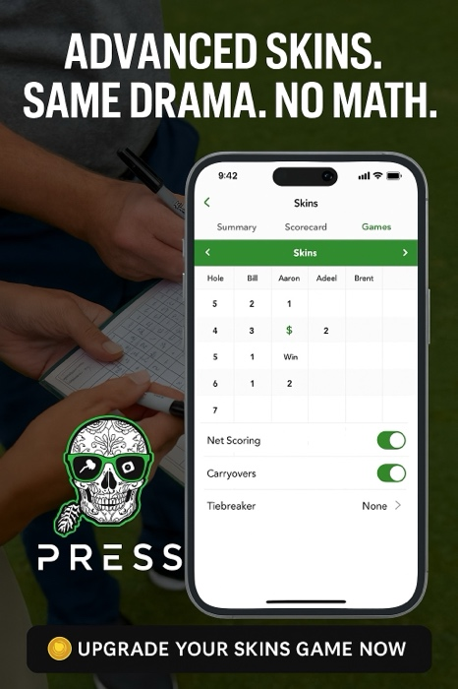

💬 CLOSING LINE
P.S. If you're still tracking net Skins on a scorecard... we need to talk.

⚪️ FOOTER
- Download buttons
- Social links
- “© 2025 Press Golf App — Built for the Bettors Who Know the Rules.”

📩 Week 10: Feature Tip — Round Templates

Subject Line Options:
- “Want to Save 10 Minutes Before Every Round?” ✅
- “Set It and Swing It: Your Games, Preloaded.”
- “Faster Setup. More Time to Talk Trash.”
- “Templates = More Golf, Less Fumbling.”

✍️ Email Copy (Formatted)

🟩 HEADER SECTION
Image/Header Banner:
Placeholder: Golfer tapping a phone in the parking lot while others warm up nearby. Press logo top right. Text overlay:
“3 Taps. Match Loaded. Let’s Go.”

🏌️‍♂️ INTRO TEXT
Subject Line:
Want to Save 10 Minutes Before Every Round?
Preheader Text:
Use match templates in Press Golf App to set up your crew’s games in seconds — not on the first tee.

💬 MAIN BODY CONTENT
Headline:
🚀 Your Crew Plays the Same Games Every Weekend. Why Set It Up From Scratch?
Body Text:
If your group plays the same format each round — think Nassau + Skins + Snake — there’s no reason to re-enter it every time.
With Press Golf App, you can:
- Save your match setup as a template
- Pre-load players, games, tees, and bet settings
- Start a new round in seconds
- Never fumble through setup while others are teeing off
Whether it’s your Saturday foursome or your Wednesday wolfpack — set it up once and play faster every time.

📱 FEATURE IMAGE / DEMO SECTION
Placeholder: App UI screen showing a “Save as Template” toggle and quick launch options for stored match formats
“Because the only thing worse than a slow group ahead… is being the slow guy in your own.”
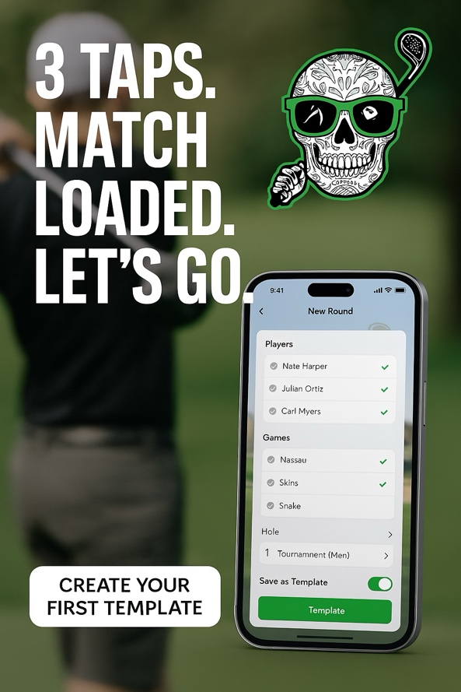

🔘 CALL TO ACTION
CTA Button (centered):
⚡️ Create Your First Template

💬 CLOSING LINE
P.S. Your match deserves more energy than your phone setup. We fixed that.

⚪️ FOOTER
- iOS / Android download links
- Follow on Instagram + TikTok
- “© 2025 Press Golf App — Built to Play Fast and Bet Hard.”

📩 Week 11: Limited-Time Referral Bonus

Subject Line Options:
- “48 Hours Only: Double Entries to Win the Qi35 Driver” ✅
- “This Week Only: Share Press. Stack Your Odds.”
- “2x Referral Power = More Chances to Win”
- “Send the App. Win the Club. Time’s Ticking.”

✍️ Email Copy (Formatted)

🟩 HEADER SECTION
Image/Header Banner:
Placeholder: Countdown-style background with Press logo + Qi35 driver in spotlight. Text overlay:
“Double Your Entries. 48 Hours Only.”

🏌️‍♂️ INTRO TEXT
Subject Line:
48 Hours Only: Double Entries to Win the Qi35 Driver
Preheader Text:
Every friend you refer in the next 2 days = 2 entries to win a TaylorMade Qi35 Driver. Go get 'em.

💬 MAIN BODY CONTENT
Headline:
⏳ The Odds Just Got Better — If You Move Fast
Body Text:
We’re running a 48-hour referral blitz to reward golfers who spread the word.
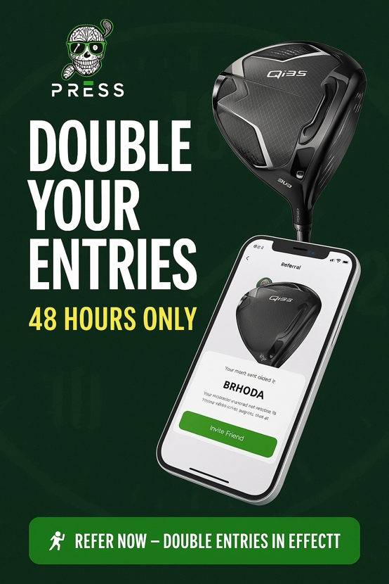
From now until [insert date/time]:
Every friend you refer who signs up and plays a round = 2 entries into the TaylorMade Qi35 Driver Giveaway.
🚀 Quick math: Refer 3 friends = 6 entries
Refer 5 = 10 entries
Stack your chances. Win the club. Brag all summer.

📱 FEATURE IMAGE / DEMO SECTION
Placeholder: App UI screen showing the referral flow + the Qi35 driver front and center
“Real friends don’t let friends track side bets on a scorecard.”

🔘 CALL TO ACTION
CTA Button (centered):
🏌️‍♂️ Refer Now — Double Entries In Effect

💬 CLOSING LINE
P.S. Clock’s ticking. Don’t sleep on this — the driver’s too good.

⚪️ FOOTER
- Terms and conditions (small print: valid through [date], entries apply only when round is completed, U.S. only if applicable)
- App Store / Google Play links
- “© 2025 Press Golf App — Fast Rounds. Fierce Action. Big Prizes.”

📩 Week 12: Community Spotlight — Big Win Story

Subject Line Options:
- “He Won $250 on 18. Press Golf Had the Receipts.” ✅
- “Last Week’s Big Winner? Played a Perfect Press.”
- “Your Game. Your Group. Your Bragging Rights.”
- “We’re Watching. The Leaderboard Doesn’t Lie.”

✍️ Email Copy (Formatted)

🟩 HEADER SECTION
Image/Header Banner:
Placeholder: Golfer celebrating with hands raised on 18, buddies around. Press logo in the corner. Text overlay:
“Big Wins. Big Moments. All Tracked.”

🏌️‍♂️ INTRO TEXT
Subject Line:
He Won $250 on 18. Press Golf Had the Receipts.
Preheader Text:
Real bets. Real winners. And full transparency. Time to get your name on the board.

💬 MAIN BODY CONTENT
Headline:
🏌️‍♂️ Your Side Bets Tell a Story — We Help You Prove It
Body Text:
Every week, golfers are cashing in on epic putts, clutch birdies, and savage presses — and Press Golf App keeps it all tracked and crystal clear.
This week’s MVP?
🎉 [Username or “One lucky player”] pressed on 16, birdied 17 & 18, and walked away with $250.
And the best part? Nobody could argue. The app handled everything.
Coming soon:
✅ Featured match highlights
✅ Top pressers of the week
✅ Most skins taken
✅ Biggest net earnings
✅ And some wild “trash talk quotes of the week”
Want your name in lights?
Play your matches. Use the app. Let the action speak.

📱 FEATURE IMAGE / DEMO SECTION
Placeholder: Leaderboard-style mockup with usernames and winnings + UI screenshot from a tracked round
“Your stories are better when they’re backed by numbers.”

🔘 CALL TO ACTION
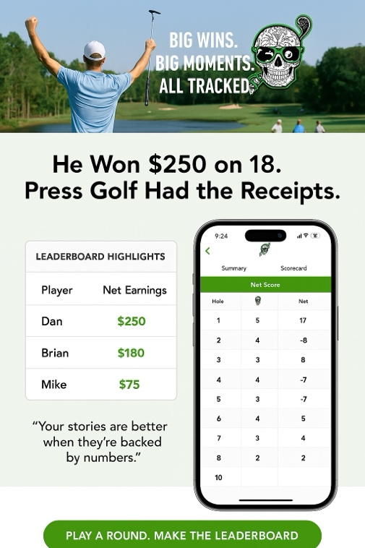
CTA Button (centered):
🏆 Play a Round. Make the Leaderboard.

💬 CLOSING LINE
P.S. You don’t need a green jacket to be legendary. Just win the back nine with a press.

⚪️ FOOTER
- App download buttons
- Submit your round/story link (optional)
- Social links
- “© 2025 Press Golf App — Built for Gamers, Talkers, and Closers.”

