
2025
SERVICES PROPOSAL

7 January 2025
Level 2, Suite 9
56 Bowman Street
Pyrmont NSW 2009

+612 8572 5000
bacchus.net.au
We are a boutique professional services firm focused on delivering customised accounting, tax and strategic business advice for our clients.
We use our extensive chartered accounting and specialist tax experience to make your life easier by providing clear and concise advice on complex tax matters and business management.
We pride ourselves on bringing life to numbers.
We are trusted advisors to small-to-medium enterprises (SMEs), Australian Securities Exchange (ASX) listed companies, local branches of significant global entities (SGEs), technology startups, and high net worth individuals (HNWI).

ABOUT BACCHUS ADVISORY



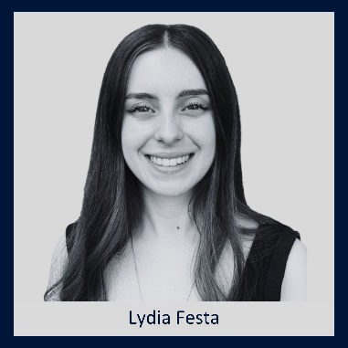

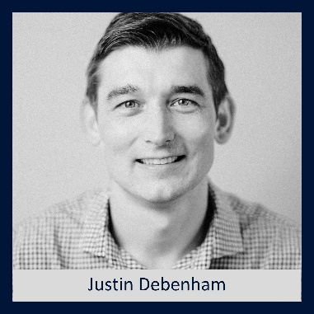
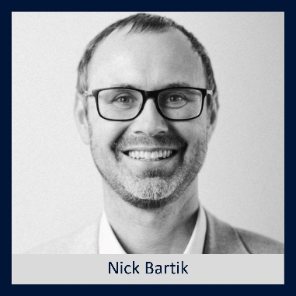
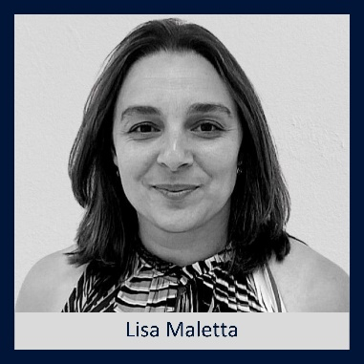
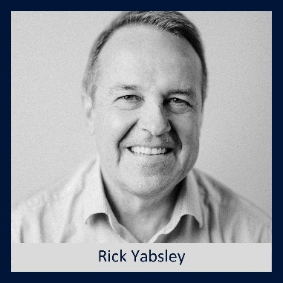
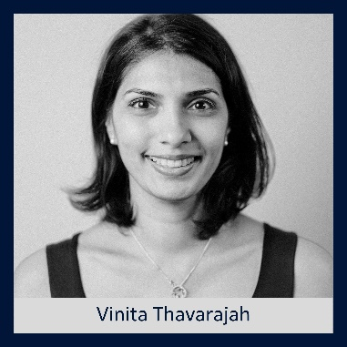
OUR TEAM
PROPOSAL FOR
OUTSOURCED CFO SERVICES

PREPARED FOR
Abc Limited
BY
Nick Bartik, Director, Bacchus Advisory
Nick Bartik will be the Bacchus Advisory Director responsible for your affairs. Should Nick not be available, your alternate contact will be Lisa Maletta.

Nick Bartik, CA, CTA, Director
Nick has been a Chartered Accountant for 20 years. He specialises in complex tax matters, international tax and business valuations.
Nick advises a number of significant clients, including Australia’s third largest privately held technology company.

Lisa Maletta, CA, Director
Financial Reporting and CFO Services
Lisa has been a Chartered Accountant for 20 years and manages a portfolio of corporate clients.
She provides strategic advice, outsourced CFO and tax services to ASX Listed Companies.


7 January 2025

[insert name]
[insert company name]
Via email:

Dear [salutation],

PROPOSAL FOR ADVISORY SERVICES

We are delighted to submit our proposal to Airteam Group for the provision of advisory services.

Based on our discussions with you we have been asked to provide the following proposal:

Our main objective is to provide you with:
- An independent review of your business forecasts and plans using xero data and Futrli Predict software to assist with making business decisions with confidence
- Comfort & certainty to allow you to reward/draw an appropriate dividend based on the forecasted future cashflows of the business (3 months of expenses kept in cash)
- We will do this by working with Brenda and using Futrli predict cashflow forecasting tool and providing you reports and meetings on an agreed schedule.

Our scope includes:
- Initial needs analysis and client “deep dive,” including understanding and incorporating your current tools and plans into the software package.
- Futrli configuration and xero linking, (including input of budgets and forecasts prepared internally). Including calls and meetings as required.
- Provision of training to Brenda in Futrli Product.
- Quarterly Cashflow forecast reports to be provided, with alternative scenarios available.
- Quarterly meetings (F2F or MS Teams) to discuss the reports.
- All calls/emails in respect of the project (except where part of agreed out of scope services)

Agreed out of scope services include:
- Bookkeeping or data input and reconciliation services (Brenda responsibility)
- Tax and accountancy services provided under our earlier engagement letter
- Additional meetings, additional scenarios or adjustments requested after meetings and subsequent reissuance of reports

Below is our estimated fee given our conversations

Task | Number per year | Cost per Quarter (ex-GST) | Estimated Annual Cost (Ex GST)
Preparation of Reports and discussions with Brenda/Airteam | 4 | $1,302.50 | $5,210.00
Quarterly Meetings | 4 | $995.50 | $3,982.00
KPI Review | 4 | $452.00 | $1,808.00
Total |  | $2,750.00 | $11,000.00
In addition to the quarterly reports there will be a one-off setup and configuration charge as listed in scope above which will also include training to Brenda as appropriate
Estimated setup costs | 1 |  | $2,500.00-$3,5000.00

Our costs will be reviewed annually to ensure the fee is appropriate to the level of service required.

It is our expectation that in the initial stages of our engagement, our time inputs will be higher than the long-term average that we have based our quote upon. We consider this our investment in the ongoing relationship as we work to understand your business and build best practice processes. We will endeavour to avoid out of scope charges to you as much as possible

In acknowledgment of our learning curve, we respectfully request a minimum 6 month engagement. We have no doubt that at the end of the year you will be delighted with the service we have provided.

The table below provides an indication of our team and their hourly rates should you request additional services.

Level of Expertise | Hourly Rates (Ex GST)
Associate Director/Director | $350 - $515 Per hour
Supervisor/Manager | $225 – $315 per hour
Senior Accountant | $180 - $225 per hour
Intermediate Accountant | $120 – $180 per hour
Bookkeeper | $80 per hour
Administration | $80 - $95 per hour
Accounting Cadette | $70 per hour

Should you have any queries or wish to discuss, please do not hesitate to contact me or Lisa on telephone (02) 8572 5000 or email lisa@bacchus.net.au.

Yours sincerely,

Nick Bartik
Director


Acceptance
I have read this proposal and I am pleased to accept the terms and conditions set out herein and attached.

CFO Services | Accepted
Onboarding | ☐
Weekly meetings | ☐
Monthly meetings | ☐
Appendix 4D | ☐
Appendix 4E | ☐
Audit committee meetings | ☐
Ad-hoc attendances | ☐

Payroll Services | Accepted
Weekly payroll | ☐
Monthly payroll | ☐

Signed:
Name: | ………………………………………………. | ……………………………………………….
 | Director | Director
Date: | ………………………………………………. | ……………………………………………….

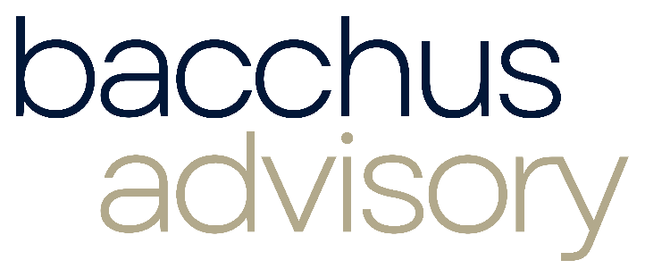
On acceptance we will send you our engagement letter.
Liability limited by a scheme approved under Professional Standards Legislation.

