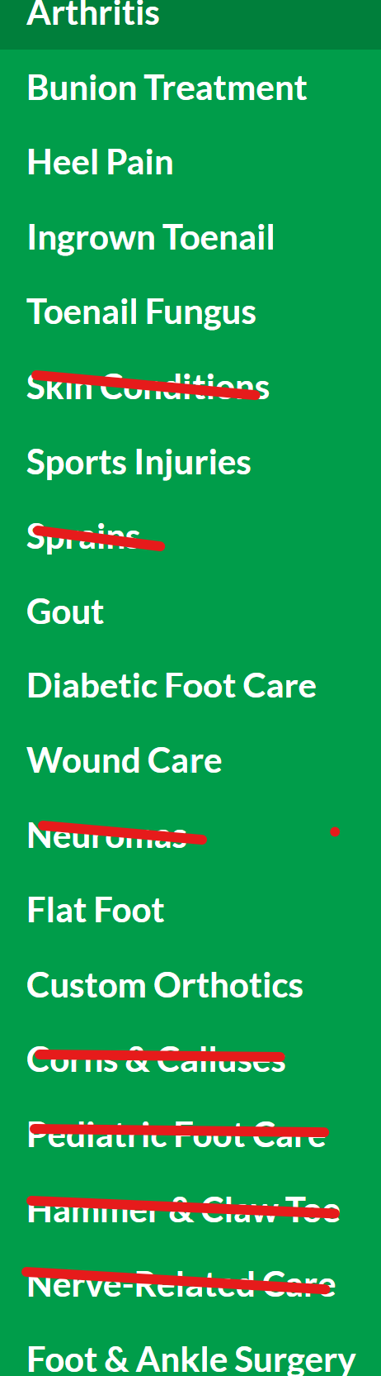

Dr. Jeffrey Petty
Dr. Petty was born in Canton Ohio, across the street from the football Hall of Fame. Dr. P is Board Certified and an Army Accommodation Medal Recipient. He is currently the Texas Podiatry Medicare Representative and sits on the Texas Podiatric Board of Directors.
Dr. Fernando Cruz
Born in Manhattan, NY, Dr. Cruz has always been active in Sports Medicine and is a former college football player. He completed a Reconstructive Foot & Ankle Residency in Cleveland Ohio and is active in the Waxahachie community and at Baylor Scott and White-Waxahachie.
Dr. Amanda Pajouh
Dr. Amanda is a native born Texan raised in Plano, TX. She is Board Certified and after her 3 year surgical residency, she completed a fellowship at UT Southwestern hospital and Parkland hospital in Diabetic Limb Salvage under the plastic surgery department. She is very active in the community and at Baylor Scott and White- Waxahachie.
Dr. Lily Raga
Dr. Raga was raised in Dallas, Texas and is a graduate of University of Texas at Dallas. She completed a 3 year surgical residency at Baylor Scott and White Memorial Hospital in Temple Texas and practices in our Waxahachie and Ennis locations.
Dr. Kent Olsen
Dr. Olsen received his Bachelor degree from Southern Utah University where he was Magna Cum Laude. After graduating from the Arizona School of Podiatric Medicine, he completed a 3 year surgical residency at Baylor Scott and White Memorial Hospital in Temple Texas.

Family Foot & Ankle Centers Locations
Waxahachie Office
1505 W. Jefferson Ave Suite 170
Waxahachie, Tx 75165
Ph: (972) 597-4132
Ennis Office
601 S. Clay St. Suite 105
Ennis, Tx 75119
Ph: (972) 875-3668
Corsicana Office
3229 W. 7th Ave
Corsicana, Tx 75110
Ph: (903) 872-9910

