Branding Brief: Acadiana Mini Splits

Business Overview
Acadiana Mini Splits is the first brand in the region to include “mini split” in its name, making us instantly recognizable in the Acadiana area. We are locally owned and operated by husband-and-wife team Nick and Chelsey Roberie. Mini split systems (also called ductless mini splits) are a type of air conditioning and heating system that work by transferring heat between indoor and outdoor units without using ductwork.
While other local retailers carry well-known mini split brands, we are the only dedicated local wholesaler with real inventory on hand, giving us a distinct competitive advantage in speed, availability, and customer experience.

Brand Identity Goals
We want a brand that is:
- Simple
- Professional
- Memorable
- Designed to leave a lasting impression
We do not have a storefront and currently operate primarily online through digital ads, with plans to grow into social media and a dedicated website. Our logo will serve as the primary visual identity across all marketing, packaging, and customer-facing collateral.

Design Preferences

Logo & Typography
- Prefer a stacked logo layout with “Acadiana” on top
- Like layered font styles and sizes with a mix of thick and thin weights
- Strong preference for clean, modern fonts (like Fat Frank) —no script fonts

Colors
- Our preferred color palette includes shades of blue, gold, and greys

Symbols & Cultural References
- We are proud of Acadiana’s rich culture, but we prefer to avoid clichés like the fleur-de-lis
- We’re open to an abstract animal or cultural symbol that gives a nod to the region but does not have to — something creative, symbolic, and unique
- We like to stay away from symbols of snow/snowflakes, fire/heat, etc. (no cliché)
- We must stay away from tools as we do not provide AC service or installation.
- Symbolism should support a modern, product-oriented wholesale brand, not a tourist or novelty feel

Project Deliverables
We are requesting a complete logo kit and brand identity package, including:
1. Primary Logo
2. Secondary Logo (stacked version)
3. Submark/Icon (for favicons, social media, stickers, etc.)
4. Color Palette and Typography Guidelines
5. Business Card Design

Precedent Graphics We Like
Please refer to the examples of logo designs, color palettes, and brand styles that inspire us.
Preferred:
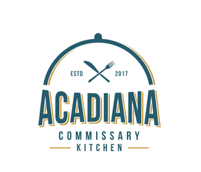
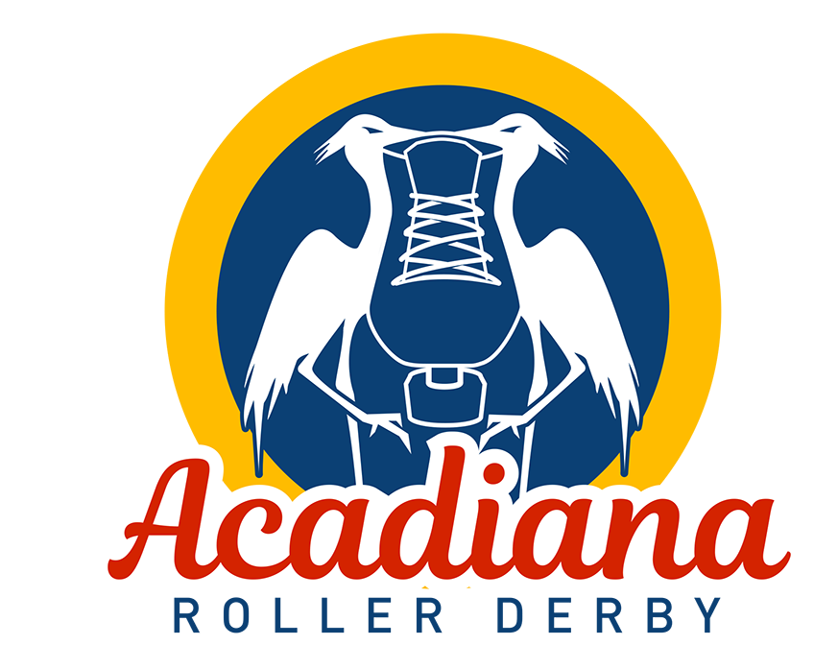

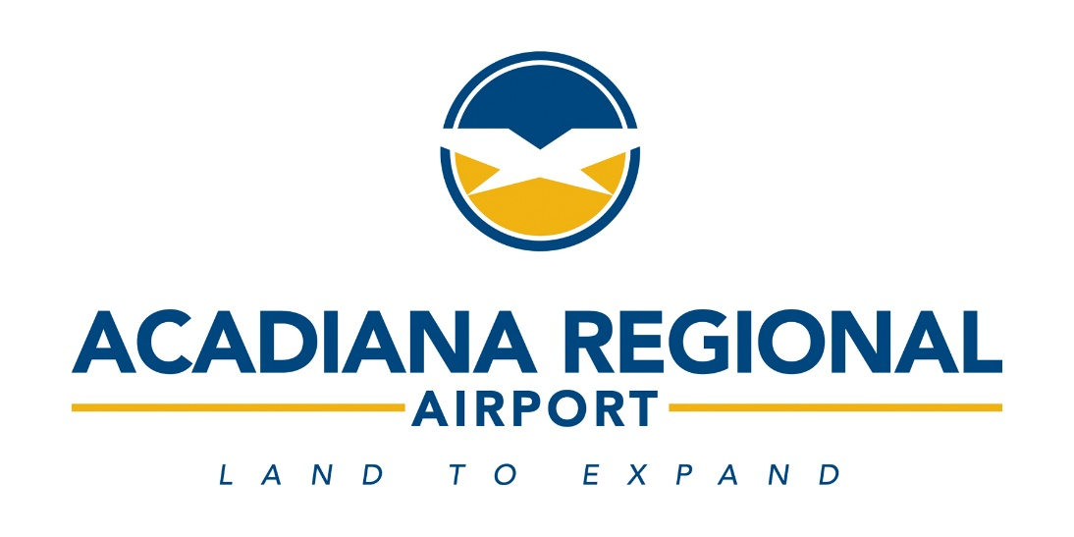
[Insert disliked graphics here]


