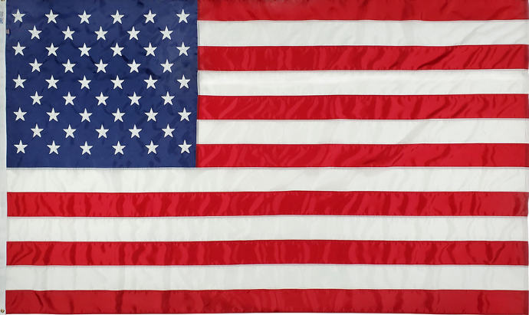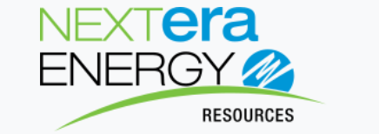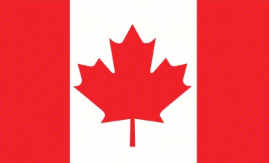
American Flag Company Logo Canadian Flag
General Information:
Company: NextEra Energy Resources:
Division: North Hub (Business unit of Mother Co.)
Unit: Strike Team (subdivision of North hub)

Industry: Wind Turbine Generation
Target Audience: Wind Techs apart of the elite and expeditious “North Hub Strike Team”
Mission: Travel Wind Technicians who swiftly deploy throughout 4 Canadian provinces and 12 Midwest States fixing highly skilled issues. i.e. bearing change outs, rope access, complex troubleshooting and outage recovery.
Style: Modern & Vintage Ideas
Color: Silver, Gold, Bronze, Blue, Navy Blue American and Canadian flags colors and modern colors apply
Logo style: will be used on Coin
Deadline ASAP
Would like to get concepts mock up drafts to vote on before we go to production. will need 1000 coins once a logo is refined.
Main POC: Harry Polenychko (480)353-0982 harry.polenychko@nee.com
Backup: Don Schroeder (712) 830-4759 Donald.Schroeder@nexteraenergy.com or
Trevor Biggs (641) 420-0844 Trevor.Biggs@nexteraenergy.com

Some Concepts from rough AI images below.
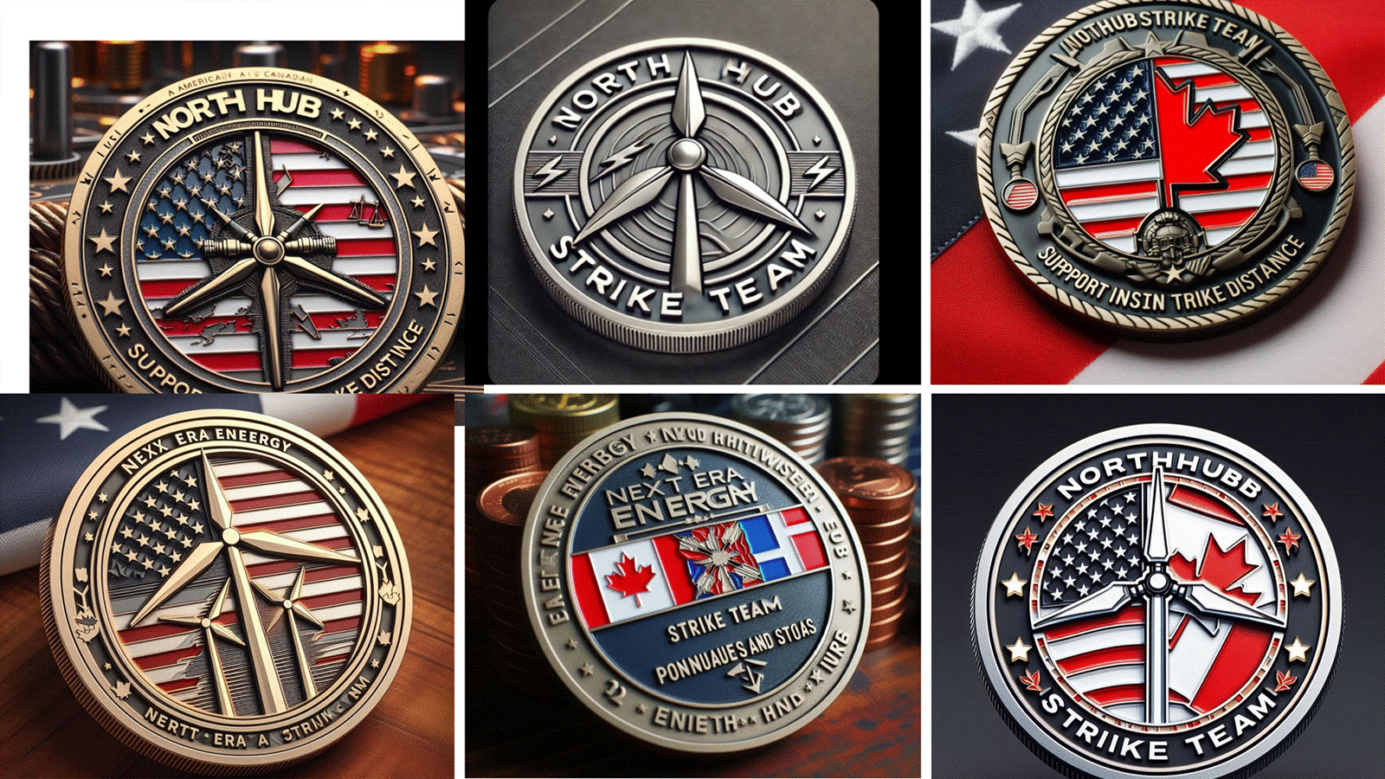

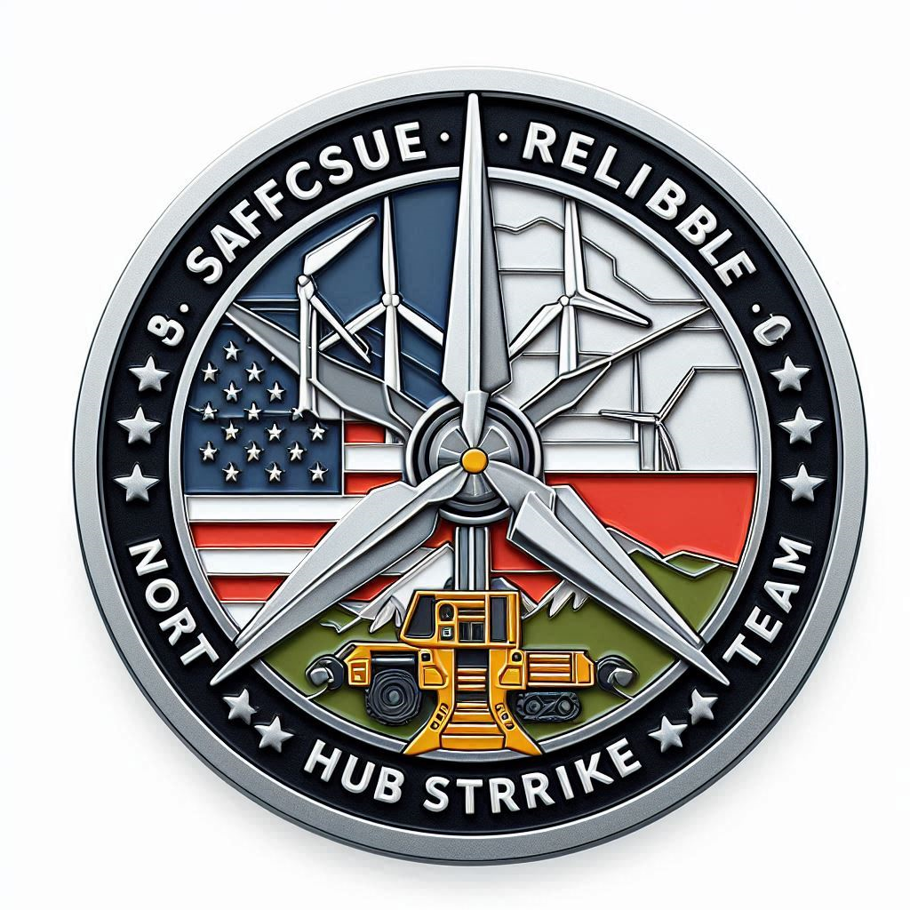
Corrections would include: North Hub Strike Team: Safe Precise, Reliable with wind turbines to look like wind turbines. 16 five point stars and even split of American and Candian Flags with mountains.

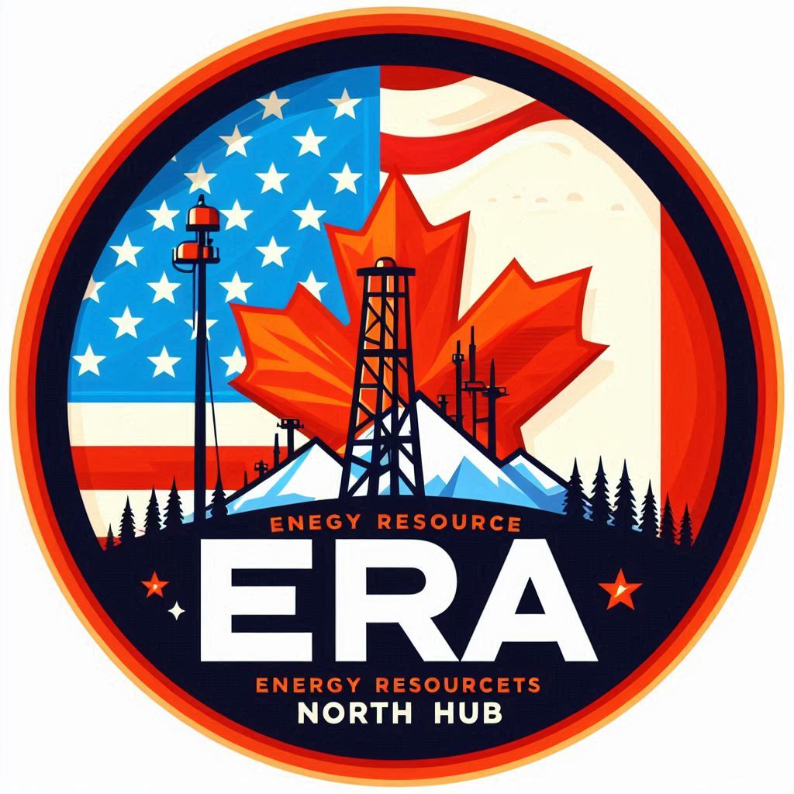
Corrections would include: NextEra Energy Resources/North Hub/Strike Team wind turbines instead of oil rigs and an even split of American and Candian Flags.


This one keep concept of large wind turbine with small ones in back ground, Bronze and Blue that says “North Hub Strike Team” around edge. Better Corn Field and 16 five-point stars.

