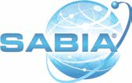
www. sabiainc .com

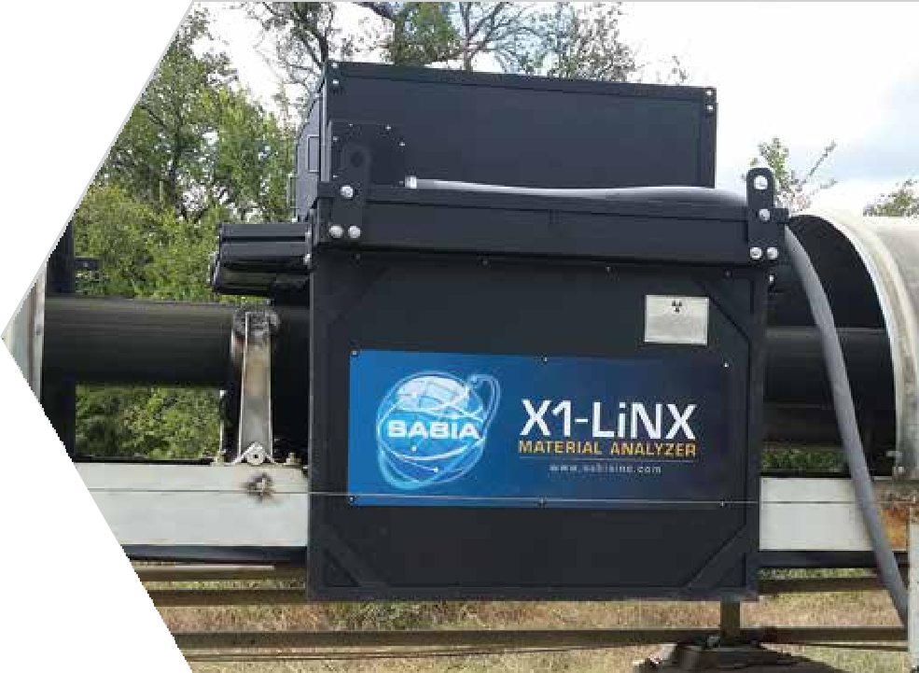

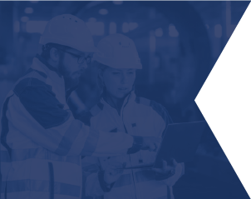
METAL

RECYCLING
WHAT IS
IN THE PRODUCT?
Wouldn’t you like to know what elements such as iron, copper and zinc are in your scrap metal product? Of course you would, because certain elements when present in quantity reduce the price of scrap metal.
Our analyzer will tell you in minutes what the composition of the scrap metal is as it passes through our machine.
EXPLORE WHAT SABIA HAS TO OFFER

Who is SABIA?
We are a twenty-five year old company manufacturing analyzers for twenty-three years of our twen- ty-five year company existence. Our analyzers have been installed all over the world and for a myriad of applications. Therefore, we are experts in this technology and the applications we sell them for.
Recently we were approached to apply our expertise to the metal recycling business and are now selling and installing our analyzers to metal recyclers.
Why do you need an analyzer?
Do you want to know the quality of your scrap metal? Do you want to improve the quality of your scrap metal to obtain a better sale price? “Yes” is the answer to both questions obviously.
Our analyzer can easily tell you what the composition is of the scrap metal material going through it. This would allow pile building to segregate quality levels.

What about “tagging” software to lessen the workload?
We Have That Too!
SOROS tagging software allows operators to easily track the composition of
stockpiles, silos, or loadout batches while automatically comparing TAG groups against quality
specifications and alerting operators accordingly.
Protected by US PATENT see www.sabiainc.com/patent


METAL RECYCLING
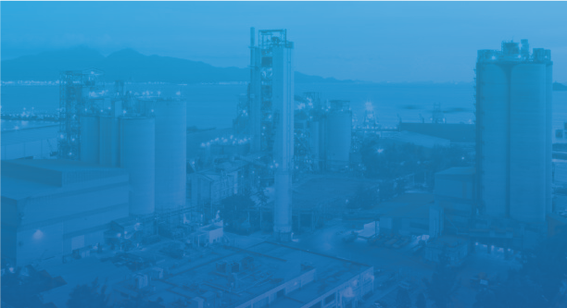
WHAT IS IN THE PRODUCT?
FUNCTIONALITY


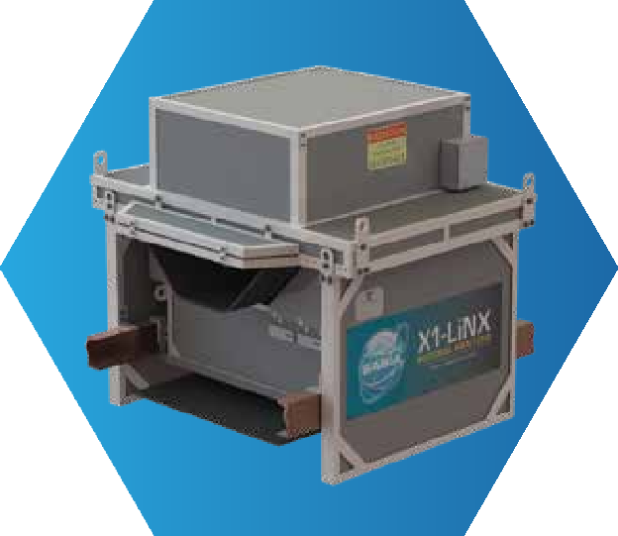
Operator Quality Set Points TAG Start/Stop Times



TAG Compositions Time/Weight Views Pile/Silo/Batch Compositions
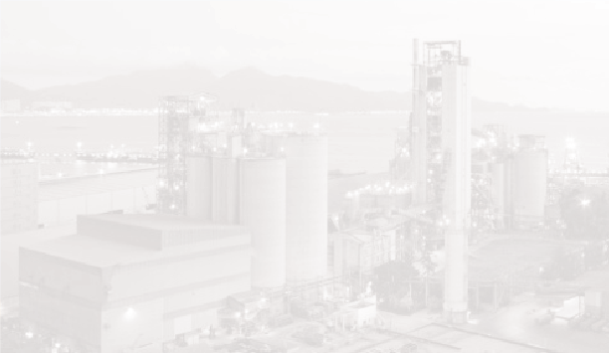

Pile/Silo/Batch Set Point Statuses

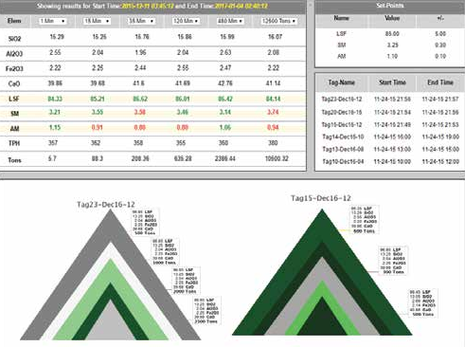









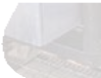


www.sabiainc.com
3000488 RevA
ISO 9001:2008 Certified Company
CONTACT INFORMATION
PHONE : +1-888-SABIAINC (722-4246)
EMAIL : sales@sabiainc.com
ADDRESS : 10919 Technology Place San Diego, CA 92127 USA

