FAQs:

What are the benefits of the Weight Loss Bundle?

Liver Focus is a liver cleanse that Accelerates fat burning, supports liver health, protects against toxins, and improves digestion.

Tummy Focus supports a healthy gut, aids in cleansing the digest tract, improves digestion and promotes the development of beneficial bacteria. Taking Tummy Focus is a simple way to stay regular and relieve occasional constipation relief. When the digestive tract is full of waste and toxins, it can make it more difficult to lose weight while also making you feel heavy and bloated. By cleansing the colon, you may feel less bloated and be able to support a healthier digestion and absorption of nutrients from your foods.

Blood Sugar Focus is a dietary supplement that will help you maintain your health, weight and energy naturally. Blood Sugar Focus is for those who want healthy fat loss and reduction in body weight, including visceral (belly) fat, when combined with a healthy lifestyle. It also increases GLP-1 levels which help you feel full longer so you eat less. This will help control hunger and reduce appetite. Blood Sugar Focus stabilizes blood sugar levels to prevent your body from storing fat and to reduce food cravings, especially for carbs and sugar. Blood Sugar Focus helps to maintain blood glucose levels within the normal range, help support normal insulin sensitivity and help manage a healthy inflammation response.

How to Use the Weight Loss Bundle?

To get the fastest results, start off with a loading dose of Blood Sugar Focus (BSF) which is to take 2 capsules twice a day, WITH MEALS, and always 2 hours away from Liver Focus. As an example, that would be 2 capsules with breakfast and 2 capsules with dinner each day. Then after a month, you can go back to the normal dosage of 2-4 capsules of BSF per day. BSF must be taken 2 hours apart from Liver Focus.

Liver Focus can be taken morning, bedtime and with or without food. Liver focus is 2 capsules the first week, then 3 capsules after that. You can take all the capsules at one time. Many take Liver Focus and Tummy Focus together at bedtime, which is very effective.

For Tummy Focus, you will take 3-5 capsules at bedtime. Start by taking 3 capsules on an empty stomach with 10-12 ounces of water at bedtime. Adjust dose up or down by 1 capsule until the desired cleanse is achieved. Continue this dosage to achieve desired results as directed by a healthcare professional. Be sure to consult your physician.

Do we really need to take Tummy Focus at bedtime?
We do recommend taking Tummy Focus at bedtime so you have a satisfying poop by morning. If you take it during the day, you may have to poop at an inconvenient times. Additionally, it’s important to take with 10-12 ounces of water to help it work more effectively.

Who is Blood Sugar Focus for? Is it just for diabetics and pre-diabetics?

Blood Sugar Focus is for anyone who wants fast, healthy weight loss as well as for diabetics, pre-diabetics, and those with insulin resistance. It has been clinically proven to maintain blood glucose levels within the normal range and help support normal insulin sensitivity. It stabilizes blood sugar levels to prevent your body from storing fat so anyone trying to manage their weight can benefit from it. Remember when you eat carbs, like breads and sugar, it causes our blood sugar to spike which causes fat storage in the body. Blood Sugar Focus helps prevent blood sugar spikes and keeps your body in fat burning mode.

What are the side effects Liver Focus since it's a detox?
There are none reported, but you may experience normal detox symptoms (e.g., fatigue, headaches) during the first week of taking the supplement. Please note that Liver Focus is a powerful detox and just as with any detox, typical detox symptoms like fatigue, headaches, nausea or breakouts can occur. This is temporary and can be reduced by taking 1 capsule and drinking more water to flush out toxins faster.

Blood Sugar Focus features Eriomin®, what is this ingredient?
Eriomin® lemon fruit extract is a patented and clinically-studied ingredient with ground-breaking results. Derived from lemons using a proprietary extraction process, Eriomin® is standardized to contain high levels of eriocitrin, a flavonoid that has shown promising effects on GLP-1 and glucose metabolism. At a clinically-studied dose, Eriomin® is shown to increase GLP-1 levels, support insulin function and promote healthy blood glucose levels in the normal range.

Blood Sugar Focus features Eriomin®, a patented and clinically proven blend for blood glucose management in human clinical trials. Eriomin® has been clinically proven to maintain blood glucose levels within the normal range, help support normal insulin sensitivity and help manage a healthy inflammation response. It has also been clinically proven to reverse prediabetes.

What are the ingredients for Liver Focus?

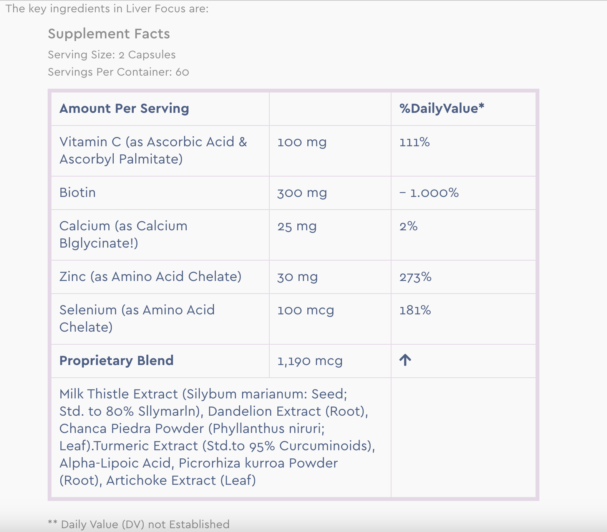

What are the ingredients for Blood Sugar Focus?

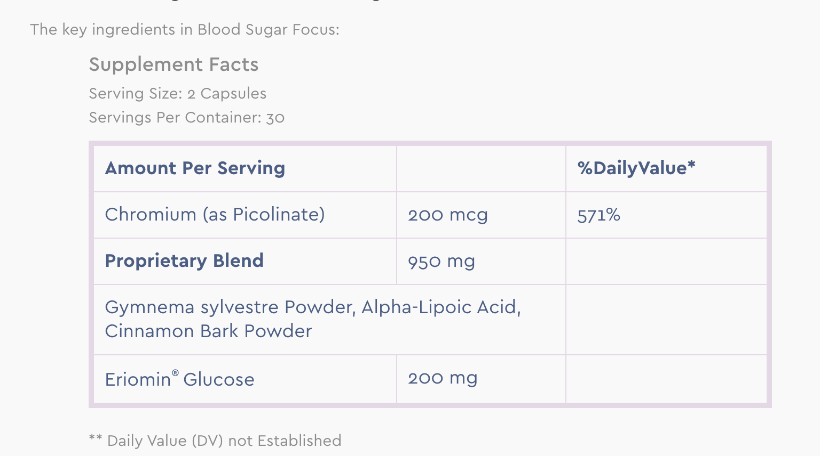

What are the ingredients for Tummy Focus?

