Weight Loss Bundle
The Ultimate Trio to Help you Burn Fat, Slim Down and See Faster Results*
Achieve your weight loss goals with the Weight Loss Bundle, a powerful combination of Tummy Focus, Liver Focus, and Blood Sugar Focus—designed to optimize digestion, detox your liver, and stabilize blood sugar for faster, healthier weight loss.

Why Choose the Weight Loss Bundle?
Losing weight isn’t just about cutting calories—it’s about supporting your body’s natural fat-burning processes. This all-in-one bundle works synergistically to:
- Boost overall metabolism – Keep your body in fat-burning mode all day long
- Support liver detoxification – Eliminate toxins and accelerate the body’s ability to burn fat (Liver Focus)
- Enhance digestion & regularity – Flush out waste and improve nutrient absorption (Tummy Focus)
- Balance blood sugar – Prevent energy crashes and support fat loss (Blood Sugar Focus)
With this three-pronged approach, you’ll break through weight loss plateaus, feel lighter, and stay energized!



What’s Inside the Weight Loss Bundle?

Tummy Focus – Gut Health & Digestive Cleansing
- Supports Healthy Digestion – Helps break down food more efficiently and absorb nutrients better for less bloating
- Cleanses the Digestive Tract – Promotes gentle detoxification to remove waste buildup and support a flatter tummy
- Relieves Occasional Constipation – Provides natural, non-habit-forming relief for digestive discomfort.
- Encourages a Balanced Gut Microbiome – Helps good bacteria thrive for overall gut health
- Fast-Acting Yet Gentle – Works effectively without cramping or urgency.

[LEARN MORE]
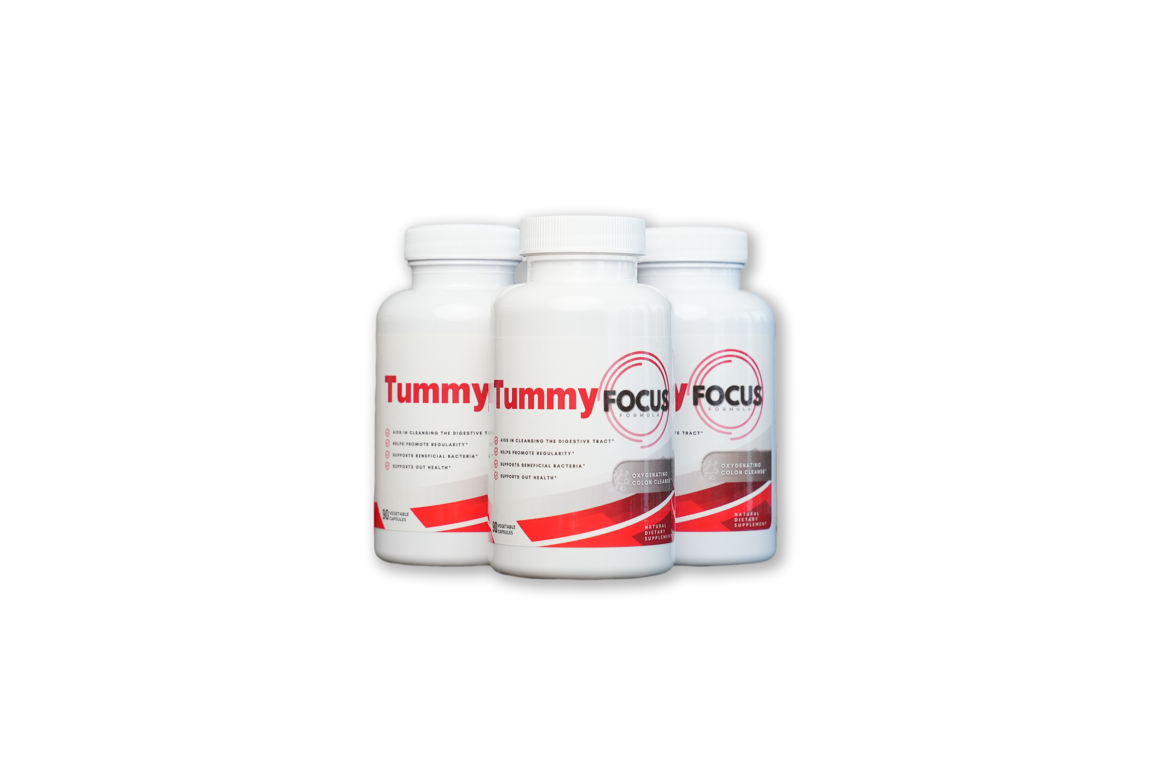

Liver Focus – Detox & Fat Metabolism
- Boosts Your Body’s Ability to Burn Unwanted Fat: A properly functioning liver helps your body process fat more efficiently, supporting healthy weight loss.
- Promotes Digestive Health – Supports optimal bile production for better digestion and nutrient absorption
- Supports Liver Detoxification – Helps flush out toxins, promoting a healthy and efficient liver
- Protects Against Toxins & Free Radicals – Packed with antioxidants that help defend against oxidative stress
- Enhances Overall Health – A clean, healthy liver means better energy, clearer skin, and improved well-being

[LEARN MORE]
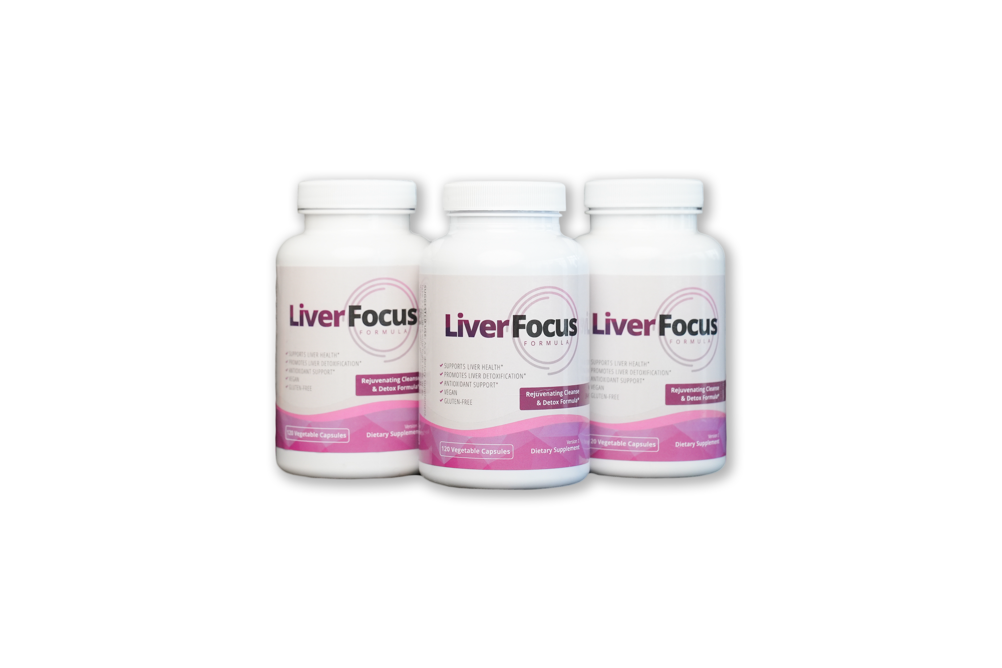

Blood Sugar Focus – Stabilize & Support Fat Loss:

- Naturally increase GLP-1 levels (with clinically-tested ingredients) so you eat less and stay full longer, reducing appetite*
- Support fat loss, accelerate fat burning and reduce body weight, including visceral (belly) fat, when combined with a healthy lifestyle (Lose Fat, Not Muscle)*
- By boosting GLP-1, your body sends signals to the brain that reduce cravings, quiet food noise, and help you feel full longer—naturally.*
- For anyone who wants fast, healthy weight loss as well as for diabetics, pre-diabetics, and those with insulin resistance*
- Support healthy blood sugar levels to prevent your body from storing fat and to reduce food cravings, especially for carbs and sugar*
[LEARN MORE]

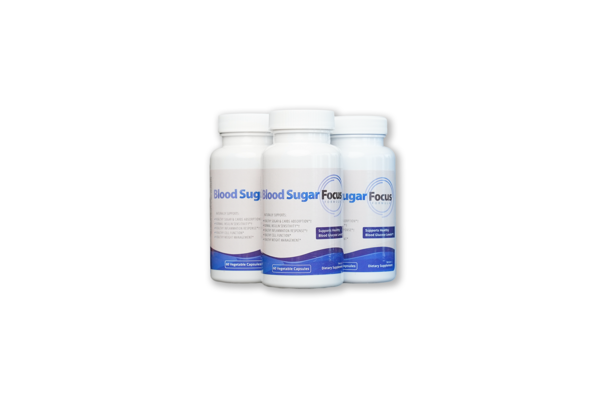

Real People, Real Results

VIDEO and Photo testimonials (UGC)
<Insert photos and videos of women holding the bottle throughout the page>

https://www.dropbox.com/scl/fo/99iledvn2bpafnm9njq9c/ACv0lzXxHRQUpvBfmNHKsjg?rlkey=jxbuclxwgtht6sr753rjjok0e&st=pyiyu1kz&dl=0

Who Is the Weight Loss Bundle For?
- Anyone struggling with slow weight loss?
- Those dealing with bloating, sluggish digestion, or irregularity
- Individuals looking to detox and boost their metabolism
- People who experience sugar cravings, energy crashes, or blood sugar spikes
- Anyone who wants a natural, science-backed way to support weight management
This bundle is your ultimate weight loss support system—helping you reset your metabolism, cleanse your system, and shed stubborn fat.

Powerful Ingredients, Backed by Science
Each product in the Weight Loss Bundle is formulated based on scientific research:
The Magnesium Oxide blend in Tummy Focus promotes gentle and effective colon cleansing, helping clear waste buildup for better digestion and improved gut health. Magnesium is clinically recognized for its ability to aid digestion, regulate bowel movements, and prevent bloating.

Milk Thistle in Liver Focus supports liver detoxification and enhances fat metabolism, crucial for weight loss and overall wellness. Studies suggest it may help improve liver function and protect against damage caused by toxins, alcohol, and fatty liver disease

Eriomin® in Blood Sugar Focus has been shown to increase GLP-1, a hormone that plays a crucial role in blood sugar regulation and appetite control. It has been clinically researched for its role in supporting healthy blood sugar levels and metabolic function.

[UGC VIDEO TESTIMONIALS]

https://www.dropbox.com/scl/fo/99iledvn2bpafnm9njq9c/ACv0lzXxHRQUpvBfmNHKsjg?rlkey=jxbuclxwgtht6sr753rjjok0e&st=z5mu3tg5&dl=0

What to Expect When Taking the Weight Loss Bundle
The Weight Loss Bundle (Blood Sugar Focus, Liver Focus, and Tummy Focus) is designed to work synergistically to support fat metabolism, balance blood sugar, detoxify the liver, and optimize digestion. Here’s what you can expect over three months with consistent use:

Week 1-4: Kickstarting Fat Burning & Detoxification
✔️ Liver Focus supports liver detox, allowing for more efficient fat metabolism
✔️ Blood Sugar Focus helps stabilize blood sugar levels, reducing cravings and energy crashes
✔️ Tummy Focus promotes regularity and digestive cleansing to help eliminate waste buildup
What you may notice: Less bloating, improved digestion, and fewer sugar cravings. Some may begin to experience gradual weight loss as the body adjusts.

Month 2: Accelerated Fat Loss & Enhanced Metabolism
✔️ The liver is more efficient at processing fat and removing toxins
✔️ More stable blood sugar levels help curb appetite and reduce fat storage
✔️ Gut health improves, leading to better digestion and nutrient absorption
What you may notice: More sustained energy, a noticeable reduction in bloating, and steady weight loss as metabolism improves.

Month 3: Sustained Weight Loss & Long-Term Balance
✔️ Liver function is optimized, supporting continued fat metabolism
✔️ Balanced blood sugar levels help maintain a steady weight and prevent crashes
✔️ A clean and balanced gut promotes long-term digestive health
What you may notice: A leaner, more energized feeling with consistent weight loss, fewer cravings, and improved digestion.
For best results, stay hydrated, maintain a balanced diet, and stay active while using the Weight Loss Bundle for long-term success!

[Testimonials/ Before and After Photos]

https://www.dropbox.com/scl/fo/99iledvn2bpafnm9njq9c/ACv0lzXxHRQUpvBfmNHKsjg?rlkey=jxbuclxwgtht6sr753rjjok0e&st=z5mu3tg5&dl=0

<FAQ: Insert FAQs from other WORD DOCUMENT ATTACHED>

Still Unsure If the Weight Loss Bundle Is Right for You?
We get it—choosing the right supplements is a big decision! That’s why we’re offering 10% off your first order when you subscribe today.
Have questions? Our team is here to help.
Get the Weight Loss Bundle & Start Your Transformation Today!

[LEAVE SPACE FOR OKENDO REVIEWS]

