Tummy Focus

A Natural Digestive Cleanser to Support a Healthy Gut and a Flatter Tummy*

Feel Lighter, Less Bloated and More Energized with Gentle Digestive Support
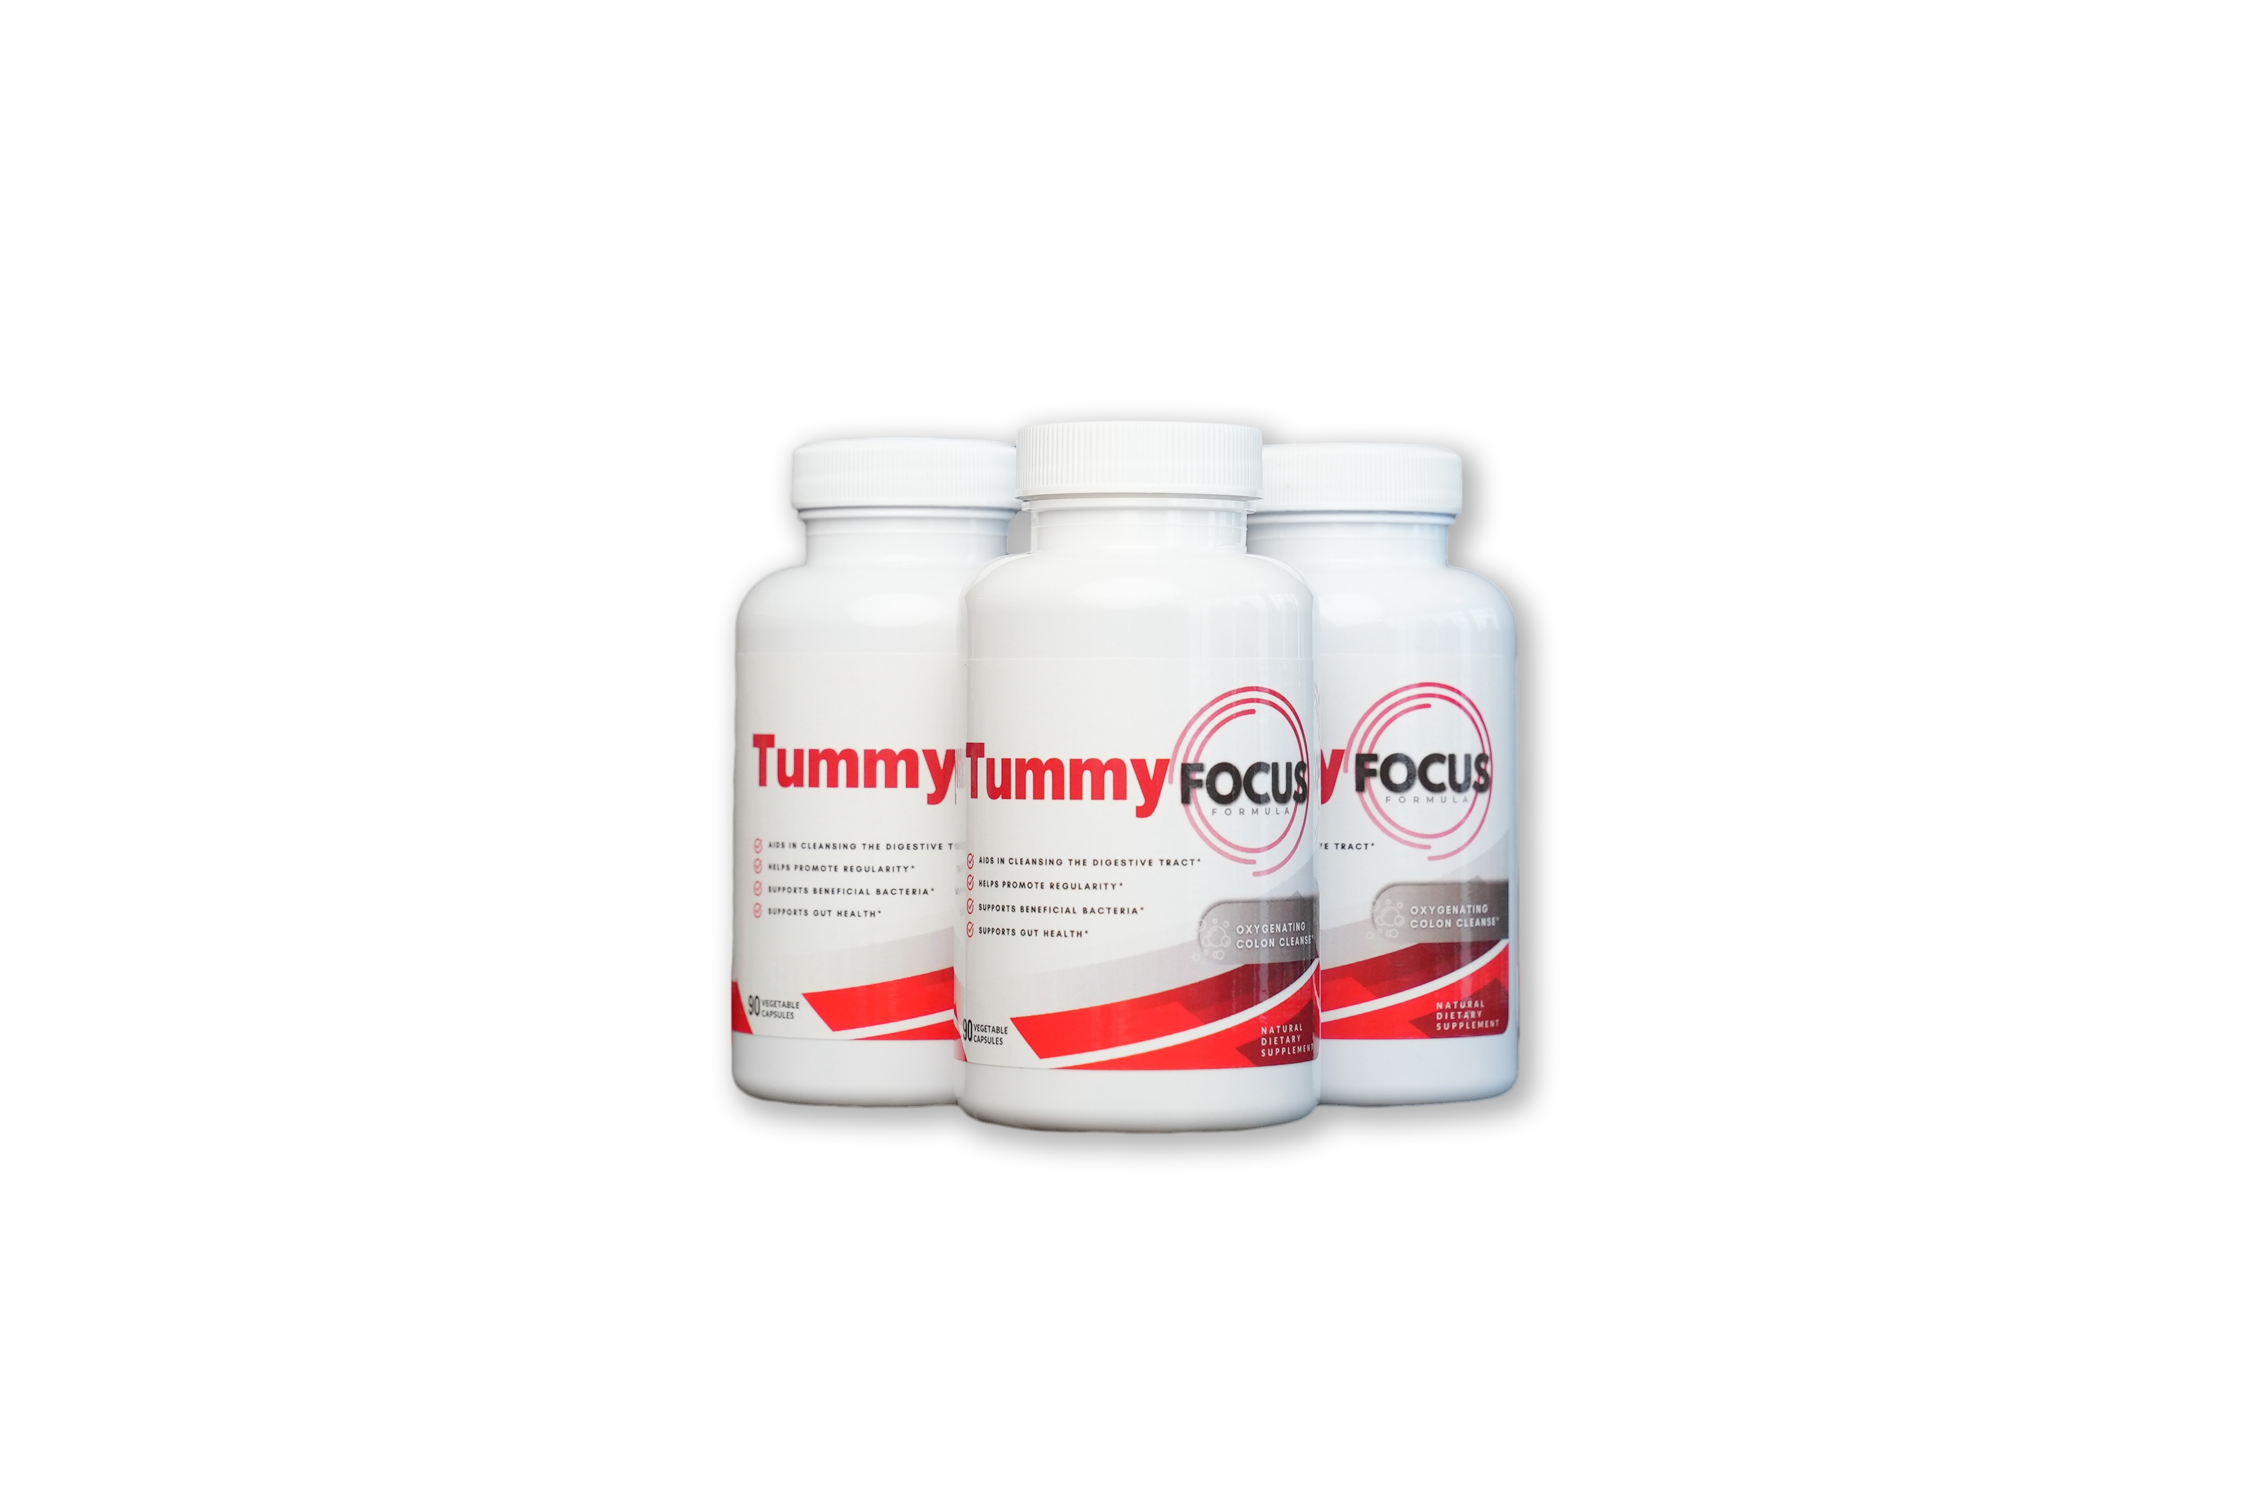

Your gut health affects everything—from digestion and metabolism to immunity and overall well-being. If you struggle with bloating, sluggish digestion, or occasional constipation, Tummy Focus is here to help! This advanced gut-support formula gently cleanses the digestive tract, supports regularity, and promotes a balanced gut microbiome—all without harsh laxatives.

Why Choose Tummy Focus?
- Supports Healthy Digestion – Helps break down food more efficiently and absorb nutrients better for less bloating
- Cleanses the Digestive Tract – Promotes gentle detoxification to remove waste buildup and support a flatter tummy
- Relieves Occasional Constipation – Provides natural, non-habit-forming relief for digestive discomfort.
- Encourages a Balanced Gut Microbiome – Helps good bacteria thrive for overall gut health
- Fast-Acting Yet Gentle – Works effectively without cramping or urgency.



Real People, Real Results

VIDEO and Photo testimonials (UGC)
<Insert photos and videos of women holding the bottle throughout the page>

https://www.dropbox.com/scl/fo/lx86q9gi17xmrnnzlzavi/AHi4iAJzX5RcBNuf1pNihl8?rlkey=p8fnq43q87bzz6wnl96ovzhqb&st=4bop19ee&dl=0

Powerful Ingredients, Backed by Science
This Magnesium Oxide blend is scientifically designed to release oxygen in the digestive tract, helping to cleanse waste buildup, promote hydration, and support gut bacteria. Magnesium is clinically recognized for its ability to aid digestion, regulate bowel movements, and prevent bloating.
Studies suggest that oxygenated magnesium compounds effectively relieve occasional constipation and support a healthy gut microbiome without dependency or irritation.
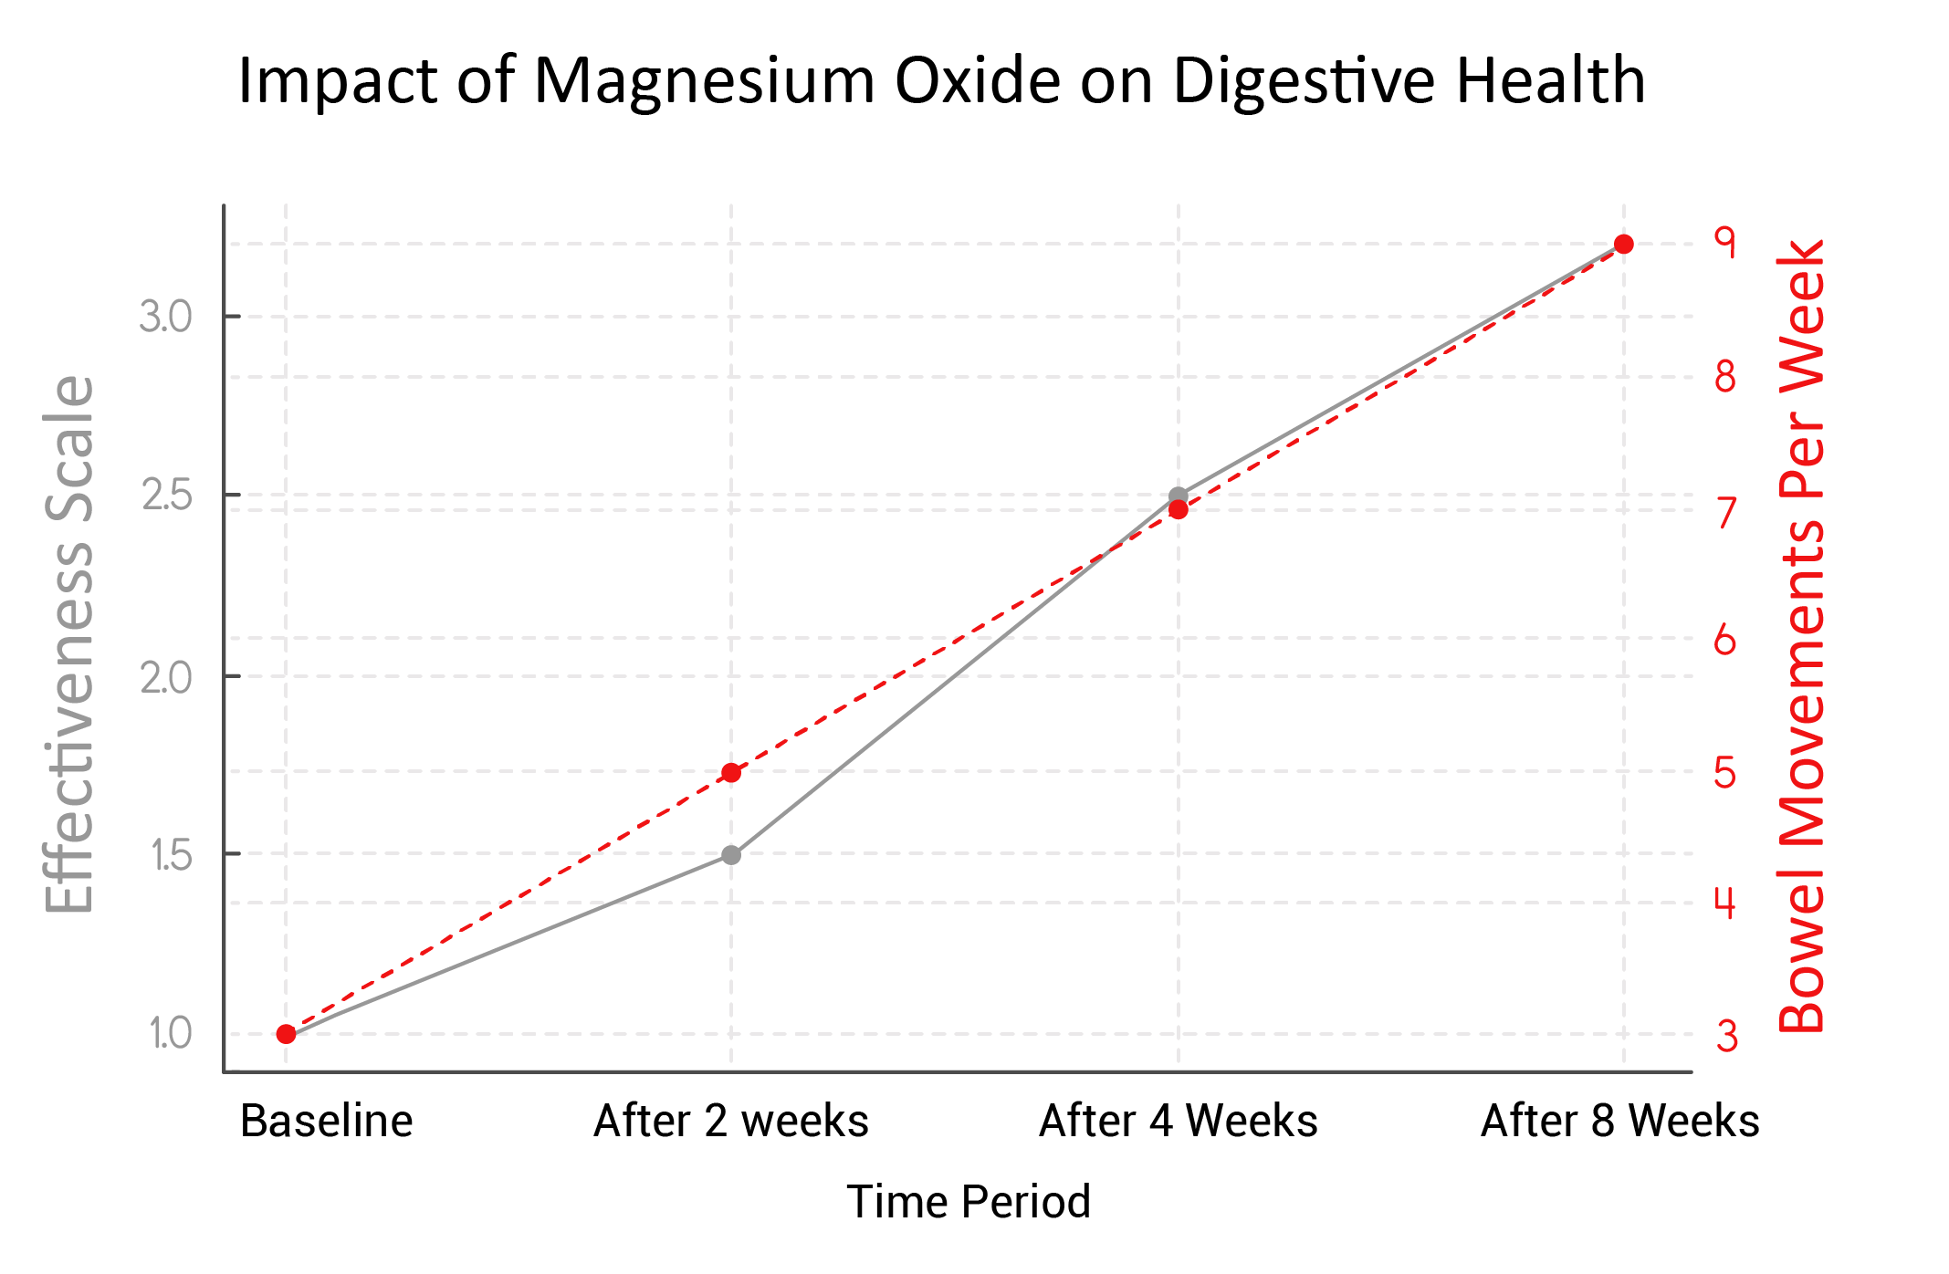
An illustrative graph showing the impact of Magnesium Oxide on digestive health. It presents improvements in gut health effectiveness and bowel movement frequency over time.

Ready to Support Your Gut Health Naturally?
Tummy Focus is backed by research and designed to gently cleanse, support digestion, and promote gut balance—without harsh laxatives or discomfort. If you're ready to experience smoother digestion and improved regularity, now is the time to take action!
Subscribe today and get 10% off your first order!
🔹 Fast-acting, gentle formula
🔹 Supports regularity & digestive health
🔹 Promotes a balanced gut microbiome
Click below to start your journey to better gut health!
[GET TUMMY FOCUS NOW]

Who Is Tummy Focus For?
- Anyone Struggling with Occasional Constipation – If you experience bloating or irregularity, Tummy Focus helps support natural elimination.
- Anyone Wanting to Feel Lighter and Slimmer – This formula helps eliminate waste and toxins so you feel lighter with less bloating.
- Those Looking for a Gentle Colon Cleanse – This formula supports detoxification without harsh effects, making it ideal for maintaining gut health.
- People Who Want to Improve Digestion & Nutrient Absorption – A clean digestive system leads to better nutrient absorption and less bloating.
- Individuals Seeking Long-Term Gut Health Support – Unlike quick-fix laxatives, Tummy Focus encourages a healthy gut environment by promoting good bacteria.

Our Customers are Loving Their Results
<ADD BEFORE AND AFTER PICS>
https://www.dropbox.com/scl/fo/lx86q9gi17xmrnnzlzavi/AHi4iAJzX5RcBNuf1pNihl8?rlkey=p8fnq43q87bzz6wnl96ovzhqb&st=4bop19ee&dl=0

What to Expect When Taking Tummy Focus
Supporting gut health and digestion is a gradual process. Tummy Focus is formulated to promote regularity, cleanse the digestive tract, and encourage the growth of beneficial gut bacteria. Here’s what you can expect over time with consistent use:

Week 1: Gentle Cleansing & Improved Regularity
✔️ Ozonated magnesium oxide begins to break down waste and support natural detoxification
✔️ Magnesium & Citric Acid work together to draw water into the intestines, softening stool and promoting regular bowel movements
✔️ Helps relieve occasional bloating and discomfort
What you may notice: Easier, more consistent bowel movements and less bloating.

Week 2-4: Deep Gut Support & Digestive Balance
✔️ Continued cleansing of the digestive tract, flushing out toxins and old waste
✔️ Reduction in occasional gas, bloating, and sluggish digestion
✔️ Encourages a healthier gut microbiome by creating an optimal environment for beneficial bacteria
What you may notice: A lighter, less bloated feeling, improved digestion, and more consistent bowel habits.

Month 2-3: Ongoing Detox, Gut Health, & Energy Boost
✔️ The gut lining is better supported, leading to improved nutrient absorption
✔️ Reduced digestive discomfort and improved long-term regularity
✔️ A cleaner digestive system helps support energy levels and overall well-being
What you may notice: Enhanced digestion, more energy, a slimmer-looking waistline and a sense of overall wellness as your body continues to detox and rebalance.
For best results, maintain proper hydration, eat fiber-rich foods, and use Tummy Focus consistently to support long-term digestive health!



Why Customers Love Liver Focus
INSERT UGC VIDEOS
https://www.dropbox.com/scl/fo/lx86q9gi17xmrnnzlzavi/AHi4iAJzX5RcBNuf1pNihl8?rlkey=p8fnq43q87bzz6wnl96ovzhqb&st=4bop19ee&dl=0

How Do You Know If Tummy Focus Is Right for You?
If you’re struggling with digestive discomfort, occasional constipation, or irregularity, Tummy Focus could be the solution you need. Here are some signs that Tummy Focus may be right for you:

- You experience occasional constipation – If you often feel bloated, sluggish, or struggle with infrequent bowel movements, Tummy Focus provides gentle support to promote regularity.
- You feel heavy or bloated after eating – If digestion feels slow or uncomfortable, Tummy Focus aids in breaking down food and improving nutrient absorption.
- You’re looking for a natural digestive cleanse – Unlike harsh laxatives, Tummy Focus gently supports the body’s natural detoxification process, helping eliminate waste efficiently.
- You have an imbalanced gut microbiome – A healthy gut is key to overall well-being. Tummy Focus helps cleanse the digestive tract, creating an optimal environment for beneficial gut bacteria to thrive.
- You want to support long-term gut health – Taking proactive steps for digestive wellness can improve your energy, metabolism, and overall well-being.

If any of these sound familiar, Tummy Focus can help restore digestive balance and keep you feeling light, refreshed, and regular.

Want Faster Weight Loss? Try the Complete Weight Loss Bundle!
While Tummy Focus provides powerful support for gut health, combining it with our full Weight Loss Bundle takes your results to the next level.

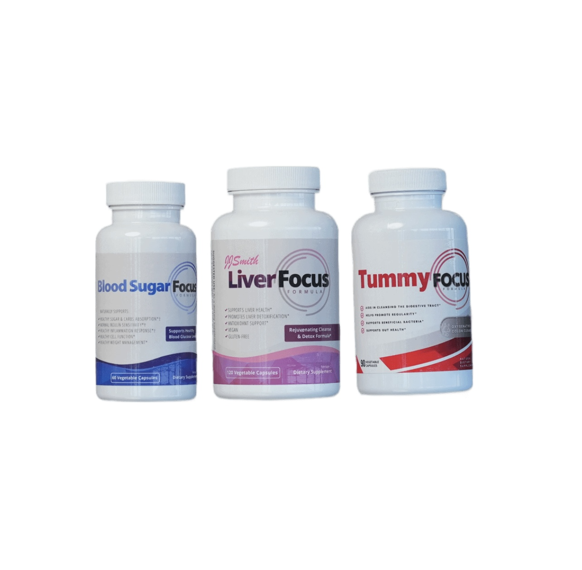
The Weight Loss Bundle includes:
- Liver Focus – A liver detox that accelerates fat burning in the body and supports liver health
- Tummy Focus –Improves digestion, promotes regularity, reduces bloating and supports gut health

- Blood Sugar Focus – Supports fat loss, reduces craving and stabilizes blood sugar
Why bundle? These three products work synergistically to reset your metabolism, eliminate waste, and keep your body in fat-burning mode.
Bundle & Save! Get all three at a discounted price for the ultimate full-body weight management support.
Upgrade to the Weight Loss Bundle & Save Now!

Still Unsure If Tummy Focus Is Right for You?
We get it—gut health is personal! That’s why we’re offering 10% OFF your first order when you subscribe.
🔹 Support your digestion naturally
🔹 Stay regular and feel lighter
🔹 Enjoy a balanced gut and better well-being
Subscribe today and save 10%! ORDER NOW
[sign up form]

FAQs

<FAQ: Insert FAQs from other WORD DOCUMENT ATTACHED>

[LEAVE SPACE FOR OKENDO REVIEWS]

