Liver Focus

All-Natural Liver Cleanse to Enhance the Body’s Ability to Burn Fat
Your liver is your body’s natural detox powerhouse, working 24/7 to break down toxins, process fats, and support digestion. But with modern lifestyles filled with processed foods, environmental toxins, and stress, your liver can become overburdened—leading to sluggish metabolism, poor digestion, and difficulty losing weight.
Liver Focus is a science-backed liver support formula designed to help your body detox naturally, accelerate fat burning, and optimize digestion. Whether you want to support liver function, improve metabolism, or promote overall wellness, Liver Focus is your go-to daily liver cleanse.

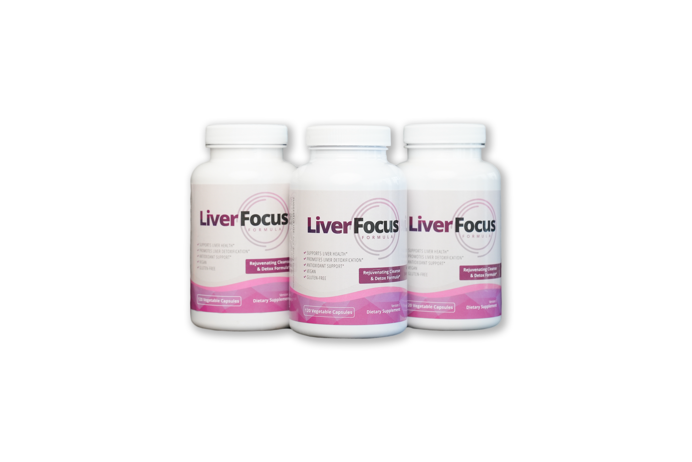

Why Choose Liver Focus?
- Boosts Your Body’s Ability to Burn Unwanted Fat: A properly functioning liver helps your body process fat more efficiently, supporting healthy weight loss.
- Promotes Digestive Health – Supports optimal bile production for better digestion and nutrient absorption
- Supports Liver Detoxification – Helps flush out toxins, promoting a healthy and efficient liver
- Protects Against Toxins & Free Radicals – Packed with antioxidants that help defend against oxidative stress
- Enhances Overall Health – A clean, healthy liver means better energy, clearer skin, and improved well-being

Real People, Real Results

VIDEO and Photo testimonials (UGC)
<Insert photos and videos of women holding the bottle throughout the page>

https://www.dropbox.com/scl/fo/l794sfz0zpvcf1jy0y84a/ACGS6ikEDwCJ6LkfoED2ZV8?rlkey=oq3uei4exh94nrlydm5xogzjj&st=mg9go5ik&dl=0

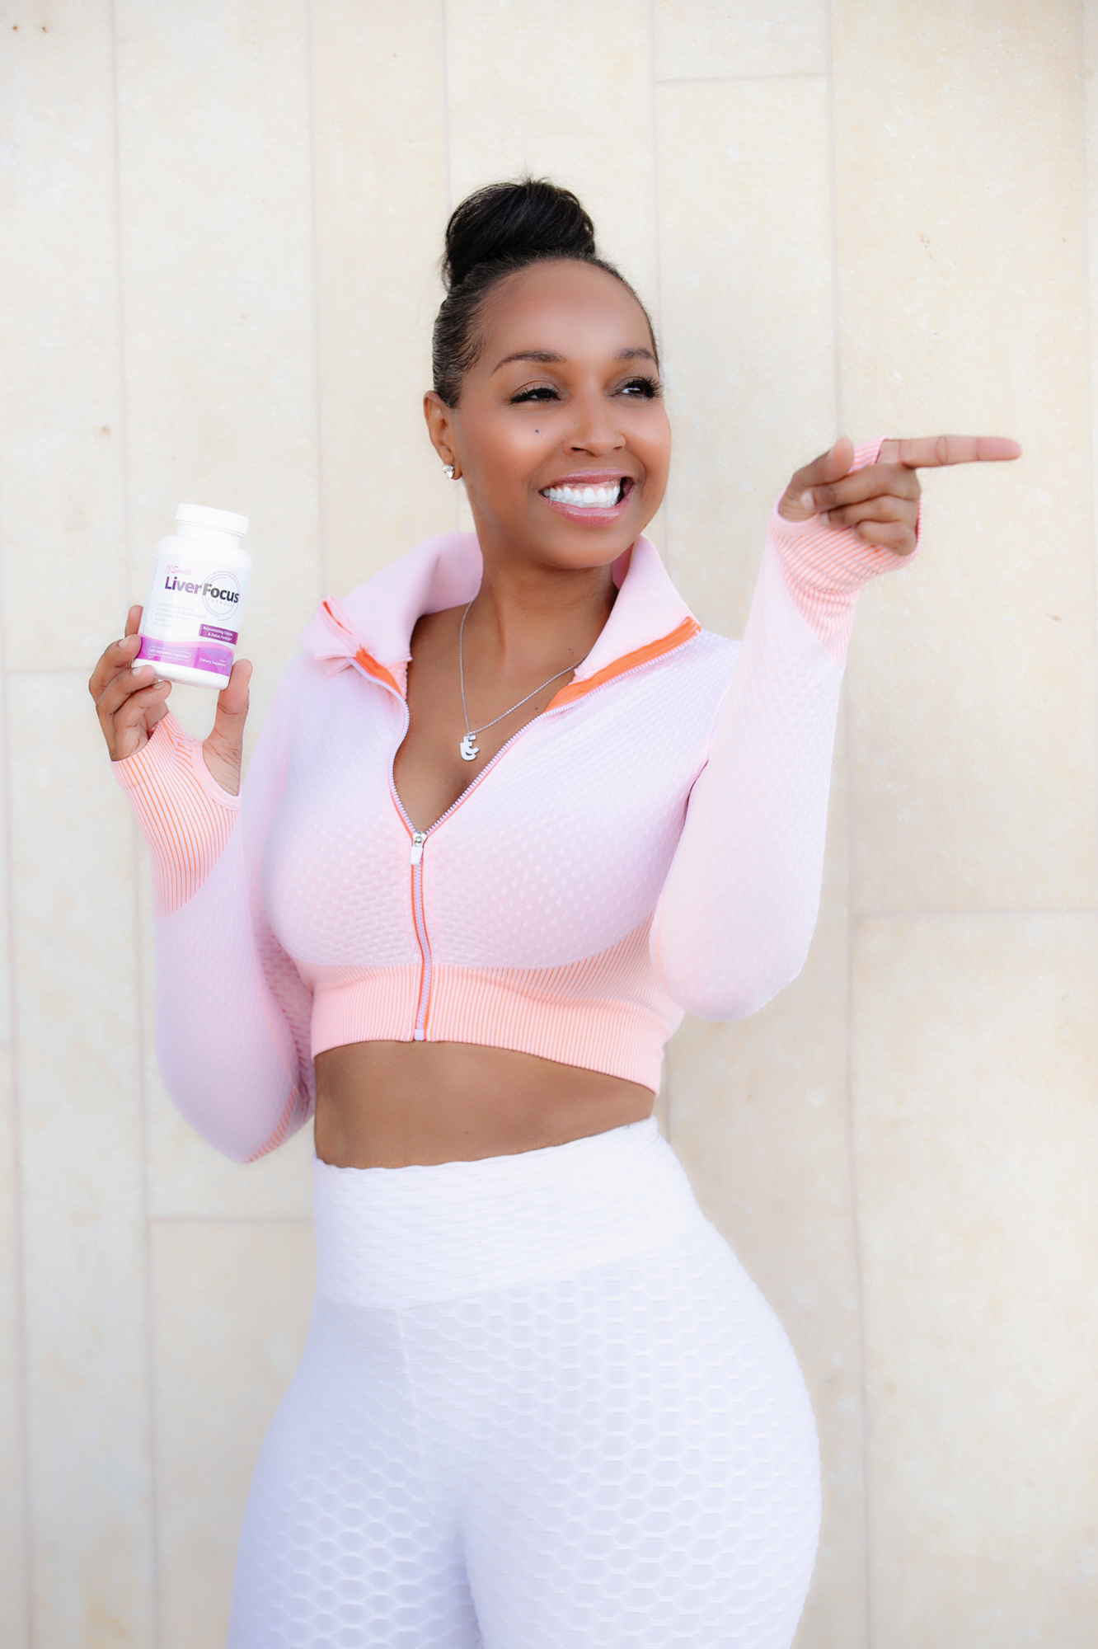

Backed by Science – Powerful Ingredients for Liver Health
Liver Focus isn't just another cleanse—it’s backed by research on clinically studied ingredients known for their powerful liver-supporting properties.
Milk Thistle Extract – The Ultimate Liver Protector
Milk Thistle (Silybum marianum); Studies suggest it may help improve liver function and protect against damage caused by toxins, alcohol, and fatty liver disease. Some research indicates it can support liver cell regeneration and reduce inflammation. (Mount Sinai)
Alpha-Lipoic Acid – A Potent Antioxidant for Liver Health
ALA: a powerful antioxidant that plays a key role in detoxification. Research suggests that it may help reduce liver inflammation, improve lipid metabolism, and support those with non-alcoholic fatty liver disease (NAFLD). (Scientific Research Publishing)
Turmeric Extract – Nature’s Anti-Inflammatory Powerhouse
Curcumin: the active compound in turmeric, is well-documented for its anti-inflammatory and antioxidant properties. Studies show it may help protect the liver from oxidative damage, reduce liver fibrosis, protect liver cells and improve overall liver function. (SAGE Journals)
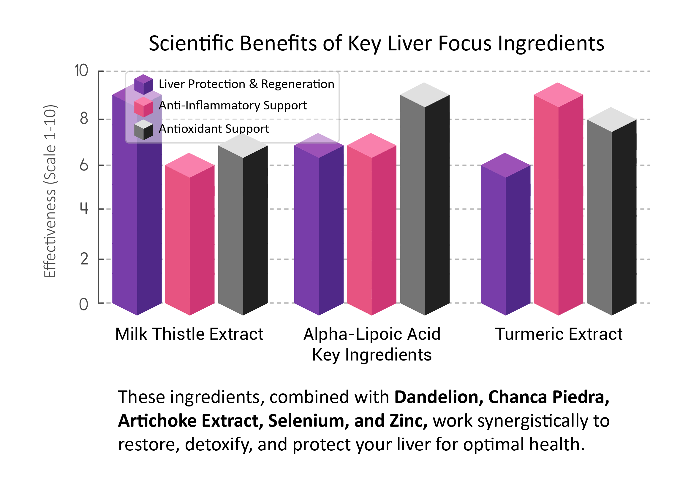
Other Key Ingredients that Enhance the Effectiveness of Liver Focus
Dandelion Root Extract – Known for its natural cleansing properties, dandelion helps flush out excess toxins and supports bile production for improved digestion.
Chanca Piedra Powder – Traditionally used in herbal medicine, this powerful ingredient supports liver detoxification and helps protect against oxidative stress.
Artichoke Extract – Helps stimulate bile production, aiding digestion, fat breakdown, and overall liver function.
Zinc, Selenium & Biotin – These essential minerals support liver enzyme function, protect against oxidative stress, and promote overall detoxification.

Take Charge of Your Liver Health Today!
Your liver works tirelessly to detoxify, metabolize, and keep your body in balance—give it the support it deserves with Liver Focus. With a science-backed formula featuring Milk Thistle, Alpha-Lipoic Acid, and Turmeric Extract, you can help protect, cleanse, and optimize your liver function every day.
Order now and get 10% off your first purchase when you subscribe!
Shop Liver Focus Now

Who Is Liver Focus For?
Anyone Looking to Accelerate Fat Burning – Your liver plays a crucial role in metabolizing fat. If you're experiencing stubborn weight gain, especially around the midsection, Liver Focus helps optimize liver function so your body can burn fat more efficiently.
Those Feeling Sluggish and Low on Energy – If you often wake up feeling drained and fatigued, even after a full night’s sleep, your liver might be overloaded with toxins. Liver Focus helps detoxify and revitalize your body, leaving you feeling refreshed and energized.
Individuals Looking to Detox from Toxins & Environmental Pollutants – Our modern lifestyle exposes us to toxins from processed foods, pollution, alcohol, and medications. These toxins build up in the liver, affecting overall health. Liver Focus contains powerful detoxifying ingredients to help your liver function at its best.
Anyone Who Wants Clearer Skin and a Healthier Complexion – Your liver is responsible for filtering out toxins that could cause breakouts, dull skin, and inflammation. By supporting your liver’s natural detoxification process, Liver Focus helps promote clearer, healthier skin from the inside out.
Those Concerned About Long-Term Liver Health – Whether you consume alcohol, have a high-fat diet, or simply want to proactively protect your liver, this formula provides science-backed ingredients that nourish and defend your liver cells against oxidative stress.
If any of these sound like you, it’s time to give your liver the support it needs!
Order Liver Focus Today and experience the difference

Our Customers are Loving Their Results
<ADD BEFORE AND AFTER PICS>
https://www.dropbox.com/scl/fo/l794sfz0zpvcf1jy0y84a/ACGS6ikEDwCJ6LkfoED2ZV8?rlkey=oq3uei4exh94nrlydm5xogzjj&st=mg9go5ik&dl=0

Order Liver Focus Now



What to Expect When Taking Liver Focus
Supporting your liver takes time, but Liver Focus is formulated to help detox, nourish, and optimize liver function efficiently. Here’s what you can expect over three months of consistent use:

Month 1: Detox & Digestion Reset
✔️ Milk Thistle and Dandelion Extract begin flushing out toxins
✔️ Turmeric and Artichoke Extract support bile production for better digestion
✔️ Alpha-Lipoic Acid and Selenium help protect liver cells from oxidative stress
What you may notice: Less bloating, improved digestion, and a "lighter" feeling as your body starts eliminating toxins.

Month 2: Fat Metabolism & Energy Boost
✔️ Liver enzymes start optimizing for improved fat metabolism
✔️ Zinc and Biotin help support liver cell function and repair
✔️ Energy levels improve as the liver processes nutrients more efficiently
What you may notice: Increased energy, reduced sluggishness, improved fat loss and better digestion of fatty foods.

Month 3: Liver Optimization & Long-Term Support
✔️ Picrorhiza kurroa and Chanca Piedra help reinforce liver health and detox pathways
✔️ Ongoing fat metabolism support makes it easier to manage weight
✔️ The liver is working efficiently, helping the body maintain balance and vitality
What you may notice: Sustained energy, improved skin clarity, fewer cravings for unhealthy foods, and an overall feeling of wellness.
For best results, continue taking Liver Focus daily consistently while staying hydrated and maintaining a nutrient-rich diet to support long-term liver health!

Why Customers Love Liver Focus
INSERT UGC VIDEOS
https://www.dropbox.com/scl/fo/l794sfz0zpvcf1jy0y84a/ACGS6ikEDwCJ6LkfoED2ZV8?rlkey=oq3uei4exh94nrlydm5xogzjj&st=mg9go5ik&dl=0

Want Faster Weight Loss? Try the Complete Weight Loss Bundle!
While Liver Focus provides powerful support for liver health, combining it with our full Weight Loss Bundle takes your results to the next level.

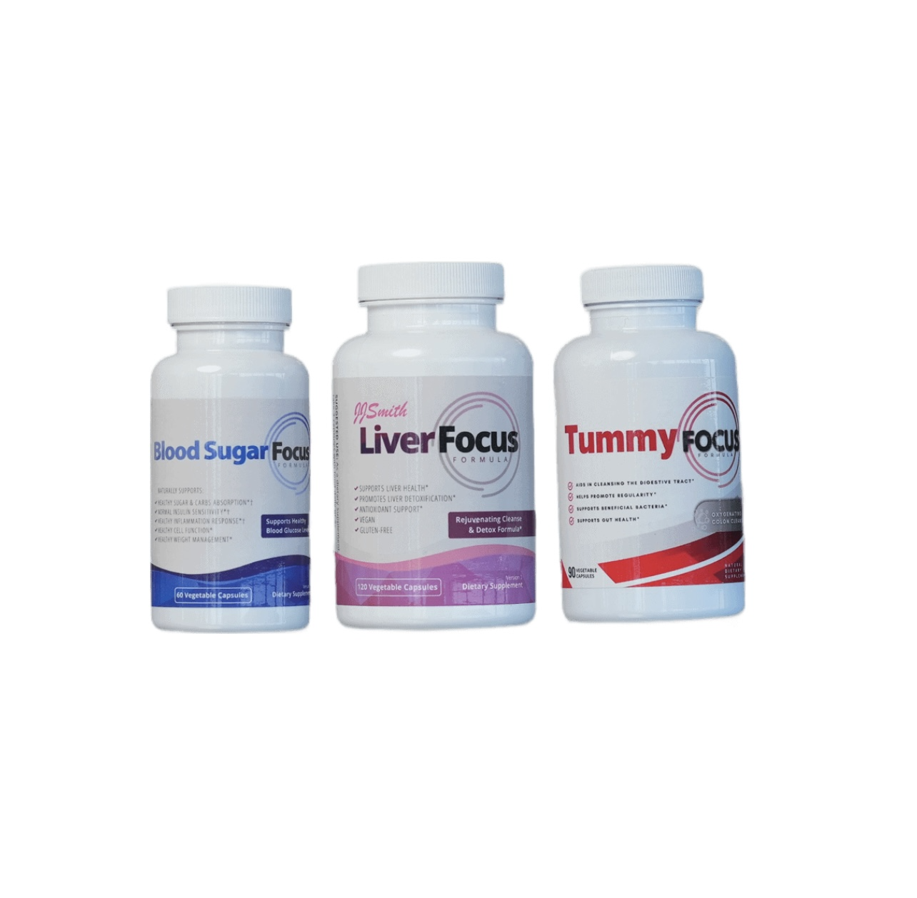
The Weight Loss Bundle includes:
- Liver Focus – A liver detox that accelerates fat burning in the body and supports liver health
- Tummy Focus –Improves digestion, promotes regularity, reduces bloating and supports gut health

- Blood Sugar Focus – Supports fat loss, reduces craving and stabilizes blood sugar
Why bundle? These three products work synergistically to reset your metabolism, eliminate waste, and keep your body in fat-burning mode.
Bundle & Save! Get all three at a discounted price for the ultimate full-body weight management support.
Upgrade to the Weight Loss Bundle & Save Now!

FAQs

<FAQ: Insert FAQs from other WORD DOCUMENT ATTACHED>

Ready to Give Your Liver the Support It Needs?
A healthy liver is key to better energy, digestion, and fat metabolism. Give your body the care it deserves with Liver Focus—your natural liver detox and metabolism booster.
Order now and take the first step toward better health!
Subscribe today and get 10% OFF your first order!

[LEAVE SPACE FOR OKENDO REVIEWS]

