The Menopause Support Bundle

Find Relief. Feel Like Yourself Again.
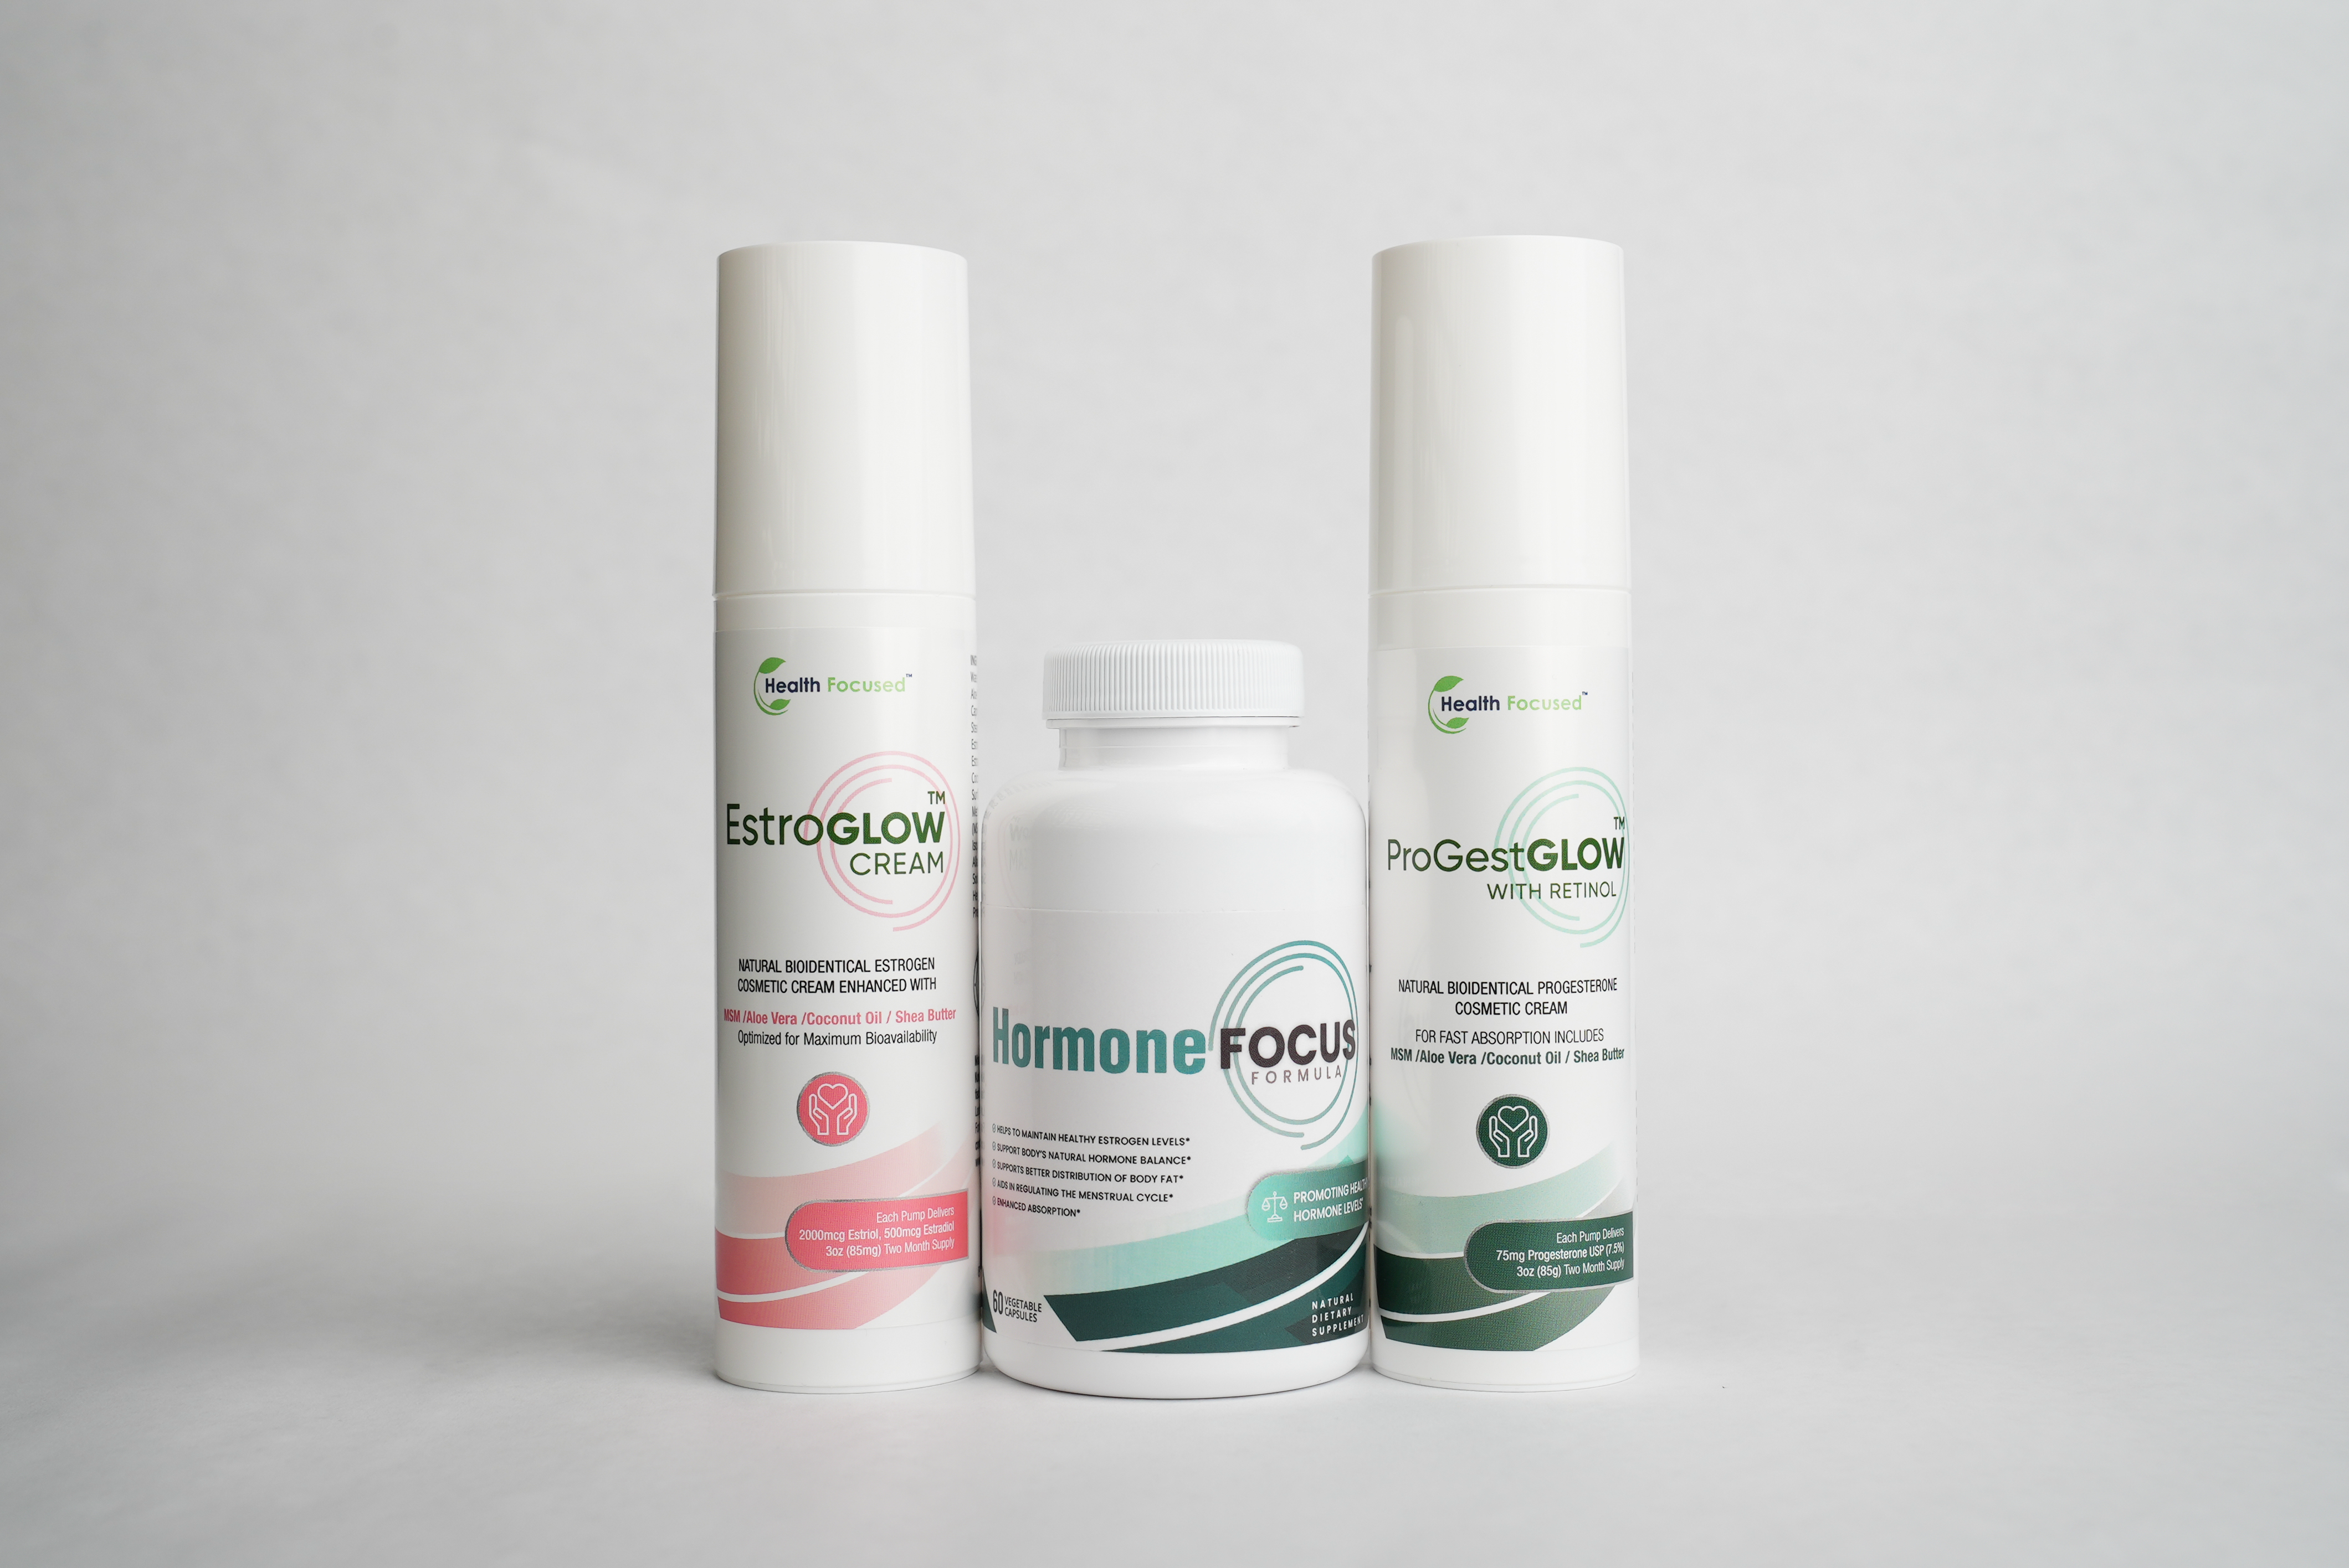

Hot flashes. Night sweats. Mood swings. Stubborn weight gain. Vaginal dryness.
If your body feels unfamiliar and you're constantly trying to “push through,” you’re not alone!
Hormonal shifts caused by menopause, post-menopause, or hysterectomy can leave you feeling out of sync with your body. Many women struggle to find a gentle, effective solution that provides real relief—without unwanted side effects.
Menopause is a natural transition, but that doesn’t mean you have to suffer through it. The Menopause Support Bundle is designed to help you navigate this stage of life with balance and ease.
Featuring Hormone Focus, EstroGlow, and ProGestGlow, this powerful trio works together to support hormone balance, estrogen metabolism, and progesterone levels—so you can feel energized, focused, and in control.

Why Choose the Menopause Support Bundle?
- Supports relief from menopausal/post-menopausal symptoms – Helps reduce hot flashes, night sweats, and vaginal dryness
- Promotes mood stability & mental clarity – Feel calmer, more focused, and emotionally balanced
- Hormonal Harmony – Supports healthy estrogen and progesterone levels for a balanced transition.
- Science-Backed Ingredients – Formulated with research-driven ingredients to promote optimal well-being.



What's Inside the Bundle?

Hormone Focus – Natural Hormonal Support
A targeted formula designed to support estrogen metabolism and hormone detoxification. Key ingredients like DIM (Diindolylmethane) and Calcium D-Glucarate help your body process excess estrogen efficiently, promoting a healthy balance and reducing symptoms like bloating, fatigue, and irritability.

EstroGlow – Estrogen Balance & Menopausal Relief
EstroGlow is a bioidentical topical estrogen cream formulated to support natural estrogen levels while easing common menopausal symptoms. With a blend of botanicals and nutrients, it helps you stay calm, focused, and comfortable throughout the day.

ProGestGlow – Progesterone Cream for Hormonal Balance
Bioidentical topical progesterone cream formulated to complement estrogen balance and support sleep, mood, and overall well-being. A gentle, non-synthetic approach to hormone support.

Real Women, Real Results

VIDEO and Photo testimonials (UGC)
<Insert photos and videos of women holding the bottle througout the page>

https://www.dropbox.com/scl/fo/oh5ogvjl3ogyri1phb4tp/AB2HvyS9G42qtASsZ_HmeKI?rlkey=b04xnr9ziy9anm0ruf0nnoy4l&st=az2z05ii&dl=0

Backed by Science: See How It Works

The Power of DIM & Calcium D-Glucarate
Research shows that both DIM and Calcium D-Glucarate play crucial roles in supporting estrogen metabolism and detoxification, helping to balance hormones naturally.

Study #1: DIM Supports Healthy Estrogen Metabolism
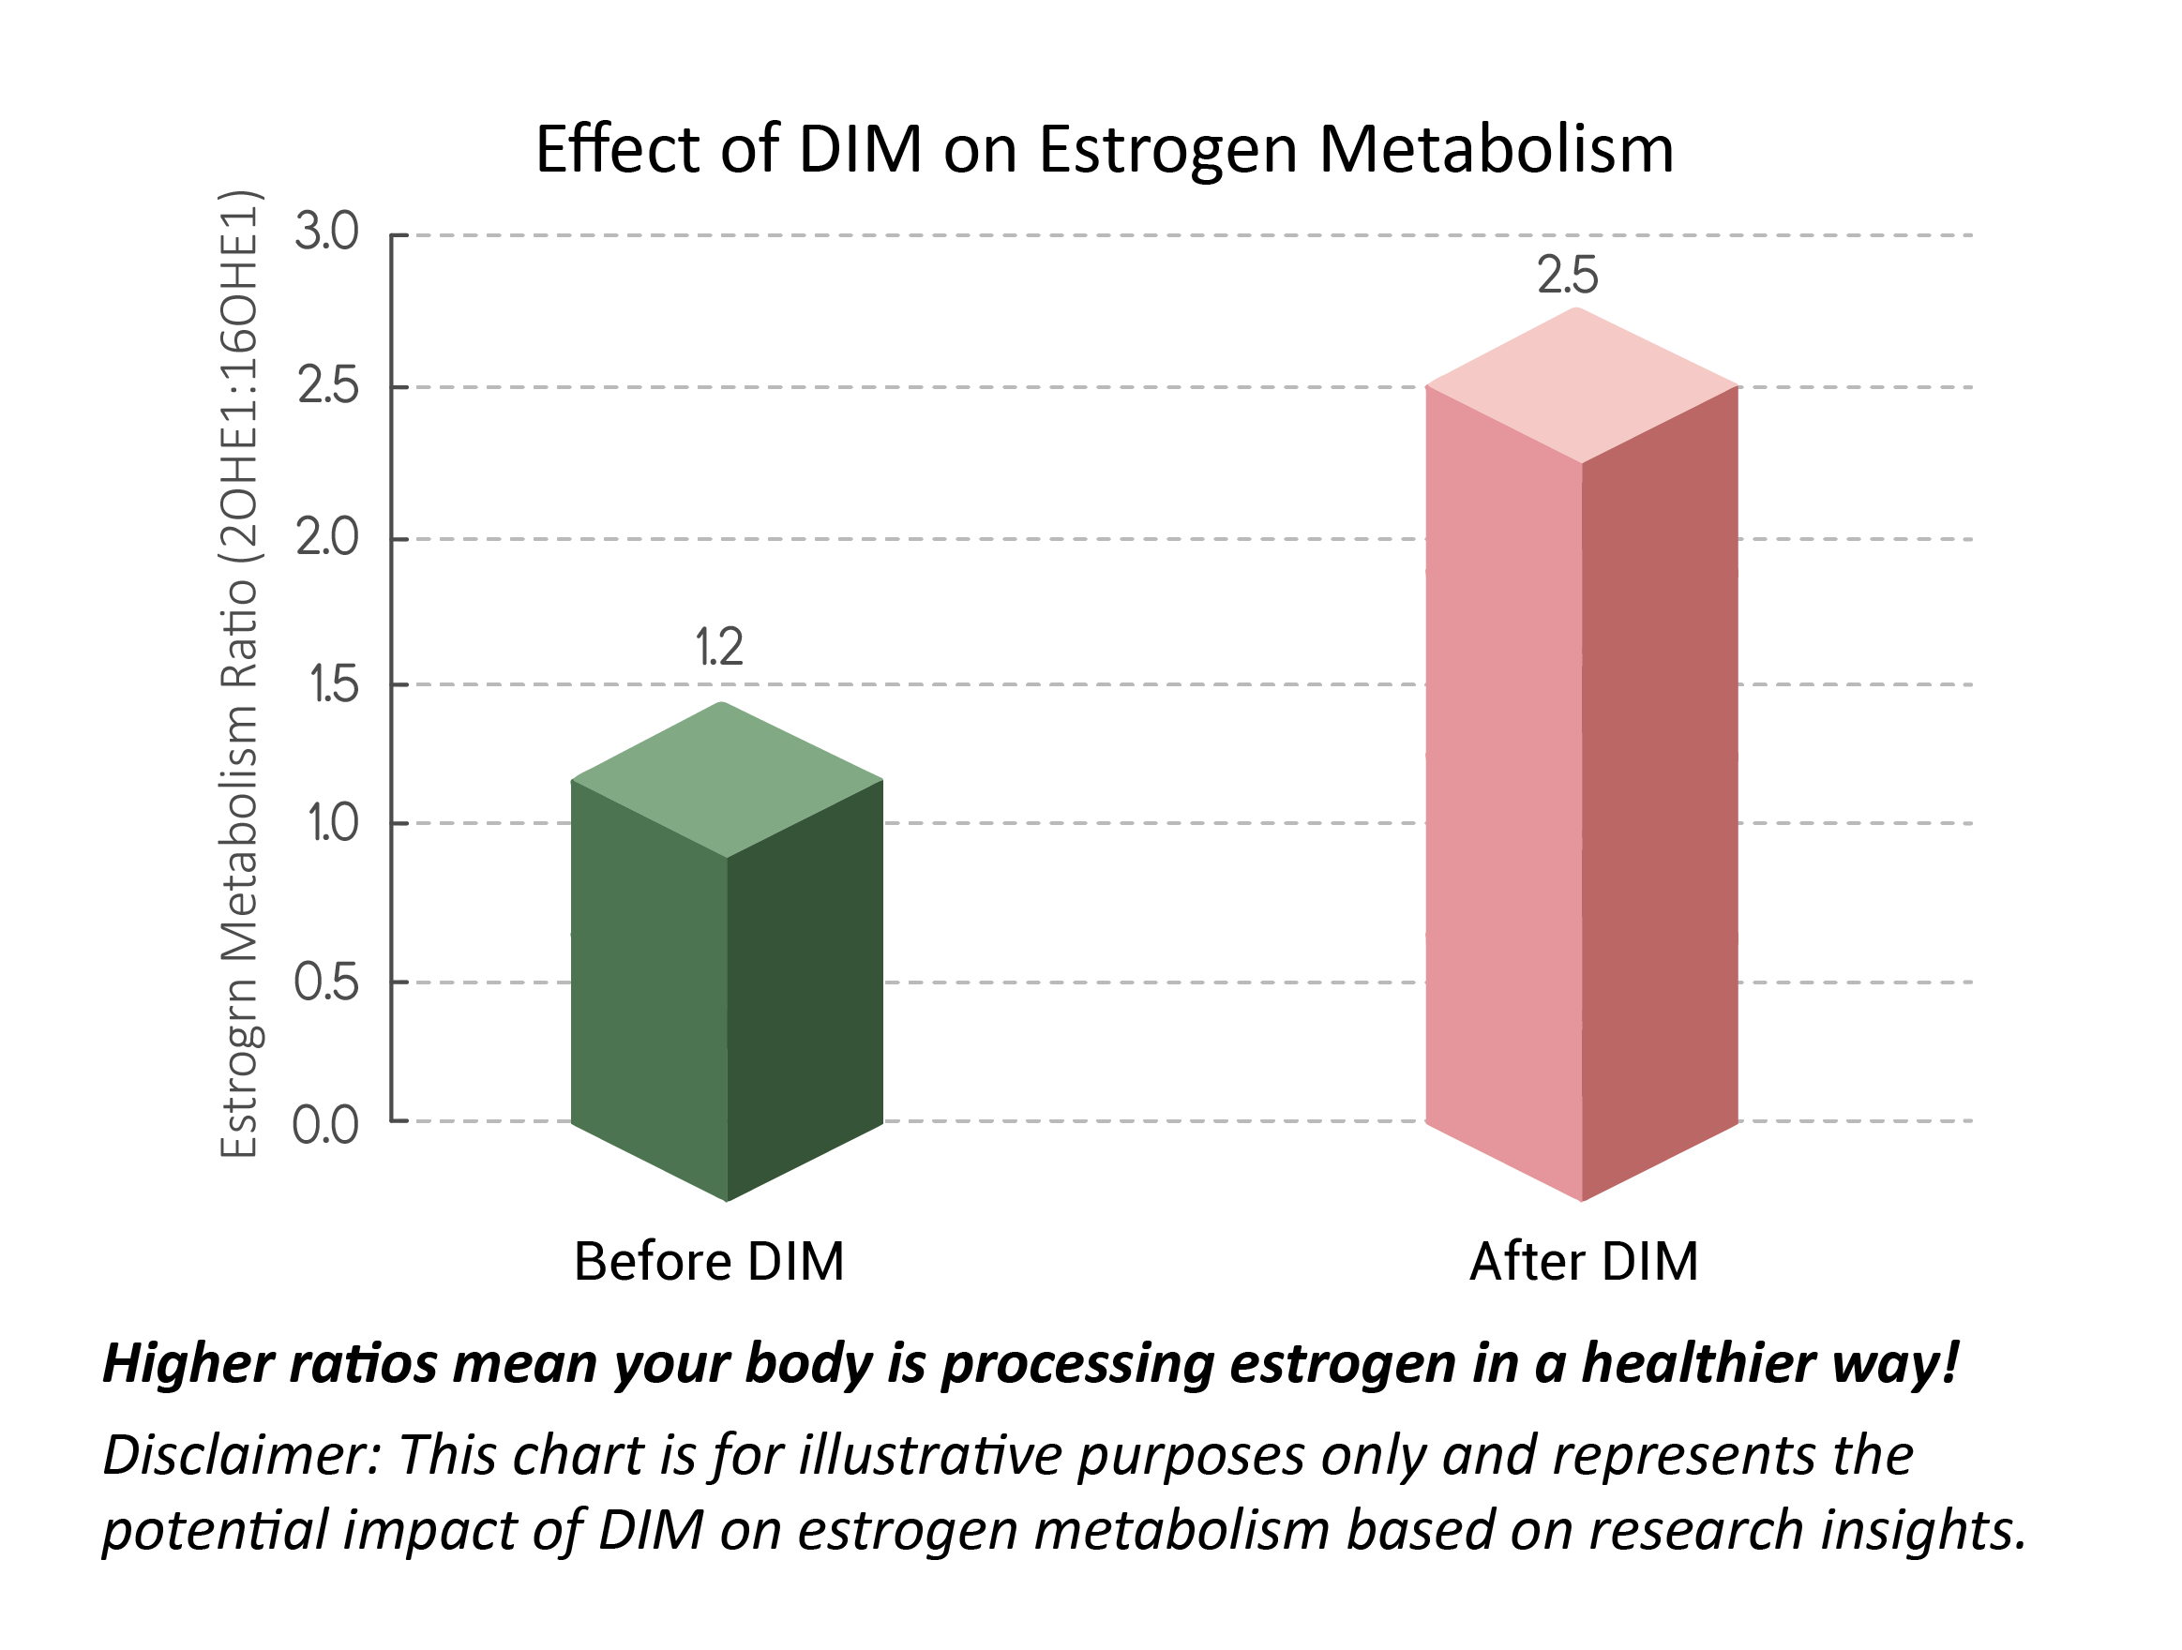
Key Takeaways from the Study:
- Promotes estrogen balance by encouraging a healthier estrogen metabolite ratio
- Reduces estrogen dominance symptoms like bloating, mood swings, and stubborn weight gain

Study 2: Calcium D-Glucarate Supports Estrogen Detoxification
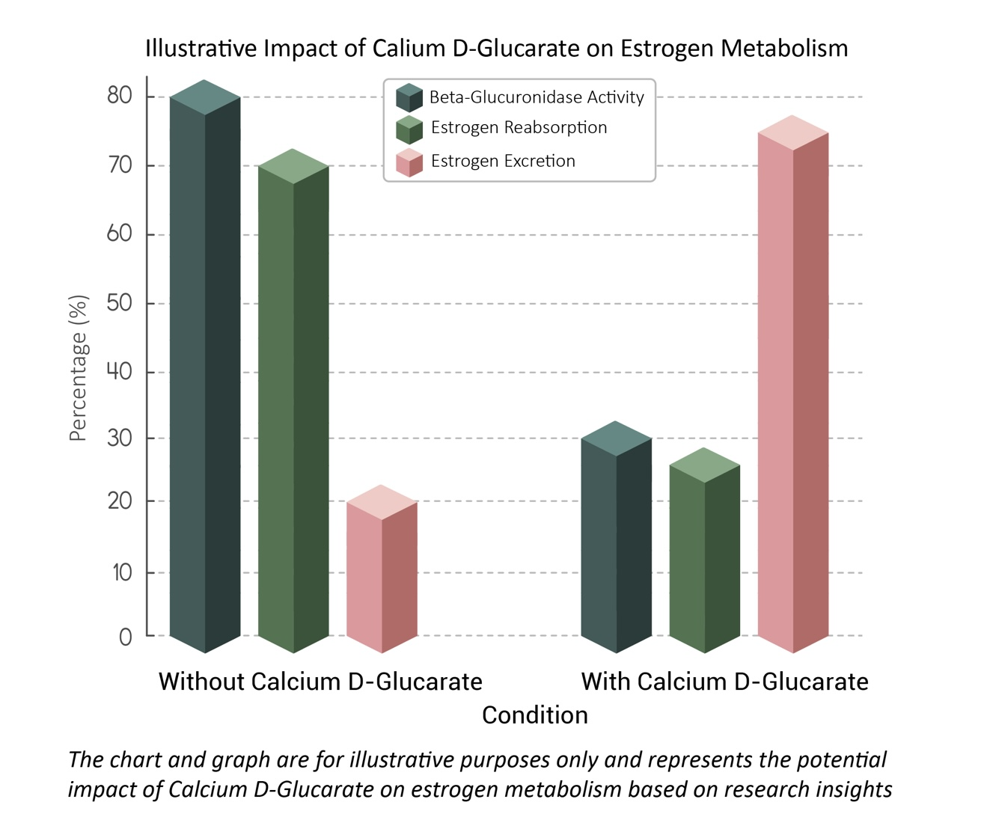
Key Takeaways from the Study:
- Supports natural hormone detoxification by preventing estrogen recycling
- Reduces the risk of estrogen dominance symptoms like bloating, weight gain, and mood swings
- Without Calcium D-Glucarate: 80% of estrogen is reabsorbed, and only 20% is detoxified.
- With Calcium D-Glucarate: Estrogen reabsorption drops to 30%, while detoxification increases to 70%.

The ProGestGlow™ Difference – More Than Just Progesterone
Unlike synthetic hormone therapies, ProGestGlow™ contains bioidentical progesterone derived from wild yam—molecularly identical to the progesterone your body naturally produces*
- Bioidentical Progesterone (USP, Wild Yam Derived) – Supports hormonal balance, cycle regularity, and emotional well-being
- MSM (Methylsulfonylmethane) – Helps reduce inflammation and support skin elasticity
- Nourishing Oils (Olive, Coconut, Shea Butter) – Hydrates and supports skin absorption for optimal results
- Vitamin E & Retinol (Vitamin A) – Helps protect and revitalize skin

Study 3: Below is an illustrative representation summarizing the potential benefits of topical progesterone cream based on the studies,

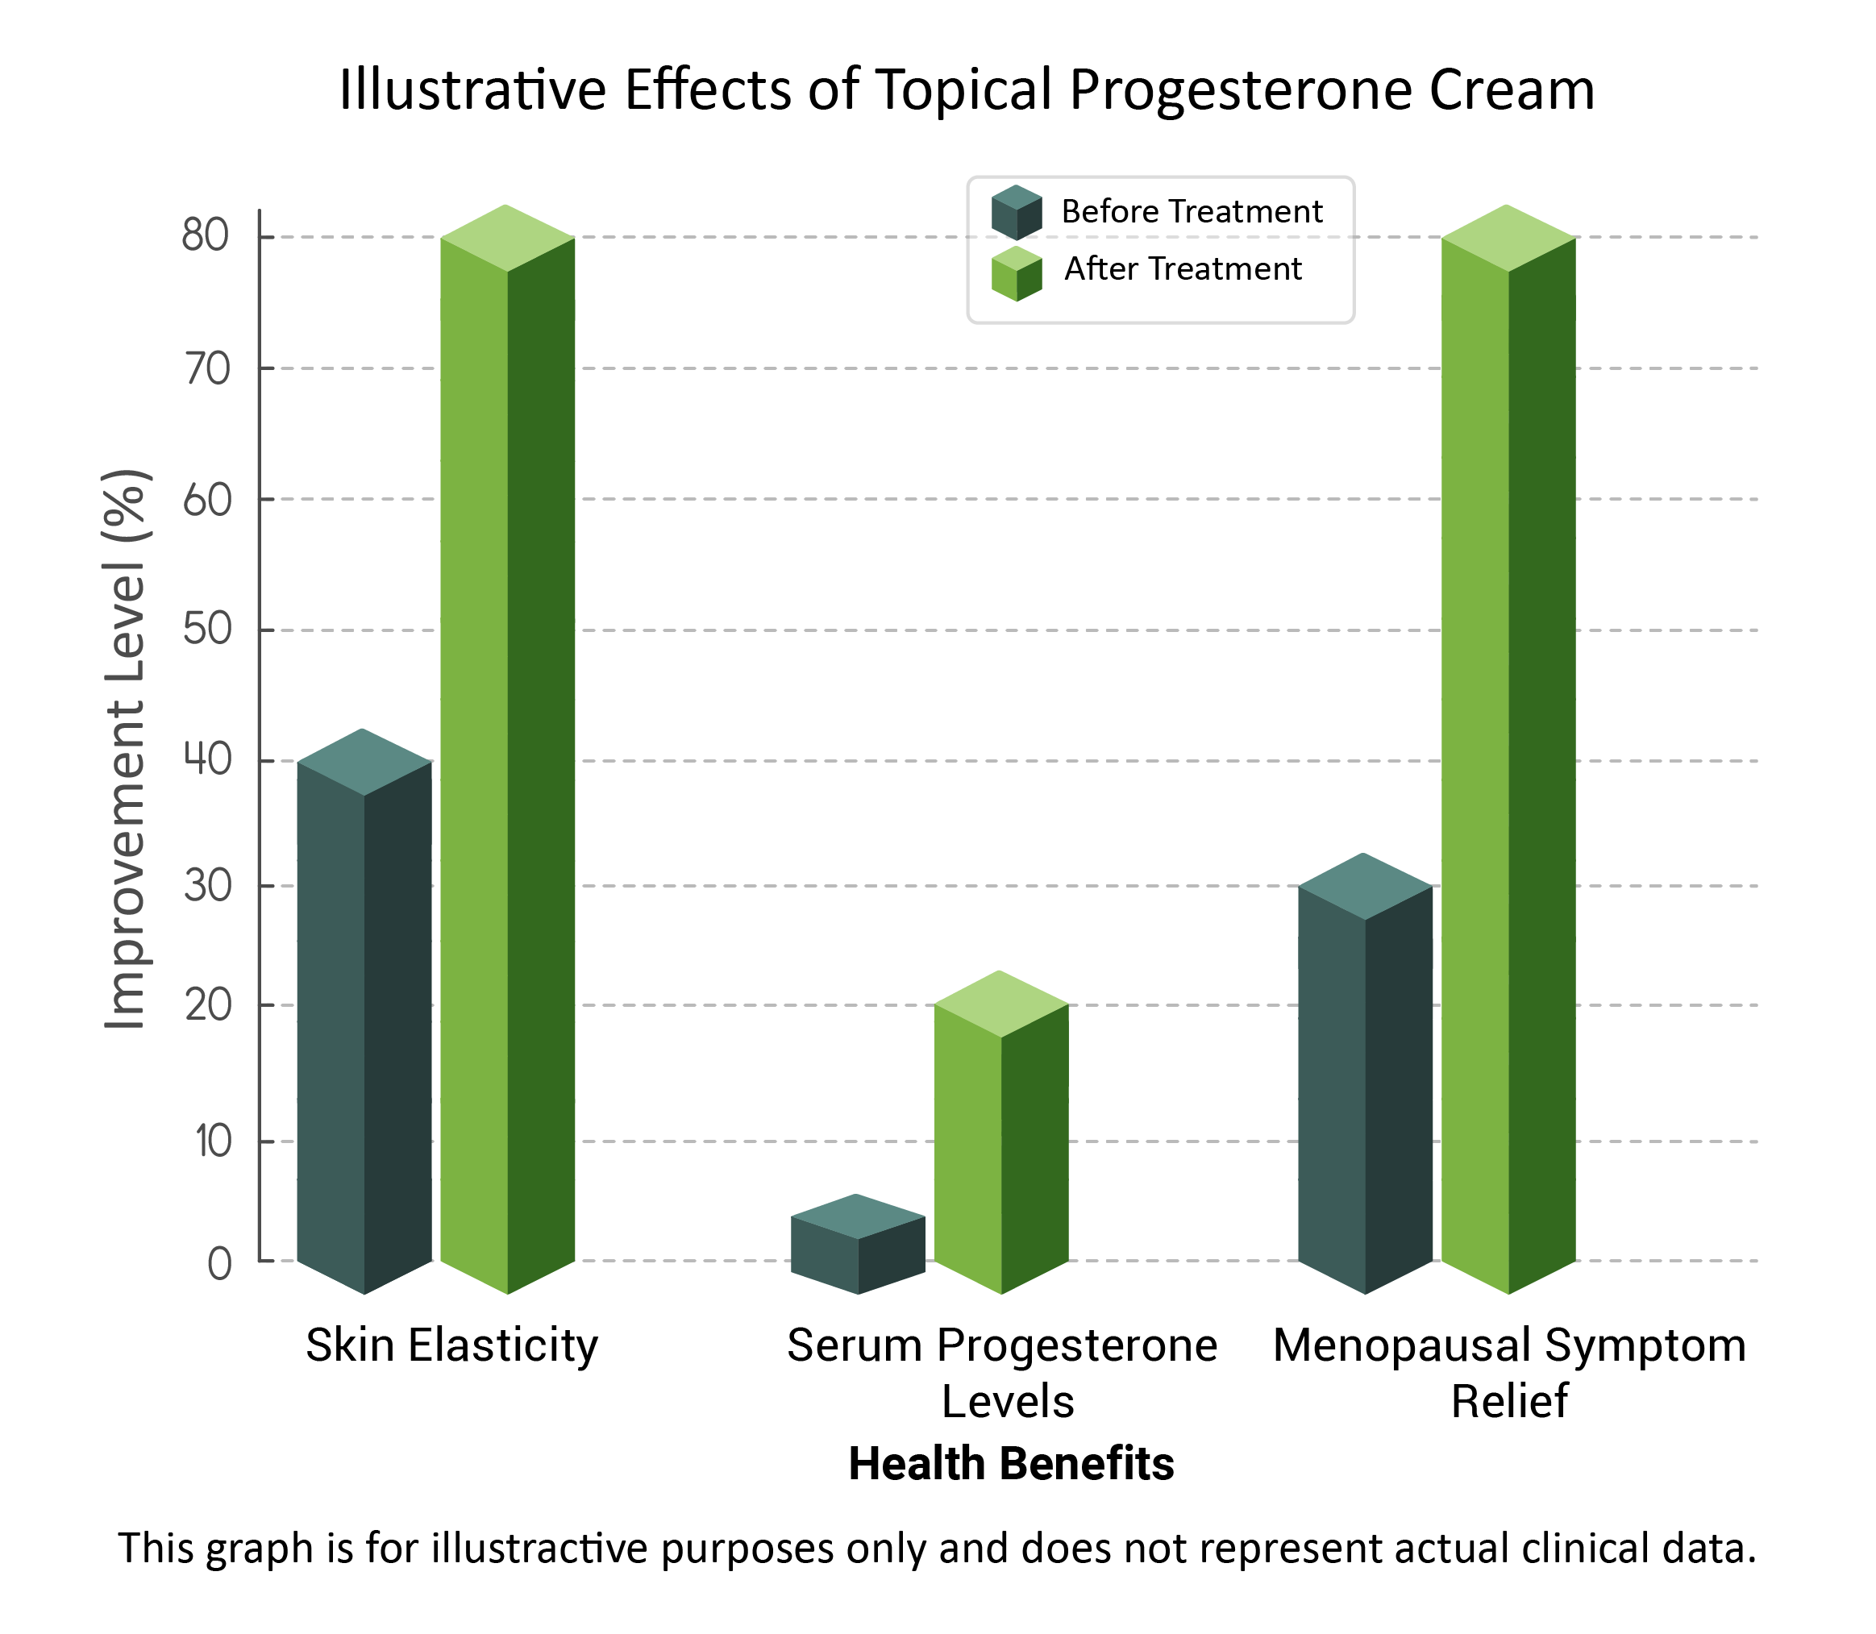

Which Hormone Products Are Right For You? Find Your Perfect Hormone Balance

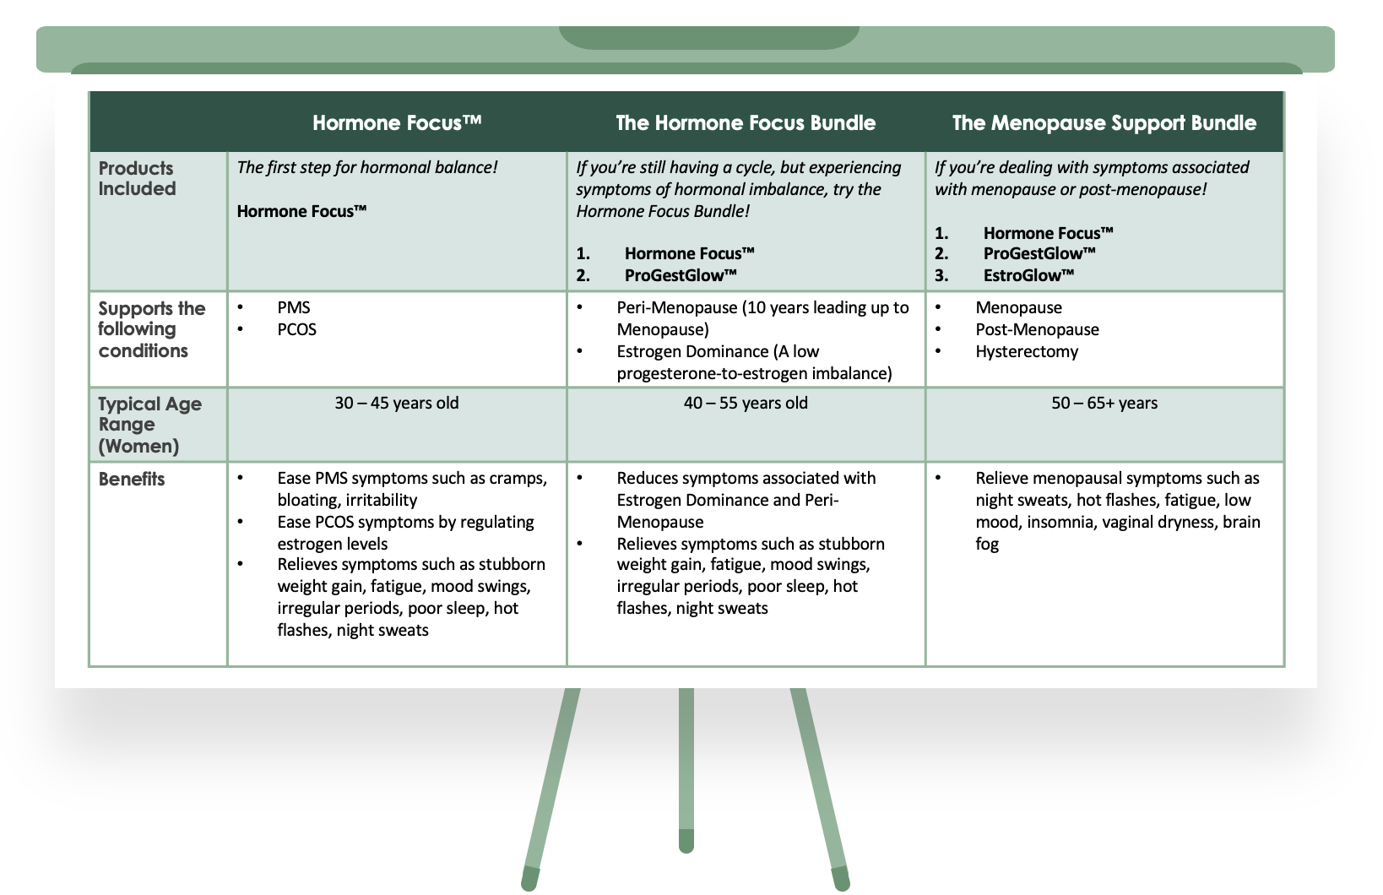


FAQs
<FAQ: Insert FAQs from other WORD DOCUMENT ATTACHED>

Take Control of Your Menopause Journey Today
Don't let menopause symptoms hold you back. The Menopause Support Bundle is here to bring balance, relief, and vitality back into your life.
🔹 Save more with the bundle discount
🔹 100% satisfaction guarantee
🔹 Backed by science and trusted by women
Save $15 When You Bundle!
Hormone Focus™ + EstroGlow™ + ProGestGlow Bundle – $134.00 Now Only $119!
Get the Menopause Support Bundle & Save! <BUY NOW>

CUSTOMER REVIEWS
LEAVE SPACE for OKENDA Reviews to be added

