The Hormone Focus Bundle

The Complete Solution for Hormonal Balance & Well-Being
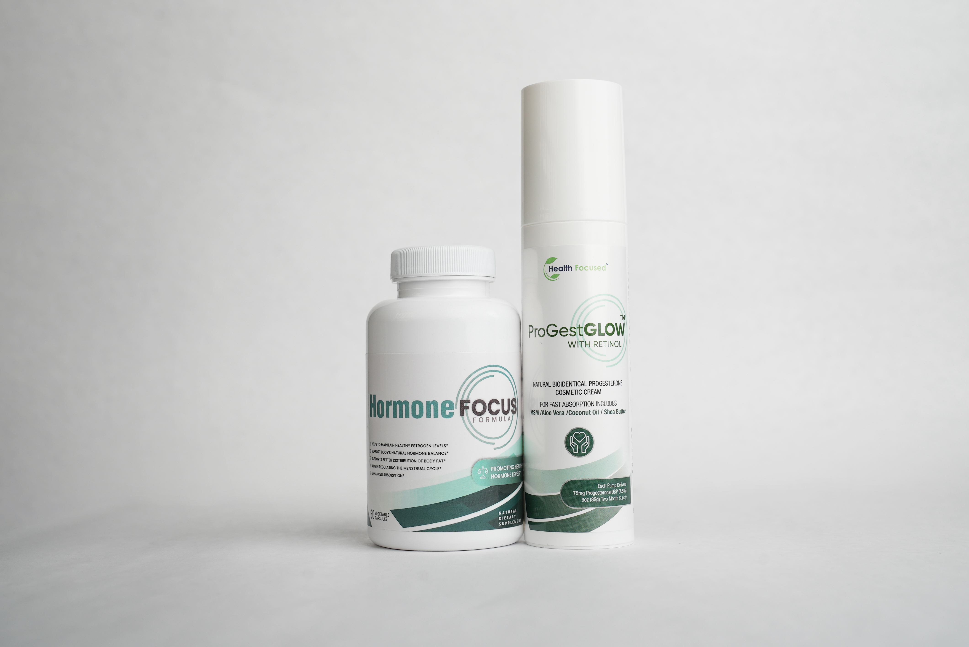
It’s Not Just in Your Head… And You’re Not Alone.
Mood swings. Sudden weight gain. Foggy thinking. Sleepless nights. You’ve been trying to “push through,” but your body is asking for help.
What you're feeling could be hormonal imbalances. And, once you learn how to balance your hormones naturally, you can feel vibrant, focused, and in control again—just like so many women already are.
The Hormone Focus Bundle combines two powerful solutions—Hormone Focus and ProGestGlow—to help you achieve optimal hormonal balance, naturally.

- Relieves PMS, Perimenopause & Estrogen Dominance Symptoms
- Boosts Energy, Improves Mood & Supports Healthy Weight
- Helps Your Body Process Estrogen Naturally
- Restores Hormonal Balance with Progesterone Support

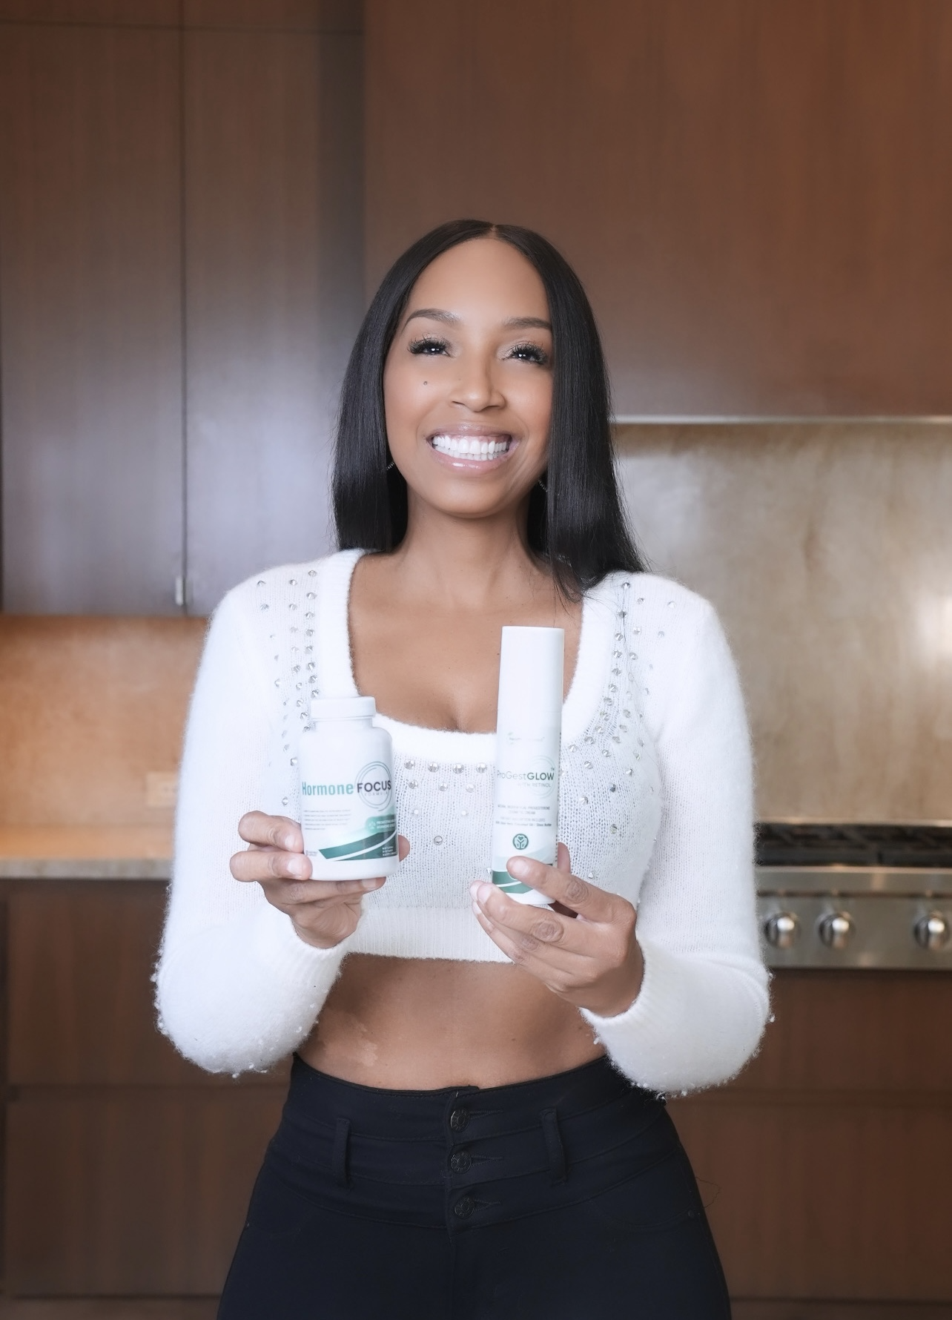

Why Use Both?

The Synergy of Hormone Focus & ProGestGlow
When estrogen and progesterone levels are out of sync, it can cause irritability, bloating, sleep disturbances, and hormonal weight gain. This bundle offers a dual approach to get your body back on track.

Hormone Focus (Capsules) – Estrogen Metabolism & Detox
- Supports healthy estrogen metabolism and detoxification
- Helps maintain a balanced estrogen-to-progesterone ratio
- Promotes clear skin, energy, and mental clarity
[Click to Learn More]

ProGestGlow (Topical Cream) – Bioidentical Progesterone Support
- Helps ease PMS, perimenopause, and estrogen dominance symptoms
- Supports restful sleep and stress relief
- Supports a healthy weight management
- Provides a gentle progesterone boost for hormonal balance
[Click to Learn More]
Better Together: This bundle works in synergy to support hormonal harmony—something one product alone can’t fully achieve.

Real Women, Real Results

VIDEO and Photo testimonials (UGC)
<Insert photos and videos of women holding the bottle througout the page>

https://www.dropbox.com/scl/fo/cclazr3g6qo4a2btvibdf/ABZSoUg7e132DZklDYo-D58?rlkey=qrg8mbtuclv3qo9ranm0g8wx2&st=p96og7tr&dl=0

Backed by Science: See How It Works

The Power of DIM & Calcium D-Glucarate
Research shows that both DIM and Calcium D-Glucarate play crucial roles in supporting estrogen metabolism and detoxification, helping to balance hormones naturally.

Study #1: DIM Supports Healthy Estrogen Metabolism
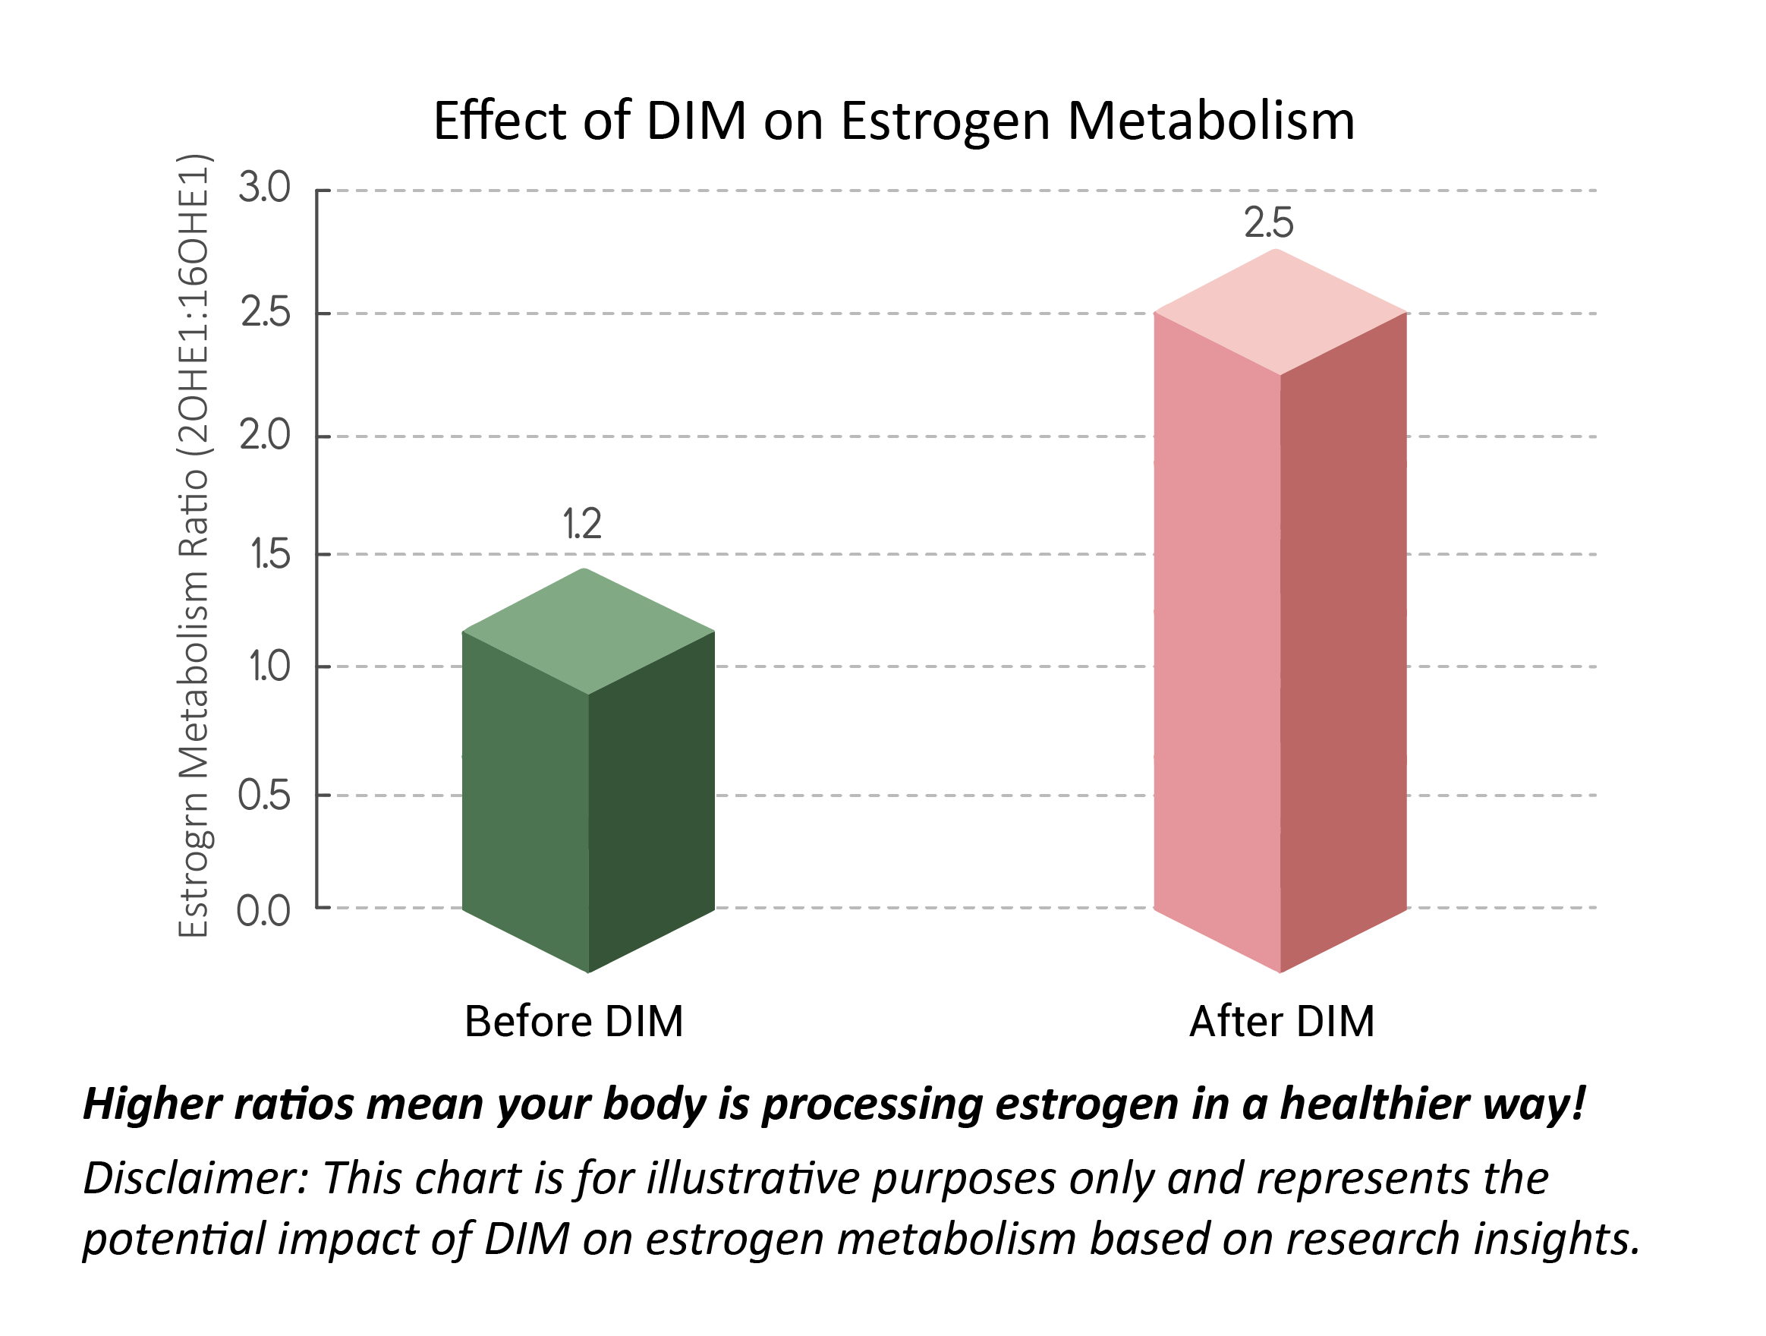
Key Takeaways from the Study:
- Promotes estrogen balance by encouraging a healthier estrogen metabolite ratio
- Reduces estrogen dominance symptoms like bloating, mood swings, and stubborn weight gain

Study 2: Calcium D-Glucarate Supports Estrogen Detoxification
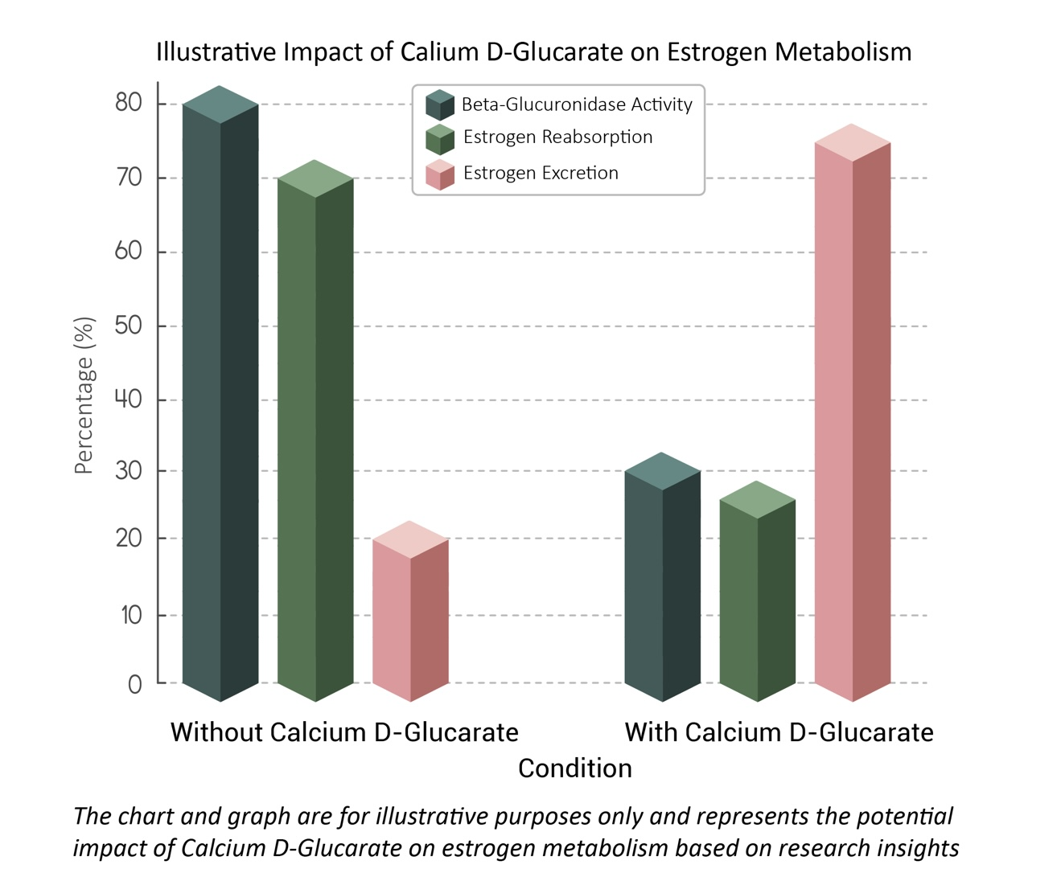
Key Takeaways from the Study:
- Supports natural hormone detoxification by preventing estrogen recycling
- Reduces the risk of estrogen dominance symptoms like bloating, weight gain, and mood swings
- Without Calcium D-Glucarate: 80% of estrogen is reabsorbed, and only 20% is detoxified.
- With Calcium D-Glucarate: Estrogen reabsorption drops to 30%, while detoxification increases to 70%.

The ProGestGlow™ Difference – More Than Just Progesterone
Unlike synthetic hormone therapies, ProGestGlow™ contains bioidentical progesterone derived from wild yam—molecularly identical to the progesterone your body naturally produces*
- Bioidentical Progesterone (USP, Wild Yam Derived) – Supports hormonal balance, cycle regularity, and emotional well-being
- MSM (Methylsulfonylmethane) – Helps reduce inflammation and support skin elasticity
- Nourishing Oils (Olive, Coconut, Shea Butter) – Hydrates and supports skin absorption for optimal results
- Vitamin E & Retinol (Vitamin A) – Helps protect and revitalize skin

Study 3: Below is an illustrative representation summarizing the potential benefits of topical progesterone cream based on the studies,

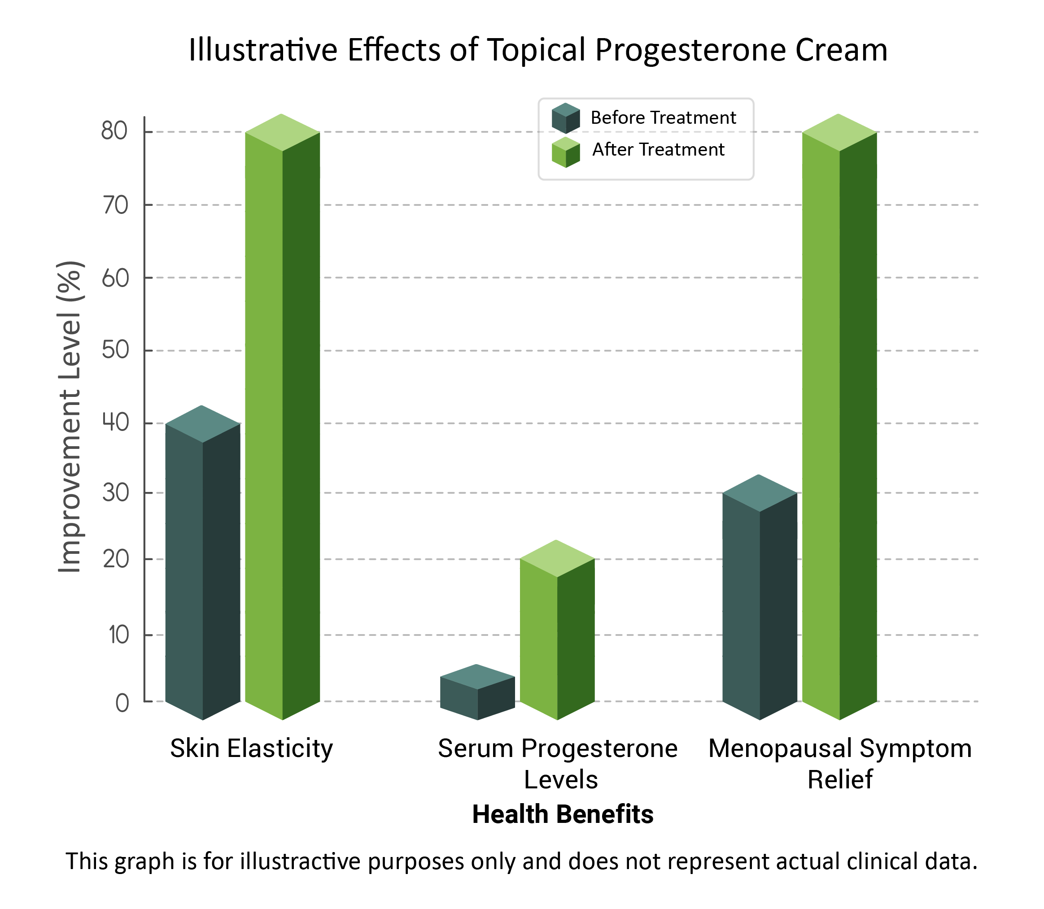

Which Hormone Products Are Right For You? Find Your Perfect Hormone Balance

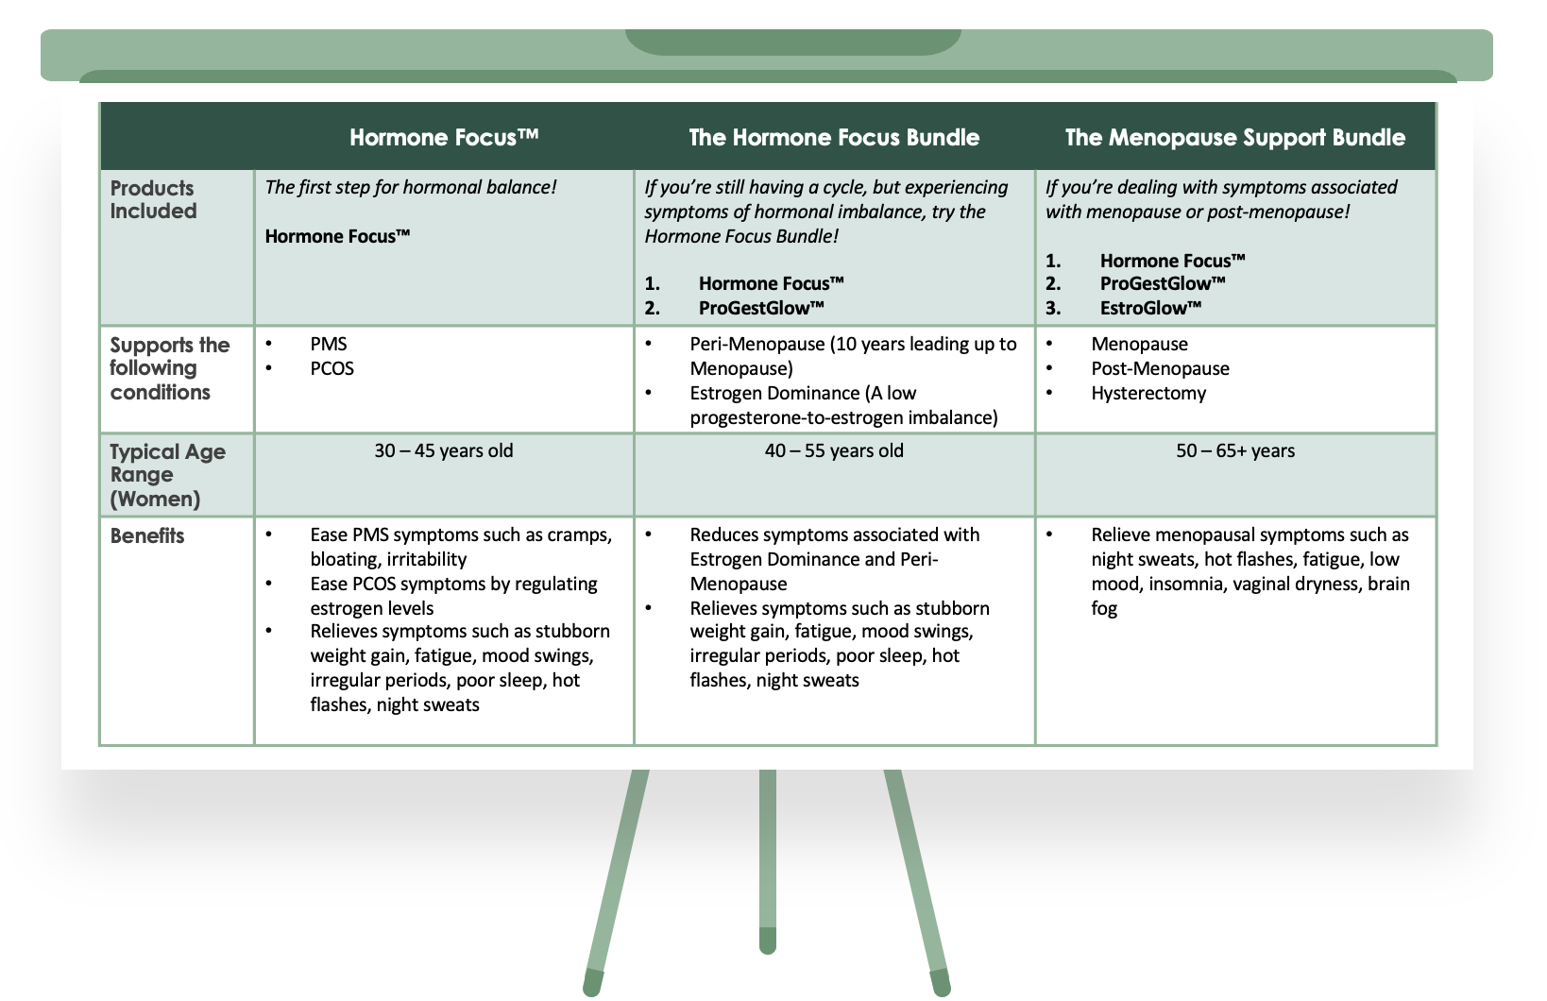
Special Offer: Bundle & Save! Get this powerful duo at an exclusive price. $89.99 Now only $79.99
[Order the Hormone Focus Bundle Now]


FAQs
<FAQ: Insert FAQs from other WORD DOCUMENT ATTACHED>

CUSTOMER REVIEWS
LEAVE SPACE for OKENDA Reviews to be added

