
Phosphate Beneficiation Plant - Vernal, UT
PhosPhate Project Profile

Situation Outline
A phosphate beneficiation plant in Vernal Utah is using Prompt Gamma Neutron Activation Analysis (PGNAA) technology to analyze their entire incoming feed slurry stream and final product.
This allows them to adjust the flotation circuits in near real time to optimize the plant output. The plant has gained greatly improved visibility/control and has reduced product variability for improved profitability and product quality.

Before Analyzers
The plant had gained visibility of their process using physical samples analyzed in their laboratory. However, the time for sample acquisition, preperation, and wait time for the lab results varied from 4 to 12 hours. This delay caused difficulties in continuous feed forward process control. By the time the lab analysis was available, the material could already be processed through their circuits and be well on its way to the processing plant.

It became apparent that greater control and benefits could be achieved by continuously measuring 100% of the material being processed. Subsequently, an order was placed with SABIA for two on-line PGNAA slurry analyzers, one for the incoming feed material and one for the final product (see process schematic on back).

Flotation Circuits
A SABIA Model X1-XP Slurry Analyzer  was installed on a 12 inch diameter pipe discharging into a flotation feed surge tank ahead of the primary flotation’s de-sliming circuit.

It provides a near real-time weight-percent measurement of elements in the material, primaraly P2O5 and MgO which are monitored to determine the relative grade of incoming feed and validate feed forward control decisions. Plant operators make changes to the primary flotation circuit by slowing down the rate of incoming feed to increase grade and adjust their reagent control.
A second SABIA Slurry Analyzer was installed on an 8-inch pipe and is used to validate the final product. The final concentrate MgO target is <0.80%. High MgO content in the chemical plant feed causes difficulty at the processing plant when reacting and filtering the final product.
Their phosphate minerals are liberated at the 35-Mesh size fraction. The challenge is liberating P2O5 minerals while not over grinding and producing excessive amounts of minus 74-Micron particles. Dolomite containing MgO tends to concentrate in the ore and becomes liberated, floating into and contaminating the phosphate concentrate.





Improved Operational Efficiency with PGNAA Analyzers in a Phosphate Production Process

www.sabiainc.com
Protected by US PATENT
see www.sabiainc.com/patent

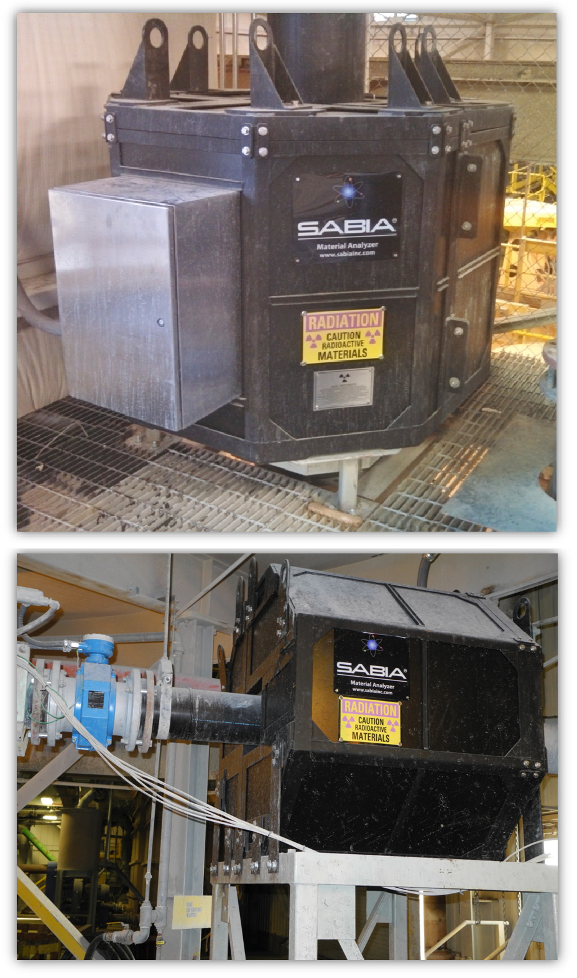
Benefits
PhosPhate Benefication Plant - Vernal, Ut

SABIA analyzers allow control responses
•
within 1 ½ hours.
Operators can bring up the mill quickly and react to slurry concentration changes in near real time.
•
Identification of problems earlier, saving time/money in troubleshooting problems whether in a cyclone, floatation cell, or screen.
•
Eliminate dependance on the lab results with 4 - 12 hour delays. The lab now only validates decisions.
•
Accuracy and precision over a wide range
•
of slurry composition
Ability to measure 100% of slurry stream
•

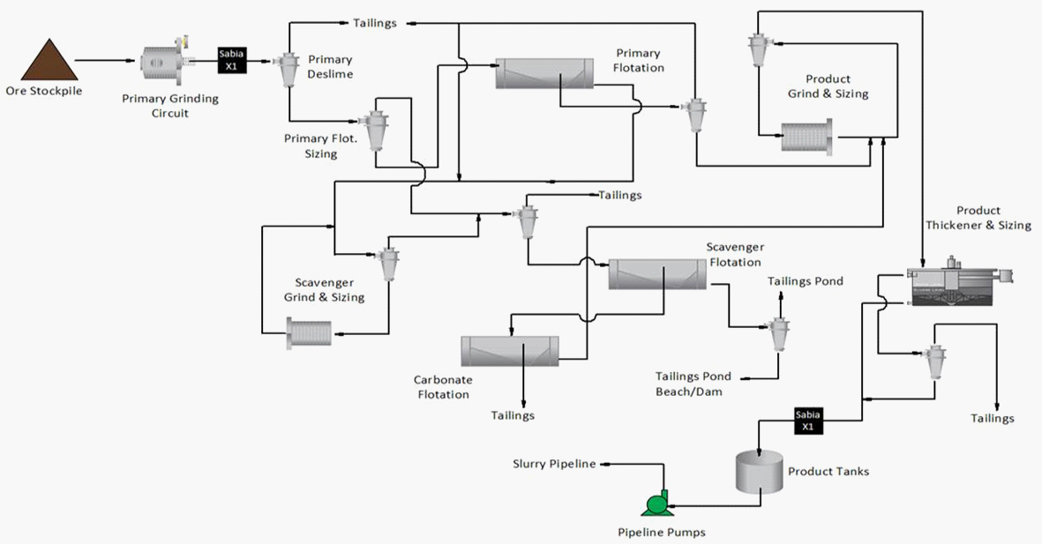


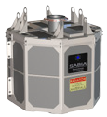
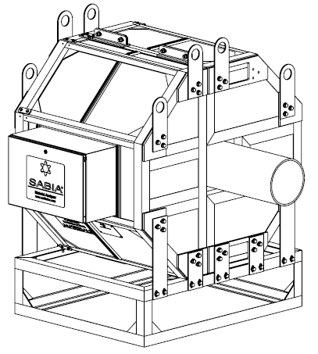

www.sabiainc.com
3000488 RevA
ISO 9001:2008 Certified Company
10915 Technology Place San Diego, CA 92127, USA
+1-888-SABIAINC (722-4246)
sales@sabiainc.com

