Format:
Width: 99mm
Height: 210 mm
Style: 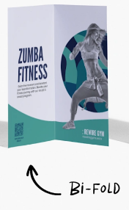

Front Cover:
Must include C4 Space logo
Must NOT include: Pictures of Space Shuttle, Astronauts, Spaceships, SciFi images

Heading: Making reports that empower your business

Inside Left:
C4 Space provides research and reports for management and technical topics related to the space industry. We are here to help you seize space opportunities by leveraging our unique combination of strategic, economic, industrial, and technical expertise to address your specific needs.
We are dedicated to providing world class solutions to critical space-sector challenges through our professional services which include:
RESEARCH SERVICES
- Market analysis
- Technical analysis
- Qualitative and Quantitative research
- Trade studies and feasibility analyses
- Training and skills gap analysis
- Interviewing/Transcription

PUBLICATION SERVICES
- Business writing
- Technical writing
- Bid and proposal writing
- Documentation and manual development
- Editing
- Desktop publishing

EVENT MANAGEMENT
- Training events
- Space industry workshops
- Webinars

Inside Right:
Who are we:
We are a dedicated team of passionate consultants, space professionals, marketing and research individuals whose main goal is to empower the current and next generation to reach for their space in space. Through collaboration we provide our clients research services, expertise and data that will unlock solutions for the Space ecosystem. Our extensive network within the Space industry enables us to connect and understand the challenges from within.
Our mission is to support the development, success, and sovereignty of the Australian space sector. We are committed to advancing the space industry through impactful research, education, and training. By harnessing our expertise in research and through close collaboration with space organisations, C4 generates practical recommendations that enhance and inform business strategies and decisions related to the Australian space sector.
Our commitment to excellence has established us as a trusted resource for government agencies and space organisations looking to strengthen their business outcomes through data-driven decisions.

Back Page:

Our services aim to fast-track project development, pre-empt and solve problems more efficiently, and inspire and guide success.
C4 generates actionable insights that enhance and inform business strategies and decisions related to the Australian space sector.
The company has already served key clients including Department of Education in South Australia, Industry Skills Australia, Defence CASG, Defence Science and Technology Group and Australian Geospatial organisations.
We can directly support the space sector in education, research and technology development that helps grow the broader community interest in space.

Contact us at enquiries@c4space.com.au with your project needs.
Address: Level 1, Lot Fourteen, Frome Rd, Margaret Graham Building, SA 5000 Australia
Web: www.C4Space.com.au
*Must include: QR Code for the website 
*Must include Space Industry Association of Australia Member badge [attached] 
*Must include Australian Space Agency Supplier badge [attached]

*Must include Space Association of Australia Inc. badge [attached]


*Must include award logo: 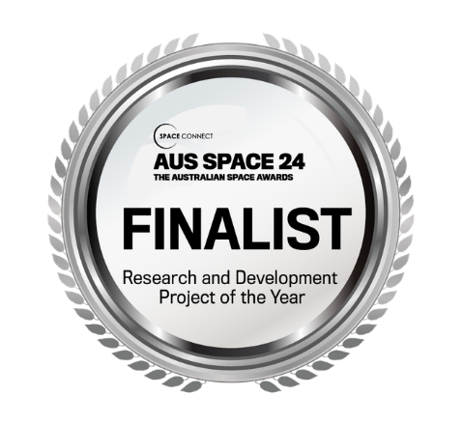

Excellence, integrity, and quality of service are our highest priorities.

[In small text at a discrete location, placed at the bottom of the last page]
C4 Space is the registered trading name of C4 Engineering Pty Ltd ABN 74 618 174 726.

C4 Space colour scheme
Logo/Brand colours
Colour | Hex | Sample |  | The font used for the logo/header is Arial Bold.
C4 Space blue | #262b71
C4 Space metallic | #84788b
Main theme colours |  |  | 50% lighter |  | 50% darker
Colour | Hex | Sample | Hex | Sample | Hex | Sample
Navy blue | #000080 |  | #0000C0 |  | #000055
Platinum | #E5E4E2 |  | #FFFEFC |  | #999897
Rocket metallic | #8A7F8D |  | #CFBFD4 |  | #5C555E
Battleship grey | #848482 |  | #C6C6C3 |  | #585857
Black | #000000 |  | #888888 |  | #000000
White | #FFFFFF |  | #FFFFFF |  | #888888
Secondary colours might include other blues, greys, and sunlight colours (kept to a minimum).

Image extracts from past reports:
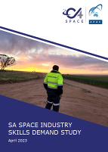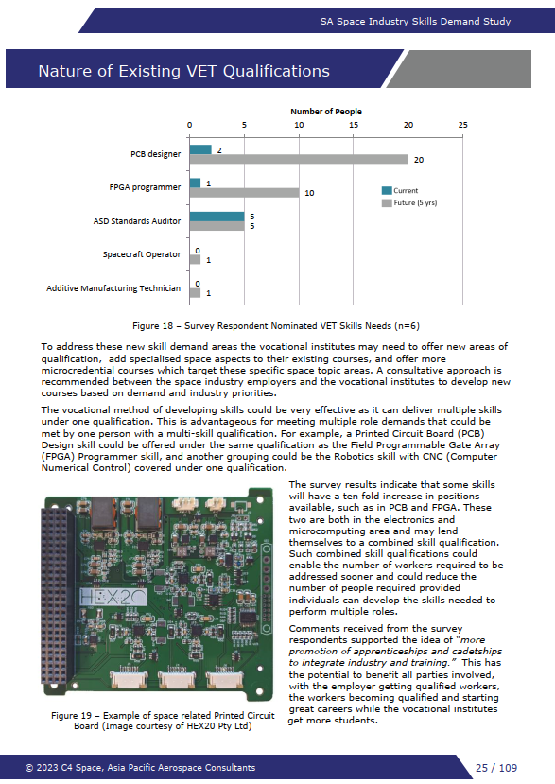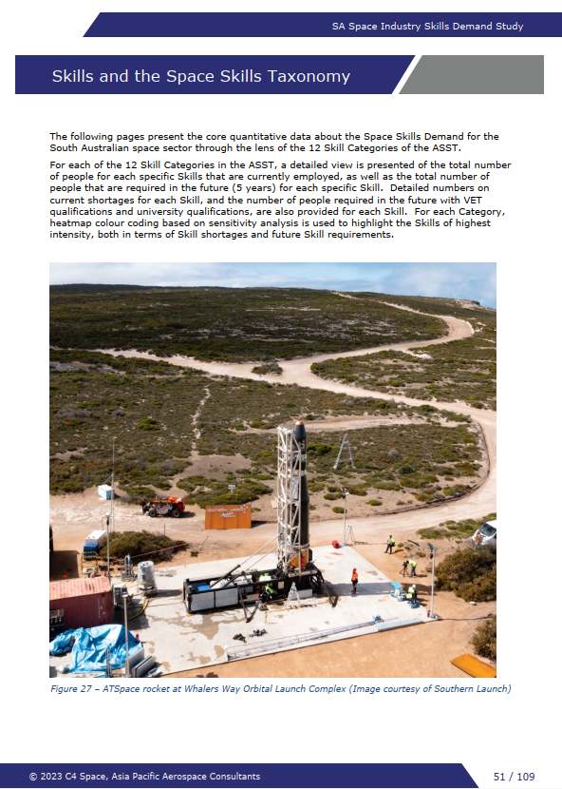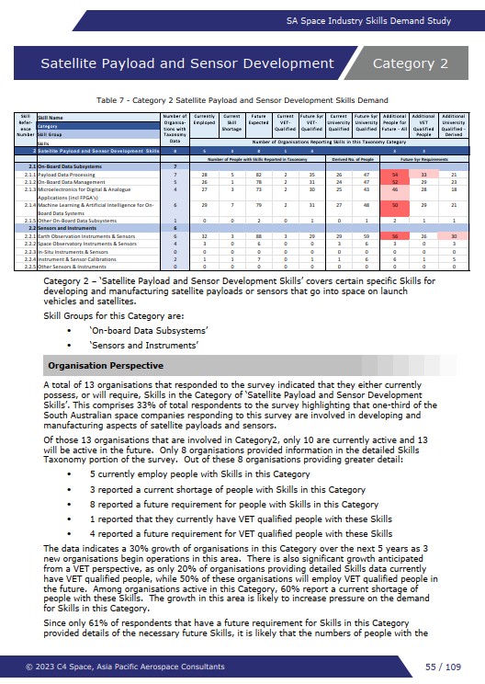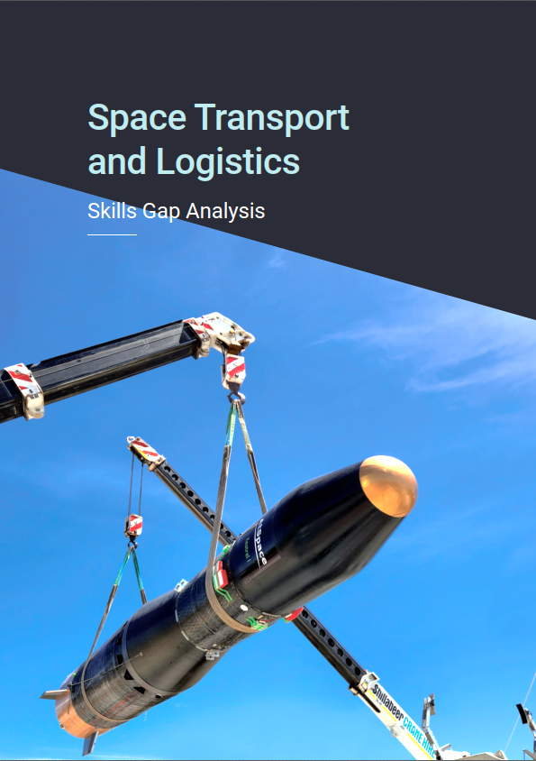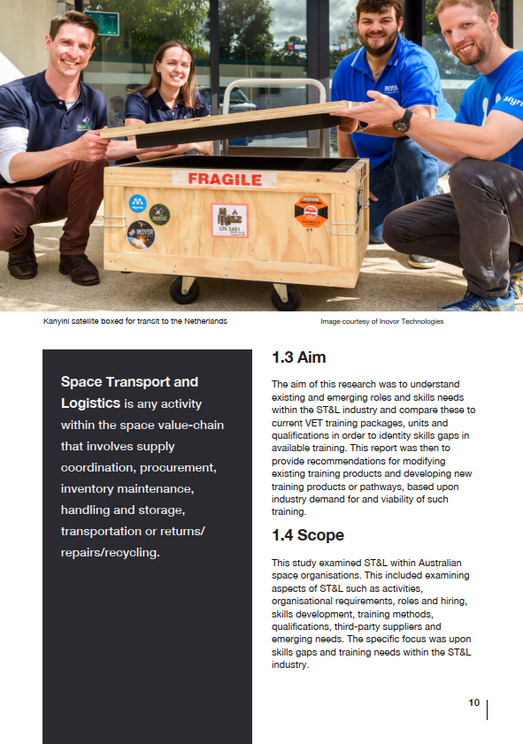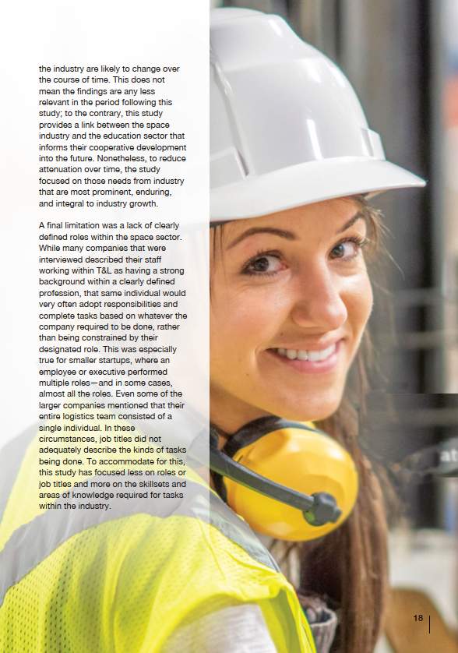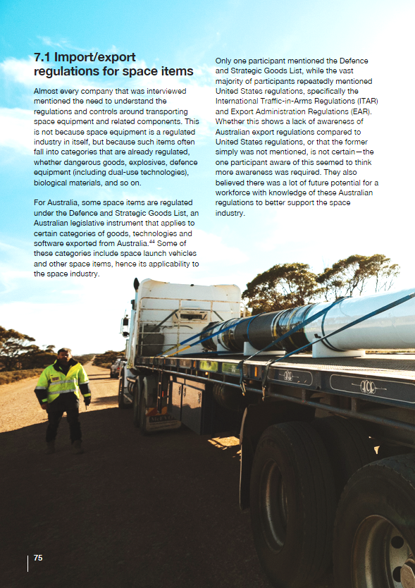

Client feedback:
“Thank you all for all the hard work that you have put into this report. I really appreciate your professionalism and the quality of the work you have delivered.
I have forwarded the report to ISA’s General Manager and CEO with a recommendation for approval. I will be in touch with you in the new year.” Industry Skills Australia
“This looks like an absolutely exceptional report. Keep on fighting the good fight.” Saber Astronautics
“It was a pleasure to work with such a professional and capable organisation as well as the wider project group. Although the project group was drawn from a diverse range of areas, C4 understood the need to have the right people ‘around the table’,” South Australian Government, Department of Education
“We look forward to working with C4 Space on future opportunities. Their genuine desire to assist with developing the Space industry in South Australia and to support the building of the skilled workforce required for this industry has created an important partnership for TAFE SA.” TAFE SA

Some photos available to use:
