Cynaptec Pharmaceutical, Inc.
Branding Design Brief
Company Overview:
Cynaptec Pharmaceuticals, Inc. is a biopharmaceutical company dedicated to developing innovative therapies for neurological and psychiatric disorders. Our lead therapeutic candidate, Conjugated Psilocin (CP), is a unique, patented, new chemical entity (NCE) of psilocin—the active metabolite of psilocybin—designed to enhance bioavailability and therapeutic efficacy. Psilocin has demonstrated potential in treating conditions such as depression, anxiety, substance abuse disorders, addictions, obsessive-compulsive disorder (OCD), and psychosis. Our low-dose, non-hallucinogenic prescription medicine is a stabilizing and highly bioavailable oral form of psilocin. Cynaptec Pharmaceuticals aims to overcome challenges associated with psilocybin potentially offering new and effective treatment options for challenging health conditions. Cynaptec Pharmaceuticals' initial development programs are focused on treatments for the significant unmet medical needs of patients with Chronic Cluster Headache (CCH) and Substance Use Disorders (SUDs).

Project Scope:
We are looking for a complete branding package that reflects Cynaptec Pharmaceutical’s innovative, trustworthy, and cutting-edge identity. The deliverables include:
- Logo Design
  - Style: Modern, clean, and professional with a focus on innovation and science.
  - Color Scheme: Open to suggestions, but current preference is for blue (RGB Red 47; Green 85; Blue 151). Color should reflect the health, science, and pharmaceutical industry (e.g., calming blues, greens, or neutrals). Avoid overly harsh or aggressive colors.
  - Iconography: Consider incorporating subtle references to chemistry, central nervous system elements, or health themes. Ensure focus is on pharmaceutical development and not psychedelic imagery.
  - Typography: Clean, legible, and professional fonts.

Target Audience:
Our audience includes:
- Investors: Venture capitalists, institutional investors, shareholders, pharmaceutical investors, and potential partners.
- Healthcare Professionals: Doctors, researchers, and regulatory bodies.
- Patients and Advocacy Groups: Especially those related to mental health, chronic cluster headaches, and CNS conditions.

Tone, Style & Personality:
- Innovative and Cutting-Edge: Reflect the revolutionary nature of our treatments.
- Trustworthy and Professional: We are working in regulated healthcare and pharmaceutical spaces.
- Minimalist and Clean: Avoid clutter; the design should be sleek, with a focus on content and ease of use.
- Hopeful: Cynaptec breakthrough treatment provides hope for patients with debilitating conditions.
- Accessible: While scientific and serious, Cynaptec is also approachable, supportive and welcoming - vaguely familiar.

References & Inspiration:
- Websites of pharmaceutical companies and health-tech innovators.
- Minimalist, professional, and scientific design approaches.
- Clean interfaces and typography that communicate trust and expertise

Look and Feel:
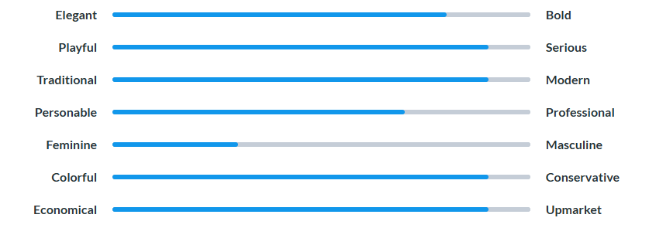

Logo Styles of Interest:
