Outline (for organization only, not part of brochure)

- Cover
- Contents
- The Porcelain Advantage
- Porcelain vs. Wood Comparison
- Fully Non-Combustible Decks
- Colors and Styles
  - Artwood
  - Texwood
  - Evoke
  - Les Bois
  - Woodside
  - Woodridge
  - 3cm Foresta Chiaro
- Applications
  - On-Grade
  - Patio Resurface
  - Rooftop Decks, patios, and terraces
- Installation
  - Elevated
  - On-Grade
- Project Gallery
- Selection Chart
- Technical Characteristics
- Contact us (end)
Main fonts:
Headers: Outfit
Text: Helvetica
New link for images >> Wood Look porcelain Pavers

Cover

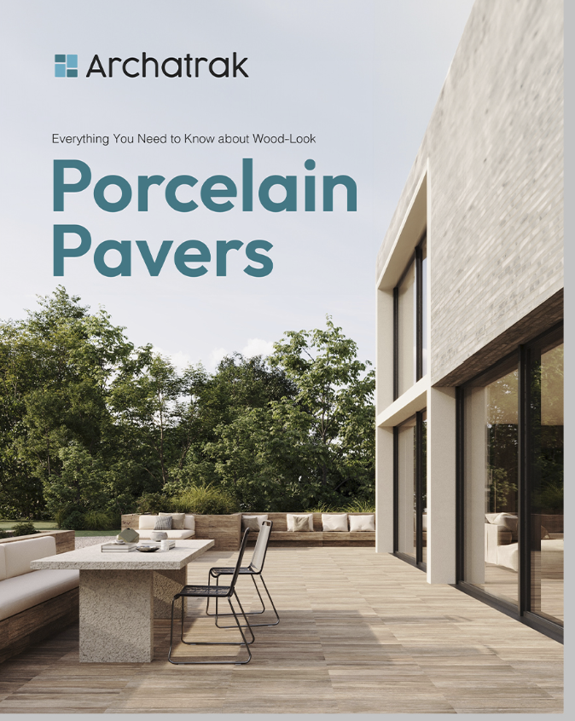
Title: Wood-Look Porcelain Pavers
(delete: everything you need to know…)
We like how the text looks on this example below, but with the style above. No bullets though.

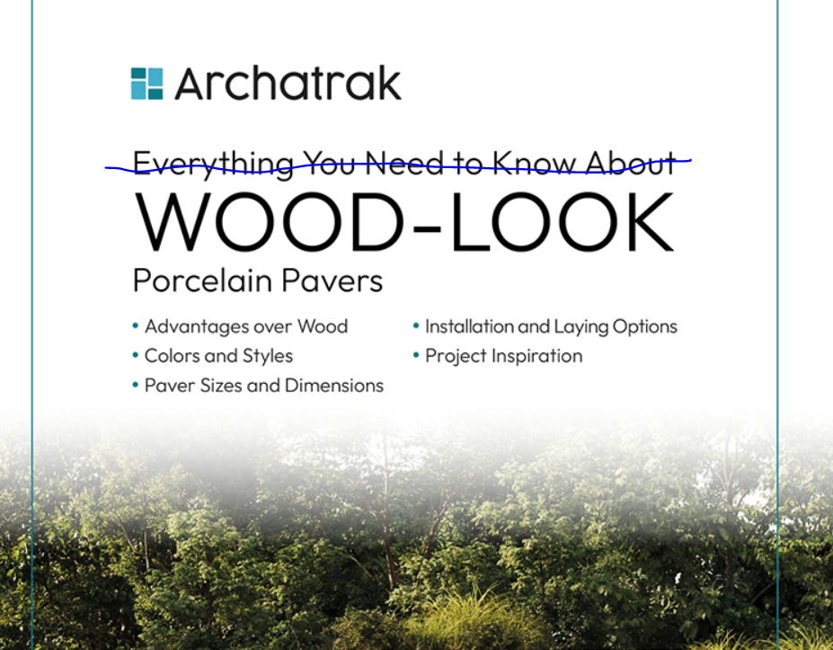

Contents

We like this page.
- We’d like the pavers in the upper right to look more like wood porcelain pavers.
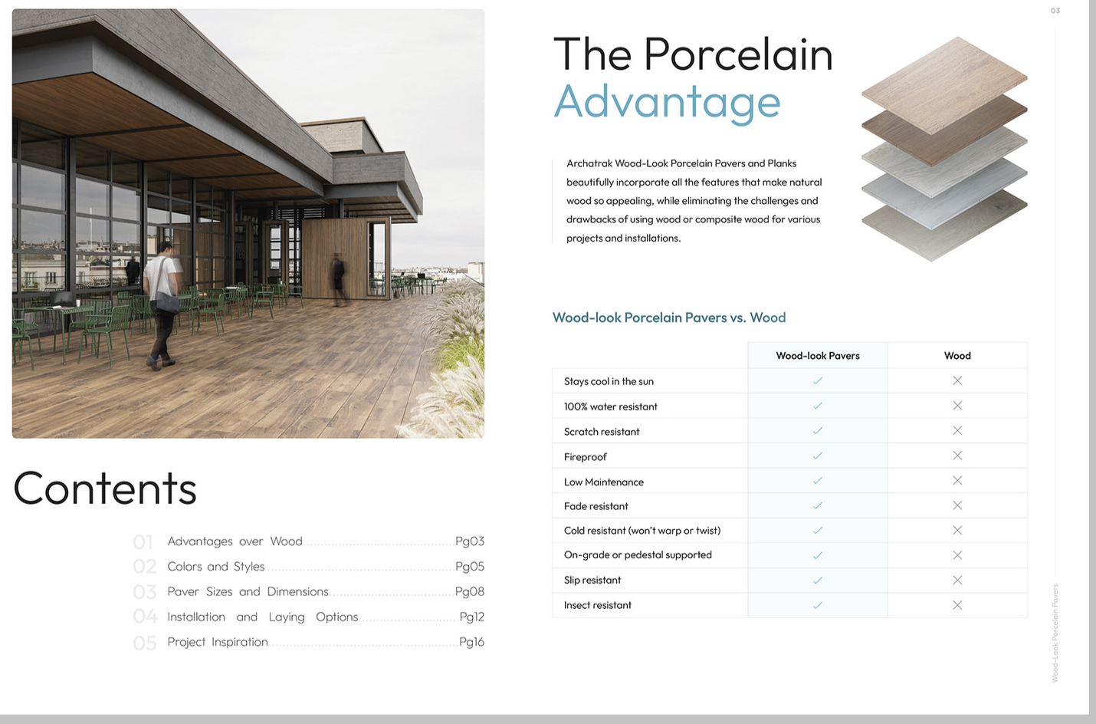
Property | Wood-look Porcelain | Natural Wood
Non-combustible |  | x
Impervious to water |  | x
Resistant to decay & rot |  | x
Scratch resistant |  | x
Warp, twist, cupping resistant |  | x
Fade resistant |  | x
Insect resistant |  | x
Oil and stain resistant |  | x
No splitting or splintering |  | x
No sealing or preservatives |  | x
Low ongoing maintenance |  | x
Sustainable material |  | x
Resistant to moss & algae |  | x

Non-Combustible
We like this page, small changes -
Needs a bold header: Fully Non-Combustible Decks
Updated copy: Wood-look porcelain pavers used with our Incendio Steel Pedestals combine to create a 100% Fireproof decking installation. Fire codes and city requirements change frequently – ensure your project is up to code and ahead of future codes with our Class A fire rated decking system.

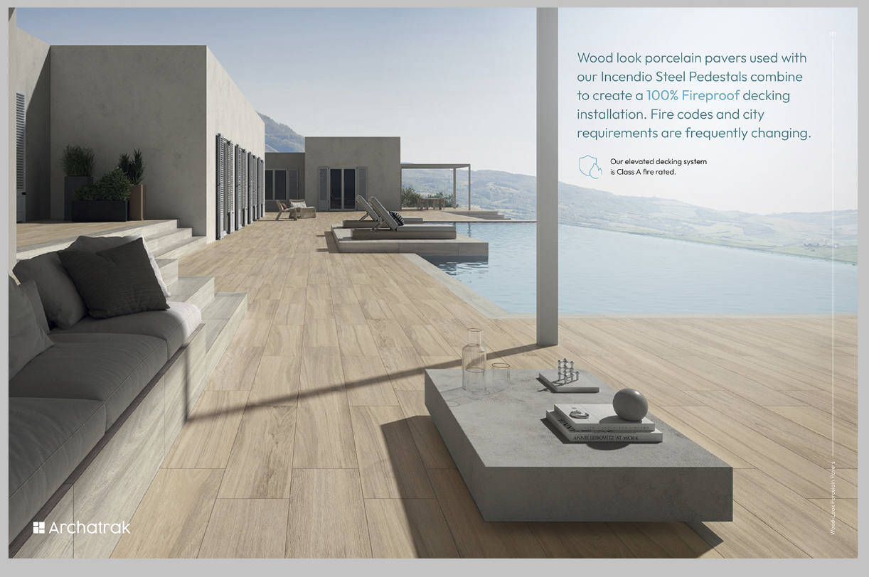

Colors and Styles Cover page

Link to separate doc for Colors and Styles section

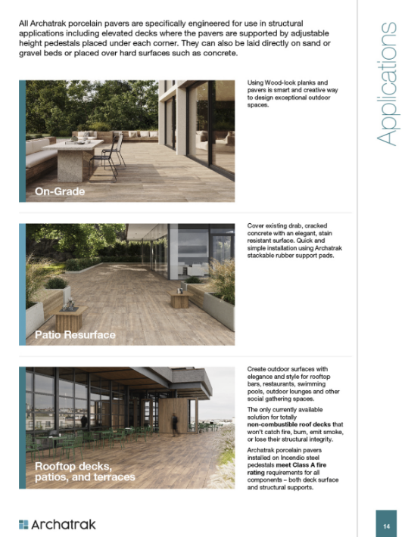
Applications
We liked this style but would prefer the title on the top to match the other pages.

All Archatrak porcelain pavers are designed for both structural applications supported by a pedestal system or laid in a more conventional manner over sand/gravel beds or existing concrete slabs.

On-Grade
Unlike natural wood which can suffer from premature decay if laid directly on the ground, wood look porcelain can be laid over sand or gravel, mortar set over a concrete foundation, or even laid among grassed or lawn areas.

Floating Patio Decks
The quickest and simplest way to level and resurface drab, cracked concrete patios. Porcelain pavers are not mortar set but are loose laid over a concrete slab using Archatrak stackable rubber support pads to maintain precise spacing and ensure a perfectly level surface with excellent drainage.

Elevated Rooftop Decks, Balconies and Terrace
Elegant and stylish wood-look surfaces for rooftop bars, restaurants, swimming pool surrounds, outdoor lounges and other social gathering spaces that won’t burn or lose their structural integrity. Archatrak pedestal supported systems include our ‘Incendio’ steel pedestals, the only totally non-combustible deck solution that meets Class A fire rating for all components – both deck surface and structural support.

Installation
Separate pages for 2 installations, Elevated and On-Grade
- Elevated (first 2)
- On-Grade (next 3)
- Need the small graphic as shown in this
example and the photos indicated on next
page.

Installation
Elevated
SUPPORTED BY ADJUSTABLE HEIGHT PEDESTALS
For perfectly level elevated decks on rooftops and other hard, stable surfaces where deck heights range from approx. 1” up to 30" or more.
- For pavers and planks greater than 16” width.
- Adjustable height pedestals are placed under each corner of the pavers and on the sides where paver lengths exceed 24".
- Use ‘Incendio’ steel pedestals for totally non-combustible decks.
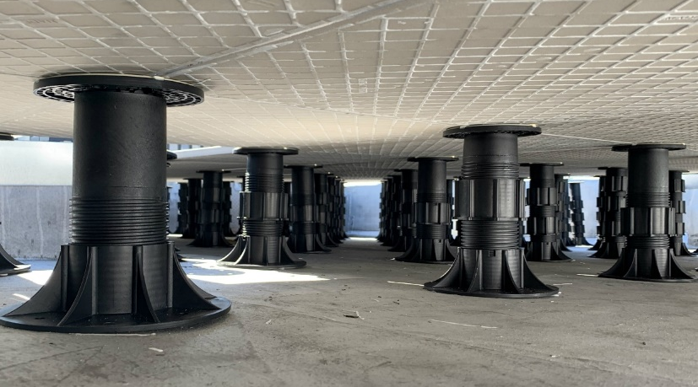
- Wind uplift and break-through considerations need to be properly assessed.

SUPPORTED BY ELEVATED ALUMINUM RAILS
For perfectly level elevated decks on rooftops, balconies and other hard, stable surfaces using plank-style pavers, 16" or less in width.
- 8' long aluminum rails are laid over adjustable height pedestals set approx. 24” apart both parallel and perpendicular to the rails.
- Rubber strips are laid along the rails to minimize noise transmission.
- Paver spacer tabs are slid into the central groove on the rails.
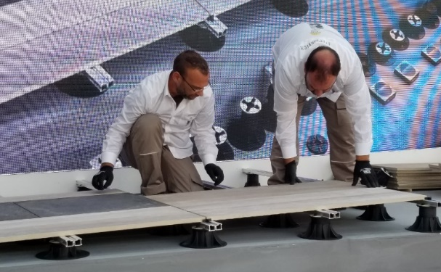
- Pavers are laid over the rails, separated by the sliding spacer tabs, with the ends of all pavers situated directly over a rail.

On Grade
LAID OVER CONCRETE WITH FIXED HEIGHT RUBBER PADS
For resurfacing existing concrete slabs with deck/patio surface elevations less than approx. 2”. A simple but very effective laying method which avoids adhesives and grout and ensures a perfectly level deck surface.

- Archatrak rubber support pads are placed under each corner of the pavers and along the sides where paver lengths exceed 24".
- The ¼” and 3/8” pads are stacked as needed to create a flat, level surface.
- 1/16” rubber shims are added where necessary for minor height adjustments and to prevent any rocking.
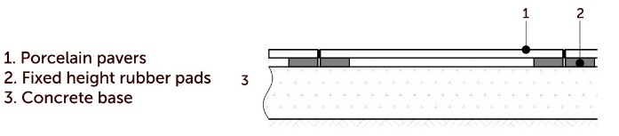

DRY INSTALLATION ON SAND/GRAVEL BEDS
For broad area landscaping, plazas, terraces.

- Pavers are laid directly over a well compacted base of crushed rock and sand.
- Plastic spacer tabs with integrated base are used to provide precise and consistent spacing and ensure that each corner where four pavers meet is set and maintained at the same level.
- Joints are filled with polymeric sand.
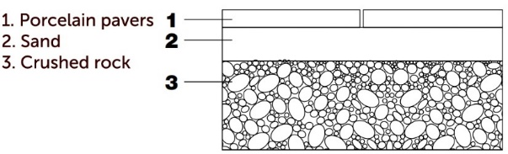

THINSET & GROUTED OVER CONCRETE SLABS
For broad area landscaping, plazas, walkways etc. subject to vehicular and high pedestrian use.

- A reinforced concrete base is first constructed in accordance with local building codes.
- Pavers are laid in conventional mortar or exterior adhesive, making sure the body of any paver is not located above an expansion gap.
- Joints are filled with an approved exterior grout.
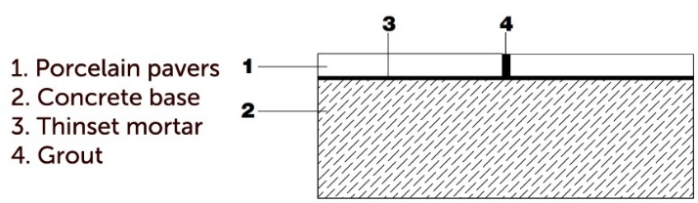
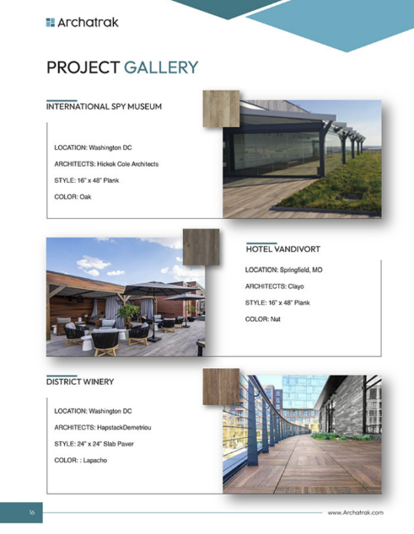
Project Gallery
We thought this was a good design. We liked the wood tile with the project photo, just needs better placement on the tile.

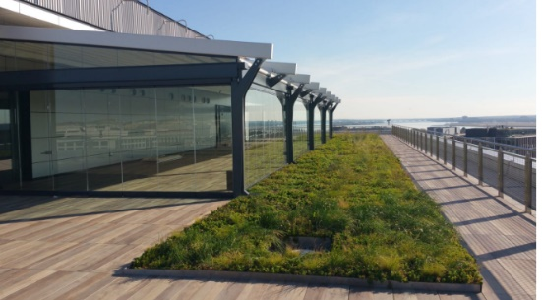
International Spy Museum
Location: Washington DC
Architects: Hickok Cole Architects
Style: 16” x 48” Plank
Color: Oak

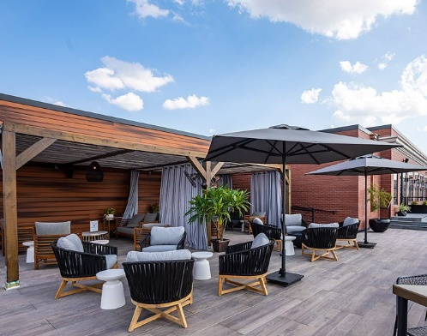
Hotel Vandivort
Location: Springfield, MO
Architects: Clayo
Style: 16” x 48” Plank
Color: Nut

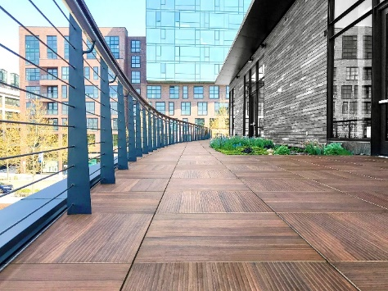
District Winery
Location: Washington, DC
Architects: HapstackDemetriou
Style: 24” x 24” Slab Paver
Color: Lapacho
Tone and Variation
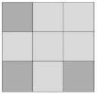 | V2 - Slight Variation  Distinguishable differences in texture and/or pattern. | 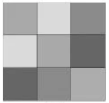 | V3 – Moderate Variation  Significant variation in shade and pattern from paver to paver and within each paver. | 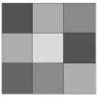 | V4 – Substantial Variation  Considerable variation with random color and/or texture differences from paver to paver.

Selection Chart
Color  2cm pavers | Origin |  | Variation |  | Sizes
Color  2cm pavers | USA | Italy | Shade/Tone | SRI | 24” x 24” | 24” x 48” | 16” x 48” | 12” x 48” | 10 ½” x 72” | 8” x 48”
Texwood Grey | ● |  | V4 | 49 | ●
Texwood Ivory | ● |  | V4 | 52 | ●
Texwood Brown | ● |  | V4 | 38 | ●
Malt |  | ● | V3 |  |  |  | ●
Clay |  | ● | V3 |  |  |  | ●
Scottish |  | ● | V3 |  |  |  | ●
Timber |  | ● | V3 |  |  |  | ●
Wenge |  | ● | V3 |  |  |  | ●
Cherry |  | ● | V3 |  |  |  | ●
Driftwood | ● |  | V3 |  |  | ● |  | ●
Pinewood | ● |  | V3 |  |  | ● |  | ●
Oakwood | ● |  | V3 |  |  | ● |  | ●
Evoke Brown |  | ● | V3 |  |  |  |  | ●
Evoke Sand |  | ● | V3 |  |  |  |  | ●
Sarawa |  | ● | V3 |  |  |  | ● |  | ● | ●
Slavonia |  | ● | V3 |  |  |  | ● |  | ●
Ash |  | ● | V4 |  | ●
Nut |  | ● | V4 | 38 |  |  | ● |  | ● | ●
Oak |  | ● | V4 | 54 |  |  | ● |  | ● | ●
Lapacho | ● |  | V4 | 36 | ●
Tectona | ● |  | V4 | 43 | ●

3cm pavers
Foresta Chiaro |  | ● | V3 |  |  |  | 16” x 32”

Technical Characteristics
Link to pdf

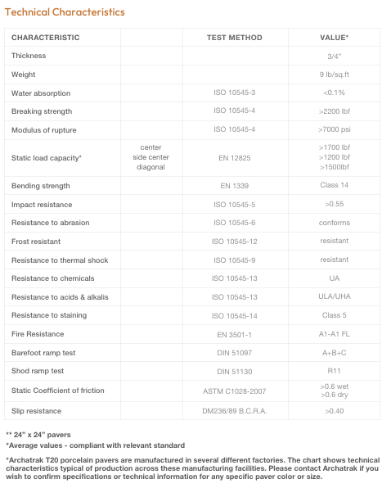

End page

Logo

Contact info
Phone icon: 866 206 8316
Mail icon: solutions@archatrak.com
Website icon: www.archatrak.com

