Hormone Focus™ – A Natural Supplement to Balance Hormone Levels

Your Hormones Deserve a Little Love—And So Do You!

Feeling “Off” Lately? It Could Be Your Hormones.
Do you ever wake up feeling drained before the day even begins?
Struggle with unexplained weight gain, mood swings, or that stubborn brain fog that makes even simple tasks feel overwhelming?
Hormonal imbalances affect millions of women, yet they often go unnoticed. From unpredictable energy levels to persistent bloating and emotional highs and lows, your body is constantly sending signals that something is off.
Estrogen dominance is one of the most common hormonal imbalances women face. It happens when your body produces too much estrogen relative to progesterone, leading to frustrating symptoms like:
- Unwanted weight gain – especially in the hips, thighs, and midsection
- Mood swings and irritability – feeling fine one moment and on edge the next
- Fatigue and brain fog – struggling to focus or remember simple things
- Bloating and digestive discomfort – feeling puffy or sluggish
- Stubborn hormonal acne – breakouts along the jawline and chin
- Low libido – a sudden lack of interest in intimacy
If any of this sounds familiar, you’re not alone—and you don’t have to keep suffering in silence.

Give Your Hormones the Support They Deserve
Your body works hard to keep you feeling your best—but without the right support, hormone imbalances can throw everything off.
Hormone Focus™- a natural supplement to balance hormones - is here to help.
We created Hormone Focus™ to help your body naturally restore harmony, balance estrogen levels, and leave you feeling like yourself again.
Unlike other supplements that only provide DIM, Hormone Focus™ is a complete supplement to balance hormones naturally, combining:

- DIM to regulate estrogen levels
- Calcium D-Glucarate to detox excess hormones
- Black Pepper Extract to enhance absorption and effectiveness
Feel lighter, clearer, and more in control—naturally.
Try Hormone Focus™ today and take the first step toward balanced hormones!
<BUY NOW>

The gentle yet powerful formula supports hormonal balance, natural detoxification, and mental clarity—so you can feel like yourself again—calm, focused, and full of energy.

Feel Clearer, Lighter & More in Control—Every Day.

Why Settle for Just DIM? Experience the Power of Synergy
Unlike other hormone supplements that focus only on DIM, Hormone Focus™ combines Diindolylmethane (DIM), Calcium D-Glucarate, and Black Pepper Extract to give your body triple-action support for hormone detoxification, balance, and absorption.

Let’s Break It Down: How These Ingredients Work Together

DIM (Diindolylmethane) – The Estrogen Regulator
Found naturally in cruciferous vegetables like broccoli and kale, DIM helps your body process "bad" estrogens and convert them into beneficial estrogen metabolites. This can:
- Reduce bloating and water retention
- Support clearer skin by balancing hormone levels
- Help with weight management, especially stubborn belly fat
- Improve mood stability and mental clarity
But DIM alone has limitations—which is why we enhanced it with Calcium D-Glucarate and BioPerine®.

Calcium D-Glucarate – The Detoxifier
This powerful compound supports liver detoxification, helping your body eliminate excess estrogen, toxins, and metabolic waste. Without proper detox, estrogen can recycle back into your system, leading to symptoms like:
- Stubborn weight gain
- Bloating and sluggish digestion
- Breakouts and dull skin
With Calcium D-Glucarate, your body can efficiently flush out excess estrogen, reducing the burden on your liver and promoting a cleaner, healthier hormonal balance.

Black Pepper Extract – The Absorption Booster
What good are powerful ingredients if your body can’t absorb them effectively? Blsvk Pepper Extract enhances the bioavailability of DIM and Calcium D-Glucarate by up to 30%, ensuring you get maximum benefits.
- Faster absorption for quicker results
- More efficient estrogen metabolism
- Enhanced detox support

Together, these three ingredients work in harmony to help your body naturally restore balance—something DIM alone simply can’t do. That’s why Hormone Focus is the best supplement to balance hormones naturally.

Backed by Science: See How It Works

The Power of DIM & Calcium D-Glucarate
Research shows that both DIM and Calcium D-Glucarate play crucial roles in supporting estrogen metabolism and detoxification, helping to balance hormones naturally.

Study #1: DIM Supports Healthy Estrogen Metabolism
A study published in the Journal of Nutrition found that Diindolylmethane (DIM), a compound derived from cruciferous vegetables, plays a key role in promoting healthy estrogen metabolism. Researchers discovered that DIM helps the body shift estrogen metabolism toward producing more beneficial 2-hydroxyestrone (2-OHE1) and reducing the production of harmful 16α-hydroxyestrone (16α-OHE1)¹.

Why Does This Matter?
- Higher levels of 16α-OHE1 are associated with estrogen dominance, which can contribute to weight gain, bloating, mood swings, and an increased risk of hormone-related issues.
- DIM helps balance estrogen levels naturally by increasing the 2-OHE1 to 16α-OHE1 ratio, supporting hormonal harmony and overall well-being.
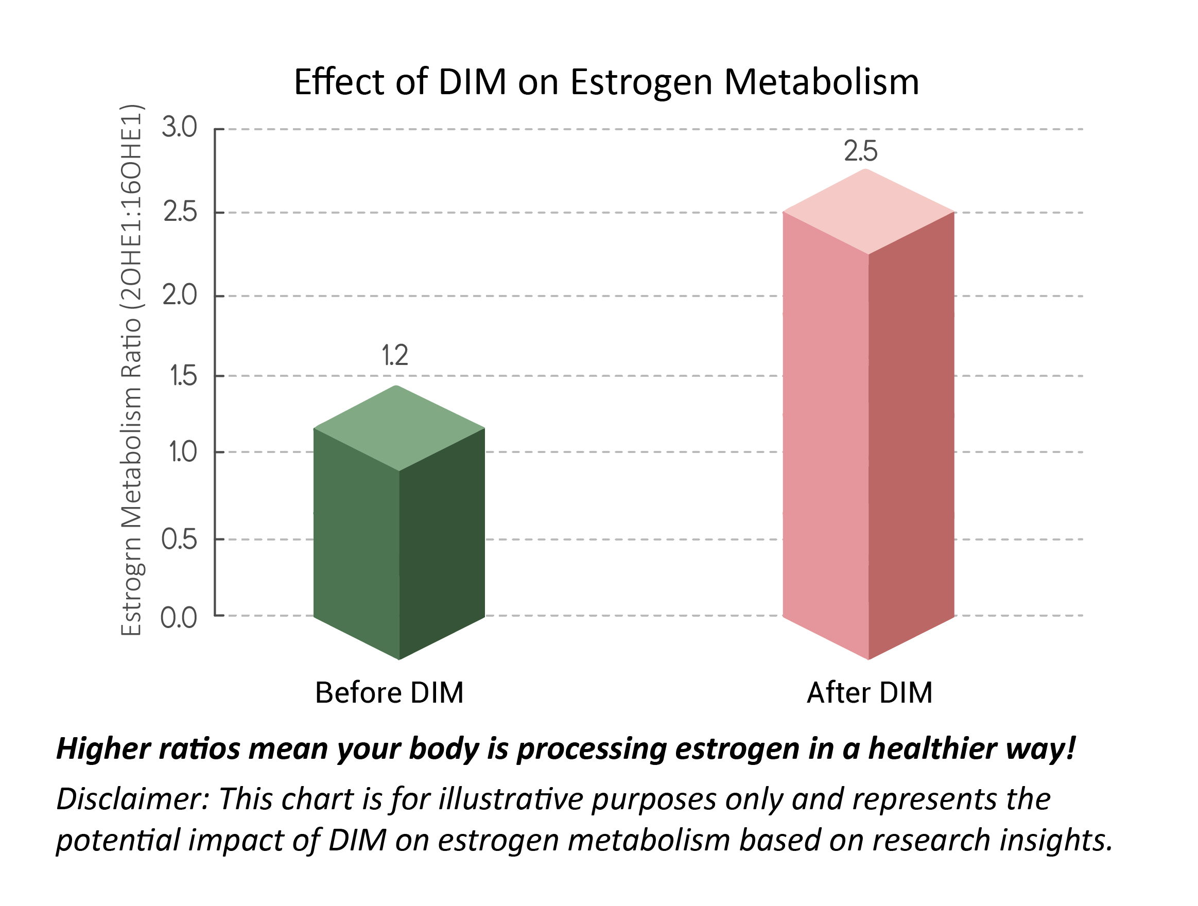

Study Highlights:
- Promotes estrogen balance by encouraging a healthier estrogen metabolite ratio
- Reduces estrogen dominance symptoms like bloating, mood swings, and stubborn weight gain

Study 2: Calcium D-Glucarate Supports Estrogen Detoxification
A study published in the journal Cancer Letters found that Calcium D-Glucarate enhances the body’s ability to remove excess estrogen and toxins² by inhibiting an enzyme called beta-glucuronidase—which can cause estrogen to be reabsorbed instead of eliminated. By reducing beta-glucuronidase activity, Calcium D-Glucarate supports liver detoxification and helps maintain a healthier estrogen balance.
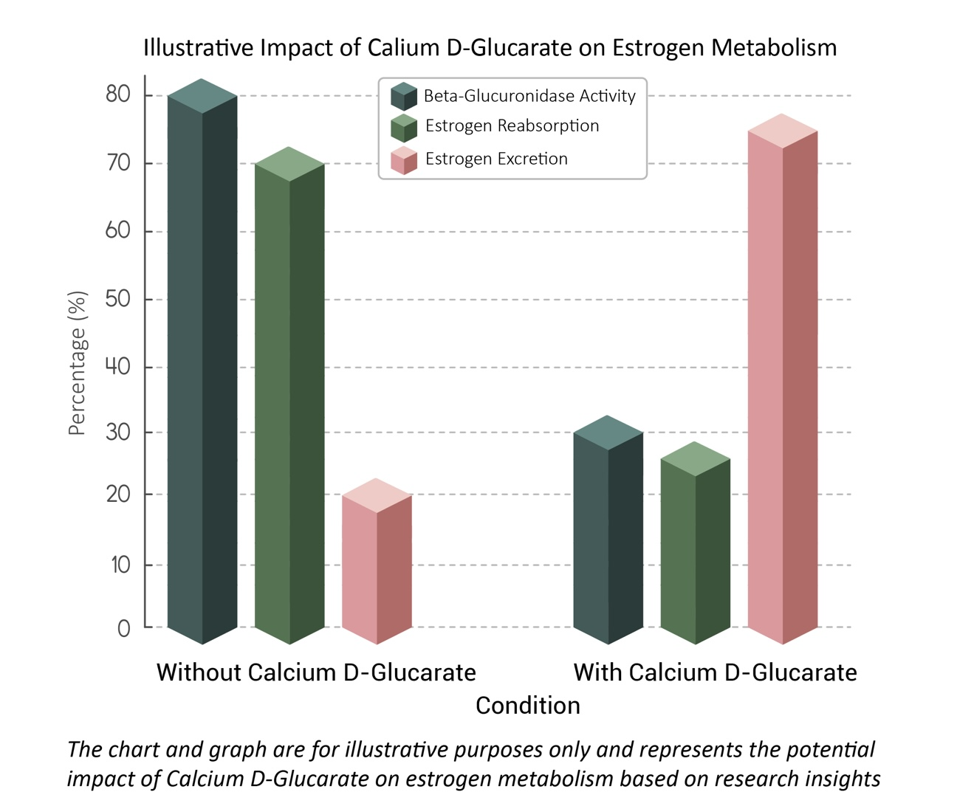
Key Takeaways from the Study:
- Supports natural hormone detoxification by preventing estrogen recycling
- Reduces the risk of estrogen dominance symptoms like bloating, weight gain, and mood swings
- Without Calcium D-Glucarate: 80% of estrogen is reabsorbed, and only 20% is detoxified.
- With Calcium D-Glucarate: Estrogen reabsorption drops to 30%, while detoxification increases to 70%.

Which Hormone Products Are Right For You? Find Your Perfect Hormone Balance

Hormone Focus Bundle (For Daily Hormonal Support)
Includes: Hormone Focus + ProGestGlow
- Supports estrogen metabolism & progesterone balance
- Helps with PMS, mood swings, and hormonal acne
- Promotes energy, focus, and overall well-being
[Shop Hormone Focus Bundle: https://www.jjsmithonline.com/supplements/hormone-focus-bundle/]

Menopause Support Bundle (For Complete Menopause Relief)
Includes: Hormone Focus + EstroGlow + ProGestGlow
- Eases hot flashes, night sweats & mood swings
- Supports restful sleep & skin elasticity
- Helps restore hormonal equilibrium naturally
[Shop Menopause Support Bundle: https://www.jjsmithonline.com/supplements/menopause-support-bundle/]

Not sure which product is right for you? Use this guide to find your perfect hormone support solution!
<Insert table: Discover Which Products Are Right For You>
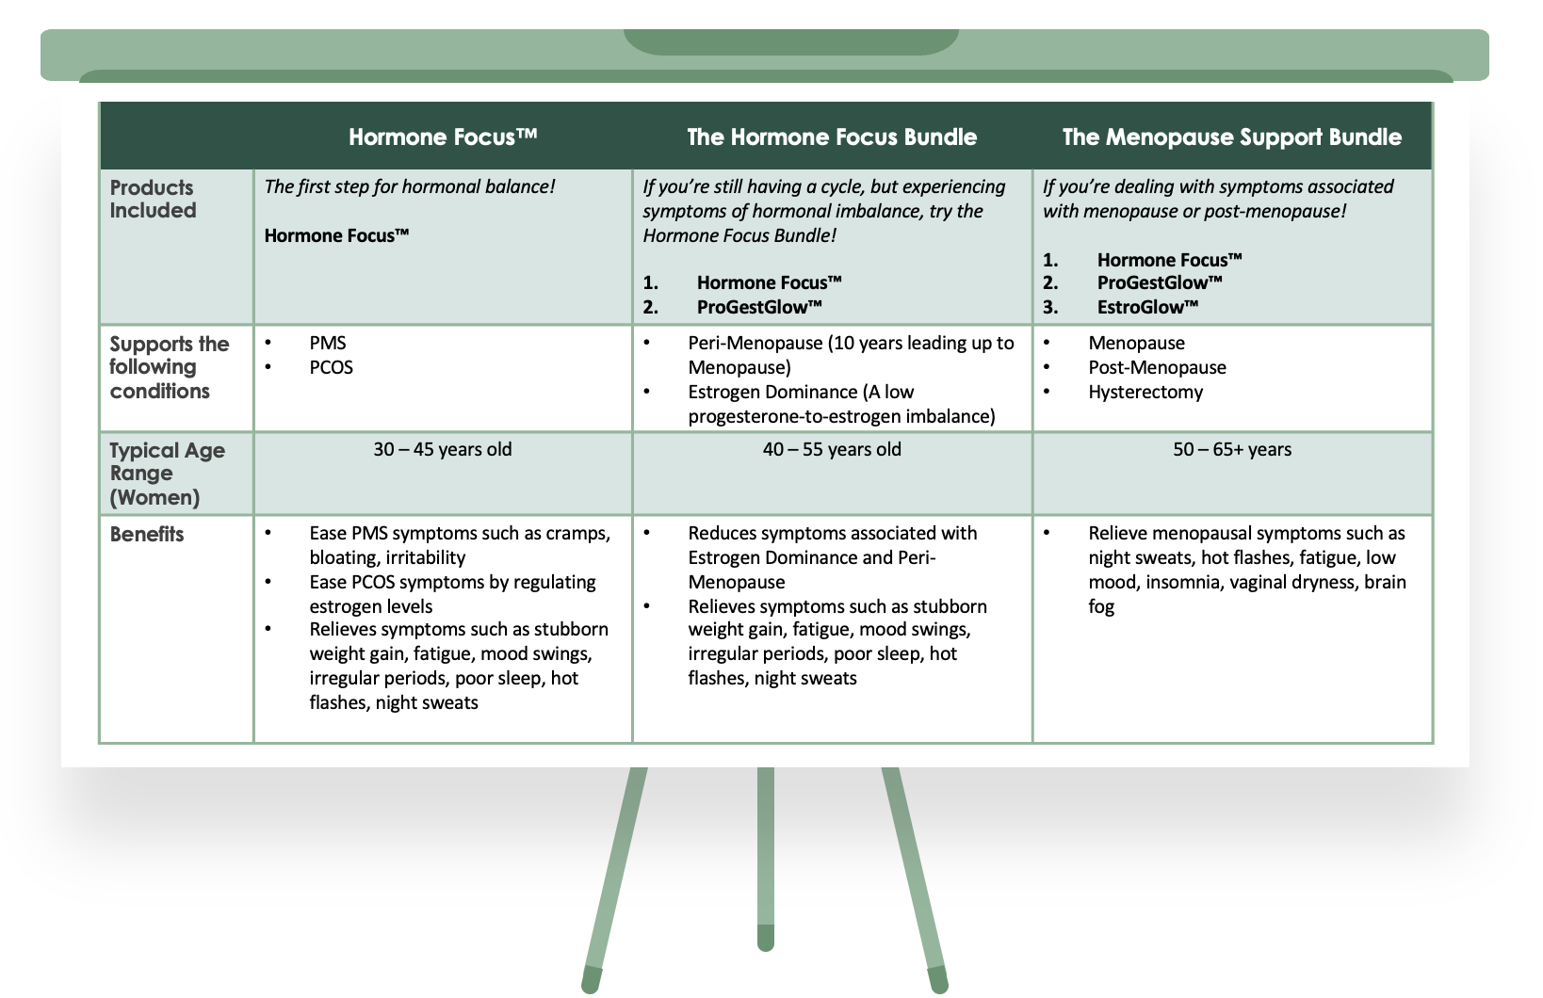

Hormone Focus For the Woman Who Wants to Feel Her Best
- If you’re experiencing PMS, perimenopause, or menopause symptoms.
- If you feel drained, moody, or just not quite like yourself.
- If you want to support your body’s natural ability to balance hormones & detox gently.
- If you’re ready to feel lighter, clearer, and more energized every day.

Why Women Love Hormone Focus
Balances Hormones Naturally – Helps your body process and remove excess estrogen for a healthier balance.
Supports Detox & Metabolism – Gently aids your body’s natural cleansing process for better energy and digestion.
Clears Brain Fog & Boosts Focus – Feel sharper, more present, and in control.
Enhances Mood & Emotional Well-being – Helps you feel calm, centered, and steady throughout the day.
Science-Backed & Made for Women – Every ingredient is carefully chosen to support your unique needs.

Meet Sarah: A Real Story of Hormone Struggles
Sarah used to feel unstoppable. A busy professional and mom, she juggled work, family, and social life effortlessly. But over the past year, something changed.
She started waking up exhausted, no matter how much sleep she got. The scale kept creeping up, even though she hadn’t changed her diet. And the worst part? Her mood swings and irritability were affecting her relationships.
She tried everything—diet changes, exercise, even cutting caffeine—but nothing worked. Then she discovered Hormone Focus™.
“Within three weeks, I felt like myself again. My energy was back, my bloating was gone, and I felt clear-headed for the first time in months. I didn’t realize how much my hormones were affecting me until I finally got them back on track.” – Sarah M., 42
Like Sarah, you don’t have to accept hormone imbalance as your “normal.” With the right support, you can reclaim your energy, your confidence, and your life.
<Insert video testimonials of women talking about the product page/they are on current product page/ You can just use a placeholder and we can add them when we make them page live but pics are here: https://www.dropbox.com/scl/fo/dt8dp0fj8mcx1q4i807on/AACnbyDQNGEhI0qZYSQJipc?rlkey=ei73p4b5t4gn3xhcemsn96w71&st=o3mtpbzj&dl=0

Be the Woman You’re Meant to Be
Take control of your hormone health with Hormone Focus™—the complete supplement to balance hormone levels naturally. Feel lighter, clearer, and more in tune with your body every day.
Don’t wait—give your hormones the support they deserve!
Order Hormone Focus™ Today!

How to Use
For optimal results, take 2 capsules with a meal and a glass of water or as directed by a healthcare professional. Some women who have trouble sleeping related to estrogen dominance, perimenopause or menopause find that taking Hormone Focus at night helps them stay asleep longer. It’s important to consult with a healthcare professional when making dosage adjustments.

<FAQ: Insert FAQs from other WORD DOCUMENT ATTACHED

Still Unsure if Hormone Focus™ is Right for You?
Not sure if Hormone Focus™ is the supplement your body needs?

You’re not alone—many women have the same questions before trying Hormone Focus™, and they’re so glad they did.
- Backed by Science – A powerful blend of DIM, Calcium D-Glucarate, and BioPerine® works synergistically to support estrogen metabolism, hormonal detox, and overall balance.
- Trusted by Women Like You – Countless women have experienced better moods, clearer skin, improved energy, and hormonal harmony with consistent use.
- A Formula You Can Trust – Clean, effective, and designed to support your body’s natural hormone balance—without unnecessary fillers or additives.

Your body deserves complete, targeted hormone support.

<Insert photos of women holding the bottle/photos are on current product page/ You can just use a placeholder and we can add them when we make them page live but pictures are here: https://www.dropbox.com/scl/fo/dt8dp0fj8mcx1q4i807on/AACnbyDQNGEhI0qZYSQJipc?rlkey=ei73p4b5t4gn3xhcemsn96w71&st=o3mtpbzj&dl=0

Get 10% Off Your First Order of Hormone Focus™!
Thinking about trying Hormone Focus™? Here’s an extra reason to say YES to balanced hormones!
Sign up today & enjoy 10% off your first purchase.
Plus, you’ll get exclusive hormone health tips, early access to new products, and special offers—just for our valued customers
Your journey to balance starts now. Don’t miss out!
[Sign Up & Save 10%]

OPTIONAL: THIS LINK INCLUDES SOME ADDITIONAL PICS THAT CAN BE USED ANYWHERE ON THE PAGE: https://www.dropbox.com/scl/fo/dt8dp0fj8mcx1q4i807on/AACnbyDQNGEhI0qZYSQJipc?rlkey=ei73p4b5t4gn3xhcemsn96w71&st=o3mtpbzj&dl=0

