Renew Dialysis

Building Colors:
- Benjamin Moore 45 Swiss Coffee
- Benjamin Moore 40 Heather Gray
- Benjamin Moore 995 Mocha Cream
- Benjamin Moore 30 Nocturnal Gray

Building Renderings:
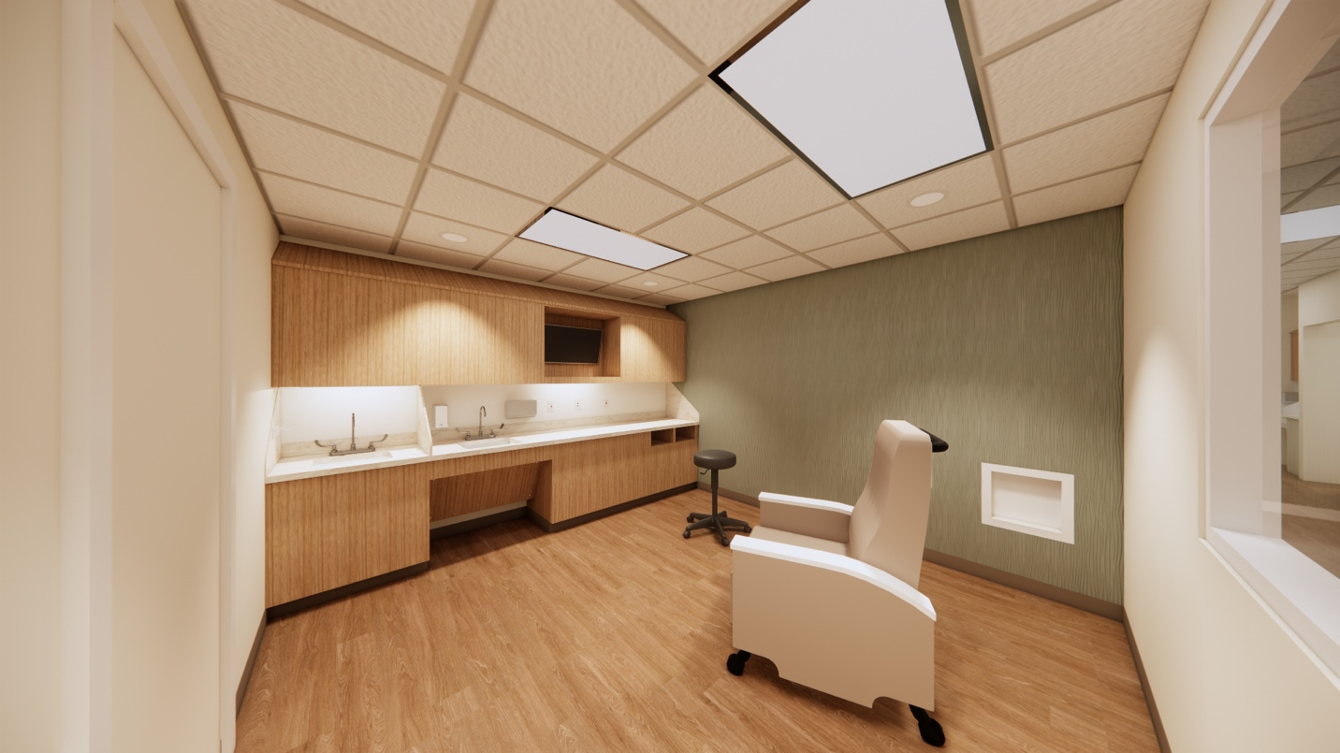
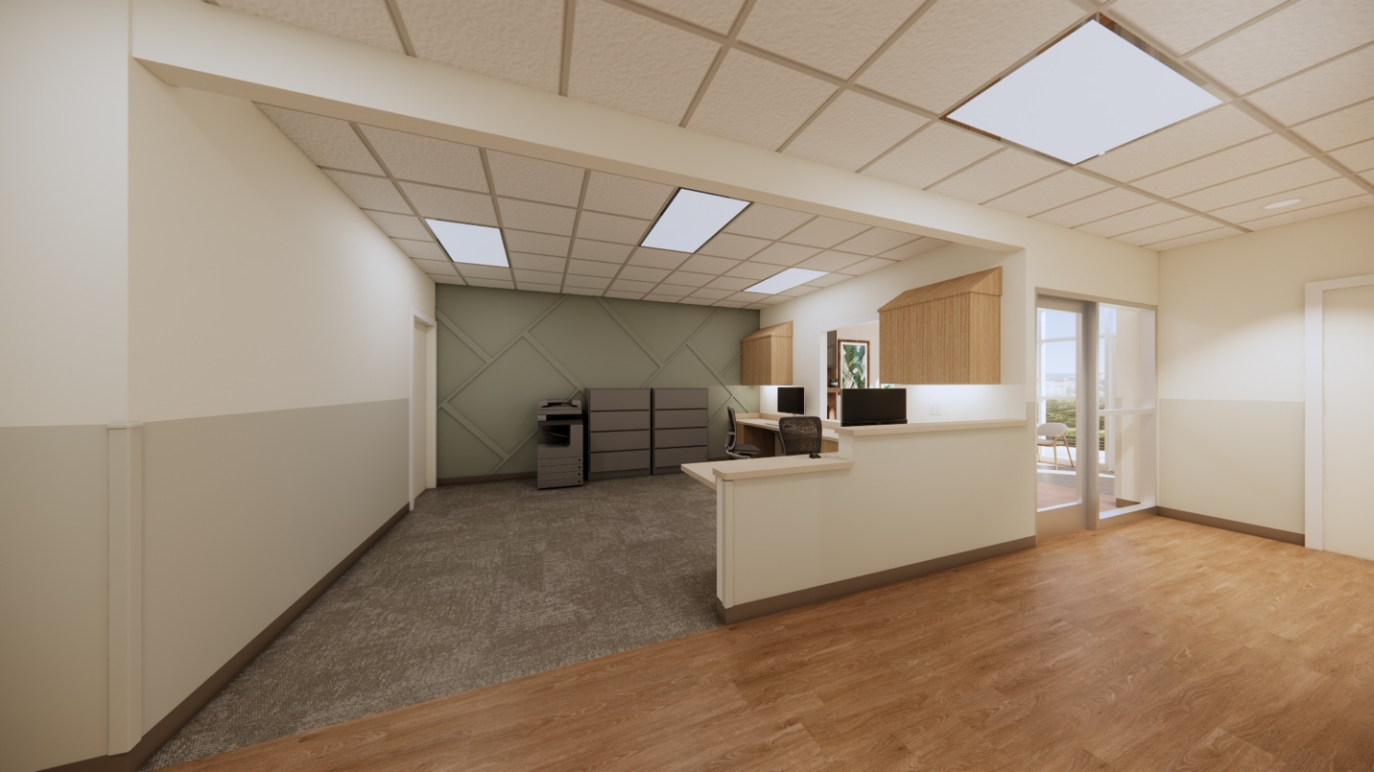
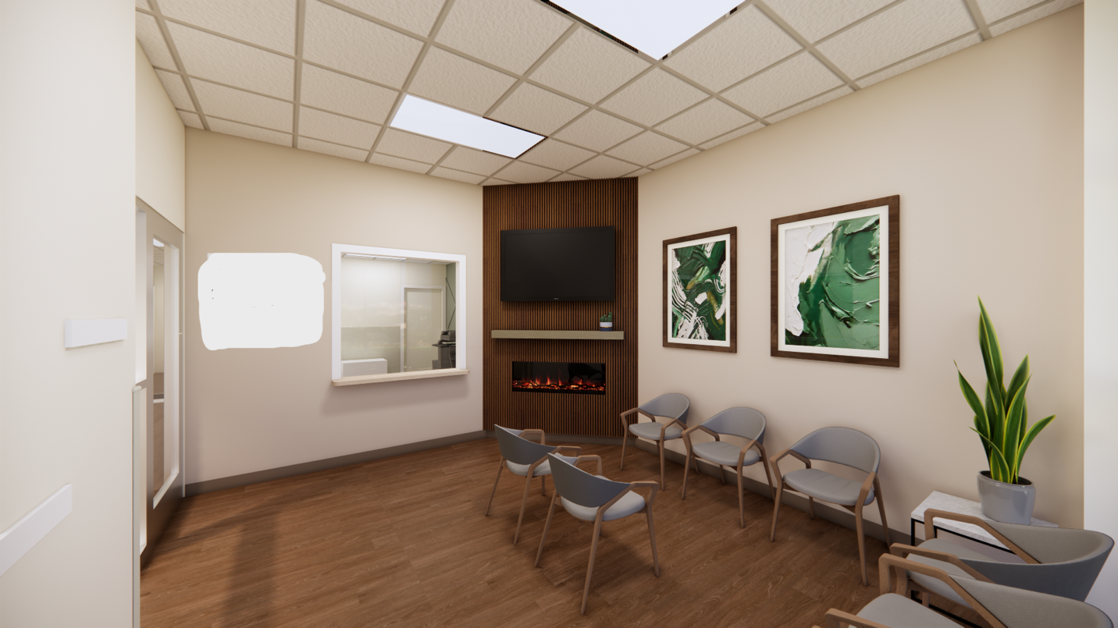

Affiliated Company Logo: (Just to give you an idea)

For Renew Dialysis, we are looking for a modern, softer logo. No red in the logo please. We are thinking maybe the same concept. An object/image with the lettering underneath. Excited to see what you come up with!

