EMPLOYEE OF THE MONTH LAPEL PIN FOR AFC DENVER

⭐⭐⭐
⭐⭐⭐⭐
EMPLOYEE OF THE MONTH

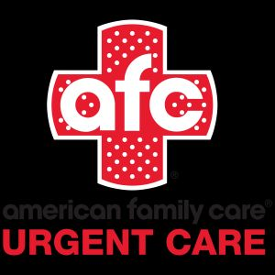

With the words curved around our logo, not like this, but just for the visual
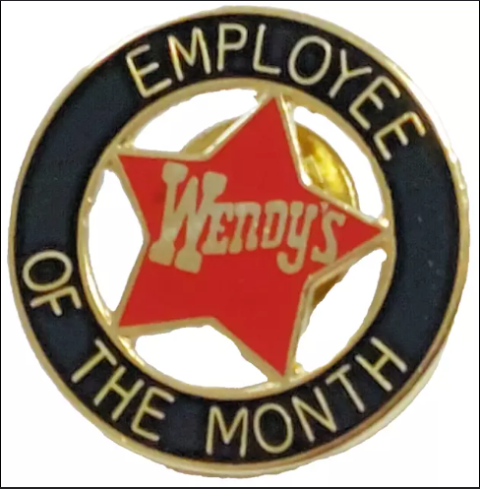

Of course get rid of the black box around the logo, and maybe the “URGENT CARE” too. Or you could make a design or two with and without the “URGENT CARE” part.
With some stars surrounding it in a fun way.
You can find a more “fun” font(s) than what I have above for the employee of the month part.
Max size probably 1.25” x 1.25” if you think it will still be legible.
No month necessary.
Can you give me a few options with the direction I have given?

